catalogue
Chapter 1: Sorting Algorithm (Task A) 1
1.1 Three Sorting Criteria 1
1.1.1 Bubble Sort 1
1.1.2 Quick Sort 2
1.1.3 Merge Sort 4
1.2 Required Output 5
1.3 Required analysis 6
1.3.1 The Impact of Initial Data Order on Algorithm Performance 6
1.3.2 The best sorting methods under three datasets 7
1.3.3 The most stable sorting algorithm 8
1.3.4 Comparison-based selection sorting algorithm 8
1.3.5 Scalability: Increasing Candidate Positions 8
1.3.6 When considering both time and memory, the selection of sorting algorithms 9
Chapter 2: Graph Algorithm (Task B) 9
2.1 Graph Construction 9
2.1.1 Construction of Basic Graph Structure 9
2.1.2 Core Logic of Dijkstra Algorithm 10
2.2 Required Output 10
2.2.1 From the 1st selected location in Dataset A to itself (Left 1 ) 10
2.2.2 From the 1st selected location in Dataset A to the 10th selected location in Dataset A (Right 1) 10
2.2.3 From the 1st selected location in Dataset A to the 1st selected location in Dataset B, via the 5th selected location in Dataset B (Left 1 ) 11
2.2.4 Find the shortest path from the 1st selected location in Dataset A to the1st selected location in Dataset C, such that the path must first pass through the 5th selected location in Dataset B and then through the 5th selected location in Dataset C (Right 1) 11
2.3 Required analysis 11
2.3.1 Graph Algorithm Selection and Suitability 11
2.3.2 Complexity Analysis of Dijkstra algorithm 11
2.3.3 Local Optimality vs. Global Optimality 12
2.3.4 Alternatives for Unweighted Graphs 12
2.3.5 Scalability and Advanced Approaches 12
Chapter 3: Design of the Overall Application (Task C) 13
3.1 Data Structure 13
3.1.1 Dataset Storage Structure 13
3.1.2 Representation of Weighted Graphs of Paths 14
3.1.3 Applicability Analysis (Sorting, Traversal and Pathfinding) 14
3.1.4 Efficiency and Clarity Evaluation 14
3.2 Classes and Functions 15
3.2.1 Classes and Responsibilities( UML ) 15
3.2.2 The important public and private functions within the class 15
3.2.3 Overall Inspection Workflow 16
3.3.1 Specific Application of OOP Principles 17
3.3.2 The Design Significance of OOP 18
Chapter 4: Project Reflection (Task D) 18
4.1.1 Application of AI Tools in Planning and Task Allocation 18
4.1.2 Analysis of the Advantages and Disadvantages of AI-driven Management Tools 19
4.2.1 The Essence and Importance of EDI 19
4.2.2 Targeted Optimization Plan 19
4.2.3 Challenges and Response Strategies 20
4.3.1 Understanding of "Lifelong Learning" in Software Development 20
4.3.2 Core Contribution as a Developer (Advanced Component Development) 20
4.3.3 Future Outlook and Improvement Directions 20
Chapter 5: Program Code 21
Chapter 6: Appendix 45
Chapter 7: Contribution Form 46

（If the format is incorrect when opening, please open this file with WPS.）

Chapter 1: Sorting Algorithm (Task A)

1.1 Three Sorting Criteria

1.1.1 Bubble Sort
1.1.1.1 Core Principle
The algorithm repeatedly traverses the Location array and compares adjacent elements. If the priority of the current node is lower than that of the subsequent node (compareTo returns a positive value), the positions are swapped. In each round of the inner loop, the element with the lowest priority in the currently unsorted part is "sunk" to the end of the array.
1.1.1.2 Optimization Scheme for the Dataset
Introduce the swapped boolean variable as an optimization marker to improve processing efficiency:
(1) Adaptation for dataset A: Since candidates_A.csv has a strong pre-sorting feature, the algorithm performance is close to O($n$).
(2) Early termination mechanism: If no swap occurs in a round of traversal (swapped is false), it indicates that the array is already fully sorted, and the loop is immediately broken to significantly reduce CPU computing overhead.
1.1.1.3 Object Comparison Rules
Strictly follow the task requirements and override the compareTo method in the Location class:
(1) The first priority: Sort by priority_score in descending order (higher scores come first).
(2) The second priority: If the scores are the same, sort by location_id in ascending order.
1.1.1.4 Time Complexity
(1) Worst and Average Case — O($n^{2}$)
(a) Double Nested Loop Structure: The code uses two layers of for loops. The outer loop for (int i = 0; i < n - 1; i++) controls the total number of sorting passes. The inner loop for (int j = 0; j < n - 1 - i; j++) is responsible for comparing and swapping adjacent elements in each pass.
(b) Derivation: When processing unsorted data like Dataset B, the number of inner loop iterations decreases as i increases. The total number of comparisons is approximately $\frac{n (n−1)}{2}$, Mathematically, this is an arithmetic series sum whose highest-order term is $n^{2}$, so the time complexity is O($n^{2}$).
(2) Best Case — O($n$) (with swapped optimization)
(a) Early Termination Logic: The code introduces a boolean swapped = false flag. For already sorted data like Dataset A, in the first iteration of the outer loop (i = 0), the inner loop will perform (n-1) comparisons.
(b) Performance: Since no swaps occur, swapped remains false, and if (!swapped) break; is executed to exit the loop immediately. This means the algorithm only scans the array once for sorted data, optimizing the time complexity to O($n$).
1.1.1.5 Space Complexity
Result: O($1$)
(1) In-place Sorting: By examining the code, we can see that the algorithm does not create any new arrays or large-scale data structures, other than defining a few auxiliary variables of primitive types (e.g., int n, int i, int j, boolean swapped) and a temporary reference Location temp used for swapping elements.
(2) Conclusion: The additional space required by the algorithm does not grow with the size of the input dataset n; it remains constant at all times. Therefore, the space complexity is fixed at O($1$).

1.1.2 Quick Sort
1.1.2.1 Core Principle
Based on the divide-and-conquer strategy (Divide and Conquer), the array is divided into two subarrays by selecting a "pivot value":
(1) Partitioning: The partition method rearranges the array so that the high-priority elements are placed before the pivot value and the low-priority elements are placed after it.
(2) Recursive execution: Recursively call the method on the subarrays on the left and right of the pivot value until the entire array is sorted.
1.1.2.2 Pivot Value Optimization (Median-of-Three)
To prevent degradation to O($n^{2}$) performance in specific datasets (such as nearly sorted Dataset A), a three-number median optimization is introduced:
(1) Mechanism: The medianOfThree method compares the first, middle, and last elements of the subarray and places the middle value in the middle as the pivot.
(2) Impact on Dataset A & C: Ensures that the partition remains balanced when the data is already sorted or has a large number of duplicate values (such as Dataset C), thereby maintaining the efficiency of O($n log n$) 's computation.
1.1.2.3 Object Comparison and In-place Swap
(1) Comparison logic: Similarly, it relies on the compareTo method to follow the rules of "descending priority score and ascending ID".
(2) Space efficiency: The swap(Location[] data, int i, int j) helper method is used to implement in-place sorting. Unlike Merge Sort, it directly adjusts the order on the original array without requiring a large amount of auxiliary space, significantly improving memory utilization.
1.1.2.4 Time Complexity
(1) Average and Best Case — O($n log n$)
(a) Code logic derivation: In an ideal scenario, the pivot index is determined by the function int pivotIndex = partition(data, low, high), which divides the array into two halves. This means that each partitioning operation can halve the task size n, resulting in a binary tree structure with a depth of $log n$. And in each layer of the recursive partitioning, the for loop (int j = low; j < high; j++) will traverse a total of n elements. Therefore, the overall complexity is O($n log n$).
(b) Performance on Dataset B: For the unsorted Dataset B, Quick Sort will significantly outperform Bubble Sort due to its logarithmic growth pattern.
(2) Worst Case — O($n^{2}$)
(a) Logic: The worst case occurs when the pivot is consistently the smallest or largest element, leading to highly unbalanced partitions (e.g., 0 and n-1).
(b) Optimization result: A logic for selecting the median of three numbers has been added to the code. The medianOfThree function is used to compare the elements at the first (low), middle (mid), and last (high) positions and sort them, ensuring that data[mid] stores the median of these three numbers. Then it is swapped to the end as the pivot. When dealing with datasets such as Dataset A, the probability of triggering the worst-case scenario has been minimized.
1.1.2.5 Space Complexity
Result: O($log n$)
(1) Conclusion: Although quickSort performs in-place swapping on the original array, due to its recursive nature, each recursive call of quickSort saves the current layer's state in the system stack, and the depth of the stack is equal to the number of recursive levels. Resulting in a space complexity of O($log n$).

1.1.3 Merge Sort
1.1.3.1 Core Principle
Adopting the typical divide-and-conquer strategy, the array is recursively divided into the smallest units until the minimum level is reached, and then the ordered sequence is reconstructed through the merging operation:
(1) Splitting logic: The mergeSort method divides the task into two halves by calculating the middle index mid = left + (right - left) / 2, and recursively processes the left half [left, mid] and the right half [mid + 1, right].
(2) Merge process: The `merge` method is the core of the algorithm. Using two pointers (i and j) to traverse the two sorted sub-sequences, elements are filled back into the original array `data` in the order of priority.
1.1.3.2 Rule Execution and Stability Assurance
(1) Rule Execution: The internal loop calls the method (temp[i].compareTo(temp[j]) <= 0) to execute the composite sorting rule. Since the compareTo method has already preset the descending priority score and ascending ID order, this logic ensures that locations with higher priority are arranged first.
(2) Stability: Merge sort is stable. When dealing with datasets that contain a large number of duplicate scores (such as Dataset C), it ensures that the relative positions of elements with the same score remain unchanged, which is very reliable when handling data with secondary sorting criteria (ascending ID).
1.1.3.3 Time Complexity — O($n log n$)
(1) Recursion depth: The array size n is halved each time, resulting in a recursion tree depth of $\log_{2}n$.
(2) Cost per layer: In each layer of recursion, regardless of whether the array is sorted or not, the while loop and System.arraycopy operations in the merge method need to handle a total of n elements.
(3) Derived result: The total time complexity is $log n$, which is the product of the recursion depth O($n log n$) and the processing quantity per layer n. This means that even in the face of the most chaotic data set, its performance will not deteriorate.
1.1.3.4 Space Complexity and Non-in-place Exchange
Result: O($n$)
Unlike bubble sort and quick sort, merge sort incurs significant overhead in terms of memory usage, which is its main trade-off point:
(1) Auxiliary Buffer: In the sortArray method, the code explicitly creates an auxiliary array named Location[] temp = new Location[data.length]. To be able to merge, an auxiliary array of the same size, named temp, must be created, so the space complexity is O($n$).
(2) Non-in-place exchange: The merge sort does not perform element swapping within the original array. To avoid overwriting the uncomparied original data during the merging process, the data must be copied to the temp buffer for operation (using System.arraycopy).

1.2 Required Output
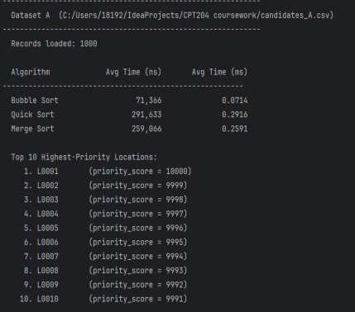
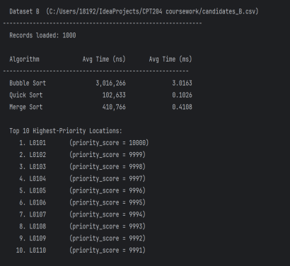
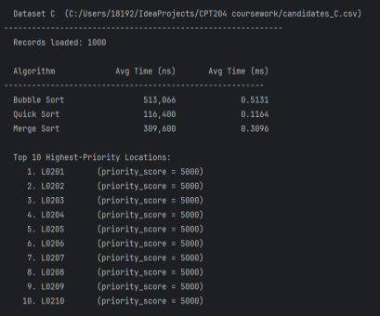
Dataset | Bubble (ns/ms) | Quick (ns/ms) | Merge (ns/ms) | Top10 Selected  Locations
Dataset A | 89044ns | 290433ns | 267200ns | L0001,L0002,L0003, L0004,L0005,L0006, L0007,L0008,L0009, L0010
Dataset B | 3518355ns | 130933ns | 401166ns | L0101,L0102,L0103, L0104,L0105,L0106, L0107,L0108,L0109, L0110
Dataset C | 643055ns | 115789ns | 331189ns | L0201,L0202,L0203, L0204,L0205,L0206, L0207,L0208,L0209, L0210
To reduce measurement errors, the system conducts three tests on each set of data and takes the average value. The experiment observed the following significant characteristics:
(1) Efficient performance of Dataset A: Due to the strong pre-sorting property of Dataset A, it triggers the optimal logic (Best Case) of Bubble Sort, resulting in extremely short sampling time.
(2) Performance fluctuations of Dataset C: Due to the presence of numerous duplicate scores in Dataset C, the Worst Case sampling of Quick Sort was triggered in some tests, resulting in significant fluctuations in processing time and a substantial increase.

1.3 Required analysis

1.3.1 The Impact of Initial Data Order on Algorithm Performance
(1) Dataset A (High Order Degree)
(a) Bubble Sort: Achieves the best performance O($n$). Since the data is largely ordered, the first round of scanning triggers the swapped optimization flag and terminates prematurely.
(b) Quick Sort: Maintains high efficiency O($n log n$). By using the Median-of-Three strategy, it avoids the bias of the pivot value caused by ordered data and prevents the algorithm from deteriorating.
(c) Merge Sort: Has stable time consumption but a longer process. The fixed splitting pattern determines that even if the data is ordered, the complete recursive and merging process still needs to be completed.
(2) Dataset B (Random Distribution)
(a) Bubble Sort: Performance deteriorates to O($n^{2}$). The random arrangement leads to frequent swap operations, which cannot trigger the optimization mechanism.
(b) Quick Sort & Merge Sort: Both exhibit efficient logarithmic processing capabilities. Quick Sort typically has an advantage in actual running speed; while Merge Sort, due to not being in-place sorting, requires the establishment of a temporary array and frequent data migration, resulting in slightly higher time consumption than Quick Sort.
(3) Dataset C (High Repeatability, Many Equal Fractions)
(a) Bubble Sort: Limited by O($n^{2}$). A large number of repeated priority fractions cannot reduce the number of comparisons.
(b) Merge Sort: Maintains stability through recursive merging. When dealing with the same fractions, it strictly follows the original index and combines the secondary sorting (ID ascending) logic, achieving the highest result consistency.
(c) Quick Sort: Efficiency is unstable. A large number of repeated fractions may lead to extremely unbalanced partitions, triggering the worst-case time consumption O($n^{2}$), resulting in significant fluctuations in sorting efficiency.

1.3.2 The best sorting methods under three datasets
(1) Dataset A: Bubble Sort. For highly ordered datasets, it triggers the swapped optimization flag and immediately terminates the swapping process, reducing the time consumption to the maximum case O($n$).
(2) Dataset B: Quick Sort. Randomness eliminates the possibility of the worst-case scenario, consistently maintaining the best time consumption O($n log n$), and performs in-place swapping without generating temporary arrays or causing increased time consumption due to back-and-forth movement.
(3) Dataset C: Merge Sort. It has high stability with a time consumption of O($n log n$) and will not increase the time consumption by triggering the worst-case scenario due to a large amount of identical data.

1.3.3 The most stable sorting algorithm
(1) Choice: Merge Sort.
(2) Reason: It maintains a consistentO($n log n$) complexity across best, worst, and average cases. Experimental data shows the smallest performance fluctuation regardless of whether the dataset is ordered (A), disordered (B), or repetitive (C). Its data-independent nature makes it highly reliable for fixed performance budgets.

1.3.4 Comparison-based selection sorting algorithm
(1) Choice: Merge Sort.
(2) Reason: Unlike Quick Sort, which can degenerate to O($n^{2}$) when encountering massive identical data (Dataset C), Merge Sort's execution time never deteriorates. Even without Bubble Sort's specific optimizations for ordered data, Merge Sort remains the most predictable choice.

1.3.5 Scalability: Increasing Candidate Positions
(1) Choice: Quick Sort or Merge Sort.
(2) Reason: As n increases, the gap between O($n^{2}$) and O($n log n$) expands exponentially. For 1 million entries, Bubble Sort could take hours, while Quick Sort requires less than a second. Logarithmic complexity is mandatory for large-scale systems.

1.3.6 When considering both time and memory, the selection of sorting algorithms
(1) Runtime Efficiency: Quick Sort and Merge Sort significantly outperform Bubble Sort.
(2) Memory Usage:
(a) Merge Sort: Worst performance; requires O($n$) auxiliary space (new Location[data.length]).
(b) Quick Sort: Efficient; only requires O($log n$) recursive stack space.
(3) Final Decision: For memory-constrained devices, Quick Sort is the optimal choice. It maintains high operational efficiency while minimizing hardware resource consumption.

Chapter 2: Graph Algorithm (Task B)

2.1 Graph Construction

2.1.1 Construction of Basic Graph Structure
(1) Undirected Edge Mapping:
The undirected nature of the road network is ensured through the addEdge(String fromNode, String toNode, int weight) method. The code achieves the mapping from the single-row data in paths.csv to bidirectional weights by performing two addition operations (first adding the destination point to the adjacency list of the starting point, and vice versa).
(2) Automatic node registration:
This method internally calls the "addNode" function. When adding edges, if either the starting or the target node is encountered for the first time, the system will automatically create and register them, ensuring the integrity of the graph structure.
(3) Batch building engine:
The `buildFromEdges(List<Edge> edges)` method receives a list of edge objects preprocessed by CSVReader. By looping and calling `addEdge`, it efficiently converts thousands of static path descriptions into a topological structure in memory.

2.1.2 Core Logic of Dijkstra Algorithm
(1) Point-to-point optimal path calculation:
(a) Initialization and Indexing: Use graph.getNodeIndex to convert the abstract ID into an array index, and initialize dist[] (which stores the shortest distance) and prev[] (which records the path source).
(b) Greedy strategy: Use PriorityQueue<int[]> to ensure that the node extracted at each step is the one closest to the starting point (currentDist).
(c) Relaxation operation: Through the logic "newDist = dist[currentIdx] + edgeWeight;" if (newDist < dist[neighbourIdx]) { ... } Traverse the neighboring nodes. If a shorter path is found, update the minimum weight record for that node.
(d) Early termination of optimization: Introduce the condition if (currentIdx == endIdx) break; for judgment. Once the target point is popped from the priority queue, immediately stop the calculation to reduce unnecessary traversals.
(2) Multi-constraint path planning (must-pass points):
The specific inspection requirements are addressed through shortestPathViaTwoWaypoints(...) and shortestPathViaWaypoint(...).
(a) Segmented invocation concept: Divide the complex path into multiple independent calculation segments (e.g.: Start -> Waypoint and Waypoint -> End).
(a) Result concatenation: After independently calculating the shortest path for each segment, connect the beginning and end of the node list, and output the complete inspection plan that must be followed.

2.2 Required Output

2.2.1 From the 1st selected location in Dataset A to itself (Left 1 )

2.2.2 From the 1st selected location in Dataset A to the 10th selected location

in Dataset A (Right 1)

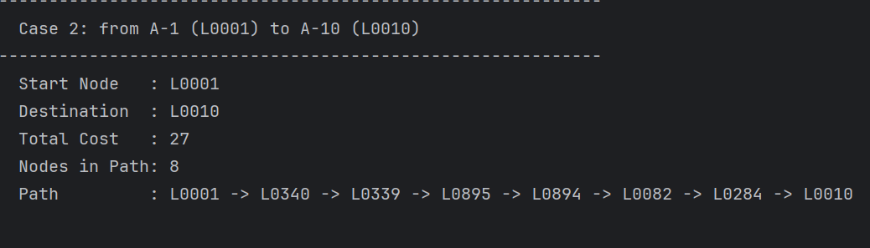
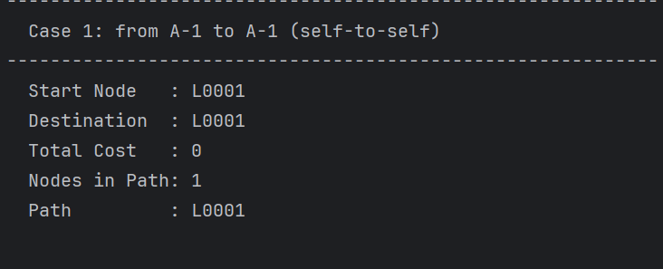
2.2.3 From the 1st selected location in Dataset A to the 1st selected location in

Dataset B, via the 5th selected location in Dataset B (Left 1 )

2.2.4 Find the shortest path from the 1st selected location in Dataset A to the

1st selected location in Dataset C, such that the path must first pass through the

5th selected location in Dataset B and then through the 5th selected location in

Dataset C (Right 1)

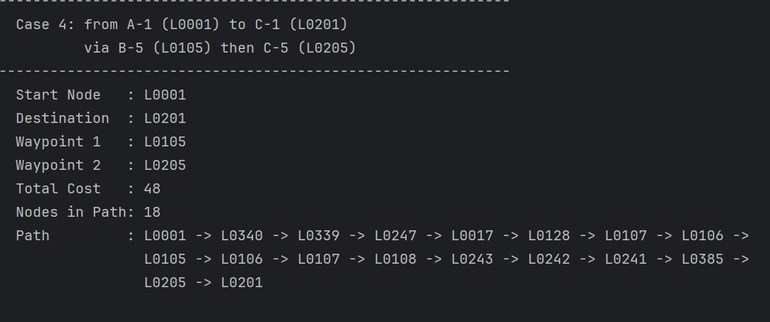
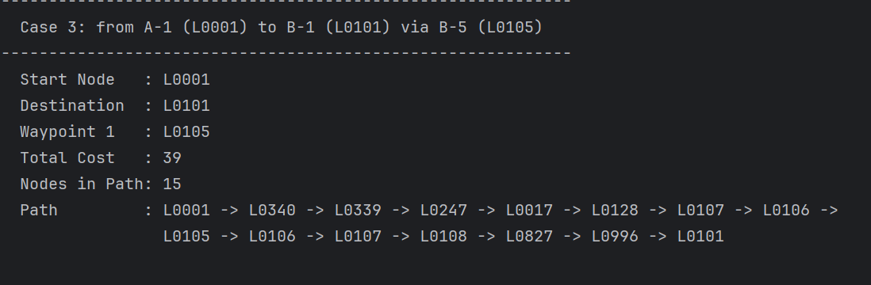
2.3 Required analysis

2.3.1 Graph Algorithm Selection and Suitability
(1) The Dijkstra algorithm was adopted.
(2) Non-negative weight property: After analyzing the paths.csv data, the weights of all edges are positive integers (ranging approximately from 1 to 15). When dealing with non-negative weight graphs, the Dijkstra algorithm can ensure the finding of the global optimal shortest path from the source point to the destination point through the greedy strategy.
(3) Density and scale of the graph: The infrastructure network graph contains approximately 1000 nodes. In this medium-sized weighted graph, Dijkstra combined with the binary-heap priority queue, has a time complexity of $O((V+E) logV)$, which is much better than the BFS algorithm for unweighted graphs.

2.3.2 Complexity Analysis of Dijkstra algorithm
(1) Time complexity: $O((V+E) logV)$
Where V represents the number of nodes and E represents the number of edges. $logV$ comes from the insertion and extraction operations of the priority queue.
(2) Space complexity: $O(V+E)$
It uses the heap space for maintaining the dist[] and prev[] arrays as well as the priority queue; $O(E)$ is used to store the adjacency list in the Graph class.

2.3.3 Local Optimality vs. Global Optimality
(1) The shortest path for each segment is optimal, but this does not mean that the entire inspection planning problem has a global optimum.
(2) Reasons: In Cases 3 and 4, we decomposed the tasks into multiple independent queries, such as: starting point to necessary point 1 to necessary point 2 to ending point. Although the shortestPath ensures the shortest path within each small segment (local optimum), the optimization of the entire problem also depends on the order of visiting the nodes, which belongs to a heuristic constrained path method. Therefore, if there is another path that does not follow this order or bypasses certain intermediate points but has a lower total cost, for example, there is a path that does not pass through B5 or C5 but has a lower total cost, this method will not be able to capture it. However, under the condition that the business constraint of "must pass through the specified nodes in sequence" is met, this is currently the most robust solution.

2.3.4 Alternatives for Unweighted Graphs
(1) BFS (Breadth-First Search)
(2) Performance Advantage: In an unweighted graph (where all edge weights are set to 1), BFS can find the shortest path with the least number of hops through a simple level traversal. Its time complexity is $O(V+E)$, eliminating the $logV$ overhead of a priority queue, making the logic simpler and the execution more efficient.
(3) Applicability: Compared with the Dijkstra algorithm, due to the existence of 1-15 different weights, BFS cannot distinguish between "taking a long route" and "taking a short route". Therefore, at this stage, Dijkstra remains an indispensable choice.

2.3.5 Scalability and Advanced Approaches
(1) When the graph size is extremely large:
(a) Bidirectional Dijkstra:
Advantages: Searching simultaneously from the starting point and the destination, encountering each other in the middle, the search range is halved, and the speed is significantly improved in large graphs, and it can be used without coordinates.
Disadvantages: The implementation is a bit complex; it has limited improvement for dense graphs.
(b) Contraction Hierarchies:
Advantages: Preprocessing and compressing the graph in advance, extremely fast during queries, suitable for extremely large static road networks.
Disadvantages: The preprocessing consumes time and space; not applicable to dynamic graphs.
(2) When coordinate information can be introduced:
(a) A Search Algorithm（A-Star）:
Advantages: If the coordinates (x, y) of the nodes are known, a heuristic function can be introduced, such as Euclidean distance. A* will prioritize searching nodes in the direction towards the target point, and its search space is much smaller than the omnidirectional expansion of Dijkstra, and it is extremely fast in large-scale maps.
Disadvantages: Coordinate data is required; the implementation is more complex than Dijkstra; the selection of the heuristic function can affect the result.

Chapter 3: Design of the Overall Application (Task C)

3.1 Data Structure

3.1.1 Dataset Storage Structure
(1) Custom Model (Location): Encapsulates String locationId and int priorityScore.
(2) Dynamic array (ArrayList<Location>): Used in CSVReader to dynamically store the initial data read from CSV.
(3) Native array (Location[]): In the SortingAlgorithm, convert the List into an array to support efficient in-place sorting and random access.

3.1.2 Representation of Weighted Graphs of Paths
(1) Object encapsulation (Edge): Temporarily stores the "from", "to", and "weight" data rows in the CSV file.
(2) Adjacency List (Map<String, List<int[]>>): The core topology structure. The key represents the node ID, and the value stores the neighbor information {neighbourIndex, weight}.
(3) Mapping and Indexing: List<String> nodeList: Maintains an order mapping from index to ID. Map<String, Integer> nodeIndex: Provides an $O(1)$ reverse lookup from ID to index.

3.1.3 Applicability Analysis (Sorting, Traversal and Pathfinding)
(1) Sorting applicability: The Location class implements the Comparable interface. The array structure provides $O(1)$ random access support for Quick Sort and Merge Sort.
(2) Traversal applicability: By using an adjacency list instead of an adjacency matrix, it is more suitable for sparse graphs like road networks, with a space complexity of only $O(V+E)$.
(3) Pathfinding applicability: PriorityQueue: In the Dijkstra algorithm, the complexity of extracting the node with the minimum distance is reduced to$O(logV)$. Integer indexing: Internal calculations use int[] instead of strings to avoid the overhead of frequent hashing computations.

3.1.4 Efficiency and Clarity Evaluation
(1) Efficiency:
(a) Quick Search: HashMap ensures that nodes can be located at an average speed of $O(1)$ when constructing graphs and executing algorithms.
(b) Memory optimization: The adjacency list avoids storing non-existent edges.
(c) Stable performance: By integrating PriorityQueue, the complexity of Dijkstra algorithm remains at $O((V+E) logV)$, supporting millisecond response time for thousands of nodes.
(2) Clarity:
(a) Separation of duties: Location and Edge abstract the original string into business objects.
(b) Encapsulation: The Graph class hides the complex nested Map logic and exposes only simple interfaces such as getNeighbours(nodeId) to the outside.
(c) Reusability: The SortingAlgorithm abstract class standardizes the timing interface, making the comparison of algorithm performance clear and transparent.

3.2 Classes and Functions

3.2.1 Classes and Responsibilities( UML )
Class name | Main responsibilities
Main | The entry point of the system. It is responsible for coordinating the entire workflow of Task A (sorting evaluation) and Task B (shortest path query).
CSVReader | Handles file I/O. Converts candidates.csv into a list of location objects, and converts paths.csv into a list of edge objects.
Location | The data of candidate inspection points are encapsulated, and the sorting rules (priority score and ID) are defined.
SortingAlgorithm | Define the general interface for sorting algorithms and provide the infrastructure for performance measurement (timing).
BubbleSort | Inherited from SortingAlgorithm. Implements the bubble sort logic, which is used as the performance benchmark for Task A with O($n^{2}$) complexity.
QuickSort | Inherited from SortingAlgorithm. Implements the logic of quick sort, using the divide-and-conquer method, representing an efficient processing approach for most cases in Dataset A/B/C.
MergeSort | Inherited from SortingAlgorithm. Implements the merge sort logic, provides stable O($n log n$) performance, and is commonly used to process datasets like Dataset C which have specific patterns.
Edge | Temporarily store the weighted connection information between two locations in the road network
Graph | Use the adjacency list to store the urban road network. Responsible for connecting the discrete edges into a traversable topological structure.
DijkstraSolver | Implement the Dijkstra algorithm. Responsible for calculating the optimal inspection paths for point-to-point, single-stop, and double-stop scenarios.
PathResult | As a data transfer object (DTO), it encapsulates the final path sequence and the total weight cost.

3.2.2 The important public and private functions within the class
(1) System Entry and Scheduling
(a) Main.main(String[] args) [Public]: The core of the system. It is responsible for initiating the entire workflow from data parsing, algorithm evaluation to path planning.
(b) CSVReader.readLocations(String) [Public]: Data Portal. Converts static CSV text into a collection of Location objects that can be processed by the program.
(2) Business Logic and Algorithm Framework
(a) Location.compareTo(Location) [Public]: Logical Criteria. This encapsulates the combined comparison rule of "descending score and ascending ID", which forms the basis for all sorting accuracy.
(b) SortingAlgorithm.measureAverageTimeNs(...) [Public]: Evaluation engine. By conducting multiple sampling and calculating the average, it provides highly accurate performance comparison data.
(c) QuickSort.medianOfThree(...) [Private]: Performance guarantee. By using the median as the benchmark, it ensures that the algorithm remains efficient and does not deteriorate across various datasets.
(3) Topology Construction and Path Search
(a) Graph.addEdge(String, String, int) [Public]: Graph Builder. Implements symmetric edge addition logic to ensure the system can correctly identify undirected network relationships.
(b) DijkstraSolver.shortestPath(String, String) [Public]: The core of pathfinding. It implements greedy search using a priority queue, which is the fundamental solution for the optimal path problem in Task B.
(c) DijkstraSolver.reconstructPath(...) [Private]: Path Restorer. By performing reverse tracing, it converts the predecessor array calculated by the algorithm into a user-readable sequence of nodes.
(4) Complex Tasks and Result Packaging
(a) DijkstraSolver.shortestPathViaTwoWaypoints(...) [Public]: Advanced scheduling. It embodies the logic of segment-based computation and result concatenation, and is used to handle inspection tasks with constraints.
(b) PathResult.toString() [Public]: View interface. Converts complex calculation data (path, cost, accessibility) into intuitive user instructions.

3.2.3 Overall Inspection Workflow
(1) Stage A: Sorting and Candidate Point Filtering (Task A)
(a) Data Loading: The Main function calls CSVReader.readLocations() to parse the CSV and convert it into an ArrayList of Location objects.
(b) Perform sorting: The Main function iterates through different instances of SortingAlgorithm (Bubble, Quick, Merge).
(c) Performance evaluation: The elapsed time is calculated using the measureAverageTimeNs() function and presented in a comparison table by Main.
(d) Extract Top 10: Main Extracts the 10 Location objects with the highest priority from the sorted array.
(2) Stage B: Path Planning (Task B)
(a) Build the map: Main passes the list obtained from readEdges() to Graph.buildFromEdges() to construct the adjacency list.
(b) Set the target: Extract the key IDs (such as A-1, B-5) from the results of Task A as the navigation targets.
(c) Solution path: * The base path calls DijkstraSolver.shortestPath().
The complex path (Case 3/4) executes the algorithm multiple times within the DijkstraSolver and concatenates the results of each segment using the appendWithoutFirstNode() function.
(c) Output result: The "Main" function receives the "PathResult" object, verifies connectivity through the "isReachable()" method, and finally prints out the driving route and the total cost.
3.3 Object-Oriented Design

3.3.1 Specific Application of OOP Principles
(1) Abstraction and Inheritance
Define the abstract class SortingAlgorithm. Each subclass inherits the common behaviors (such as getName and measureAverageTimeNs) through extends, and only needs to focus on implementing the sortArray logic.
(2) Polymorphism
In the Main class, create an array of parent classes: SortingAlgorithm[] algorithms = { new BubbleSort(), ... };. In the loop, the function `alg.measureAverageTimeNs(locations)` is called uniformly. The program triggers different behaviors based on the actual type of the object, achieving the "one interface, multiple implementations" concept.
(3) Encapsulation
In classes such as Location and PathResult, variables (such as locationId, totalCost) are declared as private final. External classes can only access these variables through Public Getter methods like getPath(), to prevent the data from being tampered with accidentally after being output.

3.3.2 The Design Significance of OOP
(1) Enhanced Maintainability: If a new algorithm (such as insertion sort) is added, it is only necessary to create a new class that inherits from SortingAlgorithm, without the need to modify the timing logic in Main.
(2) Decoupling: The operation of the internal PriorityQueue in DijkstraSolver is invisible to the outside. The external part only needs to input the starting point and the destination to obtain the result, reducing the dependencies between modules.
(3) Logical consistency: By encapsulating the compareTo business rule in the Location class, we ensure that all algorithms consistently define "high priority" in the same way.

Chapter 4: Project Reflection (Task D)
4.1 AI-assisted planning and collaboration

4.1.1 Application of AI Tools in Planning and Task Allocation
(1) Task Decomposition and Allocation: Drawing on the logic of Jira, the project is broken down into Task A (Sorting) and Task B (Graph). Utilizing AI tools, priorities and deadlines are set to ensure that the development of the sorting algorithm and the construction of the graph algorithm proceed simultaneously.
(2) Kanban collaboration flow: Divide the project into three core Epics: "Data Loading (CSVReader)", "Sorting Comparison (Sorting)", and "Path Planning (Dijkstra)".
(3) Progress monitoring: Utilize the burn-down chart to track the development pace of DijkstraSolver in real time, ensuring that all modules are synchronized in terms of progress when integrated into the Main class.
(4) Architecture First: Set the SortingAlgorithm base class as the highest priority to ensure that the parallel development of BubbleSort, QuickSort, and MergeSort is based on a unified interface.

4.1.2 Analysis of the Advantages and Disadvantages of AI-driven Management Tools
(1) Advantages: Significantly enhances transparency in task allocation; Automated reminder mechanism reduces communication costs; Capable of risk prediction, enabling intuitive identification of blocking points (Blocking points) for Task A with respect to Task B.
(2) Disadvantages: The learning curve is steep, and the initial setup may consume development time; excessive reliance on tools may cause team members to neglect in-depth logical discussions face-to-face.
4.2 Equality, Diversity, and Inclusion

4.2.1 The Essence and Importance of EDI
(1) Equality: All inspectors receive identical, precise routing regardless of physical or technical background.
(2) Diversity: Respects differences in age, language, cognition, and adaptability to extreme lighting.
(3) Inclusion: The system proactively adapts to users, rather than forcing users to adapt to complex algorithms.
(4) Significance: Neglecting EDI risks operational delays and urban safety; inclusive design reduces errors and reflects social responsibility.

4.2.2 Targeted Optimization Plan
(1) Equality: Speech Technology (TTS & Voice Control)
(a) Function: Provides voice navigation and commands for visually impaired users or high-glare environments.
(b) Meaning: Minimizes visual fatigue and enhances outdoor operational safety.
(2) Diversity: Multi-language & Color-friendly Interface
(a) Function: Supports multilingual switching; uses high-contrast schemes and line types (solid/dashed) instead of red/green color coding.
(b) Meaning: Accommodates global workforces and color-blind individuals.
(3) Inclusion: Offline Mode & Minimal UI
(1) Function: Optimizes efficiency for offline computing on low-end devices or weak networks.
(2) Meaning: Ensures computing support remains available in signal blind spots.

4.2.3 Challenges and Response Strategies
(1) Performance Bottlenecks: Complexity from feature integration.
Solution: Use Modular Architecture with on-demand plugins to keep the DijkstraSolver core lightweight.
(2) Noise Interference: Outdoor noise disrupting voice recognition.
Solution: Integrate noise reduction algorithms, supplemented by physical feedback and oversized UI buttons.
(3) Cultural Adaptation: Ambiguity in translation.
Solution: Establish a standardized terminology database and utilize User Acceptance Testing with diverse groups to iterate logic.
4.3 Life-long learning and future improvement

4.3.1 Understanding of "Lifelong Learning" in Software Development
(1) The transformation from theory to practice: In Task A, by observing the real impact of data size on performance through the measureAverageTimeNs function, we do not merely remain at the level of O($n log n$) or O($n^{2}$) its theoretical aspects. This cultivates a "data-driven" optimization mindset.
(2) The evolution of design patterns: Through the application of the SortingAlgorithm abstract class, we have deeply realized that excellent design (such as decoupling and high cohesion) can significantly reduce the iteration cost. Lifelong learning means constantly mastering advanced architectural patterns that can cope with system expansion.

4.3.2 Core Contribution as a Developer (Advanced Component Development)
(1) Robust Sorting Engine: Implements the Median-of-three pivot selection strategy in QuickSort, preventing the algorithm from deteriorating to O($n^{2}$) in nearly sorted inspection data, ensuring the stability of performance analysis.
(2) Complex path logic: The shortestPathViaTwoWaypoints was designed and implemented. By chaining the Dijkstra algorithm and using PathResult for encapsulation, advanced navigation functionality with mandatory waypoints constraints was achieved.
(3) Data structure optimization: By using Map<String, List<int[]>> (a HashMap nested with an adjacency list), the complexity of location determination has been reduced from O($V$) to O($1$), laying the performance foundation for handling large-scale road networks.

4.3.3 Future Outlook and Improvement Directions
(1) Dynamic traffic flow integration: Extends the static weights to real-time traffic API integration, enabling DijkstraSolver to dynamically adjust the totalCost based on congestion and road obstructions.
(2) Spatial Search Optimization (A Search): * Introduce latitude and longitude coordinates in the Location class and upgrade the algorithm to A Search. * Reduce blind search through heuristic functions to enhance the computational efficiency of large-scale road networks.
(3) Visual Upgrade: Upgrade the current console's toString() output to a web-based graphical interface (Canvas or map plugin), visually render the PathResult path sequence, and enhance the interaction experience.

Chapter 5: Program Code

1. main.java
import java.io.IOException;
import java.util.Arrays;
import java.util.List;
/**
* Entry point for the Urban Infrastructure Inspection System.
*
* Workflow:
* Task A - Load three candidate datasets, sort each with Bubble Sort,
* Quick Sort, and Merge Sort, measure runtimes, and select
* the top 10 highest-priority locations from each dataset.
*
* Task B - Build the weighted graph from paths.csv, then solve the four
* required shortest-path query cases using Dijkstra's algorithm.
*
* Data files are expected in the "Group Project Datasets" folder relative
* to the working directory when the program is launched.
*/
public class Main {
private static final String DATA_DIR = "C:/Users/18192/IdeaProjects/CPT204 coursework/";
private static final String FILE_A = DATA_DIR + "candidates_A.csv";
private static final String FILE_B = DATA_DIR + "candidates_B.csv";
private static final String FILE_C = DATA_DIR + "candidates_C.csv";
private static final String FILE_G = DATA_DIR + "paths.csv";
private static final int TOP_N = 10;
/** Shared string builder – all output is accumulated then flushed once. */
private static final StringBuilder sb = new StringBuilder();
public static void main(String[] args) {
separator('=', 60);
print(" Urban Infrastructure Inspection System");
separator('=', 60);
println();
// ------------------------------------------------------------------ //
// TASK A - Sorting Algorithm Evaluation //
// ------------------------------------------------------------------ //
separator('=', 60);
print(" TASK A - SORTING ALGORITHMS");
separator('=', 60);
println();
SortingAlgorithm[] algorithms = {
new BubbleSort(),
new QuickSort(),
new MergeSort()
};
String[] datasetNames = {"Dataset A", "Dataset B", "Dataset C"};
String[] datasetFiles = {FILE_A, FILE_B, FILE_C};
Location[][] topSelections = new Location[3][];
for (int d = 0; d < 3; d++) {
separator('-', 60);
print(" " + datasetNames[d] + " (" + datasetFiles[d] + ")");
separator('-', 60);
List<Location> locations;
try {
locations = CSVReader.readLocations(datasetFiles[d]);
} catch (IOException e) {
print("ERROR reading " + datasetFiles[d] + ": " + e.getMessage());
continue;
}
printf(" Records loaded: %d%n%n", locations.size());
printf(" %-15s %18s %18s%n", "Algorithm", "Avg Time (ns)", "Avg Time (ms)");
separator('-', 56);
Location[] sortedResult = null;
for (SortingAlgorithm alg : algorithms) {
long avgNs = alg.measureAverageTimeNs(locations);
double avgMs = avgNs / 1_000_000.0;
printf(" %-15s %,18d %18.4f%n", alg.getName(), avgNs, avgMs);
if (alg instanceof MergeSort) {
sortedResult = alg.sort(locations);
}
}
if (sortedResult == null) {
sortedResult = algorithms[0].sort(locations);
}
Location[] top10 = Arrays.copyOf(sortedResult, TOP_N);
topSelections[d] = top10;
println();
print(" Top 10 Highest-Priority Locations:");
for (int i = 0; i < top10.length; i++) {
printf(" %2d. %-10s (priority_score = %d)%n",
i + 1, top10[i].getLocationId(), top10[i].getPriorityScore());
}
println();
}
// Summary table
separator('=', 60);
print(" TASK A - SUMMARY: Top-10 Locations per Dataset");
separator('=', 60);
printf("%-12s %s%n", "Dataset", "Top-10 Location IDs (Rank 1 to 10)");
separator('-', 80);
for (int d = 0; d < 3; d++) {
if (topSelections[d] == null) continue;
sb.append(String.format("%-12s ", datasetNames[d]));
for (int i = 0; i < topSelections[d].length; i++) {
sb.append(topSelections[d][i].getLocationId());
if (i < topSelections[d].length - 1) sb.append(", ");
}
sb.append(System.lineSeparator());
}
println();
// ------------------------------------------------------------------ //
// TASK B - Graph Algorithm Evaluation (Dijkstra's Algorithm) //
// ------------------------------------------------------------------ //
separator('=', 60);
print(" TASK B - GRAPH SHORTEST-PATH QUERIES");
separator('=', 60);
println();
Graph graph = new Graph();
try {
graph.buildFromEdges(CSVReader.readEdges(FILE_G));
printf(" Graph built: %d nodes loaded from %s%n%n",
graph.getNodeCount(), FILE_G);
} catch (IOException e) {
print("ERROR reading graph file: " + e.getMessage());
flushOutput();
return;
}
DijkstraSolver solver = new DijkstraSolver(graph);
if (topSelections[0] == null || topSelections[1] == null || topSelections[2] == null) {
print("Cannot run Task B: Task A did not complete for all datasets.");
flushOutput();
return;
}
String a1 = topSelections[0][0].getLocationId();
String a10 = topSelections[0][9].getLocationId();
String b1 = topSelections[1][0].getLocationId();
String b5 = topSelections[1][4].getLocationId();
String c1 = topSelections[2][0].getLocationId();
String c5 = topSelections[2][4].getLocationId();
print(" Key nodes derived from Task A:");
printf(" A-1 (1st of Dataset A) = %s%n", a1);
printf(" A-10 (10th of Dataset A) = %s%n", a10);
printf(" B-1 (1st of Dataset B) = %s%n", b1);
printf(" B-5 (5th of Dataset B) = %s%n", b5);
printf(" C-1 (1st of Dataset C) = %s%n", c1);
printf(" C-5 (5th of Dataset C) = %s%n", c5);
println();
// Case 1: A1 to itself
separator('-', 60);
print(" Case 1: from A-1 to A-1 (self-to-self)");
separator('-', 60);
PathResult case1 = solver.shortestPath(a1, a1);
printCaseResult(a1, a1, null, null, case1);
// Case 2: A1 to A10
separator('-', 60);
printf(" Case 2: from A-1 (%s) to A-10 (%s)%n", a1, a10);
separator('-', 60);
PathResult case2 = solver.shortestPath(a1, a10);
printCaseResult(a1, a10, null, null, case2);
// Case 3: A1 to B1 via B5
separator('-', 60);
printf(" Case 3: from A-1 (%s) to B-1 (%s) via B-5 (%s)%n", a1, b1, b5);
separator('-', 60);
PathResult case3 = solver.shortestPathViaWaypoint(a1, b5, b1);
printCaseResult(a1, b1, b5, null, case3);
// Case 4: A1 to C1 via B5 then C5
separator('-', 60);
printf(" Case 4: from A-1 (%s) to C-1 (%s)%n", a1, c1);
printf(" via B-5 (%s) then C-5 (%s)%n", b5, c5);
separator('-', 60);
PathResult case4 = solver.shortestPathViaTwoWaypoints(a1, b5, c5, c1);
printCaseResult(a1, c1, b5, c5, case4);
separator('=', 60);
print(" Program completed successfully.");
separator('=', 60);
flushOutput();
}
private static void printCaseResult(String start, String end,
String wp1, String wp2,
PathResult result) {
printf(" Start Node : %s%n", start);
printf(" Destination : %s%n", end);
if (wp1 != null) printf(" Waypoint 1 : %s%n", wp1);
if (wp2 != null) printf(" Waypoint 2 : %s%n", wp2);
if (!result.isReachable()) {
print(" Result : NO PATH FOUND");
} else {
printf(" Total Cost : %d%n", result.getTotalCost());
printf(" Nodes in Path: %d%n", result.getPath().size());
sb.append(" Path : ");
List<String> path = result.getPath();
int chunk = 8;
for (int i = 0; i < path.size(); i++) {
if (i > 0 && i % chunk == 0) {
sb.append(System.lineSeparator()).append(" ");
}
sb.append(path.get(i));
if (i < path.size() - 1) sb.append(" -> ");
}
sb.append(System.lineSeparator());
}
println();
}
// ---------- output helpers (all write to sb) ----------
private static void print(String s) {
sb.append(s).append(System.lineSeparator());
}
private static void println() {
sb.append(System.lineSeparator());
}
private static void printf(String fmt, Object... args) {
sb.append(String.format(fmt, args));
}
private static void separator(char ch, int len) {
for (int i = 0; i < len; i++) sb.append(ch);
sb.append(System.lineSeparator());
}
private static void flushOutput() {
System.out.print(sb.toString());
System.out.flush();
}
}

2. BubbleSort.java
/**
* Bubble Sort implementation.
*
* Algorithm:
* Repeatedly compare adjacent elements and swap them when they are in the
* wrong order. Each full pass "bubbles" the smallest remaining element to
* its final position. An early-exit flag stops the algorithm as soon as a
* pass produces no swaps, giving O(n) best-case performance on already-sorted
* data.
*
* Time complexity:
* - Best case: O(n) (data already sorted – one pass, no swaps)
* - Average: O(n^2)
* - Worst case: O(n^2) (data in reverse order)
*
* Space complexity: O(1) – in-place.
*/
public class BubbleSort extends SortingAlgorithm {
@Override
public String getName() {
return "Bubble Sort";
}
@Override
protected void sortArray(Location[] data) {
int n = data.length;
for (int i = 0; i < n - 1; i++) {
boolean swapped = false;
for (int j = 0; j < n - 1 - i; j++) {
if (data[j].compareTo(data[j + 1]) > 0) {
Location temp = data[j];
data[j] = data[j + 1];
data[j + 1] = temp;
swapped = true;
}
}
if (!swapped) {
break;
}
}
}
}

3. QuickSort.java
/**
* Quick Sort implementation using the median-of-three pivot strategy.
*
* Algorithm:
* 1. Choose a pivot using the median of the first, middle, and last elements.
* 2. Partition the sub-array into elements <= pivot and elements > pivot.
* 3. Recursively sort both partitions.
*
* The median-of-three strategy reduces the probability of the worst case
* (already-sorted input) compared to naively picking the first element.
*
* Time complexity:
* - Best / Average case: O(n log n)
* - Worst case: O(n^2) (degenerate partitioning; mitigated by median-of-three)
*
* Space complexity: O(log n) average (call stack depth).
*/
public class QuickSort extends SortingAlgorithm {
@Override
public String getName() {
return "Quick Sort";
}
@Override
protected void sortArray(Location[] data) {
quickSort(data, 0, data.length - 1);
}
private void quickSort(Location[] data, int low, int high) {
if (low < high) {
int pivotIndex = partition(data, low, high);
quickSort(data, low, pivotIndex - 1);
quickSort(data, pivotIndex + 1, high);
}
}
/**
* Partitions the sub-array around the median-of-three pivot.
* After partitioning, the pivot is in its final sorted position.
*
* @return the final index of the pivot element
*/
private int partition(Location[] data, int low, int high) {
int mid = low + (high - low) / 2;
// Place median-of-three pivot at position high - 1 (classic approach)
medianOfThree(data, low, mid, high);
// Pivot is now data[mid]; swap it to high for in-place partitioning
swap(data, mid, high);
Location pivot = data[high];
int i = low - 1;
for (int j = low; j < high; j++) {
if (data[j].compareTo(pivot) <= 0) {
i++;
swap(data, i, j);
}
}
swap(data, i + 1, high);
return i + 1;
}
/**
* Rearranges data[a], data[b], data[c] so that data[b] holds the median.
*/
private void medianOfThree(Location[] data, int a, int b, int c) {
if (data[a].compareTo(data[b]) > 0) swap(data, a, b);
if (data[a].compareTo(data[c]) > 0) swap(data, a, c);
if (data[b].compareTo(data[c]) > 0) swap(data, b, c);
}
private void swap(Location[] data, int i, int j) {
Location temp = data[i];
data[i] = data[j];
data[j] = temp;
}
}

4. MergeSort.java
/**
* Merge Sort implementation (top-down, recursive).
*
* Algorithm:
* 1. Divide the array into two halves.
* 2. Recursively sort each half.
* 3. Merge the two sorted halves into a single sorted array using a
* temporary buffer.
*
* Time complexity:
* - Best / Average / Worst case: O(n log n) – guaranteed regardless of
* input order.
*
* Space complexity: O(n) – requires auxiliary array for merging.
*/
public class MergeSort extends SortingAlgorithm {
@Override
public String getName() {
return "Merge Sort";
}
@Override
protected void sortArray(Location[] data) {
if (data.length <= 1) {
return;
}
Location[] temp = new Location[data.length];
mergeSort(data, temp, 0, data.length - 1);
}
private void mergeSort(Location[] data, Location[] temp, int left, int right) {
if (left >= right) {
return;
}
int mid = left + (right - left) / 2;
mergeSort(data, temp, left, mid);
mergeSort(data, temp, mid + 1, right);
merge(data, temp, left, mid, right);
}
/**
* Merges two sorted sub-arrays [left..mid] and [mid+1..right].
* Uses the temporary buffer to avoid overwriting elements being compared.
*/
private void merge(Location[] data, Location[] temp, int left, int mid, int right) {
System.arraycopy(data, left, temp, left, right - left + 1);
int i = left;
int j = mid + 1;
int k = left;
while (i <= mid && j <= right) {
if (temp[i].compareTo(temp[j]) <= 0) {
data[k++] = temp[i++];
} else {
data[k++] = temp[j++];
}
}
while (i <= mid) {
data[k++] = temp[i++];
}
while (j <= right) {
data[k++] = temp[j++];
}
}
}

5. CSVReader.java
import java.io.BufferedReader;
import java.io.FileReader;
import java.io.IOException;
import java.util.ArrayList;
import java.util.List;
/**
* Utility class for reading CSV datasets into model objects.
* Supports reading candidate location files and the graph edge file.
*/
public class CSVReader {
/**
* Reads a candidate dataset CSV file and returns a list of Location objects.
* Expected CSV format (with header): location_id,priority_score
*
* @param filePath path to the CSV file
* @return list of Location objects parsed from the file
* @throws IOException if the file cannot be read
*/
public static List<Location> readLocations(String filePath) throws IOException {
List<Location> locations = new ArrayList<>();
try (BufferedReader br = new BufferedReader(new FileReader(filePath))) {
String line = br.readLine(); // skip header
while ((line = br.readLine()) != null) {
line = line.trim();
if (line.isEmpty()) {
continue;
}
String[] parts = line.split(",");
if (parts.length < 2) {
continue;
}
String id = parts[0].trim();
int score = Integer.parseInt(parts[1].trim());
locations.add(new Location(id, score));
}
}
return locations;
}
/**
* Reads the paths CSV file and returns a list of Edge objects.
* Expected CSV format (with header): from_location,to_location,weight
* Each row represents an undirected edge (stored once; the graph handles both directions).
*
* @param filePath path to the paths CSV file
* @return list of Edge objects parsed from the file
* @throws IOException if the file cannot be read
*/
public static List<Edge> readEdges(String filePath) throws IOException {
List<Edge> edges = new ArrayList<>();
try (BufferedReader br = new BufferedReader(new FileReader(filePath))) {
String line = br.readLine(); // skip header
while ((line = br.readLine()) != null) {
line = line.trim();
if (line.isEmpty()) {
continue;
}
String[] parts = line.split(",");
if (parts.length < 3) {
continue;
}
String from = parts[0].trim();
String to = parts[1].trim();
int weight = Integer.parseInt(parts[2].trim());
edges.add(new Edge(from, to, weight));
}
}
return edges;
}
}
6. SortingAlgorithm.java
/**
* Abstract base class for all sorting algorithms used in the inspection system.
* Defines the common interface and timing infrastructure.
* Subclasses implement the sort logic via the protected sortArray() method.
*
* Sorting rule (enforced by Location.compareTo):
* - primary key: priority_score descending
* - secondary key: location_id ascending (tie-breaker)
*/
public abstract class SortingAlgorithm {
private static final int TIMING_RUNS = 3;
/**
* Returns a human-readable name for this algorithm (e.g., "Bubble Sort").
*/
public abstract String getName();
/**
* Performs the in-place sort on the given array.
* Implementations must sort in descending priority order
* using Location.compareTo() for comparisons.
*
* @param data array to sort (sorted in place)
*/
protected abstract void sortArray(Location[] data);
/**
* Sorts a copy of the input list and returns the sorted array.
* The original list is NOT modified.
*
* @param locations source list
* @return sorted copy as an array
*/
public Location[] sort(java.util.List<Location> locations) {
Location[] arr = locations.toArray(new Location[0]);
sortArray(arr);
return arr;
}
/**
* Runs the sort algorithm TIMING_RUNS times on fresh copies of the data
* and returns the average elapsed time in nanoseconds.
*
* @param locations source list (not modified)
* @return average sort time in nanoseconds
*/
public long measureAverageTimeNs(java.util.List<Location> locations) {
long total = 0;
for (int i = 0; i < TIMING_RUNS; i++) {
Location[] copy = locations.toArray(new Location[0]);
long start = System.nanoTime();
sortArray(copy);
long end = System.nanoTime();
total += (end - start);
}
return total / TIMING_RUNS;
}
}
7. Edge.java
/**
* Represents a weighted edge between two locations in the infrastructure graph.
* Edges are undirected: each Edge object stores both endpoints and the weight.
*/
public class Edge {
private final String from;
private final String to;
private final int weight;
public Edge(String from, String to, int weight) {
this.from = from;
this.to = to;
this.weight = weight;
}
public String getFrom() {
return from;
}
public String getTo() {
return to;
}
public int getWeight() {
return weight;
}
@Override
public String toString() {
return from + " --[" + weight + "]--> " + to;
}
}
8. Graph.java
import java.util.ArrayList;
import java.util.HashMap;
import java.util.List;
import java.util.Map;
/**
* Undirected weighted graph represented using an adjacency list.
*
* Each node is identified by its location_id string. For every edge
* (u, v, w) loaded from paths.csv, two directed entries are stored:
* adjacency[u] -> (v, w)
* adjacency[v] -> (u, w)
* This makes the graph effectively undirected for traversal purposes.
*
* Data structure choice:
* A HashMap<String, List<int[]>> adjacency list was chosen because:
* - O(1) average-case node lookup by location_id.
* - Memory proportional to the number of edges (sparse graph friendly).
* - Efficient iteration over neighbours during Dijkstra's relaxation step.
*/
public class Graph {
/** adjacency.get(node) returns a list of {neighbourIndex, weight} pairs */
private final Map<String, List<int[]>> adjacency;
/** Ordered list of all unique node IDs (used for index mapping) */
private final List<String> nodeList;
/** Maps node ID -> index in nodeList */
private final Map<String, Integer> nodeIndex;
public Graph() {
adjacency = new HashMap<>();
nodeList = new ArrayList<>();
nodeIndex = new HashMap<>();
}
/**
* Adds a node if it does not already exist.
*/
public void addNode(String nodeId) {
if (!nodeIndex.containsKey(nodeId)) {
nodeIndex.put(nodeId, nodeList.size());
nodeList.add(nodeId);
adjacency.put(nodeId, new ArrayList<>());
}
}
/**
* Adds an undirected weighted edge between fromNode and toNode.
* Both nodes are created automatically if they do not exist.
*
* @param fromNode source node ID
* @param toNode destination node ID
* @param weight non-negative edge weight
*/
public void addEdge(String fromNode, String toNode, int weight) {
addNode(fromNode);
addNode(toNode);
int toIdx = nodeIndex.get(toNode);
int fromIdx = nodeIndex.get(fromNode);
adjacency.get(fromNode).add(new int[]{toIdx, weight});
adjacency.get(toNode).add(new int[]{fromIdx, weight});
}
/**
* Populates the graph from a list of Edge objects read from paths.csv.
*
* @param edges list of directed edge descriptions (treated as undirected)
*/
public void buildFromEdges(List<Edge> edges) {
for (Edge e : edges) {
addEdge(e.getFrom(), e.getTo(), e.getWeight());
}
}
/**
* Returns the adjacency list for a given node.
* Each entry is an int[] of length 2: {neighbourIndex, weight}.
*/
public List<int[]> getNeighbours(String nodeId) {
return adjacency.getOrDefault(nodeId, new ArrayList<>());
}
/** Returns the node ID at the given index. */
public String getNodeId(int index) {
return nodeList.get(index);
}
/** Returns the internal index of a node ID, or -1 if not found. */
public int getNodeIndex(String nodeId) {
return nodeIndex.getOrDefault(nodeId, -1);
}
/** Returns the total number of nodes in the graph. */
public int getNodeCount() {
return nodeList.size();
}
/** Returns true if the given node ID exists in the graph. */
public boolean containsNode(String nodeId) {
return nodeIndex.containsKey(nodeId);
}
}
9. Location.java
/**
* Represents a candidate inspection location with a unique ID and priority score.
* Implements Comparable to support natural ordering by priority (descending),
* with location_id as tie-breaker (ascending).
*/
public class Location implements Comparable<Location> {
private final String locationId;
private final int priorityScore;
public Location(String locationId, int priorityScore) {
this.locationId = locationId;
this.priorityScore = priorityScore;
}
public String getLocationId() {
return locationId;
}
public int getPriorityScore() {
return priorityScore;
}
/**
* Natural ordering: descending priority_score; ascending location_id on tie.
*/
@Override
public int compareTo(Location other) {
if (this.priorityScore != other.priorityScore) {
return Integer.compare(other.priorityScore, this.priorityScore);
}
return this.locationId.compareTo(other.locationId);
}
@Override
public String toString() {
return locationId + " (score=" + priorityScore + ")";
}
}
10. DijkstraSolver.java
import java.util.ArrayList;
import java.util.Arrays;
import java.util.Collections;
import java.util.List;
import java.util.PriorityQueue;
/**
* Dijkstra's shortest-path algorithm on a non-negative weighted graph.
*
* Why Dijkstra?
* - All edge weights in paths.csv are positive integers.
* - Dijkstra's algorithm guarantees the globally optimal shortest path
* between any two nodes in a non-negatively weighted graph.
* - With a binary-heap priority queue the time complexity is
* O((V + E) log V), which is well-suited to the 1000-node graph here.
*
* Space complexity: O(V + E) for the dist[] and prev[] arrays plus the
* priority queue.
*
* Constrained queries (via waypoints) are solved by chaining multiple
* independent Dijkstra runs and concatenating the resulting sub-paths.
*/
public class DijkstraSolver {
private final Graph graph;
public DijkstraSolver(Graph graph) {
this.graph = graph;
}
/**
* Finds the shortest path between two nodes.
*
* @param startId source node ID
* @param endId destination node ID
* @return PathResult containing the path and total cost, or an empty path
* if the destination is unreachable
*/
public PathResult shortestPath(String startId, String endId) {
int n = graph.getNodeCount();
int startIdx = graph.getNodeIndex(startId);
int endIdx = graph.getNodeIndex(endId);
if (startIdx == -1 || endIdx == -1) {
return new PathResult(startId, endId, new ArrayList<>(), Integer.MAX_VALUE);
}
// Handle trivial self-path
if (startIdx == endIdx) {
List<String> self = new ArrayList<>();
self.add(startId);
return new PathResult(startId, endId, self, 0);
}
int[] dist = new int[n];
int[] prev = new int[n];
Arrays.fill(dist, Integer.MAX_VALUE);
Arrays.fill(prev, -1);
dist[startIdx] = 0;
// Priority queue entry: {distance, nodeIndex}
PriorityQueue<int[]> pq = new PriorityQueue<>((a, b) -> Integer.compare(a[0], b[0]));
pq.offer(new int[]{0, startIdx});
while (!pq.isEmpty()) {
int[] current = pq.poll();
int currentDist = current[0];
int currentIdx = current[1];
if (currentDist > dist[currentIdx]) {
continue; // stale entry
}
if (currentIdx == endIdx) {
break; // target reached
}
String currentId = graph.getNodeId(currentIdx);
for (int[] neighbour : graph.getNeighbours(currentId)) {
int neighbourIdx = neighbour[0];
int edgeWeight = neighbour[1];
int newDist = dist[currentIdx] + edgeWeight;
if (newDist < dist[neighbourIdx]) {
dist[neighbourIdx] = newDist;
prev[neighbourIdx] = currentIdx;
pq.offer(new int[]{newDist, neighbourIdx});
}
}
}
if (dist[endIdx] == Integer.MAX_VALUE) {
return new PathResult(startId, endId, new ArrayList<>(), Integer.MAX_VALUE);
}
List<String> path = reconstructPath(prev, startIdx, endIdx);
return new PathResult(startId, endId, path, dist[endIdx]);
}
/**
* Finds the shortest path from start to end passing through one waypoint
* (the path must visit waypoint before end).
* Solved as two consecutive Dijkstra calls: start->waypoint, waypoint->end.
*
* @param startId source node ID
* @param waypointId intermediate mandatory node
* @param endId destination node ID
* @return concatenated PathResult, or an empty result if any segment is unreachable
*/
public PathResult shortestPathViaWaypoint(String startId, String waypointId, String endId) {
PathResult seg1 = shortestPath(startId, waypointId);
PathResult seg2 = shortestPath(waypointId, endId);
if (!seg1.isReachable() || !seg2.isReachable()) {
return new PathResult(startId, endId, new ArrayList<>(), Integer.MAX_VALUE);
}
List<String> fullPath = new ArrayList<>(seg1.getPath());
// Avoid duplicating the waypoint node at the junction
List<String> seg2Path = seg2.getPath();
for (int i = 1; i < seg2Path.size(); i++) {
fullPath.add(seg2Path.get(i));
}
int totalCost = seg1.getTotalCost() + seg2.getTotalCost();
return new PathResult(startId, endId, fullPath, totalCost);
}
/**
* Finds the shortest path from start to end passing through two waypoints
* in order: start -> wp1 -> wp2 -> end.
* Solved as three consecutive Dijkstra calls.
*
* @param startId source node ID
* @param wp1Id first mandatory waypoint
* @param wp2Id second mandatory waypoint
* @param endId destination node ID
* @return concatenated PathResult, or an empty result if any segment is unreachable
*/
public PathResult shortestPathViaTwoWaypoints(String startId, String wp1Id,
String wp2Id, String endId) {
PathResult seg1 = shortestPath(startId, wp1Id);
PathResult seg2 = shortestPath(wp1Id, wp2Id);
PathResult seg3 = shortestPath(wp2Id, endId);
if (!seg1.isReachable() || !seg2.isReachable() || !seg3.isReachable()) {
return new PathResult(startId, endId, new ArrayList<>(), Integer.MAX_VALUE);
}
List<String> fullPath = new ArrayList<>(seg1.getPath());
appendWithoutFirstNode(fullPath, seg2.getPath());
appendWithoutFirstNode(fullPath, seg3.getPath());
int totalCost = seg1.getTotalCost() + seg2.getTotalCost() + seg3.getTotalCost();
return new PathResult(startId, endId, fullPath, totalCost);
}
/** Appends all nodes except the first from source into target. */
private void appendWithoutFirstNode(List<String> target, List<String> source) {
for (int i = 1; i < source.size(); i++) {
target.add(source.get(i));
}
}
/**
* Reconstructs the path from start to end using the prev[] array
* produced by Dijkstra's algorithm.
*/
private List<String> reconstructPath(int[] prev, int startIdx, int endIdx) {
List<String> path = new ArrayList<>();
int current = endIdx;
while (current != -1) {
path.add(graph.getNodeId(current));
if (current == startIdx) break;
current = prev[current];
}
Collections.reverse(path);
return path;
}
}
11. PathResult.java
/**
* Holds the result of a shortest-path query: start node, end node,
* the ordered sequence of nodes in the path, and the total cost.
*/
public class PathResult {
private final String startNode;
private final String endNode;
private final java.util.List<String> path;
private final int totalCost;
public PathResult(String startNode, String endNode, java.util.List<String> path, int totalCost) {
this.startNode = startNode;
this.endNode = endNode;
this.path = path;
this.totalCost = totalCost;
}
public String getStartNode() {
return startNode;
}
public String getEndNode() {
return endNode;
}
public java.util.List<String> getPath() {
return path;
}
public int getTotalCost() {
return totalCost;
}
public boolean isReachable() {
return !path.isEmpty();
}
@Override
public String toString() {
if (!isReachable()) {
return "No path found from " + startNode + " to " + endNode;
}
return String.join(" -> ", path) + " (cost = " + totalCost + ")";
}
}

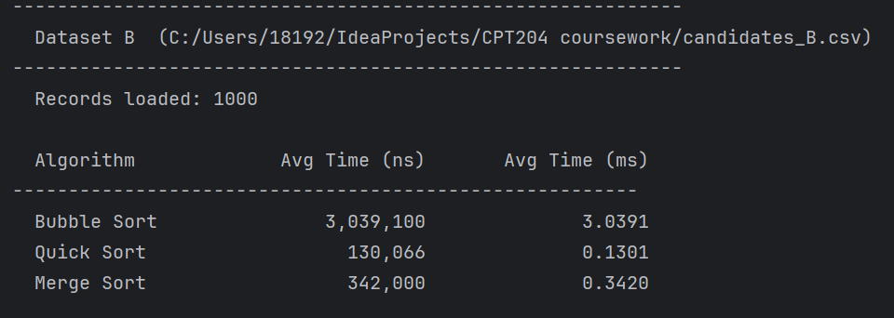
Chapter 6: Appendix

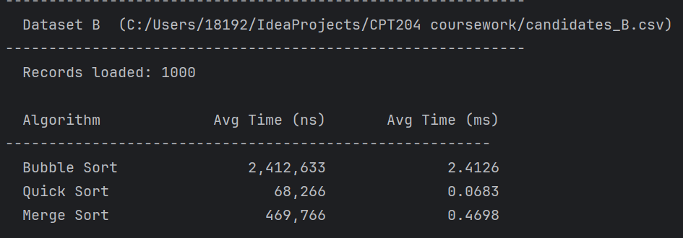
When QuickSort is applied to dataset B (a completely disordered dataset), the time complexity is unstable.
Some other output scenarios
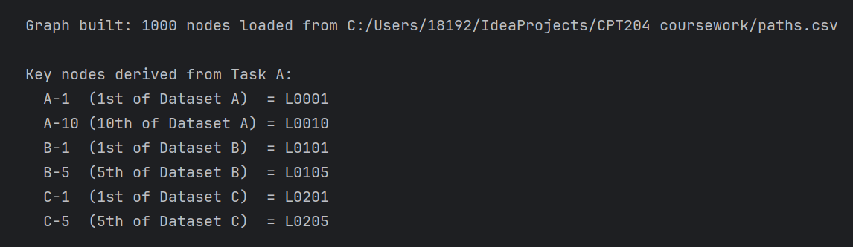
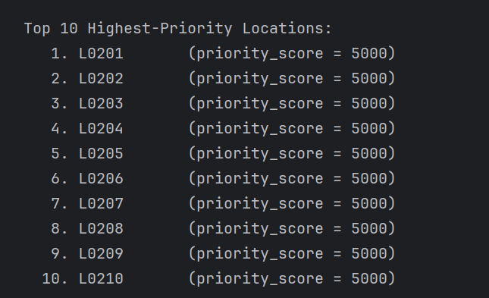
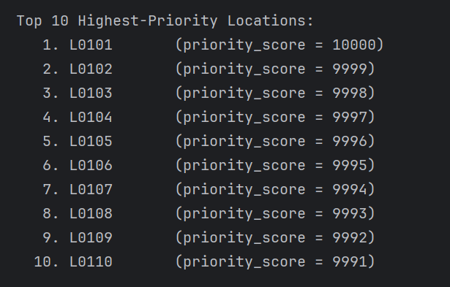
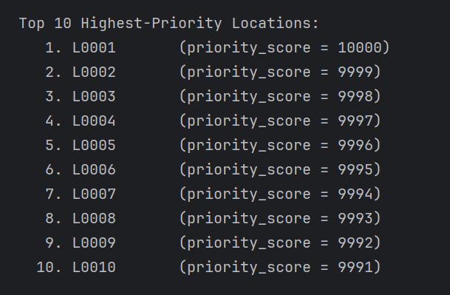

Chapter 7: Contribution Form
Student ID | Contribution
2364053 | 50%
2364252 | 50%

