Log Authorization



Date | Version | Description | Reviser
2021/02/22 | V1.0 | First edition | Lin Si

Content
Scope 4
Development Terminal 4
Production Terminal 4
Appendix 4
Use Download tool to push files. 4

Scope
In order to locate and fix the problem in production environment quickly.

Development Terminal
Log enabled by default.

Production Terminal
- Provide the SN number that need to open the log to the relevant person.
- Get resources, include a file end with .list and an authorized file named with authFile.properties from the relevant person.
- Use Download tool to push the file named with authFile.properties。Detailed in appendix.
（The authorized file is valid for one day and single connect to SDK, and need to exit and reenter the application, and it can be pushed repeatedly throughout the day.）

Appendix

Use Download tool to push files.
- Resources.
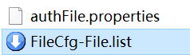
- Run the Download tool in PC and drag the .list file into tool, then click the Download.
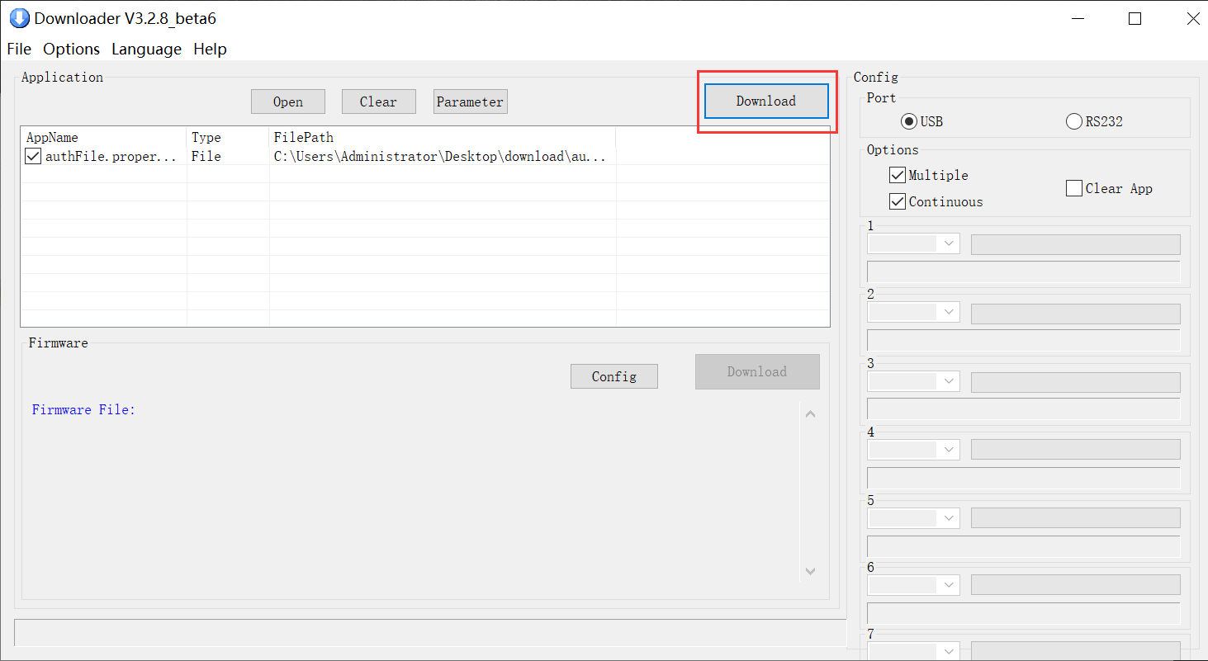
- Connect PC and Terminal with USB cable. Run the [Update Tool] in Terminal, then click the Download and Update.
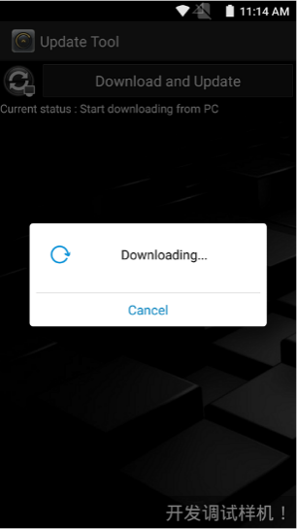
- Waiting for the download to complete.
