**JERREMITE INTERNATIONAL SCHOOL (JIS)**

POST OFFICE BOX 367

LEGON - ACCRA.

***PHONE:*** 0543523306 | 0596168386 | 0203120201



**STUDENT TERMLY REPORT**

2ND TERM, AUGUST 2022

|  |  |  |  |
| --- | --- | --- | --- |
| **LEARNER’S NAME:** | ABALO JENNIFER | **RAW SCORE:** | 178 |
| **STUDENT ID:** | JIS/WL/ | **VACATED ON:** | 11TH AUGUST, 2022 |
| **CLASS:** | PRIMARY 1 | **NEXT TERM BEGINS:** | 06TH SEPTEMBER, 2022 |
| **NO. ON ROLL:** |  |  |  |

|  |  |  |  |  |  |
| --- | --- | --- | --- | --- | --- |
| SUBJECT | CLASS SCORE 50% | EXAM SCORE 50% | TOTAL SCORE 100% | GRADE | REMARK |
| CORE |  |  |  |  |  |
| ENGLISH LANGUAGE | 31.5 | 0 | 31.5 | 8 | Weak |
| MATHEMATICS | 23.5 | 0 | 23.5 | 9 | Very Weak |
| NATURAL SCIENCE | 31 | 0 | 31 | 8 | Weak |
| ELECTIVES |  |  |  |  |  |
| R.M.E. | 31 | 0 | 31 | 8 | Weak |
| CREATIVE ARTS | 26 | 0 | 26 | 9 | Very Weak |
| OUR WORLD OUR PEOPLE | 16.5 | 0 | 16.5 | 9 | Very Weak |
| HISTORY | 18.5 | 0 | 18.5 | 9 | Very Weak |

|  |  |  |  |  |  |  |
| --- | --- | --- | --- | --- | --- | --- |
| **CLASS ATTENDANCE** | 0 | **OUT OF** | **69** |  | **PROMOTED TO:** | **-** |

|  |  |
| --- | --- |
| **TEACHER’S REMARKS** |  |
| **CHILD’S INTEREST:** | *,* |
| **CHILD’S CONDUCT:** | *,* |
| **GENERAL COMMENT:** |  |

­­­­­­­­­­­­­

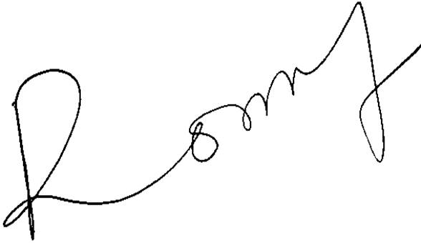

­

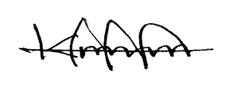

|  |  |  |  |
| --- | --- | --- | --- |
|  |  |  |  |
| **KPODO PRINCELLA** |  |  | **NANA YAW OHENE NTOW** |
| **(CLASS TEACHER)** |  |  | **(HEADMASTER)** |

**GRADING SCHEME**

|  |  |  |  |  |  |  |  |  |  |
| --- | --- | --- | --- | --- | --- | --- | --- | --- | --- |
| SCORE | 80 – 100 | 70 – 79 | 60 – 69 | 50 – 59 | 45 – 49 | 40 – 44 | 35 – 39 | 30 – 34 | 0 – 29 |
| GRADE | 1 | 2 | 3 | 4 | 5 | 6 | 7 | 8 | 9 |
| REMARKS | Excellent | Very good | Good | Credit | Pass | Average | Below average | Weak | Very weak |