Part 1: Disassembling code, going backwards, converting an executable back to Assembly
Language.
To do: I have taken the executable version of the three programs you have written recently
and renamed them A, B and C. These programs were “Hello world”, “Typing tutor” and
“Floating point calculation”.

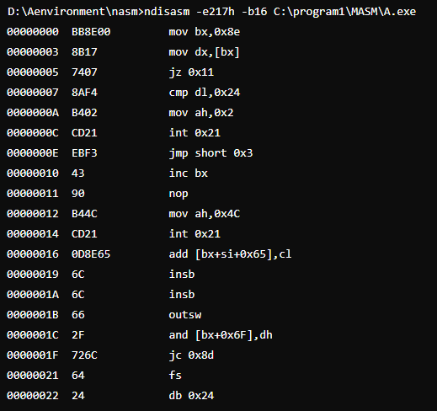
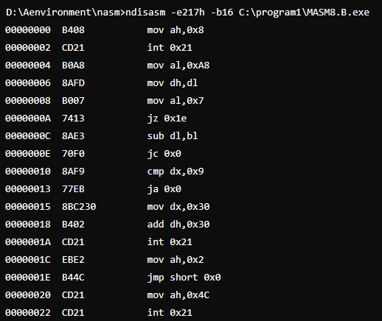
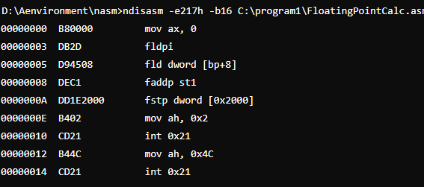

Part 2: Ask the compiler to generate Assembly Language as well as an Executable
To do: Create a New Visual Studio C++ project called “To_ASM” and save it on either your X
drive or C:\temp.

#include "stdafx.h"
#include <stdio.h>
int _tmain(int argc, _TCHAR* argv[])
{
register int total=0;
for(register int i=0;i<=20;i++)
{
total+=i;
}
printf("%d",total);
getchar();
return 0;
}
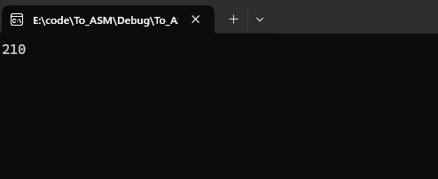
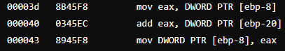

Part 3: Investigation of Pointer
To do: Consider the following program and talk through the various operators with a friend
so as to make a prediction of the final run time value of the variable y.

#include "stdafx.h"
#include <stdio.h>
int _tmain(int argc, _TCHAR* argv[])
{
int *address; // Create a pointer that can store an address (location in memory)
int x=10; // Create an integer variable called x containing value 10
int y=0; // y is an int with an initial value 0
int z[3]={5,7,11}; // Create an array of three integers
address=&x; // Let address store the value of the address of x in memory
y=*address; // y is assigned the value of whatever is pointed to by address
address =&z[0]; // address is set to the location in memory of the first value
y+=*(address+2); //y is incremented by the value pointed to at two items above address
printf("%d\n",y); // prints y to screen (y=????)
// Wait for enter to be pressed before terminating
while(getchar()!=10); // Clear buffer of previous <ret>
while(getchar()!=10); // Wait for a new <ret>
return 0;
}
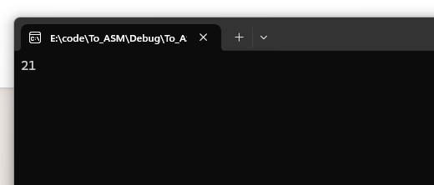
#include "stdafx.h"
#include <iostream>
using namespace std;
// Create a class (object) called Sphere, this is a
// description of the object, not an instance of the object.
// It is the cookie cutter not the cookie.
class Sphere
{
public: float radius;
public: float surface_area();
// Class constructor runs when a new instance of "sphere" is created.
Sphere()
{
radius=1.0f;
}
// In line function belonging sphere
float diameter()
{
return(2.0f*radius);
}
};
// External method used by sphere
float Sphere::surface_area()
{
float area=4.0f*3.14159*(radius*radius);
return(area);
}
int _tmain(int argc, _TCHAR* argv[])
{
class Sphere ball1; // Create an instance of Sphere called ball1 (a cookie!)
class Sphere *ball2; // Create a pointer to store the location of an instance of Sphere
ball1.radius=10; // Make the radius of ball1 = 10
ball2=new Sphere(); // Create a new instance of a sphere and assign its location to ball2
ball2->radius=10; // Make ball2 radius equal to 10
(*ball2).radius=10; // This is the same as the line above, you can dereference a
// pointer and then use the dot to access members, (*p). same as ->
cout << ball1.radius << "," << ball2->radius; // Print value of radius in ball1 and ball2
int x; cin >> x; // Wait for keypress
}
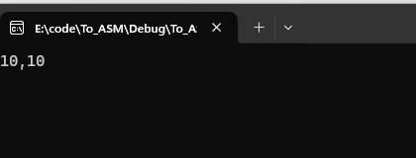

Part 4: Creating a Windows Forms Application using C/C++
private: System::Void button1_Click(System::Object^ sender, System::EventArgs^ e)
{
label1->Text="Hello";
}

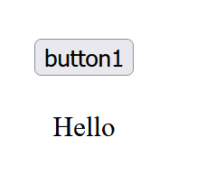
this->button1->Text = L"Start";
this->button1->UseVisualStyleBackColor = true;
this->button1->Click += gcnew System::EventHandler(this, &Form1::button1_Click);
private: System::Void timer1_Tick(System::Object^ sender, System::EventArgs^ e)
{
count++;
label1->Text="Time:"+Convert::ToString((float)count/10.0f);
}
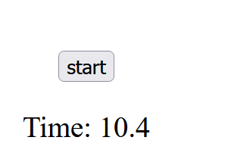
private: System::Void button1_Click(System::Object^ sender, System::EventArgs^ e)
{
//label1->Text="Hello";
timer1->Start();
}
private: System::Void button3_Click(System::Object^ sender, System::EventArgs^ e)
{
timer1->Stop();
}
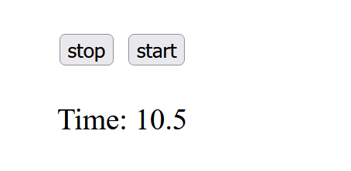

To do: Use this code base to create your own stop watch application. Submit the Form1.h
source code and a screen capture image of the application running; show your running code
to a demonstrator before you leave.

#pragma once
#include <time.h>

namespace WF_App1 {
using namespace System;
using namespace System::ComponentModel;
using namespace System::Collections;
using namespace System::Windows::Forms;
using namespace System::Data;
using namespace System::Drawing;

int count = 0;
clock_t start_time, current_time;

public ref class Form1 : public System::Windows::Forms::Form {
public:
Form1(void) {
InitializeComponent();
}

protected:
~Form1() {
if (components) {
delete components;
}
}

private:
System::Windows::Forms::Button^ Start;
System::Windows::Forms::Label^ label1;
System::Windows::Forms::Timer^ timer1;
System::Windows::Forms::Button^ button1;
System::ComponentModel::IContainer^ components;

#pragma region Windows Form Designer generated code
void InitializeComponent(void) {
this->components = gcnew System::ComponentModel::Container();
this->Start = gcnew System::Windows::Forms::Button();
this->label1 = gcnew System::Windows::Forms::Label();
this->timer1 = gcnew System::Windows::Forms::Timer(this->components);
this->button1 = gcnew System::Windows::Forms::Button();

// Start Button Setup
this->Start->Location = System::Drawing::Point(155, 28);
this->Start->Name = L"Start";
this->Start->Size = System::Drawing::Size(112, 38);
this->Start->Text = L"Start";
this->Start->UseVisualStyleBackColor = true;
this->Start->Click += gcnew System::EventHandler(this, &Form1::button1_Click);

// Label Setup
this->label1->AutoSize = true;
this->label1->Font = gcnew System::Drawing::Font(L"Arial Narrow", 48, System::Drawing::FontStyle::Regular, System::Drawing::GraphicsUnit::Point, static_cast<System::Byte>(0));
this->label1->Location = System::Drawing::Point(55, 73);
this->label1->Name = L"label1";
this->label1->Size = System::Drawing::Size(207, 147);
this->label1->Text = L"0.0";

// Timer Setup
this->timer1->Tick += gcnew System::EventHandler(this, &Form1::timer1_Tick);

// Stop Button Setup
this->button1->Location = System::Drawing::Point(12, 32);
this->button1->Name = L"button1";
this->button1->Size = System::Drawing::Size(112, 38);
this->button1->Text = L"Stop";
this->button1->UseVisualStyleBackColor = true;
this->button1->Click += gcnew System::EventHandler(this, &Form1::button1_Click_1);

// Form Setup
this->AutoScaleDimensions = System::Drawing::SizeF(12, 24);
this->AutoScaleMode = System::Windows::Forms::AutoScaleMode::Font;
this->ClientSize = System::Drawing::Size(274, 229);
this->Controls->Add(this->button1);
this->Controls->Add(this->label1);
this->Controls->Add(this->Start);
this->Name = L"Form1";
this->Text = L"Form1";
this->ResumeLayout(false);
this->PerformLayout();
}
#pragma endregion

private:
System::Void button1_Click(System::Object^ sender, System::EventArgs^ e) {
timer1->Start();
start_time = clock();
}

System::Void timer1_Tick(System::Object^ sender, System::EventArgs^ e) {
current_time = clock();
label1->Text = "Time:" + String::Format("{0:0.00}", (float)(current_time - start_time) / 1000.0f);
}

System::Void button1_Click_1(System::Object^ sender, System::EventArgs^ e) {
timer1->Stop();
}
};
}
