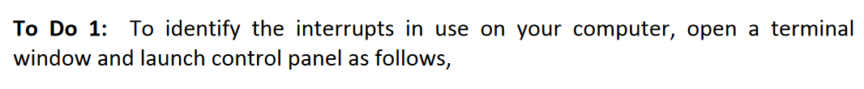
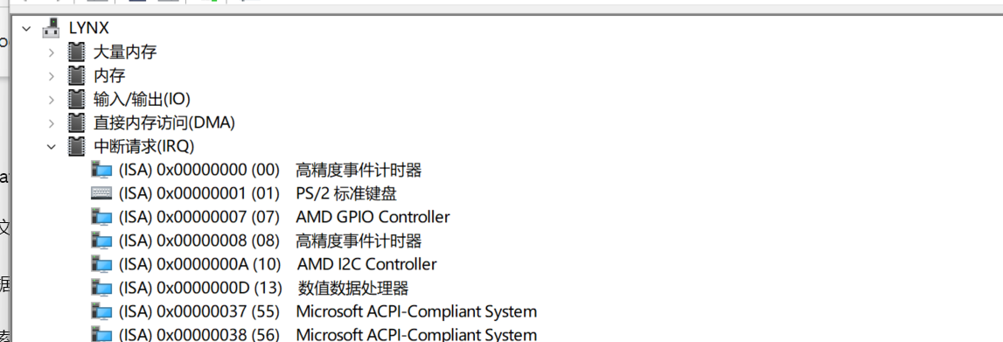

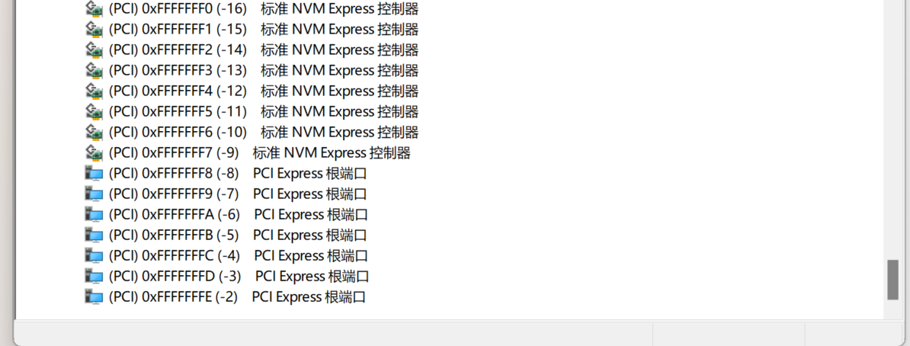
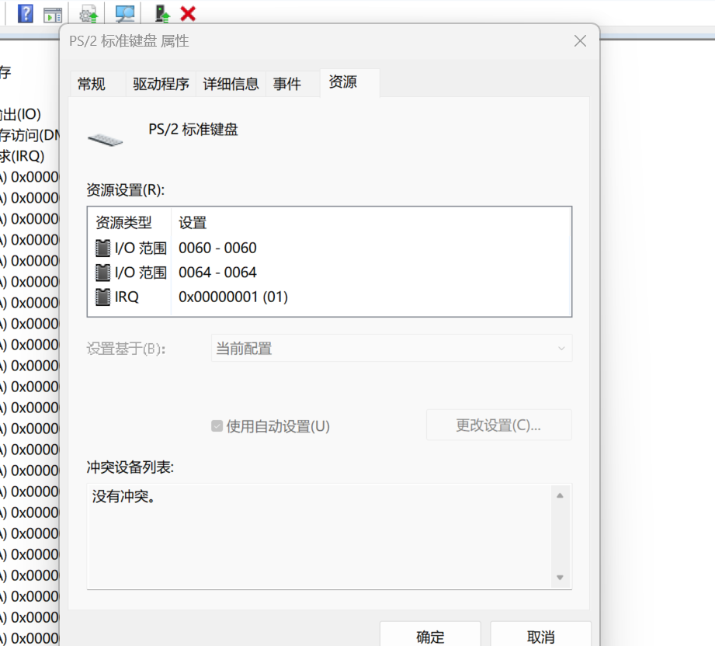

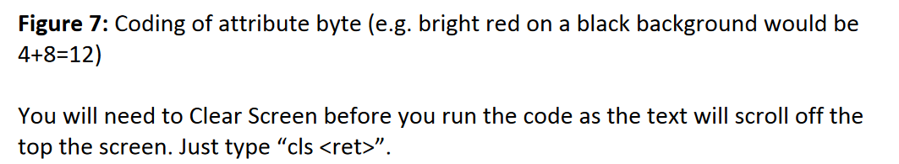
.MODEL small
.STACK
.DATA
.CODE
.STARTUP
mov ax,0b800h ; Base address of screen memory
mov es,ax ; Use extra segment register to access 0x800...
mov bx,0 ; Screen position x=0, y=0, (2*((80*y)+x))=0
mov al,'C' ; Print 'Hello' on the screen
mov es:[bx],al
inc bx
mov al,12 ; Bright red on a black background
mov es:[bx],al
inc bx ; Black on a red background
mov al,'M'
mov es:[bx],al
inc bx
mov al,64
mov es:[bx],al
quit: .EXIT
END
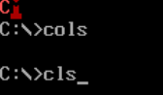
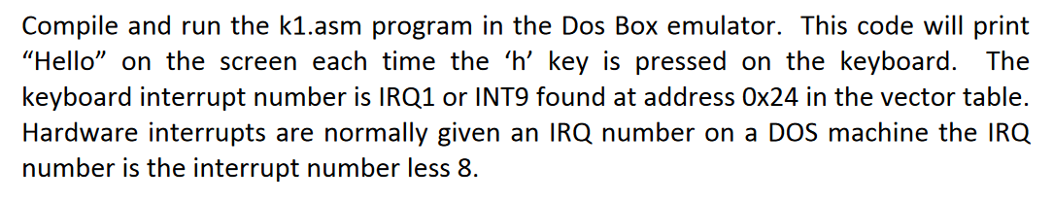
.MODEL small
.STACK
.DATA
.CODE

.STARTUP
jmp ov1
dseg db '0','0','0','0'
ov1:
push es
mov ax, 0000h
mov es, ax
mov bx, 020h
mov ax, es:[bx]
mov vtabip, ax
add bx, 2
mov ax, es:[bx]
mov vtabcs, ax
pop es

push es
mov ax, 0000h
mov es, ax
mov bx, 020h
mov ax, OFFSET isr
mov es:[bx], ax
add bx, 2
mov ax, cs
mov es:[bx], ax
pop es

mov ah, 031h
mov al, 00h
mov dx, 1024
int 021h
jmp quit

isr:
pusha
mov cx, 4
mov bx, OFFSET dseg

back:
mov al, cs:[bx]
inc al
mov cs:[bx], al
cmp al, ':'
jnz skip
mov al, '0'
mov cs:[bx], al
inc bx
loop back

skip:
mov ax, 0b800h
mov es, ax
mov bx, OFFSET dseg
mov dx, 140
mov cx, 4

nextc:
mov al, cs:[bx]
xchg bx, dx
mov es:[bx], al
xchg bx, dx
inc bx
sub dx, 2
loop nextc

ovr:
mov dx, 020h
mov al, 020h
out dx, al
popa
db 0EAh

vtabip dw 0
vtabcs dw 0
quit: .EXIT
END

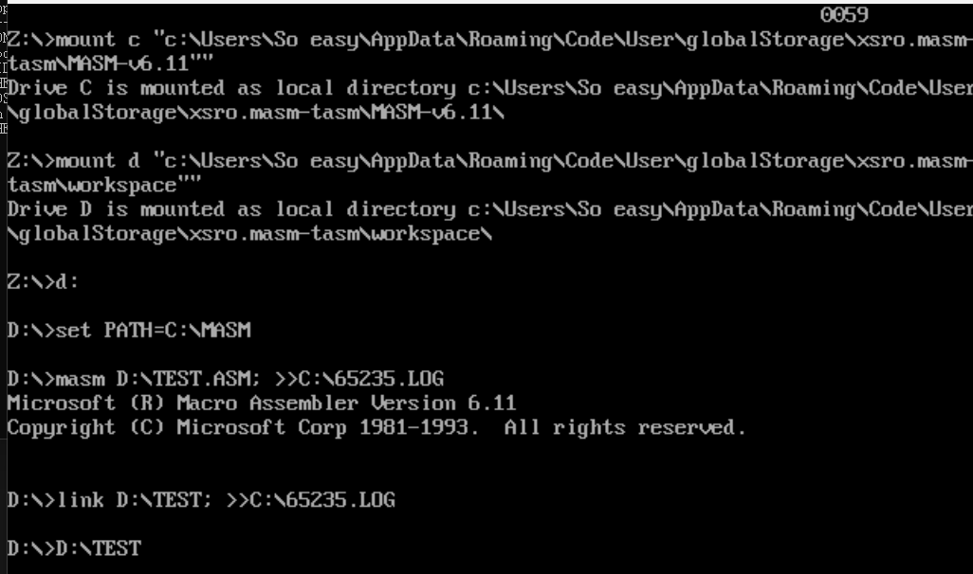
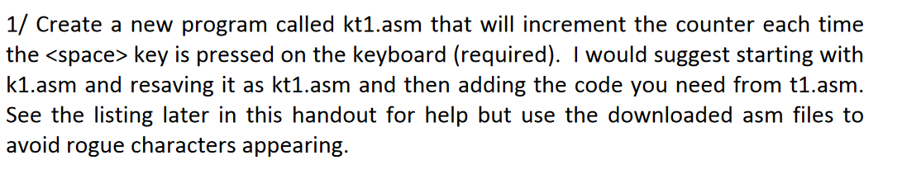
.MODEL small
.STACK
.DATA
.CODE

.STARTUP
push es
mov ax, 0000h
mov es, ax
mov bx, 024h
mov ax, es:[bx]
mov vtabip, ax
add bx, 2
mov ax, es:[bx]
mov vtabcs, ax
pop es
push es
mov ax, 0000h
mov es, ax
mov bx, 024h
mov ax, OFFSET isr
mov es:[bx], ax
add bx, 2
mov ax, cs
mov es:[bx], ax
pop es
mov ah, 031h
mov al, 00h
mov dx, 1024
int 021h

jmp quit

isr:
pusha
mov dx, 60h
in al, dx
and al, 127
cmp al, 23h
jnz ovr1
mov ax, 0b800h
mov es, ax
mov bx, 140
mov al, 'H'
mov es:[bx], al
add bx, 2
mov al, 'e'
mov es:[bx], al
add bx, 2
mov al, 'l'
mov es:[bx], al
add bx, 2
mov al, 'l'
mov es:[bx], al
add bx, 2
mov al, 'o'
mov es:[bx], al
jmp ovr2

ovr1:
mov ax, 0b800h
mov es, ax
mov bx, 140
mov cx, 5
again:
mov al, ' '
mov es:[bx], al
add bx, 2
loop again

ovr2:
mov dx, 020h
mov al, 020h
out dx, al

popa
db 0EAh

vtabip dw 0
vtabcs dw 0

quit: .EXIT

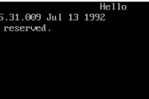
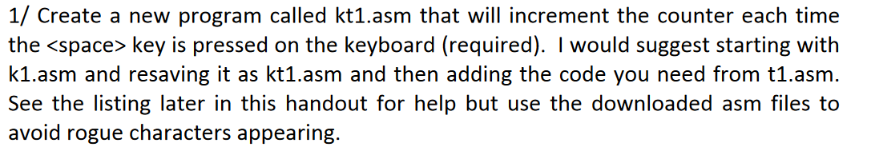
.MODEL small
.STACK
.DATA
dseg db '0','0','0','0' ; Data segment storage for TSR
.CODE
.STARTUP
jmp ov1 ; Bypass data initialization in execution

ov1:
push es ; Preserve extra segment register
mov ax, 0000h ; Zero out AX for DS reset
mov es, ax ; Set extra segment to page 0 (IVT)
mov bx, 024h ; Address for INT 9 (keyboard IRQ1)
mov ax, es:[bx] ; Retrieve CS from IVT
mov vtabip, ax ; Store original CS
inc bx
inc bx
mov ax, es:[bx] ; Retrieve IP from IVT
mov vtabcs, ax ; Store original IP
pop es ; Restore ES register
push es ; Prepare ES for ISR address set
mov ax, 0000h ; Reset AX for DS
mov es, ax ; Set ES to page 0 (IVT)
mov bx, 024h ; Set up for new ISR
mov ax, OFFSET isr ; Address of new ISR
mov es:[bx], ax ; Set IP in IVT
inc bx
inc bx
mov ax, cs ; Segment of current program
mov es:[bx], ax ; Update CS in IVT
pop es ; Restore ES register
mov ah, 031h ; AH = 31h for TSR
mov al, 00h ; AL = 00h
mov dx, 1024 ; Space to keep resident
int 021h ; TSR interrupt

jmp quit ; Never execute beyond this in normal flow

isr:
pusha ; Save all general registers
mov dx, 60h ; Port 60h, keyboard data
in al, dx ; Read scan code
cmp al, 1Ch ; Check if Enter key scan code
jz ovr1 ; Jump if Enter pressed
cmp al, 39h ; Check if Space key scan code
jnz ovr2 ; Jump if not Space

mov cx, 4 ; Counter for loop
mov bx, OFFSET dseg
back:
mov al, cs:[bx] ; Get current counter digit
inc al ; Increment character code
mov cs:[bx], al ; Store back to memory
cmp al, ':' ; Check if rollover is needed
jnz skip ; Skip if no rollover
mov al, '0' ; Reset to '0'
mov cs:[bx], al ; Store reset digit
inc bx ; Move to next digit
loop back ; Loop back for next digit

ovr1:
mov cx, 4 ; Counter for clearing digits
mov bx, OFFSET dseg
back1:
mov al, '0' ; Set all digits to '0'
mov cs:[bx], al ; Store '0' to each digit
inc bx ; Next digit
loop back1 ; Loop for all digits

skip:
mov ax, 0b800h ; Video memory for text mode
mov es, ax ; Set ES to video memory
mov bx, OFFSET dsg ; Start of digits in memory
mov dx, 140 ; Screen offset
mov cx, 4 ; Digit count
nextc:
mov al, cs:[bx] ; Get digit from storage
xchg bx, dx ; Swap BX and DX for storing
mov es:[bx], al ; Write digit to video memory
xchg bx, dx ; Swap back
inc bx ; Next digit in memory
sub dx, 2 ; Next screen position
loop nextc ; Repeat for all digits

jmp ovr2 ; Jump to ISR end routine

ovr2:
mov dx, 020h ; End of interrupt command port
mov al, 020h ; Command for EO
out dx, al ; Send EOI to PIC
popa ; Restore all general registers

db 0EAh ; Opcode for JMP far
vtabip dw 0 ; Placeholder for original IP
vtabcs dw 0 ; Placeholder for original CS

quit:
.EXIT ; Exit and stay resident

END ; End of program marker
