Part 1: Looking at the Microsoft .NET frame work and CIL using a simple C# program
namespace CIL
{
class Program
{
static void Main(string[] args)
{
int a = 10, b = 10, c;
c = a + b;
Console.WriteLine(c.ToString());
Console.ReadKey();
}
}
}

Find the ildasm (intermediate language disassembler) and start it by double clicking on the Icon
in Windows Explorer. Use this program to open the CIL.exe (executable) file you created. You
can launch the Windows explorer by holding down the Windows Key á and E.
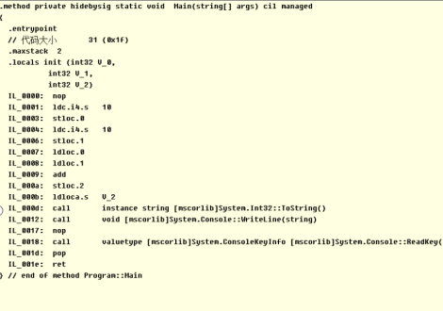

Figure 9 A Windows PE executable run on a DOS emulator, CIL.EXE.

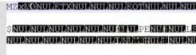

Part 2: Using the debugging tools available in the IDE
Using a debugger is an essential skill when using an IDE. Use your existing CIL Windows Console
Application and modify the program so that it adds the integers from 1 to 20.
using System;
using System.Collections.Generic;
using System.Linq;
using System.Text;
namespace CIL
{
class Program
{
static void Main(string[] args)
{
int total = 0;
for (int i = 1; i <= 20; i++)
{
total += i;
}
Console.WriteLine(total.ToString());
Console.ReadKey();
}
}
}
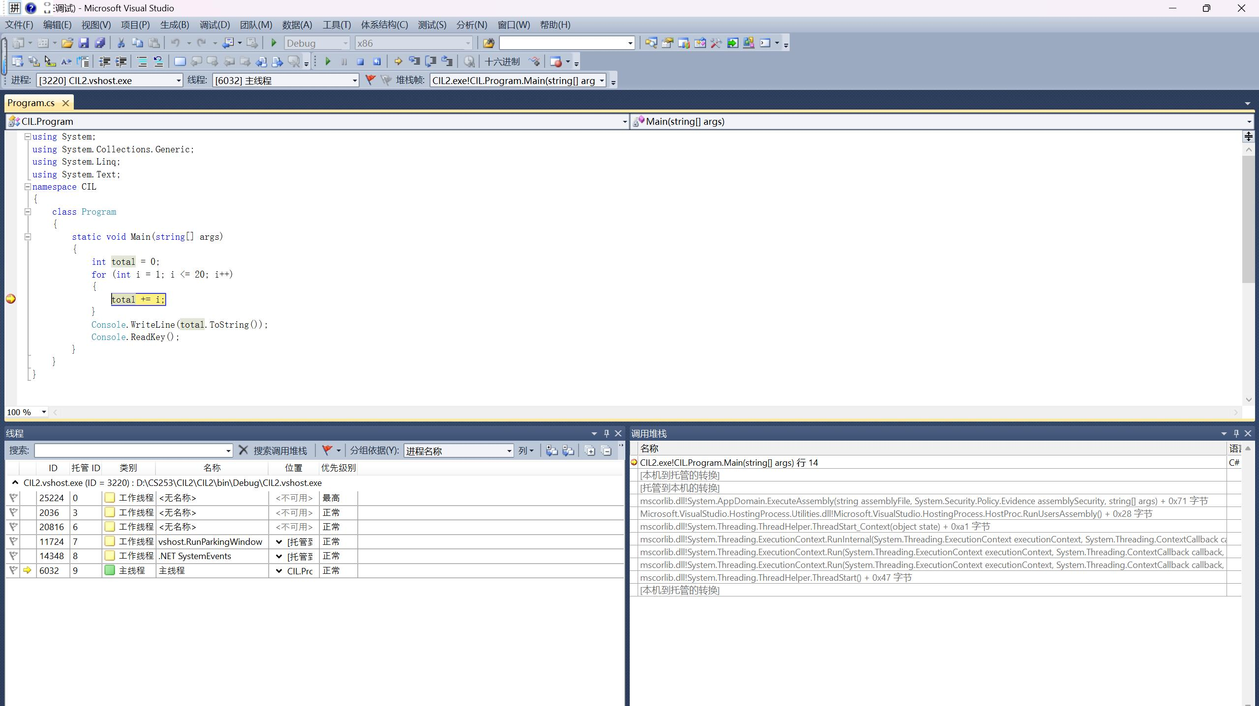

part 3: Recreating a classic computer game, Pong as a C# Windows Form Application
using System;
using System.Collections.Generic;
using System.ComponentModel;
using System.Data;
using System.Drawing;
using System.Linq;
using System.Text;
using System.Windows.Forms;
using System.Runtime.InteropServices;
namespace Pong
{
public partial class Form1 : Form
{
[DllImport("user32.dll")]
static extern ushort GetAsyncKeyState(int vKey);
public static bool IsKeyPushedDown(Keys keyData) // For fast keyboard input
{
return 0 != (GetAsyncKeyState((int)keyData) & 0x8000);
}
Point Ball;
Point Ball_Direction;
int Paddle_Left_Y = 128;
int Paddle_Right_Y = 128;
int Left_score = 0;
int Right_score = 0;
bool Game_paused = true;
public Form1()
{
InitializeComponent();
Ball = new Point(25, 13); // Set starting position of ball
Ball_Direction = new Point(3, 3);
}

private void label1_Click(object sender, EventArgs e)
{

}

private void Form1_Load(object sender, EventArgs e)
{

}

private void timer1_Tick(object sender, EventArgs e)
{
if (IsKeyPushedDown(Keys.W)) Paddle_Left_Y -= 10;
if (IsKeyPushedDown(Keys.X)) Paddle_Left_Y += 10;
if (IsKeyPushedDown(Keys.P)) Paddle_Right_Y -= 10;
if (IsKeyPushedDown(Keys.M)) Paddle_Right_Y += 10;
if (IsKeyPushedDown(Keys.Space)) Game_paused = false;
if (Paddle_Left_Y < 5) Paddle_Left_Y = 0; // Clamp paddle positions
if (Paddle_Left_Y > 251) Paddle_Left_Y = 251;
if (Paddle_Right_Y < 5) Paddle_Right_Y = 0;
if (Paddle_Right_Y > 251) Paddle_Right_Y = 251;
if (IsKeyPushedDown(Keys.Escape)) Application.Exit();
// Ball/Paddle collision detection on left paddle
if ((Ball.X < 30) && (Math.Abs(Ball.Y - Paddle_Left_Y) < 50) && (Ball_Direction.X < 0))
{
Ball_Direction.X = -Ball_Direction.X;
}

if ((Ball.X > 482) && (Math.Abs(Ball.Y - Paddle_Right_Y) < 50) && (Ball_Direction.X > 0))
{
Ball_Direction.X = -Ball_Direction.X;
}
if (!Game_paused)
{
Ball.X += Ball_Direction.X;
if ((Ball.X > 511) && (Ball_Direction.X > 0)) // Ball hit back wall travelling left
{
Ball.X = 30; // Restart ball in front of paddle
Ball.Y = Paddle_Left_Y;
Game_paused = true;
Left_score++;// Reverse horizontal motion
}
if ((Ball.X < 1) && (Ball_Direction.X < 0)) // Ball hit back wall travelling right
{
// Ball_Direction.X = ‐Ball_Direction.X; // Remove or “comment out” this line
Ball.X = 480; // Restart ball in front of paddle
Ball.Y = Paddle_Right_Y;
Game_paused = true;
Right_score++;// Reverse horizontal motion
}
Ball.Y += Ball_Direction.Y;
if ((Ball.Y > 255) && (Ball_Direction.Y > 0)) // Ball hit bottom wall travelling down
{
Ball_Direction.Y = -Ball_Direction.Y; // Reverse horizontal motion
}
if ((Ball.Y < 1) && (Ball_Direction.Y < 0)) // Ball hit top wall travelling down
{
Ball_Direction.Y = -Ball_Direction.Y; // Reverse horizontal motion
}
}
Bitmap image = new Bitmap(pictureBox1.Width, pictureBox1.Height);
Graphics g = Graphics.FromImage(image);
g.FillEllipse(new SolidBrush(Color.Red), Ball.X - 10, Ball.Y - 10, 20, 20);
g.FillRectangle(new SolidBrush(Color.Blue), 10, Paddle_Left_Y - 50, 10, 100);
g.FillRectangle(new SolidBrush(Color.Blue), 490, Paddle_Right_Y - 50, 10, 100);
g.Dispose();
label1.Text = Left_score.ToString("0.#");
label2.Text = Right_score.ToString("0.#");
if ((Left_score > 2) || (Right_score > 2)) // Identify a winner
{
timer1.Stop(); // Stop game loop
String text = "Right";
if (Left_score > Right_score) text = "Left";
DialogResult reply = MessageBox.Show(text + " player wins\rDo you wish to play again?",
"Winner", MessageBoxButtons.YesNo);
if (reply == DialogResult.Yes)
{
Left_score = 0; // Reset game values
Right_score = 0;
Paddle_Left_Y = 128;
Paddle_Right_Y = 128;
Game_paused = true;
Ball.X = 25; Ball.Y = 13;
Ball_Direction.X = 3; Ball_Direction.Y = 3;
timer1.Start(); // Restart game loop
}
else
{
Application.Exit(); // Quit game
}
}
pictureBox1.Image = image;

}

private void pictureBox1_Click(object sender, EventArgs e)
{

}

private void label2_Click(object sender, EventArgs e)
{

}

}
}

Pong:
namespace Pong
{
partial class Form1
{
/// <summary>
/// 必需的设计器变量。
/// </summary>
private System.ComponentModel.IContainer components = null;

/// <summary>
/// 清理所有正在使用的资源。
/// </summary>
/// <param name="disposing">如果应释放托管资源，为 true；否则为 false。</param>
protected override void Dispose(bool disposing)
{
if (disposing && (components != null))
{
components.Dispose();
}
base.Dispose(disposing);
}

#region Windows 窗体设计器生成的代码

/// <summary>
/// 设计器支持所需的方法 - 不要
/// 使用代码编辑器修改此方法的内容。
/// </summary>
private void InitializeComponent()
{
this.components = new System.ComponentModel.Container();
this.timer1 = new System.Windows.Forms.Timer(this.components);
this.label1 = new System.Windows.Forms.Label();
this.label2 = new System.Windows.Forms.Label();
this.pictureBox1 = new System.Windows.Forms.PictureBox();
((System.ComponentModel.ISupportInitialize)(this.pictureBox1)).BeginInit();
this.SuspendLayout();
//
// timer1
//
this.timer1.Tick += new System.EventHandler(this.timer1_Tick);
//
// label1
//
this.label1.AutoSize = true;
this.label1.Font = new System.Drawing.Font("宋体", 48F);
this.label1.Location = new System.Drawing.Point(12, 106);
this.label1.Name = "label1";
this.label1.Size = new System.Drawing.Size(60, 64);
this.label1.TabIndex = 0;
this.label1.Text = "0";
this.label1.Click += new System.EventHandler(this.label1_Click);
//
// label2
//
this.label2.AutoSize = true;
this.label2.Font = new System.Drawing.Font("宋体", 48F);
this.label2.Location = new System.Drawing.Point(652, 106);
this.label2.Name = "label2";
this.label2.Size = new System.Drawing.Size(60, 64);
this.label2.TabIndex = 1;
this.label2.Text = "0";
//
// pictureBox1
//
this.pictureBox1.BorderStyle = System.Windows.Forms.BorderStyle.FixedSingle;
this.pictureBox1.Location = new System.Drawing.Point(90, 20);
this.pictureBox1.Name = "pictureBox1";
this.pictureBox1.Size = new System.Drawing.Size(512, 256);
this.pictureBox1.TabIndex = 2;
this.pictureBox1.TabStop = false;
this.pictureBox1.Click += new System.EventHandler(this.pictureBox1_Click);
//
// Form1
//
this.AutoScaleDimensions = new System.Drawing.SizeF(6F, 12F);
this.AutoScaleMode = System.Windows.Forms.AutoScaleMode.Font;
this.ClientSize = new System.Drawing.Size(724, 302);
this.Controls.Add(this.pictureBox1);
this.Controls.Add(this.label2);
this.Controls.Add(this.label1);
this.Name = "Form1";
this.Text = "Form1";
((System.ComponentModel.ISupportInitialize)(this.pictureBox1)).EndInit();
this.ResumeLayout(false);
this.PerformLayout();

}

#endregion

private System.Windows.Forms.Timer timer1;
private System.Windows.Forms.Label label1;
private System.Windows.Forms.Label label2;
private System.Windows.Forms.PictureBox pictureBox1;
}
}
