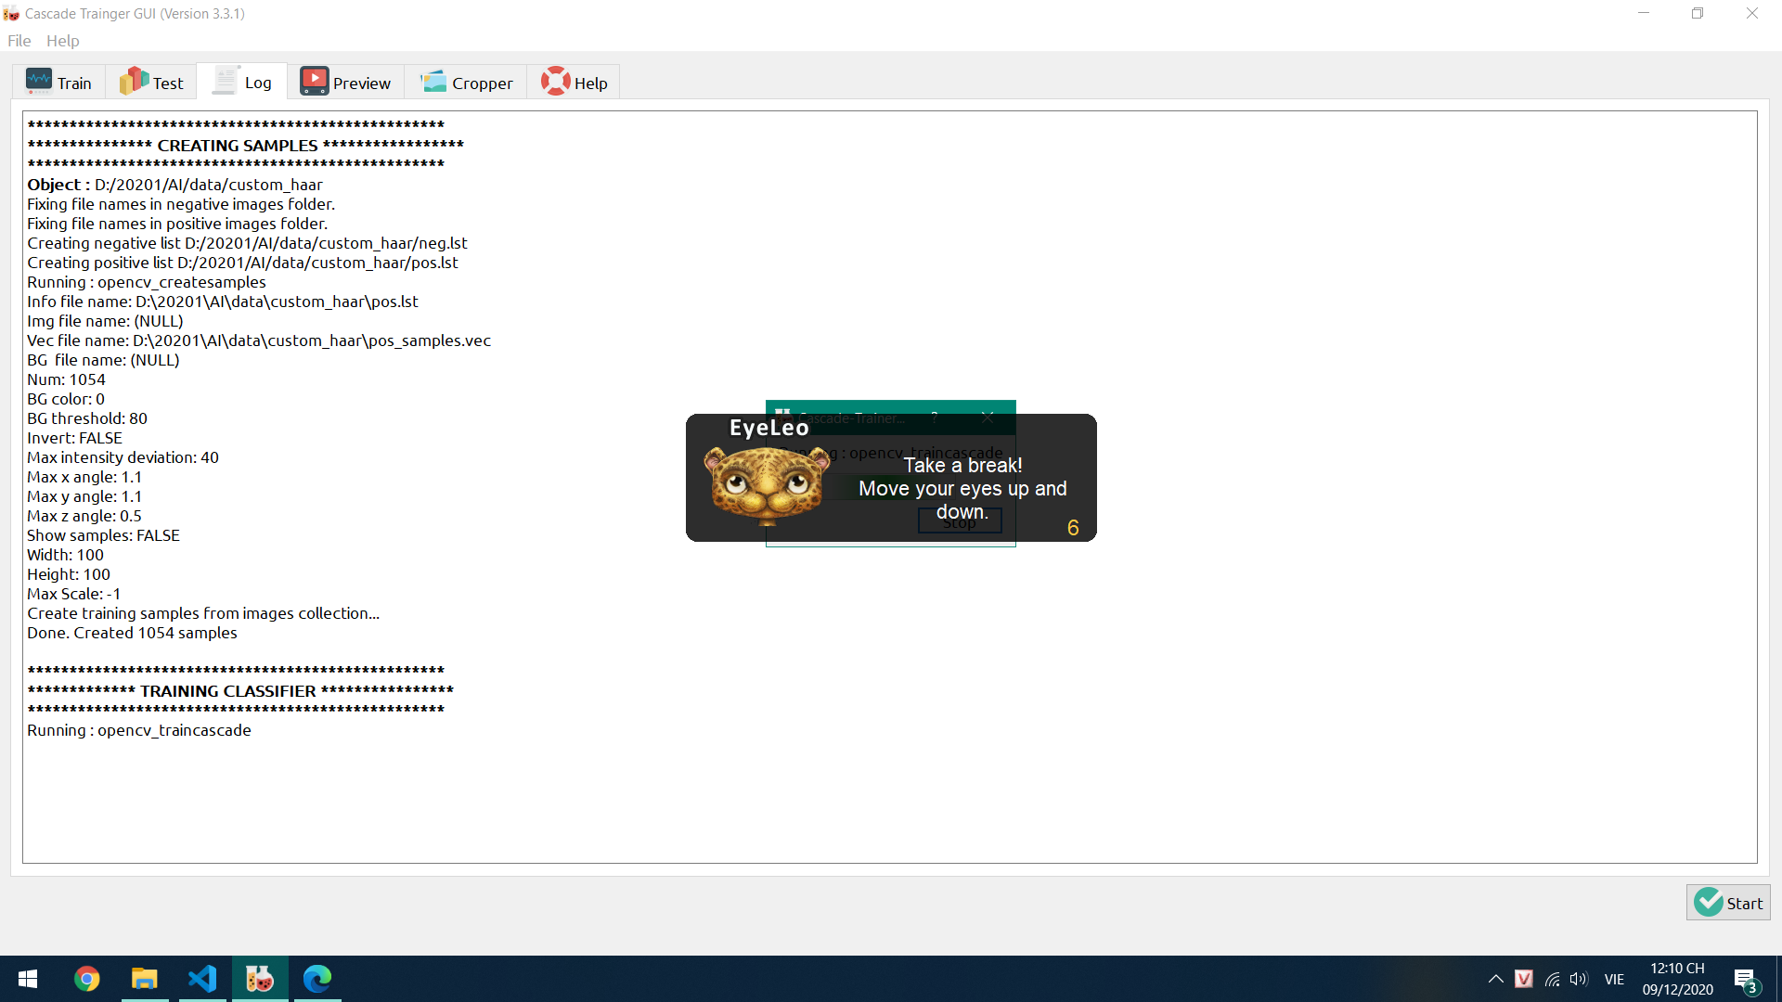

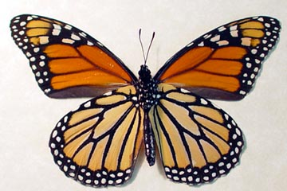 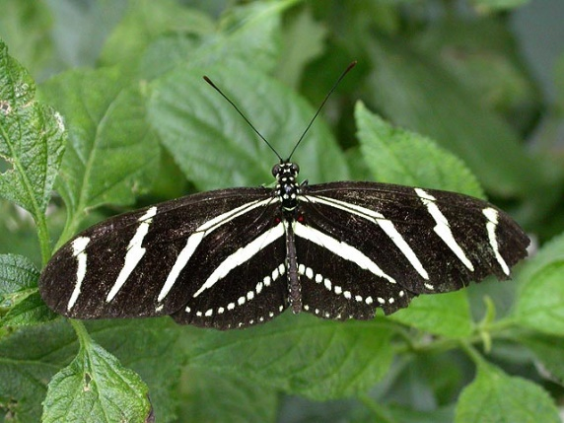 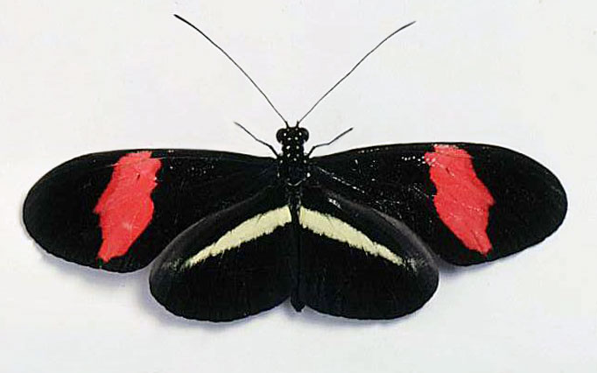

00 : Danaus_plexippus 01: Heliconius_charitous 02: Heliconius_erato

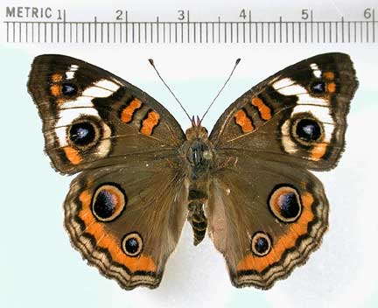 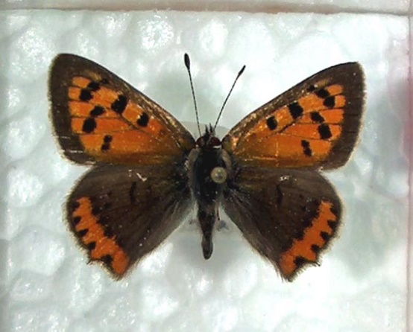 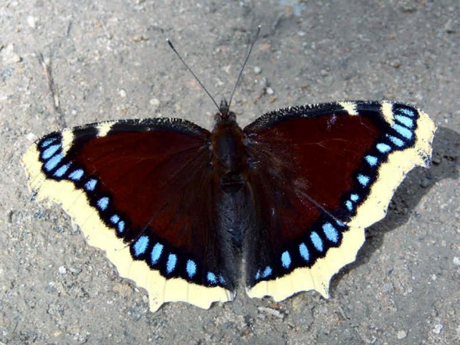

03: Junonia_coenia 04: Lycaena_phlaeas 05: Nymphalis_antiopa

Layer (type) Output Shape Param #

=================================================================

conv2d_1 (Conv2D) (None, 98, 98, 400) 11200

_________________________________________________________________

activation_1 (Activation) (None, 98, 98, 400) 0

_________________________________________________________________

max_pooling2d_1 (MaxPooling2 (None, 49, 49, 400) 0

_________________________________________________________________

conv2d_2 (Conv2D) (None, 47, 47, 200) 720200

_________________________________________________________________

activation_2 (Activation) (None, 47, 47, 200) 0

_________________________________________________________________

max_pooling2d_2 (MaxPooling2 (None, 23, 23, 200) 0

_________________________________________________________________

flatten_1 (Flatten) (None, 105800) 0

_________________________________________________________________

dropout_1 (Dropout) (None, 105800) 0

_________________________________________________________________

dense_1 (Dense) (None, 50) 5290050

_________________________________________________________________

dense_2 (Dense) (None, 10) 510

=================================================================

Total params: 6,021,960

Trainable params: 6,021,960

Non-trainable params: 0