Ans No:1

In Microsoft word ,illustration is a collection of tools that allow users to insert image ,shapes and other graphics into their documents to enhance their appearance and layout.

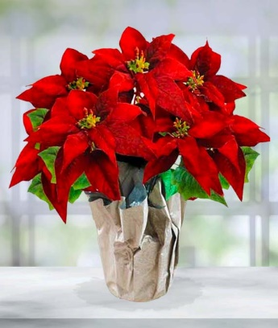

SHAPE (UNGROUP)

group

SMART ART

**B)paragraph**

My country’s name is [Bangladesh](https://www.paragraphbuzz.com/short-paragraph-on-flower-of-bangladesh). Bangladesh is a very small country huge population. It is a medium- B) PARAGRAPh

developed country in South Asia. We have a very good and progressing economy. It has an area of 147,570 square kilometers. But it has a population of 164 million. That is huge than the area.

But it is still a very beautiful and peaceful country. People of Bangladesh are so friendly with each other. This country has a glorious history of independence. We got independence from [Pakistan](https://www.paragraphbuzz.com/paragraph-on-my-country-pakistan)in 1971 after nine mothers’ blood-shedding war. More than 3 million Bangladeshi sacrificed their life in that genocide.

.

We are the leader in world garments exporting right after china. Not only in the economy, but we also good at sports too. Our cricket team is one of the top seven teams in the world. Bangladesh has a very heart touching history behind. In 1971 Ezoicthis country got independence from Pakistan after a nine months war.

Lots of people sacrificed their lives in that time. On 16 December the Pakistani army surrendered and we got a new nation. That’s why we celebrate on 16 December as our Victory Day. Bangladesh is a very beautiful country with lots

|  |  |  |  |  |
| --- | --- | --- | --- | --- |
|  | January test |  |  |  |
| Surname | Name | English | German | COMPUTER |
| Xuereb | Norbert | 85 | 42 | 98 |
| Spiteri | Richard | 53 | 45 | 75 |
| Borg | Clive | 55 | 85 | 82 |
| Caruana | Michelle | 45 | 45 | 25 |