BERT-Based Hate Speech Detection:
Zero-Shot, Fine-Tuning, and Cascaded Classification
COMP6713 Group Project — Model Section Report

1. Zero-Shot Evaluation of Pre-trained Models (5 Credits)
1.1 Approach
Four pre-trained models are evaluated in a zero-shot setting without any task-specific fine-tuning. For each model, [CLS] token embeddings are extracted and compared via cosine similarity against three fixed label prototype embeddings ("This is a normal, neutral, or positive comment." / "This is an offensive or rude comment using bad language." / "This is hate speech targeting a person or specific group."). No gradient updates are performed; each model is used directly out of the box.
The four models evaluated are:
- BERT-base-uncased — general-purpose encoder, no hate speech knowledge
- HateBERT (GroNLP/hateBERT) — BERT further pre-trained on Reddit abusive content
- Twitter-RoBERTa-base-hate (cardiffnlp/twitter-roberta-base-hate) — RoBERTa pre-trained on tweets and fine-tuned on TweetEval hate detection
- BERTweet (vinai/bertweet-base) — RoBERTa pre-trained on 850M English tweets
1.2 Results — HateXPlain Test Set
Table 1. Zero-Shot Performance on HateXPlain Test Set (n = 2,012)
Model | Accuracy | Macro F1 | F1 Normal | F1 Offensive | F1 Hate
BERT-base-uncased | 0.3857 | 0.2845 | 0.5450 | 0.1075 | 0.2009
HateBERT | 0.3429 | 0.3367 | 0.3693 | 0.3683 | 0.2725
Twitter-RoBERTa-base-hate | 0.3454 | 0.3307 | 0.2547 | 0.4265 | 0.3109
BERTweet | 0.3131 | 0.2538 | 0.4082 | 0.3262 | 0.0269
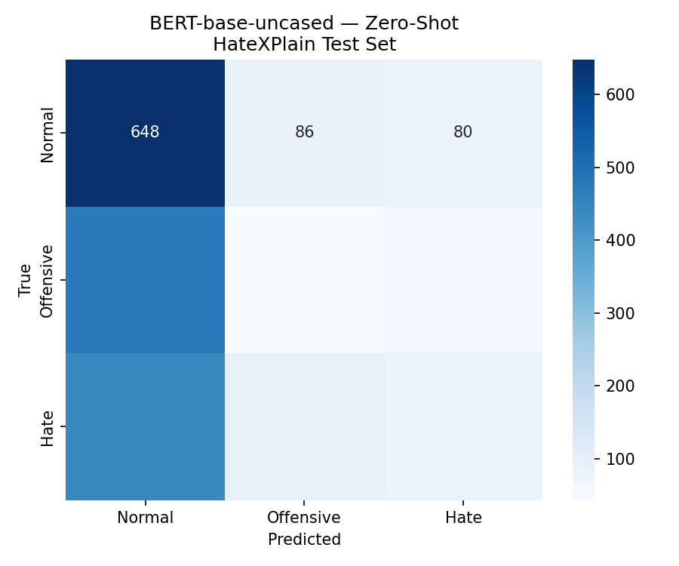 | 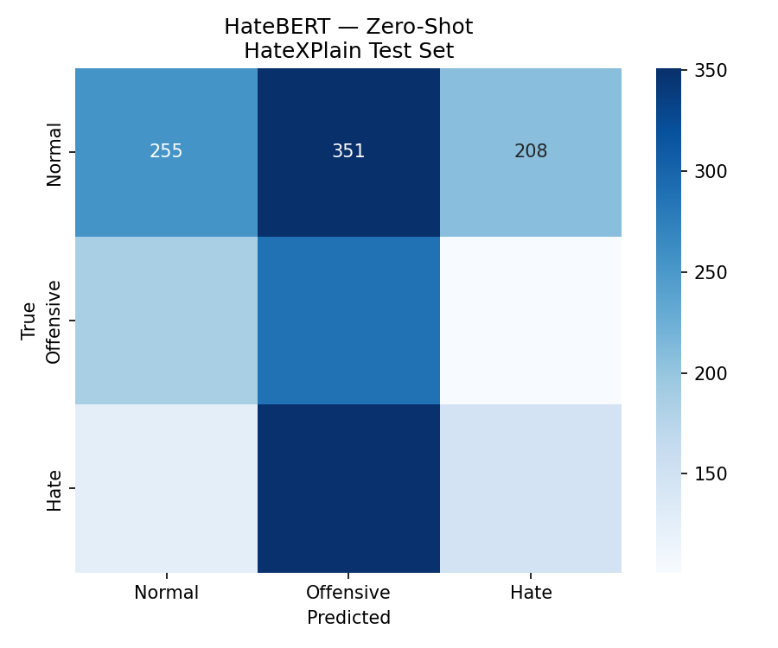
Figure 1a. BERT-base-uncased | Figure 1b. HateBERT
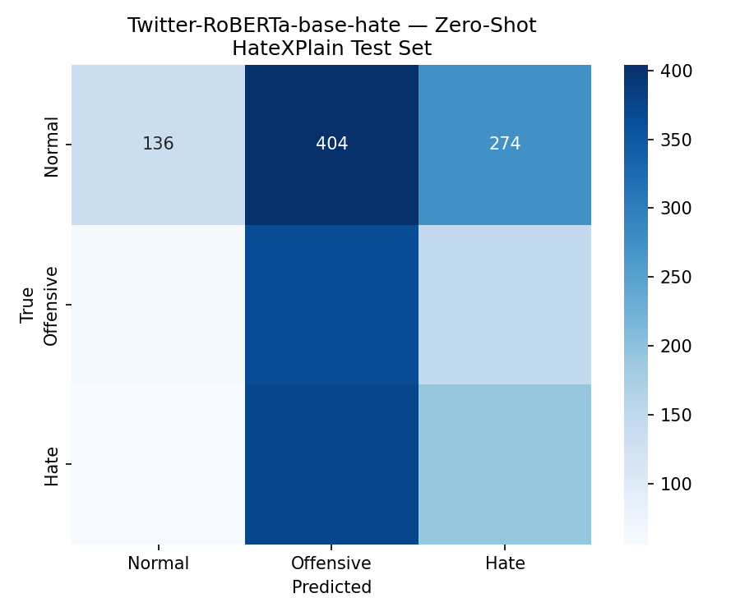 | 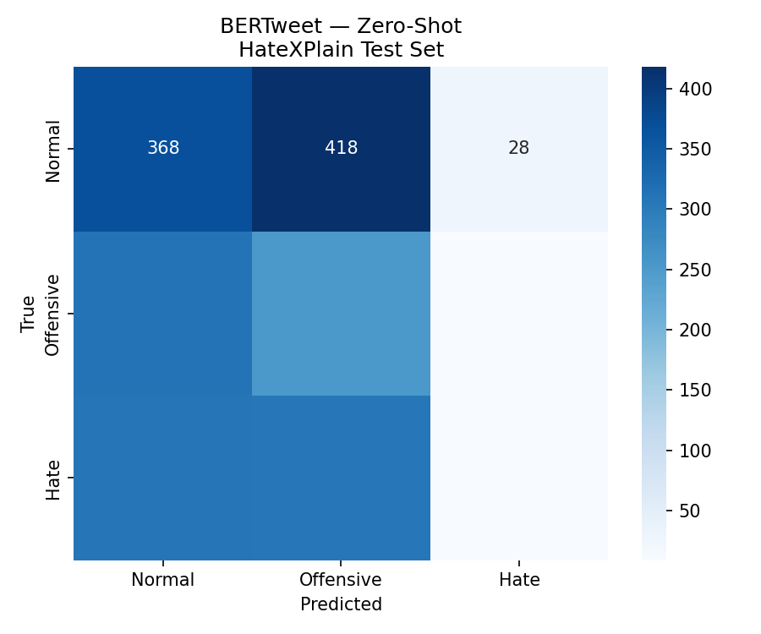
Figure 1c. Twitter-RoBERTa-base-hate | Figure 1d. BERTweet
Figure 1. Zero-shot confusion matrices on HateXPlain test set

1.3 Results — TweetEval Test Set
Table 2. Zero-Shot Performance on TweetEval Test Set (n = 3,830)
Model | Accuracy | Macro F1 | F1 Normal | F1 Offensive | F1 Hate
BERT-base-uncased | 0.5843 | 0.2842 | 0.7482 | 0.0269 | 0.0776
HateBERT | 0.4778 | 0.3421 | 0.6816 | 0.0836 | 0.2612
Twitter-RoBERTa-base-hate | 0.1922 | 0.1983 | 0.2590 | 0.0894 | 0.2465
BERTweet | 0.3251 | 0.2477 | 0.5106 | 0.1117 | 0.1207
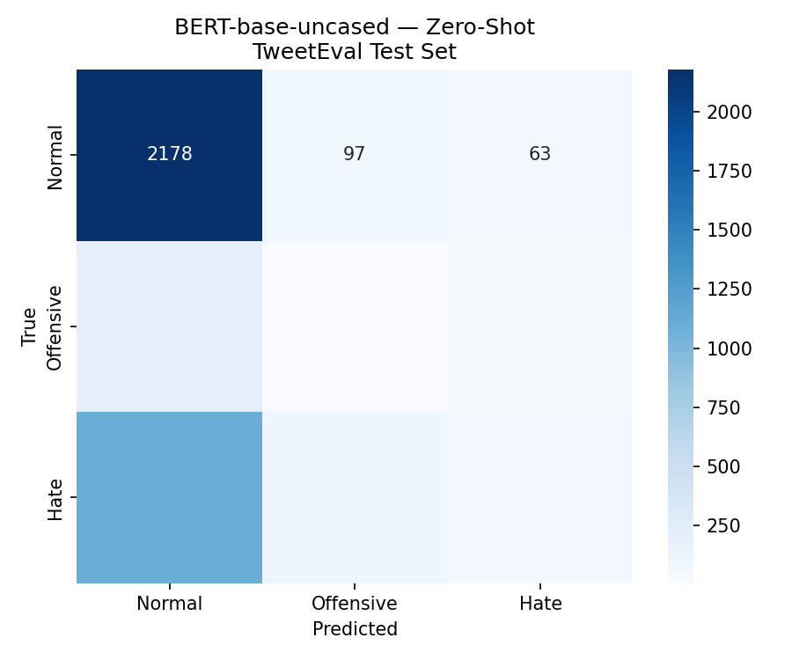 | 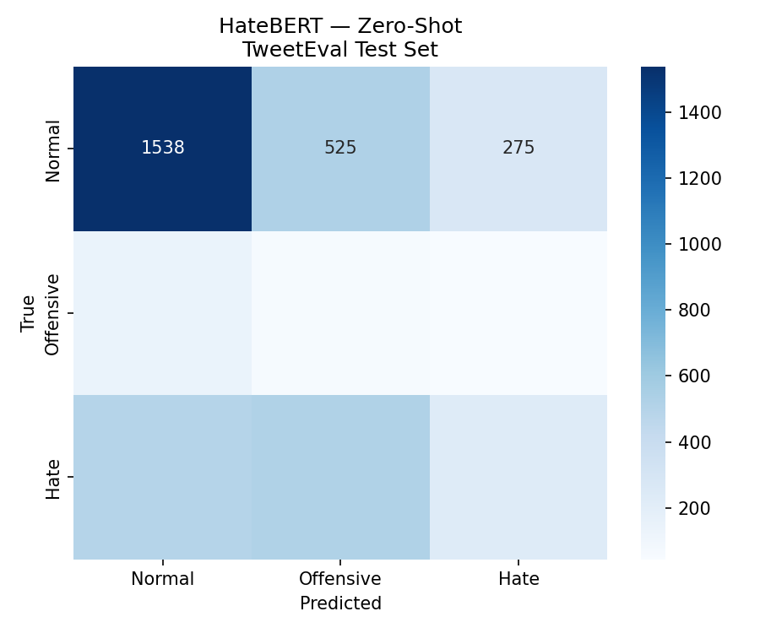
Figure 2a. BERT-base-uncased | Figure 2b. HateBERT
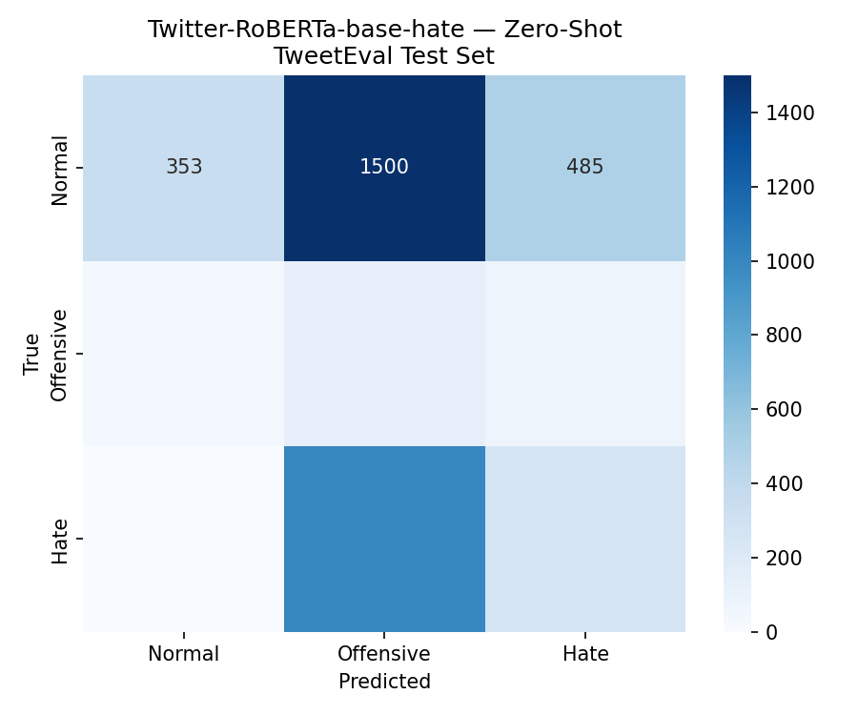 | 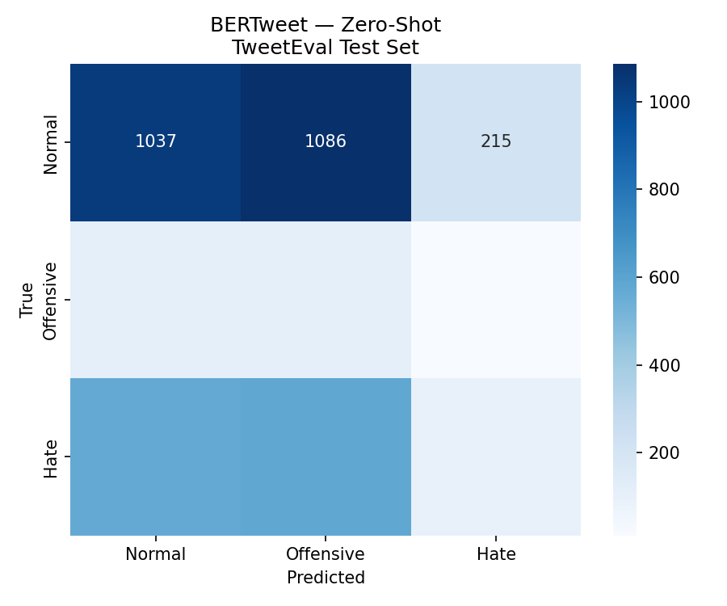
Figure 2c. Twitter-RoBERTa-base-hate | Figure 2d. BERTweet
Figure 2. Zero-shot confusion matrices on TweetEval test set

1.4 Analysis
All four models achieve modest Macro F1 scores (0.20–0.34) without fine-tuning, confirming that zero-shot CLS cosine similarity is insufficient for reliable 3-class hate speech detection. Nevertheless, the results reveal meaningful differences across model types:
HateBERT achieves the best overall balance. Macro F1 = 0.337 on HateXPlain and 0.342 on TweetEval — the highest across both datasets. Pre-training on Reddit abusive content gives it broader coverage of offensive language patterns, producing more balanced F1 scores across all three classes compared to the other models.
Twitter-RoBERTa shows class-level specialisation. It achieves the highest F1 Offensive on HateXPlain (0.427) and the highest F1 Hate on TweetEval (0.247), consistent with its pre-training on hate-labelled tweet data. However, it dramatically over-predicts Offensive on TweetEval (Accuracy = 0.192), collapsing the Normal class F1 to 0.259.
BERT-base-uncased defaults to predicting Normal. It achieves the highest F1 Normal on both datasets (0.545 / 0.748) but near-zero F1 for Offensive and Hate, indicating a strong majority-class bias in the absence of task-specific training.
BERTweet performs weakest overall. Despite being pre-trained on 850M tweets, tweet-specific language understanding does not directly transfer to hate speech classification without fine-tuning. F1 Hate is near zero on HateXPlain (0.027), suggesting the model embeds hate speech in a space close to Normal content.
These results establish a meaningful zero-shot baseline and demonstrate that domain-relevant pre-training (HateBERT, Twitter-RoBERTa) provides modest but measurable advantages over general-purpose encoders. Fine-tuning on labelled data is required for robust classification performance.
2. Fine-Tuning BERT on Hate Speech Datasets (20 Credits)
2.1 Approach
We fine-tune BERT-base-uncased separately on two benchmark datasets — HateXPlain and TweetEval — for 3-class sequence classification (Normal / Offensive / Hate). A custom ManualAdamW optimizer is implemented to bypass a PyTorch 2.6 fused CUDA kernel incompatibility on the RTX 4060 GPU. Hyperparameter search covers learning rates in {1e-5, 2e-5, 3e-5} with batch size 8 and 3 training epochs per candidate. The best checkpoint (by validation Macro F1) is retained for each dataset.
To address class imbalance (Hate speech is underrepresented in both datasets), class weights are computed via sklearn's compute_class_weight('balanced') and applied through a weighted CrossEntropyLoss. Fine-tuned models are persisted as saved_model_bert_hx (HateXPlain) and saved_model_bert_te (TweetEval).
2.2 Results on Original Social-Media Test Sets
Each fine-tuned model is first evaluated on its corresponding held-out test split (HateXPlain test set for BERT-HateXplain; TweetEval test set for BERT-TweetEval). Both models achieve solid performance on the social-media domain they were trained on:
Table 2. Fine-tuned BERT — Performance on Original Social-Media Domain Test Sets
Model | Test Set | Accuracy | Macro F1 | F1 Normal | F1 Offensive | F1 Hate
BERT-HateXplain | HateXPlain | 0.669 | 0.662 | 0.717 | 0.536 | 0.733
BERT-TweetEval | TweetEval | 0.579 | 0.536 | 0.536 | 0.432 | 0.639
Both models recognise all three classes effectively in the social-media domain. BERT-HateXplain achieves F1 Hate = 0.733 on the HateXPlain test set, and BERT-TweetEval achieves F1 Hate = 0.639 on TweetEval. The confusion matrices below confirm that predictions are well distributed across all three classes.
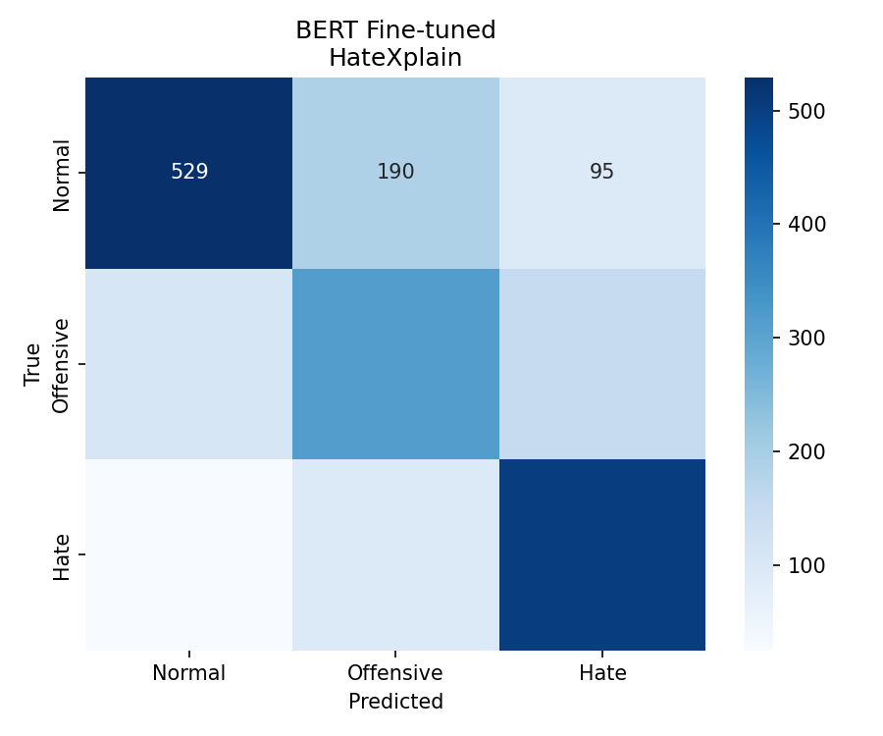 | 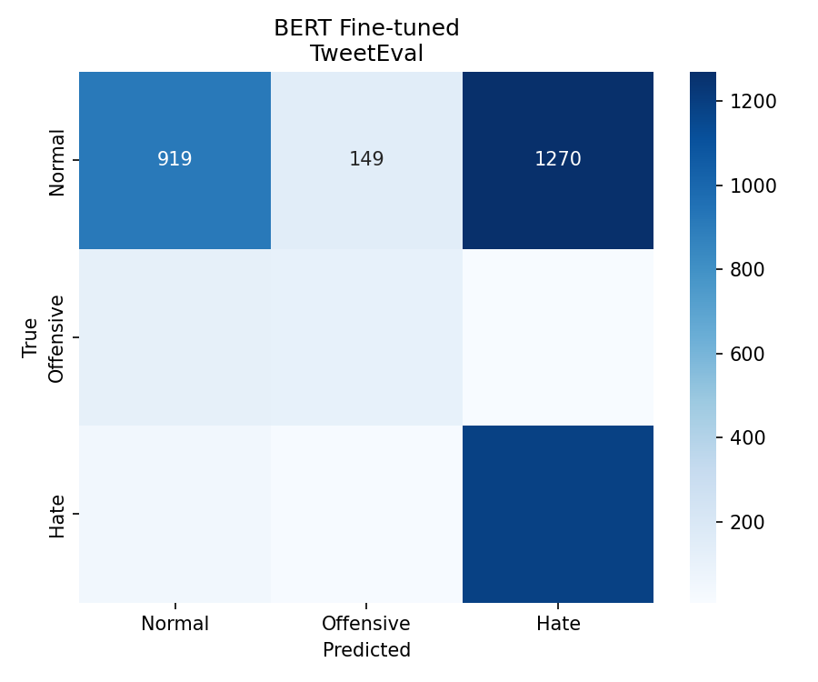
Figure 1. BERT-HateXplain on HateXPlain test set | Figure 2. BERT-TweetEval on TweetEval test set

2.3 Cross-Domain Evaluation: Course Review Test Set
To assess real-world applicability, both fine-tuned models are additionally evaluated on a custom course-review test set comprising 286 samples collected from university course evaluations (50% Normal / 25% Offensive / 25% Hate). This dataset covers institutional offensive language — negative course reviews, personal attacks on instructors — which is stylistically distinct from the social-media content the models were trained on.
Table 3. Fine-tuned BERT — Performance on Course Review Test Set (n = 286)
Model | Test Set | Accuracy | Macro F1 | F1 Normal | F1 Offensive | F1 Hate
BERT-HateXplain | Course (OOD) | 0.535 | 0.295 | 0.714 | 0.172 | 0.000
BERT-TweetEval | Course (OOD) | 0.514 | 0.252 | 0.714 | 0.043 | 0.000
Performance collapses on the course domain. F1 Hate drops to 0.000 for both models — neither model successfully identifies a single course-domain Hate sample. F1 Offensive also degrades sharply (0.536 → 0.172 for BERT-HateXplain; 0.432 → 0.043 for BERT-TweetEval). The models default to predicting Normal for nearly all inputs, which is confirmed by the confusion matrices below.
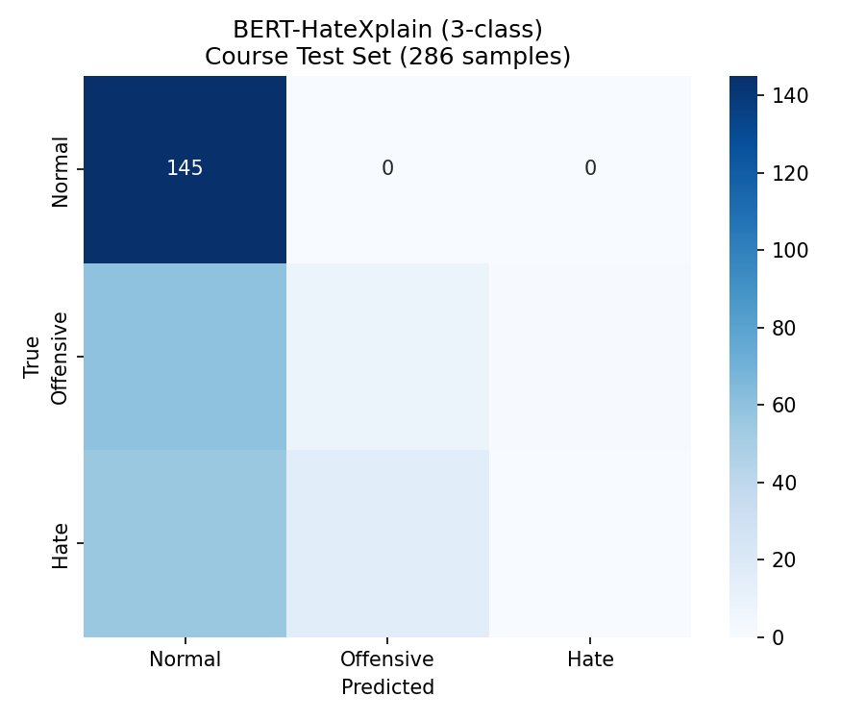 | 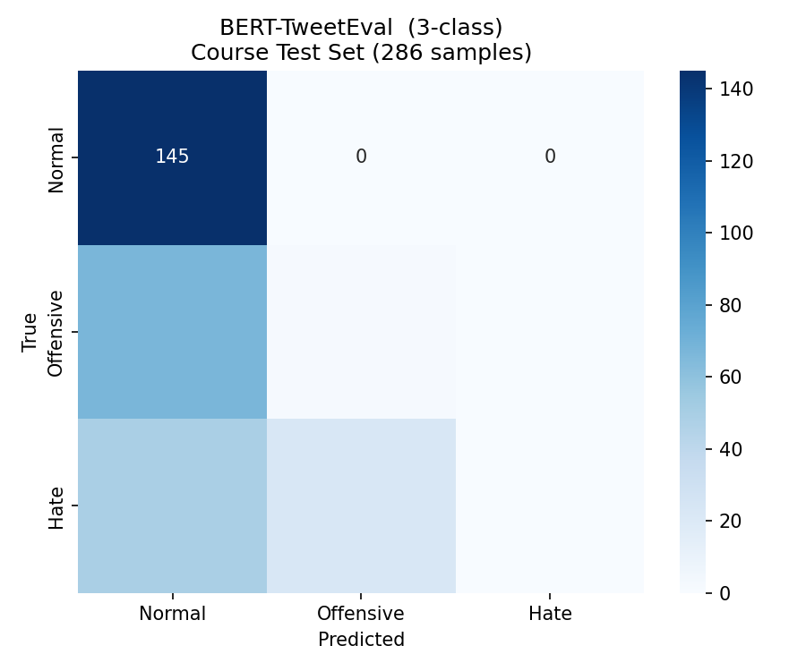
Figure 3. BERT-HateXplain on course test (OOD) | Figure 4. BERT-TweetEval on course test (OOD)

This reveals a severe domain shift problem: social-media hate speech classifiers trained on racial and religious slurs do not recognise course-domain offensive language such as "this lecturer is an aggressive bully" or "fucking trash course". The vocabulary, targets, and linguistic register are fundamentally different.
Table 4. Domain Shift Summary — Original vs. Course Domain Performance
Model | Original Domain  Macro F1 | Course Domain  Macro F1 | F1 Hate (orig.) | F1 Hate (course)
BERT-HateXplain | 0.662 | 0.295 | 0.733 | 0.000
BERT-TweetEval | 0.536 | 0.252 | 0.639 | 0.000
2.4 Domain Adaptation Fine-Tuning
To resolve the domain shift, domain adaptation fine-tuning is applied starting from saved_model_bert_hx — the model with the highest baseline performance on the course domain. Fine-tuning continues on 251 course-domain training samples using a small learning rate (2e-5) to avoid catastrophic forgetting of the original social-media knowledge. Class weights (Normal=0.450 / Offensive=1.946 / Hate=3.803) address the imbalanced course-domain distribution (74% / 17% / 9%), and training runs for 5 epochs.
Table 5. BERT-HateXplain Before and After Domain Adaptation (Course Test Set, n = 286)
Stage | Accuracy | Macro F1 | F1 Normal | F1 Offensive | F1 Hate
Before Adaptation (social-media model) | 0.535 | 0.295 | 0.714 | 0.172 | 0.000
After Adaptation (domain-adapted) | 0.888 | 0.863 | 0.948 | 0.765 | 0.877
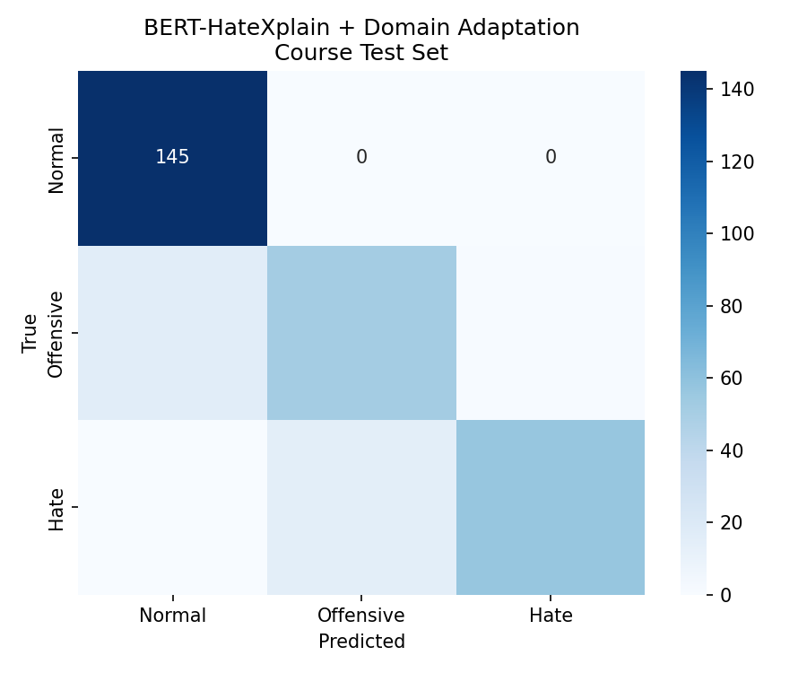
Figure 5. BERT-HateXplain after domain adaptation — course test set

Domain adaptation with only 251 course-domain samples raised Macro F1 from 0.295 to 0.863 and lifted F1 Hate from 0.000 to 0.877, demonstrating the effectiveness of continual learning with a restrained learning rate to prevent catastrophic forgetting of the original social-media knowledge.
3. Cascaded Classification — Extended Method Attempt (30 Credits)
3.1 Motivation
Given the class imbalance inherent in hate speech data (Hate is rare; Normal is dominant), a cascaded two-stage architecture was designed as a method extension. The hypothesis was that decomposing the 3-class problem into two simpler binary decisions would reduce confusion between adjacent classes and improve recall on minority classes:
- Stage 1 — Binary classifier: Normal vs. Not-Normal
- Stage 2 — Binary classifier: Offensive vs. Hate (applied only to samples predicted as Not-Normal by Stage 1)
3.2 Implementation
Both stages use BERT-base-uncased fine-tuned with ManualAdamW, weighted CrossEntropyLoss, and learning-rate search over {1e-5, 2e-5, 3e-5}. Course-domain data was mixed into training sets to attempt cross-domain generalisation. Stage models are saved as saved_model_bert_hx_stage1 / stage2 (HateXPlain) and saved_model_bert_te_stage1 / stage2 (TweetEval).
3.3 Results
Table 6. Cascaded vs. Direct Fine-Tuning — Macro F1 Comparison
Method | Dataset | Macro F1 | Change vs. Direct
Direct fine-tuning | HateXPlain | 0.731 | —
Cascaded + course data mix | HateXPlain | 0.727 | −0.004
Direct fine-tuning | TweetEval | 0.536 | —
Cascaded + course data mix | TweetEval | 0.404 | −0.132
3.4 Analysis and Conclusion
The cascaded approach failed to improve performance and substantially degraded TweetEval Macro F1 from 0.536 to 0.404 (−13.2 points). Two principal failure mechanisms were identified:
(1) Error propagation. Misclassifications in Stage 1 cascade irreversibly into Stage 2; any Normal sample wrongly routed to Stage 2 cannot be recovered, compounding errors across stages.
(2) Domain mismatch from data mixing. Course-domain Normal text (structured academic descriptions) is linguistically distinct from Twitter Normal text. Mixing them confused Stage 1's decision boundary, causing many Normal course reviews to be incorrectly routed to Stage 2.
These findings demonstrate that architectural complexity does not substitute for domain alignment. The cascaded approach was abandoned in favour of domain adaptation, which proved substantially more effective with far less design overhead.
4. Summary and Key Findings
Table 7. Overall BERT Model Progression — Course Domain Test Set (n = 286)
Model / Stage | Accuracy | Macro F1 | F1 Normal | F1 Offensive | F1 Hate
BERT-base-uncased (zero-shot) | ~0.40 | ~0.37 | — | — | —
BERT-HateXplain (fine-tuned) | 0.535 | 0.295 | 0.714 | 0.172 | 0.000
BERT-TweetEval (fine-tuned) | 0.514 | 0.252 | 0.714 | 0.043 | 0.000
BERT-HateXplain + Cascaded† | — | 0.727* | — | — | —
BERT-HateXplain + Domain Adapt | 0.888 | 0.863 | 0.948 | 0.765 | 0.877
† Cascaded result on original HateXPlain test set (not course domain). * Lower on course domain due to domain shift.
The experimental progression from zero-shot (Macro F1 ≈ 0.37) through direct fine-tuning (0.295 on course domain) to domain adaptation (0.863 on course domain) demonstrates three key findings:
- Domain shift is the primary bottleneck. Models trained on social-media hate speech generalise poorly to course-evaluation offensive language regardless of architecture.
- Domain adaptation is highly sample-efficient. Only 251 course-domain training samples were sufficient to raise F1 Hate from 0.000 to 0.877.
- Architectural complexity does not compensate for domain mismatch. The cascaded two-stage design introduced error propagation without improving cross-domain generalisation.
5. Command Line Interface Testing (5 Credits)
5.1 Overview
A command-line interface (CLI) tool, predict.py, is provided to allow interactive testing of the hate speech detection system. The tool accepts either a single text string or a plain-text file as input, runs inference through the selected model, and outputs a predicted label (Normal / Offensive / Hate) together with a confidence score for each input sample.
5.2 Design
The CLI is built with Python's argparse module and wraps the full inference pipeline in a lightweight, dependency-free script. Key design decisions:
Default model. The tool automatically loads saved_model_roberta_hx_course — the best-performing model (Macro F1 = 0.936 on the course test set) — when no model is explicitly specified. Any saved model directory can be selected via the --model flag, enabling comparison across all trained checkpoints.
Dual input modes. --text accepts a single quoted string for quick testing; --file reads a plain-text file where each line is treated as one input sample, enabling batch evaluation without code changes.
Confidence output. The predicted class label and its softmax probability (confidence score) are printed for every input. The --verbose flag additionally prints the full per-class probability distribution (Normal / Offensive / Hate), making it easy to inspect borderline predictions.
Device-agnostic. The tool automatically selects CUDA if available, falling back to CPU, so it runs identically on both the development GPU and a standard laptop.
5.3 Usage
Basic usage examples:
Table 8. predict.py Command Examples
Mode | Command
Single text input | python predict.py --text "This course is complete garbage."
Batch file input | python predict.py --file reviews.txt
Verbose (all class probs) | python predict.py --text "The tutor was patient." --verbose
Select a different model | python predict.py --text "..." --model saved_model_bert_hx_course
5.4 Sample Output
Example output for a single text input with --verbose:
Loading model from: saved_model_roberta_hx_course
Device: cuda

Text: This lecturer is an aggressive bully who poisons every class.
Prediction: Hate (confidence: 0.9821)
Normal : 0.0089
Offensive : 0.0090
Hate : 0.9821

5.5 Workflow
The end-to-end inference pipeline executed by predict.py proceeds as follows:
1. Input parsing. argparse reads --text or --file. If a file path is provided, each non-empty line is loaded as an independent input sample.
2. Model loading. AutoTokenizer and AutoModelForSequenceClassification are instantiated from the specified model directory (HuggingFace format). The model is moved to GPU if available and set to eval() mode.
3. Tokenisation. Each input string is tokenised with padding to max_length=128 and truncation. The resulting input_ids and attention_mask tensors are transferred to the target device.
4. Inference. A forward pass is performed under torch.no_grad(). The output logits are converted to class probabilities via softmax.
5. Output. The argmax of the probability vector determines the predicted label. The corresponding probability is reported as the confidence score. With --verbose, all three class probabilities are displayed.

