Alternative statistical distributions for estimating Value-at-Risk : theory and evidence

Cheng-Few Lee ．Jung-Bin Su∗
Abstract The normality assumption is extensively adopted to forecast value-at-risk (VaR) while asset returns are typically skewed, leptokurtic and fat-tailed. The VaR estimators based on the normal distribution thus lead to the underestimation of the true value of the risk. This study thus presents a composite trapezoid rule, a numerical integral method, for estimating quantiles on the skewed generalized t distribution (SGT) which permits returns innovation to flexibly treat skewness, leptokurtosis and fat tails. Daily spot prices of the thirteen stock indices in North America, Europe and Asia provide data for examining the one-day-ahead VaR forecasting performance of the GARCH-N, GARCH-T and GARCH-SGT models.
Empirical results indicate that the GARCH-SGT models yield more accurate VaR forecasts than the GARCH-N and GARCH-T models particularly for high and most low confidence levels. Furthermore, the descriptive graphs of daily returns also demonstrate that the SGT better fits the empirical distribution of log-returns than the normal and student t across all series for the estimation and forecast period. These findings show that using SGT distribution is essential for out-of-sample VaR forecasting in stock markets.

Keywords Value-at-risk．GARCH．SGT．Composite trapezoid rule．Quantile
JEL Classification C52．C53．G15
1 Introduction
The recent decade has witnessed the accelerated development of techniques for determining and managing market risk. A popular method of risk quantification is the Value-at-Risk (VaR) measure, which numerous financial institutions and risk managers have adopted as a first line of defense against market risk. VaR has also become a standard risk measure used in financial risk management owing to its conceptual simplicity, ease of computation, and ready applicability. Consequently, VaR techniques are widely used to assess the risk exposure of investments. For long positions, the risk comes from a decline in the price of the commodity, meaning that traders are merely concerned with the downside of the returns distribution, especially the tailed distribution. However, the extent of fat-tail and skewness influence the tail of the returns distribution.
Estimation of VaR often assumes a normal distribution of returns. However, substantial empirical evidence suggests that the distribution of financial returns is leptokurtic and fat-tailed (see Mandelbrot, 1963; Fama, 1965; Baillie and de Gennaro, 1990; Jansen and de Vries, 1991; Bollerslev et al., 1992; Loretan and Phillips, 1994; Kearns and Pagan, 1997), leading to underestimation or overestimation of true VaR. Consequently, numerous studies have proposed using student t distribution (Billio and Pelizzon, 2000; Huang and Lin, 2004; So and Yu, 2006; Ané, 2006; Angelidis et al., 2004; Cheong, 2008), generalized error distribution (GED) ( Angelidis et al., 2004), which is fat-tailed, to capture extreme events in modeling VaR. The related literature is summarized below. Billio and Pelizzon (2000) introduced a multivariate switching regime model for calculating the VaR of ten Italian stocks, and concluded that a switching regime specification is more accurate than other known methods, such as RiskMetrics or generalized autoregressive conditional heteroskedasticity (GARCH) model under both normal and student t distribution. Huang and Lin (2004) used the daily Taiwan stock index futures prices to investigate the forecasting performance of three VaR models (RiskMetrics, asymmetric power GARCH (APARCH) model under both normal and student t distribution). The empirical results indicate that asset returns exhibit fat tails and volatility clustering. So and Yu (2006) studied the RiskMetrics, GARCH, integrated GARCH (IGARCH) and fractionally integrated GARCH (FIGARCH) models with conditional normal and conditional t error distributions in VaR estimation. Furthermore, Ané (2006) applied the APGARCH model and used Japanese’s TOPIX indices to forecast VaR. The distribution of the standardized error term is assumed to be normal and student t. Dynamic estimation is used to compare the three GARCH family, such as Bollerslev GARCH(1,1), Taylor GARCH(1,1) and Ding, Granger and Engle GARCH(1,1) models, and examines their forecasting performances in a VaR setting. Angelidis et al. (2004) assessed the performance of an extensive family of autoregressive conditional heteroskedasticity (ARCH) models, such as GARCH, threshold ARCH (TARCH) and exponential GARCH (EGARCH), in modeling the daily VaR of perfectly diversified portfolios in five stock indices, using various distributional assumptions(normal, student t and GED) and sample sizes. Cheong (2008) proposed a simple Pareto distribution to explain the heavy-tailed property in the empirical distribution of returns, and also used the well-known two components ARCH modeling technique assuming normality and heavy-tailed (student t distribution) for the innovations.
However, the distribution of financial returns is also skewed leftwards and the student t and GED distributions do not consider the skewness characteristics of return innovations. Notably, Brooks and Persand (2003) concluded that models which do not allow for asymmetries in either the unconditional return distribution or volatility specification underestimate the true VaR. Giot and Laurent (2003) estimated the daily VaR for stock indices using a skewed student t distribution, and found that it outperformed the pure symmetric one, and that it is crucial to account for the observed skewness and kurtosis in VaR estimation. Bali and Theodossiou (2007) proposed a conditional technique for estimating VaR and expected shortfall measures based on the skewed generalized t (SGT) distribution, and also confirmed that VaR models permitting asymmetry in the conditional return distribution are substantial in VaR determination. Lee et al. (2008) proposed a composite Simpson’s rule, a numerical integral method, for estimating quantiles on the skewed generalized error distribution (SGED) and examined the one-day-ahead VaR forecasting performance of the GARCH model under both normal and SGED distribution, and also demonstrated that the use of SGED distribution, which explicitly accommodates both skewness and kurtosis, is essential for out-of-sample VaR forecasting.
The returns distributions in most of the VaR literature are normal, student t, or GED. These distributions are symmetrical and can only deal with the issues of fat tails and leptokurtosis in realized returns distribution. Such distributions of returns thus are unable to fully correct the problem of underestimation of risk. This study thus employs the SGT distribution of Theodossiou (1998) to estimate VaR measures. The SGT provides a flexible distribution for modeling the empirical distribution of financial data exhibiting skewness, leptokurtosis and fat tails. Furthermore, the estimation of the conditional mean and variance of returns, required for implementing the parametric technique, is based on the simple GARCH (1, 1) model of Bollerslev (1986). In contrast to Bali and Theodossiou (2007), they adopted the quintile regression approach to estimate a conditional autoregressive VaR model which was introduced by Engle and Manganelli (2004). But in this paper, we use QMLE (Quasi maximum likelihood estimation) and the BFGS (Broyden, Fletcher, Goldfarb and Shanno) optimization algorithm to estimate the parameters of GARCH-SGT model, the conditional mean and variance of returns thus are obtained, then apply a composite trapezoid rule, a numerical integral method, for estimating the quantiles of SGT distribution based on the estimated shape parameters. The one-day-ahead VaR based on GARCH-SGT model thus can be calculated.
This investigation has three objectives. First, this work derives the standardized SGT distribution as presented in Appendix A and demonstrates its ability to fit the empirical distribution of log-returns for thirteen stock market indices: the U.S. DowJones, NASDAQ and S&P500, and the Mexico in North America; the Austria ATX, the Belgium Brussels, the France CAC40 and the Switzerland Swiss in Europe; the India Bombay, the Indonesia JKSE, the Malaysia KLSE, the Singapore STRAITS and the South Korea KOSPI in Asia. Second, this study employs a composite trapezoid rule, as presented in Appendix B, to derive the quantiles of SGT distribution at different confidence levels for the estimated shape parameters during the forecasting VaR process. Third, the investigation implements GARCH models under three distributional assumptions (normal, student t and SGT) for estimating the 95%, 99% and 99.5% one-day-ahead VaR for the thirteen stock market indices. The predictive accuracies of the GARCH-SGT model estimates are then compared with those obtained by applying a GARCH-N or GARCH-T methodology to these stock indices, an approach which does not simultaneously consider the skewness and kurtosis features of returns innovations.
The rest of this paper is organized as follows. Section 2 presents the GARCH models based on normal, student t and SGT distributions. Section 3 then provides criteria used to evaluate risk management. Subsequently, section 4 reports data and descriptive statistics. Section 5 then lists the empirical results. Conclusions are finally drawn in Section 6.

2 Methodology
Many time series data of financial assets appear to exhibit autocorrelated and volatility clustering. Bollerslev et al. (1992) showed that the GARCH(1,1) specification works well in most applied situations. This study thus considers the applicability of the GARCH(1,1) model with three conditional distributions, namely the normal, student t and SGT distributions, to estimate the corresponding volatility in terms of different stock indices.
Let 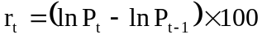, where 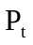 denotes the stock price, denotes the continuously compounded daily returns of the underlying assets on time t. The GARCH(1,1) model with SGT distribution (GARCH-SGT) can be expressed as follows:
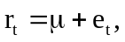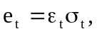 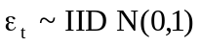 (1)
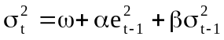 (2)
where and 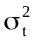 are the conditional mean and variance of return, respectively. Since 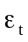 is drawn from the standardized SGT distribution which allows returns innovation to follow a flexible treatment of both skewness and excess kurtosis in the conditional distribution of returns. The probability density function for the standardized SGT distribution is derived in Appendix A and can be represented as follows:
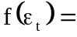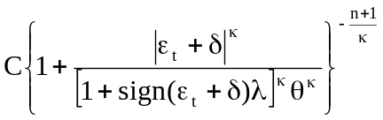 (3)
where 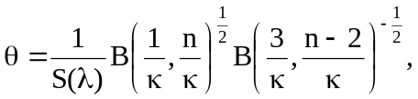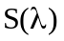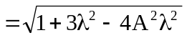, 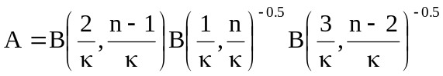, 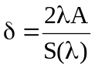, 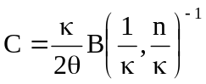
where 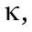 n and are scaling parameters and C and are normalizing constants ensuring that 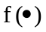is a proper p.d.f.. The parameters and n control the height and tails of density with constraints 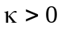 and 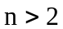, respectively. The skewness parameter controls the rate of descent of the density around 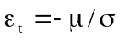 with 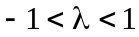. In the case of positive (resp. negative) skewness, the density function skews toward to the right (resp. left). Sign is the sign function and 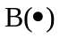 is the beta function. The parameter has the degrees of freedom interpretation in case 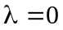 and 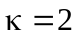. The log-likelihood function of the GARCH-SGT model thus can be written as :
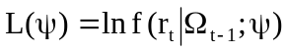 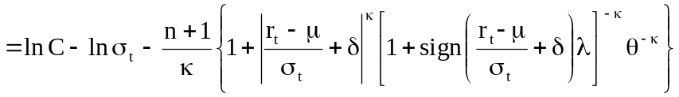 (4)
where 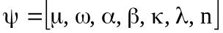 is the vector of parameters to be estimated, and 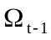 denotes the information set of all observed returns up to time 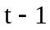. Under the framework of the parametric techniques (Jorion, 2000), the one-day-ahead VaR based on GARCH-SGT model can be calculated as:
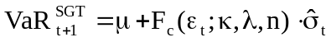 (5)
where 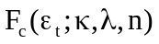 denotes the left quantile at for standardized SGT distribution with shape parameters , and . Meanwhile, the algorithm of the left quantile at c, , is presented in Appendix B.
Particularly, the SGT distribution generates the student t distribution for and . The probability density function for the standardized student t distribution can be represented as follows:
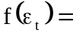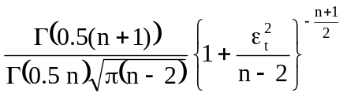 (6)
where 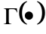 is the gamma function and n is the shape parameter. Hence the log-likelihood function of the GARCH-T model (GARCH(1,1) model with student t distribution) can be expressed as :
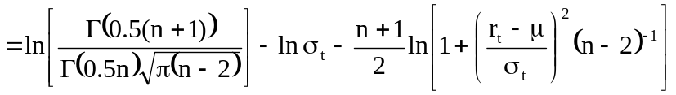 (7)

where 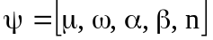 is the vector of parameters to be estimated. The one-day-ahead VaR based on GARCH-T model can be obtained as:
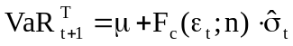 (8)
where 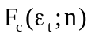 denotes the left quantile at for standardized student t distribution with shape parameter .
Moreover, the SGT distribution generates the normal distribution for , and . The probability density function for the standardized normal distribution can be represented as follows:
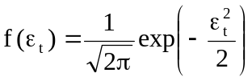 (9)
, and the log-likelihood function of GARCH-N model (GARCH(1,1) model with
normal distribution) thus can be written as:
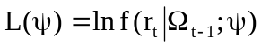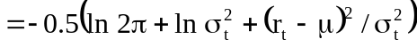 (10)
where 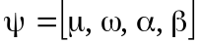 is the vector of parameters to be estimated. The one-day-ahead VaR based on GARCH-N model can be calculated as:
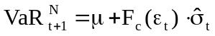 (11)
where 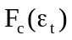 is the left quantile at for the standardized normal distribution.

3 Evaluation mthods of model-based VaR
To compare the forecasting ability of the aforementioned models in terms of VaR, this study considers four accuracy measures: a binary loss function, a quadratic loss function, the unexpected loss, and the likelihood ratio (LR) test of unconditional coverage (or back-testing) which is quite standard in the literatures.

3.1 Binary loss function
If the predicted VaR is not able to cover the realized loss, this is termed a violation. A binary loss function (BLF) is merely the reflection of the LR test of unconditional coverage test and gives a penalty of one to each exception of the VaR. The BLF for long position can be defined as follows.
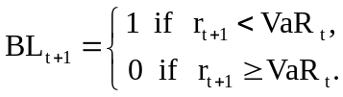 (12)
where 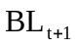 represents the one-day-ahead BLF for long position. If a VaR model truly provides the level of coverage defined by its confidence level, then the average binary loss function (ABLF) over the full sample will equal for the 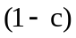th percentile VaR.

3.2 Quadratic loss function
The quadratic loss function (QLF) of Lopez (1999) penalizes violations differently from the binary loss function, and pays attention to the magnitude of the violation. The QLF for long position can be expressed as:
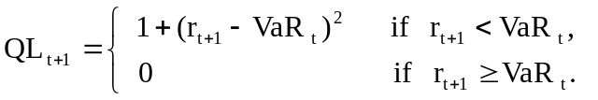 (13)
where 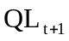 represents the one-day-ahead QLF for long position. The quadratic term in Eq. (13) ensures that large violations are penalized more than the small violations which, provides a more powerful measure of model accuracy than the binary loss function.

3.3 LR test of unconditional coverage
Kupiec (1995) proposed a likelihood ratio test for testing the model accuracy which is identical to a test of the null hypothesis that the probability of failure for each trial () equals the specified model probability (p). The likelihood ratio test statistics is given by:
(14)
where 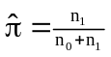 is the maximum likelihood estimate of p, 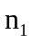 denotes a Bernoulli random variable representing the total number of VaR violations, and 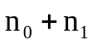 represents the full sample size. The LR_{uc} test can be employed to test whether the sample point estimate is statistically consistent with the VaR model’s prescribed confidence level or not.

3.4 Unexpected loss
The unexpected loss (UL) will equal the average magnitude of the violation over the full sample. The magnitude of the violation for long position is given by:
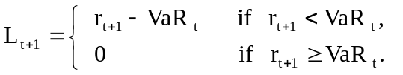 (15)
where 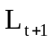 is the one-day-ahead magnitude of the violation for long position.

4 Data description preliminary analysis
The study data comprises daily prices of the following thirteen stock indices: the U.S. DowJones, NASDAQ and S&P500, and the Mexico in North America; the Austria ATX, the Belgium Brussels, the France CAC40 and the Switzerland Swiss in Europe; the India Bombay, the Indonesia JKSE, the Malaysia KLSE, the Singapore STRAITS and the South Korea KOSPI in Asia. Daily closing spot prices for the study period, totaling 2500 observations, were obtained from the Yahoo finance website. Stock returns are defined as the first difference in the logarithms of daily stock prices then multiplied by 100.
Table 1 lists the periods covered by the data. Table 2 summarizes the basic statistical characteristics of return series for both the estimation and forecast periods. Notably, the average daily returns are all negative (resp. positive) for forecast (resp. estimation) period and very small compared with the variable standard deviation, indicating high volatility. All returns series almost exhibit negative skewness for both the estimation and forecast periods. The excess kurtosis all significantly exceeds zero at the 1% level, indicating a leptokurtic characteristic. Furthermore, J-B normality test statistics are all significant at the 1% level and thus reject the hypothesis of normality and confirm that neither returns series is normally distributed. Moreover, the Ljung-Box 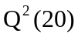 statistics for the squared returns are all significant at the 1% level and thus indicate that the return series exhibit linear dependence and strong ARCH effects. Therefore, the preliminary analysis of the data suggests the use of a GARCH model to capture the fat tails and time-varying volatility found in these stock indices returns series.
Figure 1 (a)-(m) graphically illustrate the levels of spot prices of the thirteen stock indices for the study period. Figure 2 (a)-(m) depict the empirical distributions of the corresponding thirteen log-return series based on the normal, student t, SGT distribution and a non-parametric method (the histogram or piecewise linear curves) proposed by Tapia and Thompson (1978) for the estimation period. These graphs demonstrate that the SGT and student t provide a good fit to the empirical distribution of log-returns across all series. Moreover, the estimated SGT and non-parametric probability density curves are more indistinguishable than the estimated student t and non-parametric probability density curves, but all deviate significantly from those of the normal distribution. This indicates that the SGT, which explicitly accommodates both skewness and kurtosis, accurately represents the empirical distribution of each series.

5 Empirical results and analyses
5.1 Estimation for alternate VaR models
This section estimates the GARCH(1,1) model with alternative distributions for performing VaR analysis. For each data series, three GARCH models are estimated with a sample of 2000 daily returns, and the estimation period is then rolled forwards by adding one new day and dropping the most distant day. In this procedure, the out-of-sample VaR are computed for the next 500 days.
Table 3 lists the estimation results of the GARCH-N, GARCH-T and GARCH-SGT models for the DowJones, NASDAQ, S&P500 and Mexico stock indices in North America, and the ATX, Brussels, CAC40 and Swiss stock indices in Europe during the in-sample period. Table 4 presents those for the Bombay, JKSE, KLSE, STRAITS and KOSPI stock indices in Asia.
The variance coefficients , and are all positive and significant almost at the 1% level. Furthermore, the sums of parameters and for these three models are less than one thus ensuring that the conditions for stationary covariance hold. Parameter of the GARCH-SGT model, which is between 4.9846 (KLSE) and 21.4744 (KOSPI), reveals that the distributions of returns series are leptokurtic. Parameter of the GARCH-SGT model ranges from -0.1560 (Bombay) to -0.0044 (KLSE). Parameter of the GARCH-SGT model lies between 1.5399 (KOSPI) and 2.3917 (Bombay). These findings indicate that the distributions of the returns series are all left-skewed and almost leptokurtic except for Brussels, CAC40, Swiss, Bombay, KLSE and STRAITS. Moreover, parameter of the GARCH-T model, which lies between 4.9906 (KLSE) and 17.8759 (NASDAQ), shows that the distributions of all returns series are also leptokurtic. Diagnostics of the standardized residuals of the three different GARCH-type models indicate that serial correlation does not exist in standard residuals, confirming that the GARCH(1,1) specification in these models is sufficient to correct the serial correlation of these five returns series in the conditional variance equation. Moreover, the 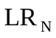 statistics for testing the null hypothesis of normality of standardized returns against that of the student t or SGT are large and all highly significant, rejecting the null hypothesis of normality for either stock index, thus implying that the student t or SGT distribution closely approximates the empirical return series. Furthermore, 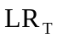 is the likelihood ratio statistic from testing the null hypothesis that the series followed the student t distribution against the SGT specification. statistics in Table 3 and Table 4 are significant only for S&P500, Brussels, CAC40, Swiss, Bombay, STRAITS and KOSPI, thus implying that the SGT distribution closely approximates the empirical return series for these stock indices.

5.2 Out-of-sample VaR forecasting performance
Having obtained the estimates of these VaR models, the model-based VaR can be calculated using Eqs. (5), (8) and (11). This section reports and analyzes the out-of-sample results and the predictive performances of three VaR models.
Table 5 lists the results of three VaR models for 95% confidence level. For the 95% confidence level, the GARCH-SGT model yields the highest VaR estimates, lowest ABLF, AQLF and unexpected loss for most data except STRAITS, KLSE and JKSE. In these three indices, the GARCH-N model yields the highest VaR estimates, the lowest average failure rate (ABLF), quadratic loss (AQLF) and unexpected loss. On the other hand, the GARCH-T model yields the lowest VaR estimates, highest ABLF, AQLF and unexpected loss for most data except Brussels. For Brussels, the GARCH-N model yields the lowest VaR estimates, highest ABLF, AQLF and unexpected loss. Simply stated, the GARCH-SGT (resp. GARCH-T) model has the best (resp. worst) out-of-sample VaR performance for the 95% confidence level.
Table 6 and Table 7 report the results obtained with three VaR models, using the high confidence levels (99% and 99.5%). The GARCH-SGT models yield higher VaR estimates than the GARCH-N and GARCH-T model. Consequently, the ABLF, AQLF and unexpected loss generated by the GARCH-SGT models are the lowest for all data. However, the GARCH-N models yield the lowest VaR estimates, and the highest ABLF, AQLF and unexpected loss for most data. It seems reasonable to conclude that the GARCH-SGT (resp. GARCH-N) model has the best (resp. worst) out-of-sample VaR performance for the 95% and 99.5% confidence levels.
From the column of 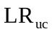, Table 5 shows that the GARCH-N, GARCH-T and GARCH-SGT models pass the tests with a total of 2, 2 and 6 indices, respectively. On the other hand, Table 6 (resp. Table 7) shows that the GARCH-N, GARCH-T and GARCH-SGT models pass the tests with a total of 1(resp. 5), 7(resp. 10) and 11(resp. 11) indices, respectively. These results lead to the conclusion that the GARCH-SGT model not only passes the test for most of data than the others two models, but also the various statistics generated by this model are also the lowest as well. Restated, the GARCH-SGT model is the most accurate model since its empirical failure rate is closer to the prescribed one than are those of the GARCH-N and GARCH-T models. Moreover, these results reveal that the three models in this case underestimate VaR since the average binomial loss functions are higher than the prescribed model failure rates.
To briefly summarize, this study finds that, at 95%, 99% and 99.5% confidence levels, using the GARCH model with SGT distribution for stock indices generates the most conservative VaR forecasts.

6 Conclusion
Numerous applications presume that asset returns are normally distributed, yet they are widely known to exhibit skewness and excess kurtosis, resulting in underestimation or overestimation of true VaR. Therefore, accurately calculating VaR using GARCH-type models requires with an adequate conditional distribution. The selection of an appropriate distribution for the innovation process is important since it directly affects the quality of the estimate of the required quantiles. Consequently, this study applies the SGT distribution of Theodossiou (1998) which permits returns innovation to flexibly treat skewness, leptokurtosis and fat tails in the conditional distribution of returns. This investigation incorporates the SGT distribution with the GARCH(1,1) model for estimating one-day-ahead VaR for the thirteen stock indices in North America, Europe and Asia, and then compares the forecasting accuracy with that obtained using the GARCH-N and GARCH-T models.
The study makes three contributions to VaR estimation in risk management. First, the standardized SGT distribution is derived in Appendix A for calculating the quantiles of the SGT distribution, and this paper assesses its ability to fit the empirical (unconditional) distribution of thirteen stock indices. In most cases, the SGT provides a good fit to the empirical distribution of the log-returns. Second, since the quantiles of the SGT distribution at any confidence level are difficult to obtain when forecasting VaR in the rolling step, this study employs a composite trapezoid rule, a numerical integral method, for adequately calculating the corresponding quantile for various combinations of shape parameters (, and ). By using the composite trapezoidal rule, the algorithm of the left quantile is presented at Appendix B. Third, the GARCH-SGT models provide more accurate VaR forecasts than the GARCH-N and GARCH-T models for high and most low confidence levels, indicating that both skewness and kurtosis in the returns innovation process play a key role in VaR estimates and are essential in risk management particularly at high confidence levels. Overall, the results of this study demonstrate that the proposed GARCH-SGT model is considerably superior to the GARCH-N and GARCH-T model, and is a useful technique for forecasting VaR in the stock markets.

Appendix A Derivation of the standardized SGT
The probability density function for the Skewed Generalized t (SGT) distribution introduced by Theodossiou (1998) is represented as follows:
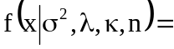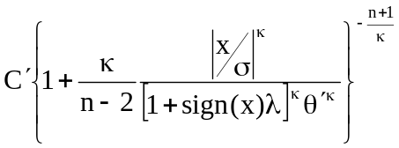 (A1)
where 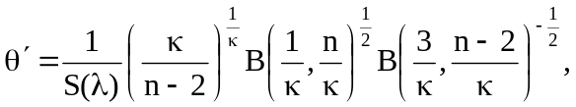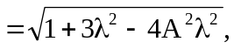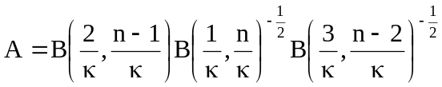,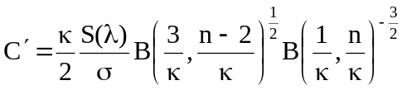
The expected value of is 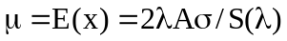 and the variance of is 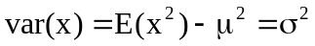. For simplicity, the derivation of parameters, 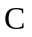, and , for the standardized SGT distribution is accomplished using the transformed random variable 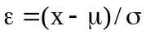, which has a mean of 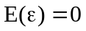 and a variance of 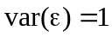. The random thus can be expressed as 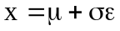 and let 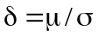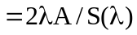, therefore 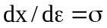,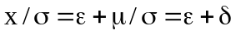
and 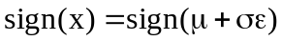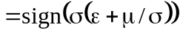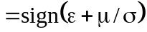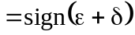.
Substitute the above expressions and equation (A1) into the following equation.
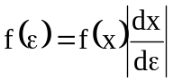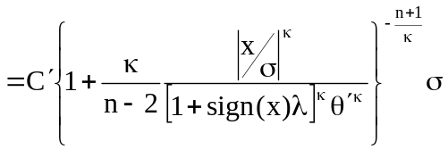
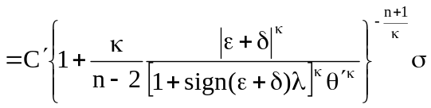
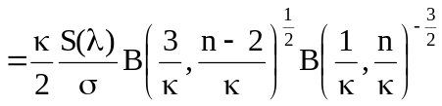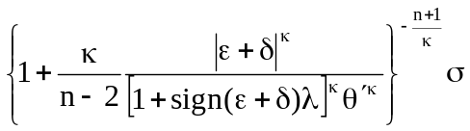
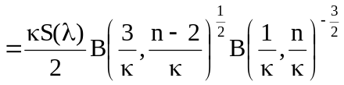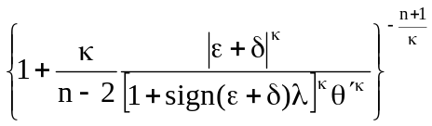 (A2)
where 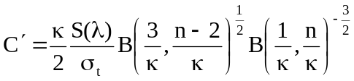,
Letting 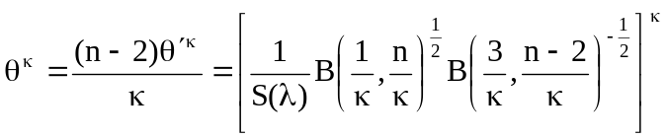 and substituting the expression into Eq. (A2) gives the equation which is the standardized SGT distribution.
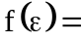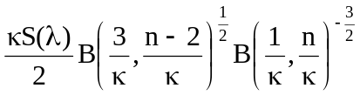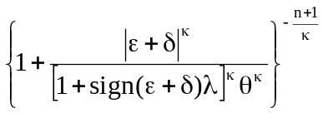
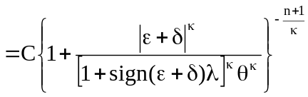 (A3)
where , , ,
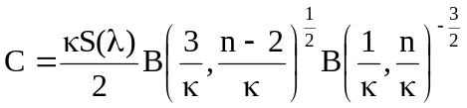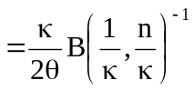

Particularly, the SGT distribution generates the student t distribution for and . Using the recurrence identities of Beta function, 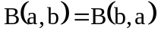
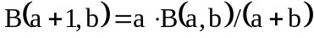, and 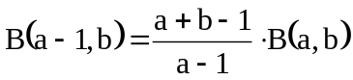, we can obtain 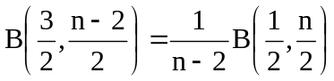.
Therefore 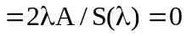,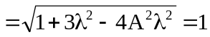 and
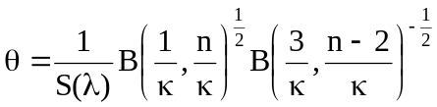
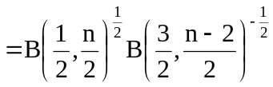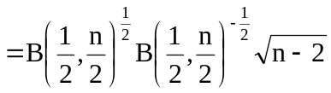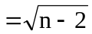
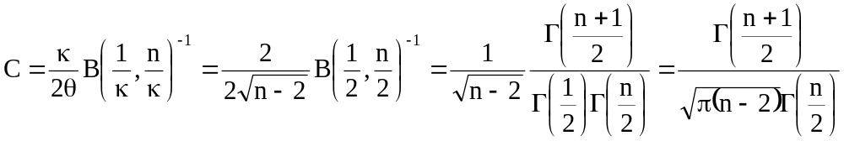
The probability density function for the standardized student t distribution thus can be represented as follows.
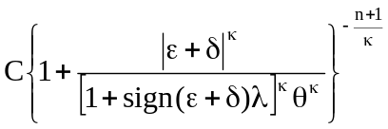
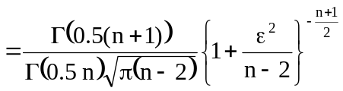 (A4)

Appendix B Approximation of the quantiles for SGT using composite trapezoid rule
The trapezoid rule is a way to approximately calculate the definite integral in mathematics or works by approximating the region under the graph of the function f(x) by a trapezoid and calculating its area. It follows that
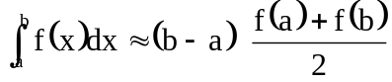 (B1)
To calculate this integral more accurately, one first splits the interval of integration 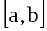 into n smaller subintervals (ie. 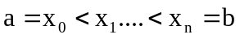), and then applies the trapezoid rule on each of them. We then obtain the composite trapezoid rule. That is, the composite trapezoid rule is a method for approximating a definite integral by evaluating the integrand at n points. For example, the composite trapezoid rule can be applied to a partition which is uniformly spaced, that is 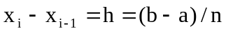 for all 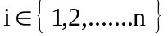. In this case, the formal rule is given
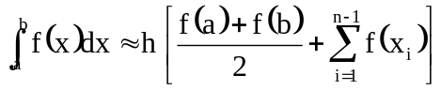 (B2)
where 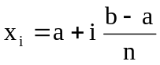, 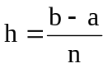 and thus 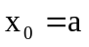and 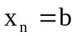. This can alternatively be written as:
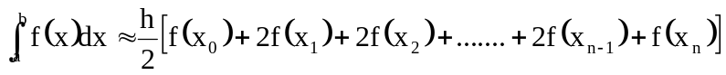
(B3)
Additionally, 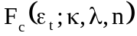 in Eqs. (5) denotes the left quantile at c for the standardized SGT distribution, and it must satisfy the definite integral
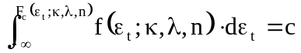. (B4)
By using the composite trapezoid rule, the algorithm of the left quantile at c 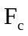is expressed as follows.
INPUT
a = the lower limit of integration (we replace with 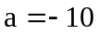 because the value of 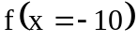 is enough small.)
h= the length of uniformly spaced partition ( we set h = 0.00001 to insure that the quantile is calculated precisely.)
n = the number of iteration (we set the value of n= 1000000 to insure that the upper limit of integration is zero)
c = the confidence
TOL = the tolerance ( we set TOL = 0.000001 to insure that the quantile is calculated precisely. )
Calculating the definite integral
SET a = -10
SET h = 0.00001
SET n = 1000000
SET sum = 0
DO i =1 ,n-1
SET 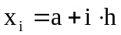
SET 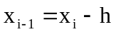
SET 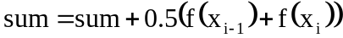
SET 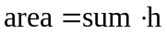
IF 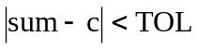 THEN
{
SET 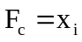
BREAK
}
END DO i
References
- Ané T (2006) An analysis of the flexibility of asymmetric power GARCH models. Computational Statistics & Data Analysis 51: 1293-1311.
- Angelidis T, Benos A, Degiannakis S (2004) The use of GARCH models in VaR estimation. Statistical Methodology 1:105-128.
- Baillie R, de Gennaro R (1990) Stock returns and volatility. Journal of Financial and Quantitative Analysis 25:203-14.
- Bali TG, Theodossiou P (2007) A conditional-SGT-VaR approach with alternative GARCH models. Annals of Operations Research 151:241-267.
- Billio M, Pelizon L (2000) Value-at-risk: a multivariate switching regime approach. Journal of Empirical Finance 7: 531-554.
- Bollerslev T (1986) Generalized autoregressive conditional heteroskedasticity. Journal of Econometrics 31: 307-327.
- Bollerslev T, Chou RY, Kroner KF (1992) ARCH modeling in finance: a review of the theory and empirical evidence. Journal of Econometrics 52: 5-59.
- Brooks C, Persand G (2003) The effect of asymmetries on stock index return Value-at-Risk estimates. Journal of Risk Finance 4: 29-42.
- Cheong CW (2008) Heavy-tailed value-at-risk analysis for Malaysian stock exchange. Physica A 387 :4285–4298.
- Engle RF, Manganelli S (2004) CAViaR: conditional autoregressive Value at Risk by Regression Quantiles. Journal of Business and Economic Statistics 22: 367-381.
- Fama E (1965) The behavior of stock market prices. Journal of Business 38 :34-105.
- Giot P, Laurent S (2003) Value-at-Risk for long and short trading positions. Journal of Applied Econometrics 18: 641-664.
- Huang YC, Lin BJ (2004) Value-at-Risk analysis for Taiwan stock index futures: fat tails and conditional asymmetries in return innovations. Review of Quantitative Finance and Accounting 22: 79-95.
- Jansen D, de Vries C (1991) On the frequency of large stock returns: putting booms and busts into perspective. Review of Economics and Statistics 73 :18-24.
- Jarque CM, Bera AK (1987) A test for normality of observations and regression residuals. International Statistics Review 55: 163-172.
- Jorion P (2000) Value at Risk: the new benchmark for managing financial risk. McGraw-Hill, New York.
- Kearns P, Pagan A (1997) Estimating the density tail index for financial times series. The Review of Economics and Statistics 79 :171-175.
- Kupiec P (1995) Techniques for verifying the accuracy of risk management models. The Journal of Derivatives 3 :73-84.
- Lee MC, Su JB, Liu HC (2008) Value-at-risk in US stock indices with skewed generalized error distribution. Applied Financial Economics Letters 4: 425-431.
- Lopez JA (1999) Methods for evaluating value-at-risk estimates. Federal Reserve Bank of San Francisco Economic Review 2: 3-17.
- Loretan M, Phillips P (1994) Testing the covariance structure of heavy-tailed time series. Journal of Empirical Finance 1: 211-248.
- Mandelbrot B (1963) The variation of certain speculative prices. Journal of Business 36: 394-419.
- So MKP, Yu PLH (2006) Empirical analysis of GARCH models in value at risk estimation. International Financial Markets, Institutions & Money :16 180-197.
- Tapia RA, Thompson JR (1978) Nonparametric Probability Density Estimation, Baltimore: Johns Hopkins University Press, section 2.5.
- Theodossiou P (1998) Financial data and the skewed generalized t distribution. Management Science 44 :1650-1661.

C.-F. Lee Finance and Economics, Rutgers Business School, Rutgers University, Rockafeller Road, Piscataway, NJ 08854-8054, USA e-mail: lee@business.rutgers.edu; Tel: (732) 445-3907 Graduate Institute of Finance, National Chiao Tung university, 1001 Ta Hsueh Road, Hsinchu 30010, Taiwan e-mail: cflee@mail.nctu.edu.tw J.-B. Su 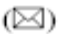 Department of Finance, China University of Science and Technology, 245, Yen-Chiu-Yuan (Academia) Road, Sec3, Nankang, Taipei 11581, Taiwan e-mail: jungbinsu@cc.cust.edu.tw ;Tel: 886-2-2786-4501 ext 16; Fax: 886-2-27864534. ∗
The general consensus regarding volatility forecasting in most of the literature is that generalized autoregressive conditional heteroskedasticity (GARCH) models. This study thus considers the applicability of the GARCH(1,1) model in modeling VaRs.
The standardized SGT distribution, which has zero mean and unit variance, was checked by Mathematica software and another analogous standardized SGT distribution was proposed by Bali and Theodossiou(2007).
The parameters are estimated by QMLE (Quasi maximum likelihood estimation; QMLE) and the BFGS optimization algorithm, using the econometric package of WinRATS 6.1.
LR_{N} for GARCH-T model follows the 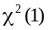 distribution with one degree of freedom. On the other hand, LR_{N} for GARCH-SGT model follows the 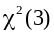 distribution with three degree of freedom.
LR_{T} for GARCH-SGT model follows the 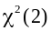 distribution with two degree of freedom. LR_{N} and LR_{T} are the log-likelihood ratio test statistics and are specified as follows: LR = −2(LR_{r} - LR_{u}) ~ 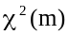, where LR_{r} and LR_{u} are , respectively, the maximum value of the log-likelihood values under the null hypothesis of the restricted model and the alternative hypothesis of the unrestricted model, and m is the number of the restricted parameters in the restricted model.

