暨南大学本科实验报告专用纸
课程名称 高级语言程序设计实验 成绩评定
实验项目名称 指针的使用 指导教师 张鑫源
实验项目编号 实验项目类型 实验地点 家
学生姓名 赖 智 聪 学号 2019051118
学院 智能科学与工程学院 专业 信息安全
实验时间 2020年5月27日下午～5月28日 下午 温度 ℃湿度
- 实验目的
练习编写程序，练习使用指针。
- 实验内容和要求

- 主要仪器设备
仪器：计算机
实验环境：Dev-C++ 5.11, windows 10
- 源程序

程序1：（使用int*作为参数）
#include <stdio.h>
#include <stdlib.h>
#include <time.h>
int row, col;
int main(void) {
int dis;
srand(time(NULL));
printf("Enter three numbers, the first is row, the second is column,\nthe third is represneted ordering rule(1 is from large to small, else it is from small to large):\n");
scanf("%d %d %d", &row, &col, &dis);
int a[row][col], * pa;
void sort1(int* p);
void sort2(int* p);
for (pa = *a; pa < *a + row * col; pa++) {
*pa = rand() % 100;
}
printf("The %d random numbers in a are:\n", row * col);
for (pa = *a; pa < *a + row * col; pa++) {
printf("%d ", *pa);
}
printf("\nAfter sorted, a is:\n");
if (dis == 1) {
sort1(*a);
}
else {
sort2(*a);
}
for (pa = *a; pa < *a + row * col; pa++) {
printf("%d ", *pa);
}
return 0;
}
void sort1(int* p) {
int t;
int* q, * r;
for (r = p + row * col - 1; r > p; r--) {
for (q = p; q < r; q++) {
if (*q < *(q + 1)) {
t = *q;
*q = *(q + 1);
*(q + 1) = t;
}
}
}
}
void sort2(int* p) {
int t;
int* q, * r;
for (r = p + row * col - 1; r > p; r--) {
for (q = p; q < r; q++) {
if (*q > * (q + 1)) {
t = *q;
*q = *(q + 1);
*(q + 1) = t;
}
}
}
}
程序2：（使用int（*）[]作为参数）
#include <stdio.h>
#include <stdlib.h>
#include <time.h>
int row, col;
int main(void) {
int dis;
srand(time(NULL));
printf("Enter three numbers, the first is row, the second is column,\nthe third is represneted ordering rule(1 is from large to small, else it is from small to large):\n");
scanf("%d %d %d", &row, &col, &dis);
int a[row][col], * pa;
void sort1(int(*p)[row]);
void sort2(int(*p)[row]);
for (pa = *a; pa < *a + row * col; pa++) {
*pa = rand() % 100;
}
printf("The %d random numbers in a are:\n", row * col);
for (pa = *a; pa < *a + row * col; pa++) {
printf("%d ", *pa);
}
if (dis == 1) {
sort1(a);
}
else {
sort2(a);
}
printf("\nAfter sorted, a is:\n");
for (pa = *a; pa < *a + row * col; pa++) {
printf("%d ", *pa);
}
return 0;
}
void sort1(int(*p)[row]) {
int* q, * r;
int t;
for (q = *p + row * col - 1; q > * p; q--) {
for (r = *p; r < q; r++) {
if (*r < *(r + 1)) {
t = *r;
*r = *(r + 1);
*(r + 1) = t;
}
}
}
}
void sort2(int(*p)[row]) {
int* q, * r;
int t;
for (q = *p + row * col - 1; q > * p; q--) {
for (r = *p; r < q; r++) {
if (*r > * (r + 1)) {
t = *r;
*r = *(r + 1);
*(r + 1) = t;
}
}
}
}
程序3：（使用int*[]作为参数）
#include <stdio.h>
#include <stdlib.h>
#include <time.h>
int row, col;
int main(void) {
int dis;
srand(time(NULL));
printf("Enter three numbers, the first is row, the second is column,\nthe third is represneted ordering rule(1 is from large to small, else it is from small to large):\n");
scanf("%d %d %d", &row, &col, &dis);
int a[row][col], * q;
int* pa[row * col], ** r;
void sort1(int* p[row * col]);
void sort2(int* p[row * col]);
r = pa;
for (q = *a; q < *a + row * col; q++) {
*q = rand() % 100;
*r = q;
r++;
}
printf("The %d random numbers in a are:\n", row * col);
for (q = *a; q < *a + row * col; q++) {
printf("%d ", *q);
}
if (dis == 1) {
sort1(pa);
}
else {
sort2(pa);
}
printf("\nAfter sorted, a is:\n");
for (q = *a; q < *a + row * col; q++) {
printf("%d ", *q);
}
return 0;
}
void sort1(int* p[row * col]) {
int* q, * r;
int t;
for (q = *p + row * col - 1; q > * p; q--) {
for (r = *p; r < q; r++) {
if (*r < *(r + 1)) {
t = *r;
*r = *(r + 1);
*(r + 1) = t;
}
}
}
}
void sort2(int* p[row * col]) {
int* q, * r;
int t;
for (q = *p + row * col - 1; q > * p; q--) {
for (r = *p; r < q; r++) {
if (*r > * (r + 1)) {
t = *r;
*r = *(r + 1);
*(r + 1) = t;
}
}
}
}
实验结果与分析

每个图从上到下依次对应1，2，3个程序。
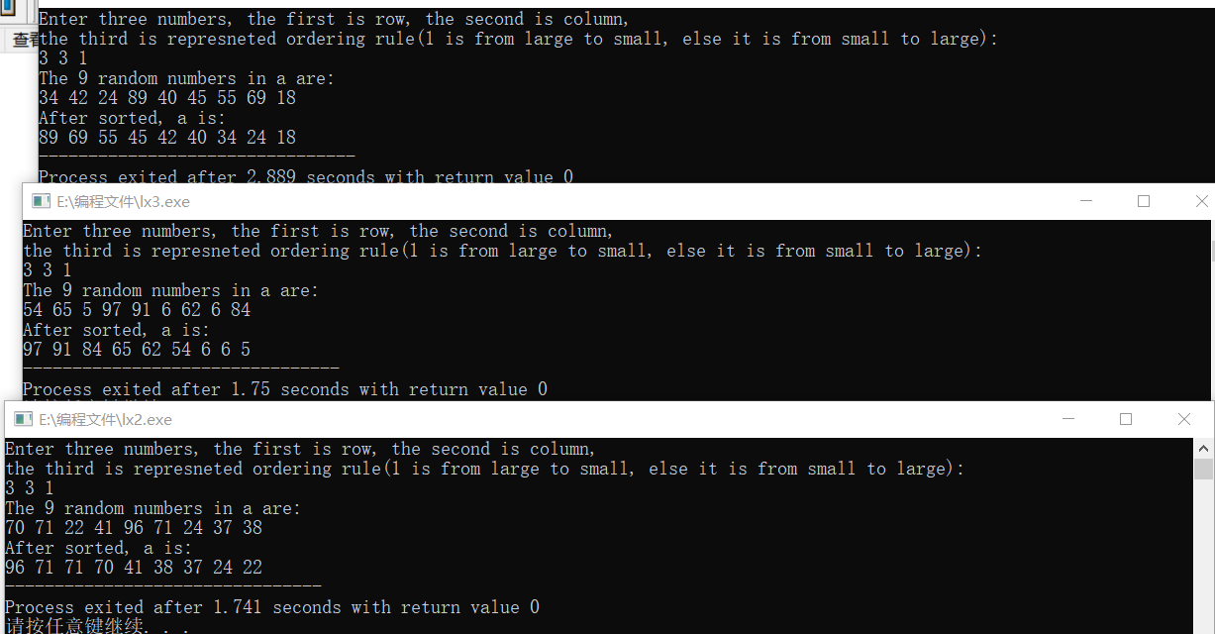
正确。

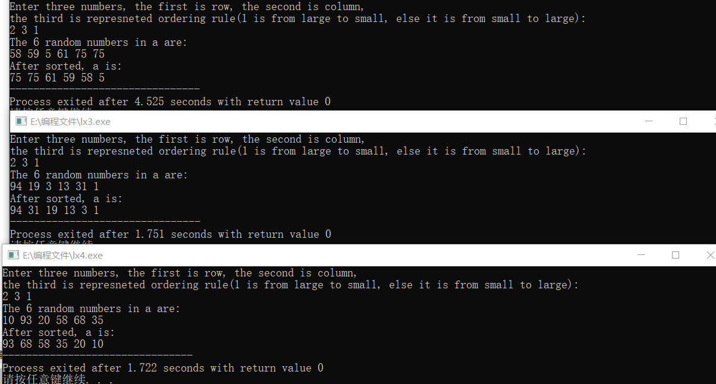
正确。

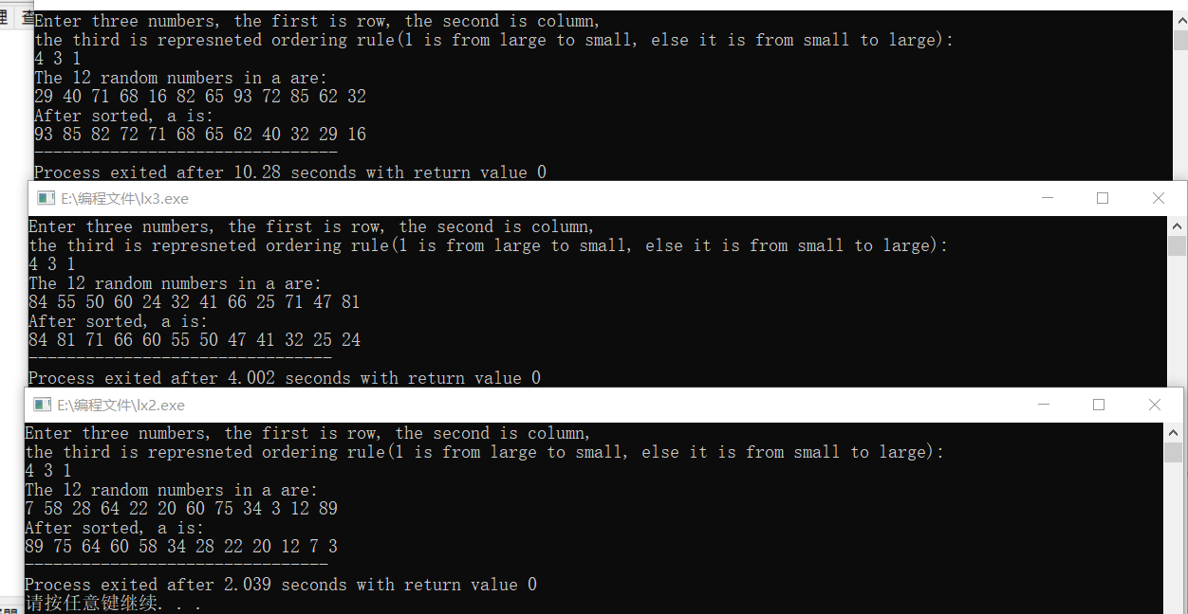
正确。

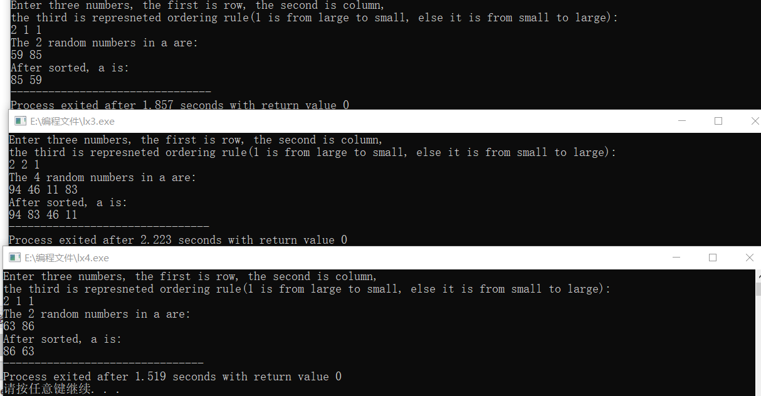
正确。

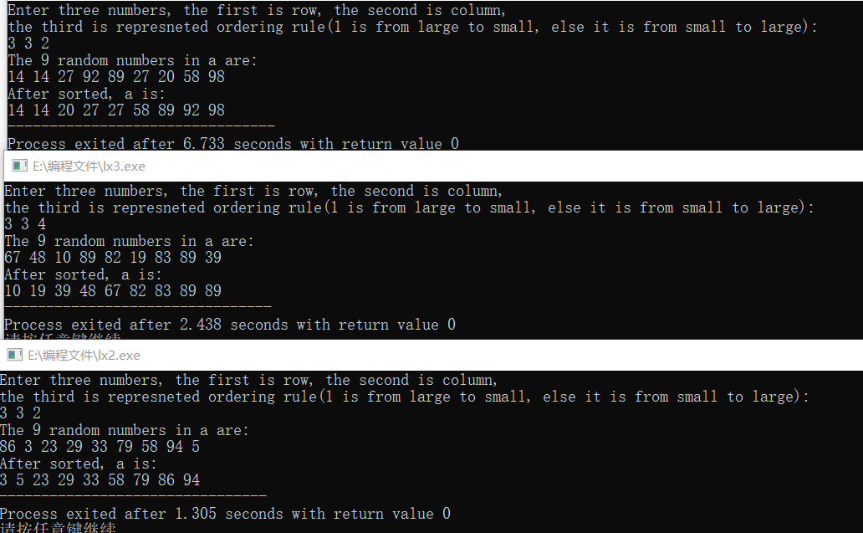
正确。

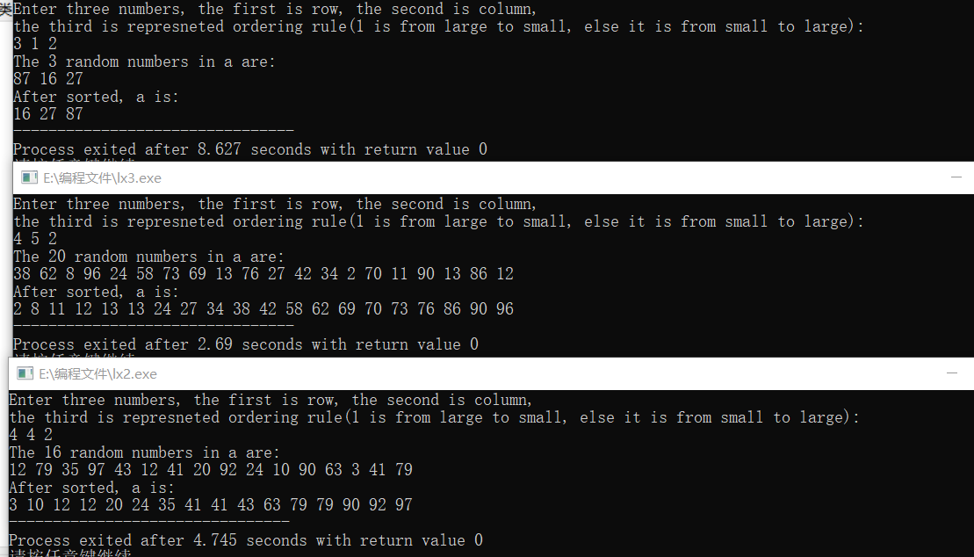
正确。
（程序没有对用户输入进行检查，默认用户输入格式正确，否则程序将运行异常）
在所测试的范围内得到的数据表明程序正确。

