Back to Projects Page! Home!
VARIABLE BANDWIDTH CW FILTER
BY N1HFX
As the sunspots return and DX propagation conditions to improve, the age old problem with QRM begins to show up on the amateur bands. Fortunately, help is at hand. The circuit in figure 1 is a variable bandwidth CW filter using two IC's. The first IC is a 741 op amp used as an active filter and the second IC is a 386 audio amp IC. This circuit connects to the headphone or speaker jack of your HF rig. The volume is controlled by the volume control of your rig and R2 controls the bandwidth. There is plenty of audio to drive a small speaker or a pair of headphones.
This circuit is different from other active filter circuits because it provides an audio boost which more than compensates for any attenuation in the filter stage. Many active filter circuits do not have enough volume to make them useful for most operators. Capacitor C5 and R7 were added to prevent the LM386 IC from oscillating which is common with this family of IC's. Use good construction practices since this circuit contains a very large amount of gain at the selected bandwidth. To make life easier, only Radio Shack parts were used for those who hate mail order.
The circuit in Figure 1 has been shown to be most effective for older radios and QRP sets which lack adequate filtering.
DE N1HFX
Parts List
R1 |  | 100K resistor (brown, black, yellow)
R2 |  | 10K potentiometer
R3 |  | 330 ohm resistor (orange, orange, brown)
R4 |  | 220K resistor (red, red, yellow)
R5,R6 |  | 47K resistor (yellow, violet, orange)
R7 |  | 10 ohm resistor (brown, black, black)
C1,C2,C3 |  | .01 microfarad capacitor (103 marking)
C4 |  | 10 microfarad electrolytic capacitor (observe polarity)
C5,C6 |  | 220 microfarad electrolytic capacitor (observe polarity)
IC1 |  | 741 op amp IC (use 8 pin socket)
IC2 |  | LM386 audio amp IC (use 8 pin socket)
Note: All resistors are ¼ watt 5% tolerance unless otherwise specified.
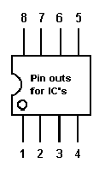
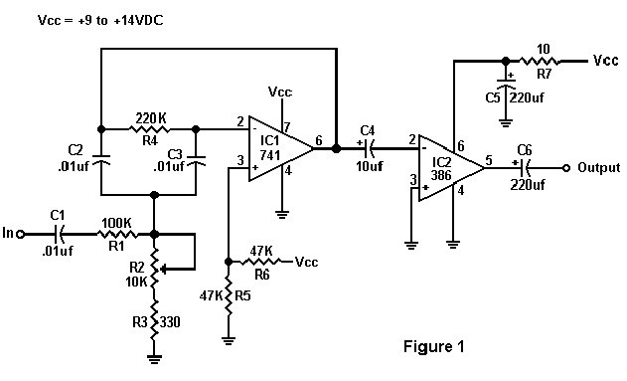
Back to Projects Page! Home!

