Causal Inference: *The Mixtape*

Zonghao Li

2021/2/22

library(haven)  
library(tidyverse)  
library(stargazer)  
library(estimatr)  
# This chapter only  
library(rdd)  
library(rdrobust)  
library(rddensity)  
lmb_data <- read_dta("E:/DOU/UT Au/Spring2021/Casual/lmb-data.dta") %>%  
 mutate(demvoteshare_c=demvoteshare-0.5)

## Original results based on ADA Scores -- Close Elections Sample

##   
## =========================================================  
## Model 1 Model 2 Model 3   
## ---------------------------------------------------------  
## (Intercept) 31.20 * 18.75 * 0.24 *   
## [28.57; 33.82] [17.09; 20.40] [0.20; 0.28]  
## lagdemocrat 21.28 * 0.48 *   
## [17.45; 25.11] [0.43; 0.54]  
## democrat 47.71 *   
## [45.04; 50.37]   
## ---------------------------------------------------------  
## R^2 0.12 0.58 0.23   
## Adj. R^2 0.11 0.58 0.23   
## Num. obs. 915 915 915   
## RMSE 29.52 20.38 0.44   
## N Clusters 915 915 915   
## =========================================================  
## * Null hypothesis value outside the confidence interval.

## Warning: Removed 1093 rows containing non-finite values (stat_smooth).

## Warning: Removed 15 rows containing missing values (geom_point).

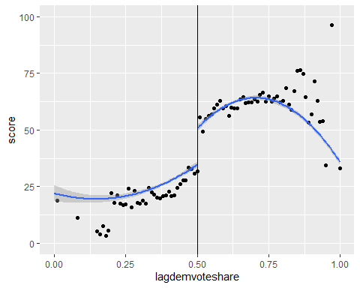

## `geom_smooth()` using formula 'y ~ x'

## Warning: Removed 1093 rows containing non-finite values (stat_smooth).  
  
## Warning: Removed 15 rows containing missing values (geom_point).

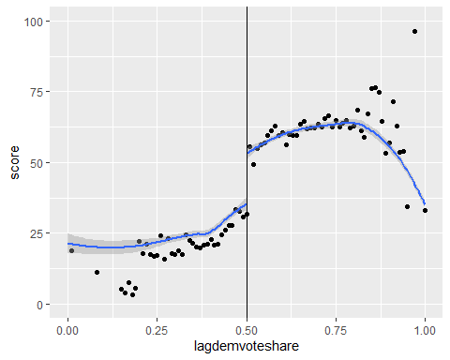

## `geom_smooth()` using formula 'y ~ x'

## Warning: Removed 1093 rows containing non-finite values (stat_smooth).  
  
## Warning: Removed 15 rows containing missing values (geom_point).

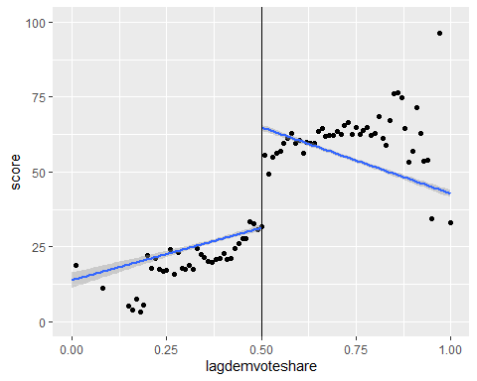

## `geom_smooth()` using method = 'gam' and formula 'y ~ s(x, bs = "cs")'  
## `geom_smooth()` using method = 'gam' and formula 'y ~ s(x, bs = "cs")'

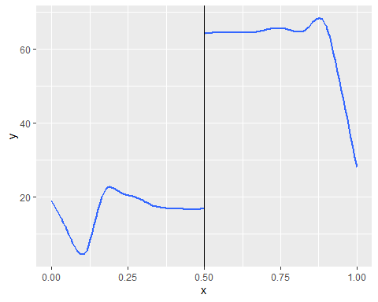

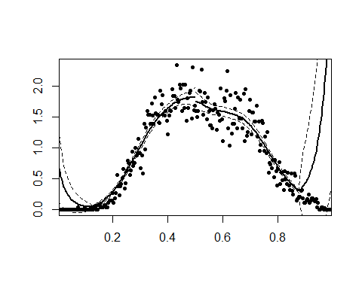

## [1] 0.5925909

## Warning in rddensity(lmb_data$demvoteshare, c = 0.5): 11 missing observations are ignored.

## Warning in rdplotdensity(density, lmb_data$demvoteshare): 11 missing observations are ignored.

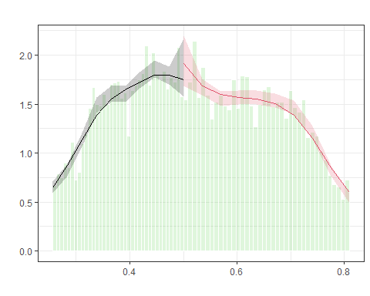

## $Estl  
## Call: lpdensity  
##   
## Sample size 5480  
## Polynomial order for point estimation (p=) 2  
## Order of derivative estimated (v=) 1  
## Polynomial order for confidence interval (q=) 3  
## Kernel function triangular  
## Scaling factor 0.40357984678845  
## Bandwidth method user provided  
##   
## Use summary(...) to show estimates.  
##   
## $Estr  
## Call: lpdensity  
##   
## Sample size 8097  
## Polynomial order for point estimation (p=) 2  
## Order of derivative estimated (v=) 1  
## Polynomial order for confidence interval (q=) 3  
## Kernel function triangular  
## Scaling factor 0.596346493812611  
## Bandwidth method user provided  
##   
## Use summary(...) to show estimates.  
##   
## $Estplot

