

|  |
| --- |
| **LEARNING OBJECTIVES: MTL objectives include activities and competencies that…** |
| Are meaning for you and align your learning goals with your team. |
| Develop systems thinking skills to help you see how several things fit together, and understand causes hard to see without data and modeling resources. |
| Make VA data, initiatives, and standards transparent to you. |
| Empower you to realize ongoing improvements in team quality of care and team quality of work life. |



**Data UI Cheat Sheet**

**WORKFLOW**

**Open data**

Open most recent data_ui file using workbook not web app

**Select clinic grids**

Specify grids w clinic names, location, etc. Click on the arrow in column B to add to column A

**3**

**2**

**1**

**Save data file**

Add team name to file name (system will auto-populate station # & date)

1) data_ui folder or

2) team_data_sim_ui folder

**5**

**Pull data**

1) “Get Patient-level Data” or

2) Pick a model and “Create Team Data table for Sim UI”

**4**

**Open mtl.how/data**

Use Internet Explorer. Select VISN and facility.



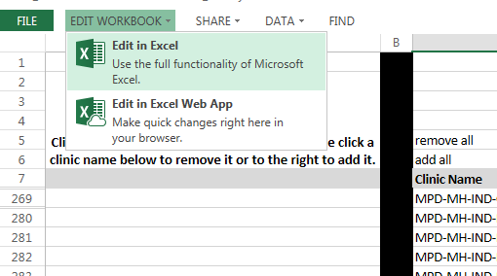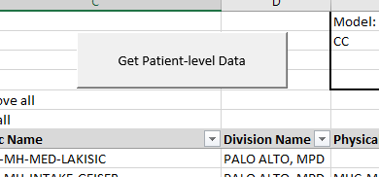

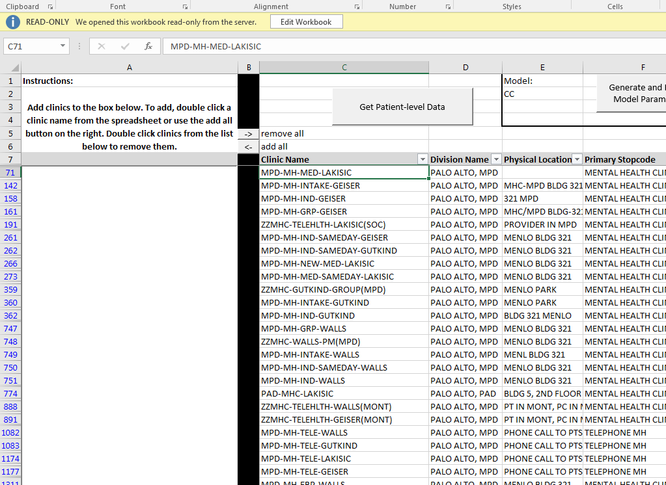

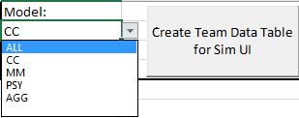

**NOTE: This is PHI.** Save back to **SharePoint or places for PHI.** If attaching to an email, ***encrypt***.

**!**

**TIME-SAVERS**

1) Explore clinic trends on Splash Page | 2) Use the most recent file | 3) Save a file w/ preferred filters.

**DEFINITIONS**

**ACRONYMS**

**TROUBLESHOOTING**

**AGG:** Aggregate

**CC:** Care Coordination

**Diag:** Diagnostic data

**Data:** Sortable report of data

**Enc:** Encounter types of visits

**HF:** Health Factors data related to visits

**Meas:** Measures or flag names

**MM:** Medication Management

**MTL:** Modeling to Learn

**PSD:** Participatory System Dynamics

**PSY:** Psychotherapy

**UI:** User Interface

**Viz:** Visualization of trends

0

**Hidden clinic grids?** Widen Column B to the right

**Don’t see data?** Clear filters next to the heading of each column

**PivotTable refresh error?** Click refresh from Data or Analyze tabs at top

**Add clinic error?** Make sure to click on the Column B to move chosen clinic names to the left in Column A

**Other questions?**

Check out resources at mtl.how

Email - lindsey.zimmerman@va.gov; stacey.park2@va.gov

Skype - Zimmerman, Lindsey E.; Park, Stacey D.

**Create Team Data Table for Sim UI:** Shows parameters for each model based on team data

**Get Patient-level Data:** Shows data derived from charting

**Restricted Patients:** Patient identifiers asterisked out with last initial and last 4 of SSN in Column H

**Deactivated Clinics:** Clinic names start with “ZZ”

**“ZZ” Clinic Names:** Deactivated clinics

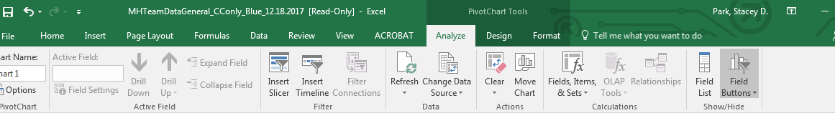







Modeling to Learn (MTL) is an ongoing quality improvement project by VA Team Participatory System Dynamics Info: [lindsey.zimmerman@va.gov](mailto:lindsey.zimmerman@va.gov); [stacey.park2@va.gov](mailto:stacey.park2@va.gov) Updated 2018/09/03