

|  |
| --- |
| **LEARNING OBJECTIVES: MTL objectives include activities and competencies that…** |
| Are meaning for you and align your learning goals with your team. |
| Develop systems thinking skills to help you see how several things fit together, and understand causes hard to see without data and modeling resources. |
| Make VA data, initiatives, and standards transparent to you. |
| Empower you to realize ongoing improvements in team quality of care and team quality of work life. |



**Sim UI Cheat Sheet**

**PLAY SCREEN**

**HOME SCREEN**

**LOGIN**

**../Desktop/Screen%20Shot%202018-09-05%20at%207.53.04%20AM.png**

**Open mtl.how/sim and login**

Use Chrome. Username (VA email) and password all lowercase.

**1**

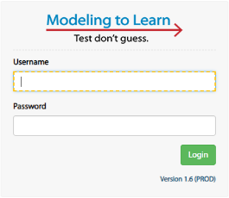

***Output Charts:*** View ≤ 6 output charts of variables overtime (variables selected from Expanded Outputs tile)

***Join Current Session:*** Play

- or -

***Start a New Session:*** Select model, Select team data file, Click play

../Desktop/Screen%20Shot%202018-09-05%20at%209.41.38%20AM.png

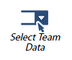

***Select Previous Experiment:***Select a previous run to automatically populate experimental values to those from that previous run

***Experimental Sliders:*** Change sliders from basecase (BC) to test a hypothesis



***Delete*** old files that aren’t needed

***Rename*** to be meaningful

***Add*** new files. Copy + Paste name from Data UI (include .xlsx)

*Can sort by Name; Date/Time

**2**

**Select World**

Individual world for learning on your own. Team world for experimenting as a team.

**EXPANDED OUTPUTS TILE**

***Q|H|F|D:*** Fill out the question, hypothesis, findings, and decisions for each run as you run through it

***Control Panel:*** Shows experimental values for current run.

***Current Experiment Values:*** Shows experimental values chosen for variables in current run

***Results Dashboard:*** Choose ≤ 6 variables to explore in output charts

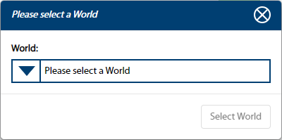

***Delete*** old runs that aren’t needed

***Rename*** runs to be meaningful later

***Export*** data from ≤ 10 runs in an Excel file

*Can sort by Name; Type; Date/Time

../Desktop/Screen%20Shot%202018-09-05%20at%2010.49.27%20AM.png

***Saving the Run:***Choose items changed in run. “Add” to populate the Experiment Name. Date will automatically append once saved.

**TROUBLESHOOTING**

**Data not loading?** Make sure the .xlsx extension is included

**Questions on the variables?** Click on the “i” icon for more information

**Rendering issues?** Log-off completely and log back in

**Other questions?** Check out resources at mtl.how

Email - lindsey.zimmerman@va.gov; stacey.park2@va.gov

Skype - Zimmerman, Lindsey E.; Park, Stacey D.

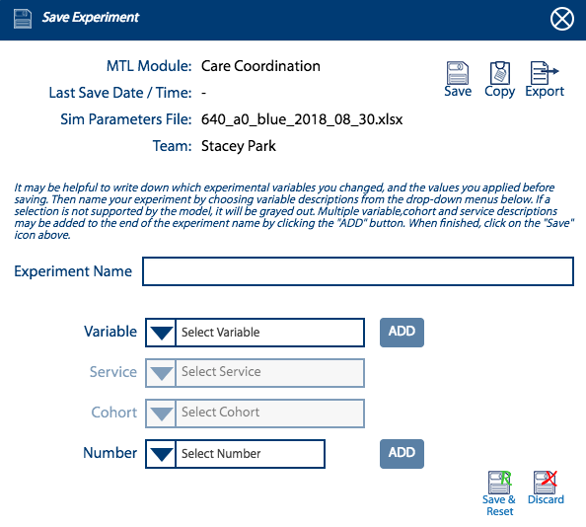

***Make sure to log off once you’re done!***



[](mailto:Lindsey.Zimmerman@va.gov;%20Stacey.Park2@va.gov)

Modeling to Learn (MTL) is an ongoing quality improvement project by VA Team Participatory System Dynamics Info: [lindsey.zimmerman@va.gov](mailto:lindsey.zimmerman@va.gov); [stacey.park2@va.gov](mailto:stacey.park2@va.gov) Updated 2018/09/05