

信息科学与工程学院

XXX－XXX学年第二学期

课程实验报告

课程名称： 数据结构与算法导论
实验名称： 学生信息管理系统

专 业 班 级 通信二班
学 生 学 号 202400120045
学 生 姓 名 刘哲旭
实 验 时 间 2026年5月27日
一、实验目的
1.加深对抽象数据类型 ADT 栈和队列的理解
二、实验原理
单链表：用于保存所有学生信息，每个学生结点保存一个学生的基本信息和成绩链表。
成绩链表：每个学生可以有多门课程成绩，因此使用链表保存课程名和分数。
哈希表：用学号作为关键字，提高按学号查找学生的效率。
栈：用于保存被删除学生的信息，实现“撤销删除”功能。
快速排序：按照学生平均成绩从高到低排序显示。
模块化设计：main.c 负责菜单调度，student.c 负责学生信息管理，input.c 负责输入校验，academic.c 负责年级、学院、专业、班级选择

三、实验内容
本系统主要实现以下功能：
- 添加学生信息，包括学号、姓名、年龄、性别、年级、学院、专业、班级、宿舍、手机号和课程成绩。
- 显示所有学生信息。
- 按学号查找学生。
- 修改学生基本信息，支持按学号或姓名定位学生。
- 删除学生信息，并将删除记录压入撤销栈。
- 为已有学生添加课程成绩。
- 按平均成绩排序显示。
- 统计学生总人数、全体平均成绩、最高平均分和最低平均分。
- 撤销上一次删除操作。
- 退出系统并释放动态内存。

四、实验源程序
main.c:程序入口文件。
负责显示主菜单、读取用户选择，并调用对应功能，比如添加学生、显示学生、查找学生、修改学生、删除学生、排序、统计、撤销删除、退出系统。
#include <stdio.h>
#include "input.h"
#include "student.h"

void menu()
{
printf("\n=====================================\n");
printf(" 学生信息管理系统\n");
printf("=====================================\n");
printf("1. 添加学生信息\n");
printf("2. 显示所有学生信息\n");
printf("3. 按学号查找学生\n");
printf("4. 修改学生基本信息\n");
printf("5. 删除学生信息\n");
printf("6. 为已有学生添加课程成绩\n");
printf("7. 按平均成绩排序显示\n");
printf("8. 成绩统计\n");
printf("9. 撤销上一次删除\n");
printf("0. 退出系统\n");
printf("=====================================\n");
}

int main()
{
int choice;

while (1)
{
menu();
choice = readInt("请输入你的选择：");

switch (choice)
{
case 1:
addStudent();
break;
case 2:
showStudents();
break;
case 3:
searchStudent();
break;
case 4:
modifyStudent();
break;
case 5:
deleteStudent();
break;
case 6:
addGradeForStudent();
break;
case 7:
sortByAverageScore();
break;
case 8:
statistics();
break;
case 9:
undoDelete();
break;
case 0:
freeAllStudents();
freeHashTable();
freeUndoStack();
printf("程序已退出，相关内存已释放。\n");
return 0;
default:
printf("输入有误，请重新选择！\n");
}
}
}
student.c：学生管理核心实现文件。
负责真正处理学生数据，包括新增学生、显示学生、按学号查找、修改基本信息、删除学生、撤销删除、添加课程成绩、按平均成绩排序、成绩统计、释放内存等。
它主要用到了学生链表、成绩链表、哈希表和撤销栈。
#include <stdio.h>
#include <stdlib.h>
#include <string.h>
#include "common.h"
#include "input.h"
#include "academic.h"
#include "student.h"

static StudentNode *studentHead = NULL;
static HashNode *hashTable[HASH_SIZE] = {NULL};
static UndoNode *undoTop = NULL;
static int studentCount = 0;

static GradeNode *createGradeNode(char subject[], float score);
static void inputGrades(Student *s);
static void showOneStudent(Student s);
static float getAverageScore(Student s);

static unsigned int hashFunc(char id[]);
static void insertHash(char id[], StudentNode *ptr);
static void removeHash(char id[]);
static StudentNode *searchHash(char id[]);
static StudentNode *selectStudentForModify();
static StudentNode *selectStudentByIdForModify();
static StudentNode *selectStudentByNameForModify();
static int inputModifiedBasicInfo(Student *s);
static void showModifyFieldMenu();
static int modifyOneBasicField(Student *s, int choice);
static void copyBasicInfo(Student *dest, Student src);

static GradeNode *copyGrades(GradeNode *head);
static Student copyStudent(Student s);
static void pushUndo(Student s);
static void freeGrades(GradeNode *head);
static void freeStudent(Student s);

static void quickSort(StudentNode *arr[], int left, int right);

void addStudent()
{
StudentNode *newNode = (StudentNode *)malloc(sizeof(StudentNode));

if (newNode == NULL)
{
printf("内存申请失败！\n");
return;
}

newNode->data.grades = NULL;
newNode->next = NULL;

readStudentId(newNode->data.id);

if (searchHash(newNode->data.id) != NULL)
{
printf("该学号已存在，添加失败！\n");
free(newNode);
return;
}

readName(newNode->data.name);

newNode->data.age = readIntRange("请输入年龄：", 1, 100);

chooseGender(newNode->data.gender);

chooseAcademicInfo(&newNode->data);

readDorm(newNode->data.dorm);

readPhone(newNode->data.phone);

printf("\n开始录入课程成绩。\n");
inputGrades(&newNode->data);

newNode->next = studentHead;
studentHead = newNode;
studentCount++;

insertHash(newNode->data.id, newNode);

printf("学生信息添加成功！\n");
}

static void inputGrades(Student *s)
{
char subject[SUBJECT_LEN];
float score;

while (1)
{
readString("请输入科目名称，输入 0 结束成绩录入：", subject, SUBJECT_LEN);

if (strcmp(subject, "0") == 0)
{
printf("成绩录入结束。\n");
break;
}

char prompt[100];
sprintf(prompt, "请输入 %s 的成绩：", subject);

score = readFloatRange(prompt, 0, 100);

GradeNode *newGrade = createGradeNode(subject, score);

if (newGrade == NULL)
{
printf("成绩结点创建失败！\n");
return;
}

newGrade->next = s->grades;
s->grades = newGrade;

printf("成绩录入成功！\n");
}
}

static GradeNode *createGradeNode(char subject[], float score)
{
GradeNode *node = (GradeNode *)malloc(sizeof(GradeNode));

if (node == NULL)
{
return NULL;
}

strcpy(node->subject, subject);
node->score = score;
node->next = NULL;

return node;
}

void showStudents()
{
if (studentHead == NULL)
{
printf("当前没有学生信息。\n");
return;
}

StudentNode *p = studentHead;
int index = 1;

while (p != NULL)
{
printf("\n---------- 第 %d 个学生 ----------\n", index);
showOneStudent(p->data);
p = p->next;
index++;
}
}

static void showOneStudent(Student s)
{
printf("学号：%s\n", s.id);
printf("姓名：%s\n", s.name);
printf("年龄：%d\n", s.age);
printf("性别：%s\n", s.gender);
printf("年级：%s\n", s.gradeYear);
printf("学院：%s\n", s.college);
printf("专业：%s\n", s.major);
printf("班级：%s\n", s.className);
printf("宿舍门牌号：%s\n", s.dorm);
printf("手机号：%s\n", s.phone);

if (s.grades == NULL)
{
printf("课程成绩：暂无\n");
}
else
{
printf("课程成绩：\n");

GradeNode *g = s.grades;
while (g != NULL)
{
printf(" %s：%.2f\n", g->subject, g->score);
g = g->next;
}

printf("平均成绩：%.2f\n", getAverageScore(s));
}
}

void searchStudent()
{
char id[ID_LEN];

readStudentId(id);

StudentNode *result = searchHash(id);

if (result == NULL)
{
printf("未找到该学生信息。\n");
}
else
{
printf("查找成功！\n");
showOneStudent(result->data);
}
}

static StudentNode *selectStudentByIdForModify()
{
char id[100];

while (1)
{
printf("请输入要修改学生的学号（12位数字，输入 0 取消）：");
readLine(id, sizeof(id));

if (strcmp(id, "0") == 0)
{
return NULL;
}

if (strlen(id) != 12 || !isAllDigits(id))
{
printf("输入错误！学号必须是 12 位数字。\n");
continue;
}

StudentNode *target = searchHash(id);

if (target == NULL)
{
printf("未找到该学生，无法修改！\n");
}

return target;
}
}

static StudentNode *selectStudentByNameForModify()
{
char name[NAME_LEN];
char temp[100];
int count = 0;

while (1)
{
printf("请输入要修改学生的姓名（输入 0 取消）：");
readLine(temp, sizeof(temp));

if (strcmp(temp, "0") == 0)
{
return NULL;
}

if (!isValidName(temp))
{
printf("输入错误！姓名不能为空，且不能包含数字。\n");
continue;
}

strncpy(name, temp, NAME_LEN - 1);
name[NAME_LEN - 1] = '\0';
break;
}

StudentNode *p = studentHead;

while (p != NULL)
{
if (strcmp(p->data.name, name) == 0)
{
count++;
}

p = p->next;
}

if (count == 0)
{
printf("未找到该姓名对应的学生，无法修改！\n");
return NULL;
}

StudentNode **matches = (StudentNode **)malloc(sizeof(StudentNode *) * count);

if (matches == NULL)
{
printf("内存申请失败，无法按姓名查找！\n");
return NULL;
}

p = studentHead;
int index = 0;

while (p != NULL)
{
if (strcmp(p->data.name, name) == 0)
{
matches[index++] = p;
}

p = p->next;
}

if (count == 1)
{
StudentNode *target = matches[0];
printf("已找到学生：%s，学号：%s。\n", target->data.name, target->data.id);
free(matches);
return target;
}

printf("找到多个同名学生，请选择要修改的记录：\n");

for (int i = 0; i < count; i++)
{
Student *student = &matches[i]->data;

printf("%d. 学号：%s，姓名：%s，学院：%s，专业：%s，班级：%s\n",
i + 1,
student->id,
student->name,
student->college,
student->major,
student->className);
}

int choice = readIntRange("请选择编号（输入 0 取消）：", 0, count);

if (choice == 0)
{
free(matches);
return NULL;
}

StudentNode *target = matches[choice - 1];
free(matches);
return target;
}

static StudentNode *selectStudentForModify()
{
int choice;

printf("\n请选择查找方式：\n");
printf("1. 按学号查找\n");
printf("2. 按姓名查找\n");
printf("0. 取消修改\n");

choice = readIntRange("请输入选项：", 0, 2);

if (choice == 0)
{
return NULL;
}
else if (choice == 1)
{
return selectStudentByIdForModify();
}

return selectStudentByNameForModify();
}

static int inputModifiedBasicInfo(Student *s)
{
if (!readNameCancelable(s->name))
{
return 0;
}

s->age = readIntRange("请输入新的年龄（输入 0 取消）：", 0, 100);

if (s->age == 0)
{
return 0;
}

if (!chooseGenderCancelable(s->gender))
{
return 0;
}

if (!chooseAcademicInfoCancelable(s))
{
return 0;
}

if (!readDormCancelable(s->dorm))
{
return 0;
}

if (!readPhoneCancelable(s->phone))
{
return 0;
}

return 1;
}

static void showModifyFieldMenu()
{
printf("\n请选择要修改的信息：\n");
printf("1. 姓名\n");
printf("2. 年龄\n");
printf("3. 性别\n");
printf("4. 年级、学院、专业、班级\n");
printf("5. 宿舍门牌号\n");
printf("6. 手机号\n");
printf("7. 修改全部基本信息\n");
printf("8. 保存当前全部修改\n");
printf("0. 取消并退出修改\n");
}

static int modifyOneBasicField(Student *s, int choice)
{
Student temp = *s;

switch (choice)
{
case 1:
if (!readNameCancelable(temp.name))
{
return 0;
}
strcpy(s->name, temp.name);
break;
case 2:
temp.age = readIntRange("请输入新的年龄（输入 0 取消）：", 0, 100);

if (temp.age == 0)
{
return 0;
}

s->age = temp.age;
break;
case 3:
if (!chooseGenderCancelable(temp.gender))
{
return 0;
}
strcpy(s->gender, temp.gender);
break;
case 4:
if (!chooseAcademicInfoCancelable(&temp))
{
return 0;
}
strcpy(s->gradeYear, temp.gradeYear);
strcpy(s->college, temp.college);
strcpy(s->major, temp.major);
strcpy(s->className, temp.className);
break;
case 5:
if (!readDormCancelable(temp.dorm))
{
return 0;
}
strcpy(s->dorm, temp.dorm);
break;
case 6:
if (!readPhoneCancelable(temp.phone))
{
return 0;
}
strcpy(s->phone, temp.phone);
break;
case 7:
if (!inputModifiedBasicInfo(&temp))
{
return 0;
}
copyBasicInfo(s, temp);
break;
default:
return 0;
}

return 1;
}
static void copyBasicInfo(Student *dest, Student src)
{
strcpy(dest->name, src.name);
dest->age = src.age;
strcpy(dest->gender, src.gender);
strcpy(dest->gradeYear, src.gradeYear);
strcpy(dest->college, src.college);
strcpy(dest->major, src.major);
strcpy(dest->className, src.className);
strcpy(dest->dorm, src.dorm);
strcpy(dest->phone, src.phone);
}

void modifyStudent()
{
StudentNode *target = selectStudentForModify();
Student temp;
int choice;

if (target == NULL)
{
printf("已取消修改学生基本信息。\n");
return;
}

temp = target->data;

while (1)
{
printf("当前待保存的学生信息如下：\n");
showOneStudent(temp);
showModifyFieldMenu();

choice = readIntRange("请输入选项：", 0, 8);

if (choice == 0)
{
printf("已取消修改学生基本信息，原信息保持不变。\n");
return;
}

if (choice == 8)
{
copyBasicInfo(&target->data, temp);
printf("学生基本信息修改已保存！\n");
return;
}

if (modifyOneBasicField(&temp, choice))
{
printf("本项信息已修改，按 8 保存后才会生效。\n");
}
else
{
printf("已取消本项修改，当前待保存信息保持不变。\n");
}
}
}
void deleteStudent()
{
char id[ID_LEN];

readStudentId(id);

StudentNode *cur = studentHead;
StudentNode *pre = NULL;

while (cur != NULL && strcmp(cur->data.id, id) != 0)
{
pre = cur;
cur = cur->next;
}

if (cur == NULL)
{
printf("未找到该学生，无法删除！\n");
return;
}

pushUndo(cur->data);

if (pre == NULL)
{
studentHead = cur->next;
}
else
{
pre->next = cur->next;
}

removeHash(id);
freeGrades(cur->data.grades);
free(cur);
studentCount--;

printf("学生信息删除成功！可以通过菜单 9 撤销本次删除。\n");
}

void addGradeForStudent()
{
char id[ID_LEN];

readStudentId(id);

StudentNode *target = searchHash(id);

if (target == NULL)
{
printf("未找到该学生，无法添加成绩！\n");
return;
}

printf("正在为学生 %s 添加课程成绩。\n", target->data.name);
inputGrades(&target->data);
}

void sortByAverageScore()
{
if (studentCount == 0)
{
printf("当前没有学生信息，无法排序。\n");
return;
}

StudentNode **arr = (StudentNode **)malloc(sizeof(StudentNode *) * studentCount);

if (arr == NULL)
{
printf("排序数组申请失败！\n");
return;
}

StudentNode *p = studentHead;
int i = 0;

while (p != NULL)
{
arr[i++] = p;
p = p->next;
}

quickSort(arr, 0, studentCount - 1);

printf("\n按平均成绩从高到低排序结果：\n");

for (i = 0; i < studentCount; i++)
{
printf("\n第 %d 名：\n", i + 1);
showOneStudent(arr[i]->data);
}

free(arr);
}

static void quickSort(StudentNode *arr[], int left, int right)
{
if (left >= right)
{
return;
}

int i = left;
int j = right;
float pivot = getAverageScore(arr[(left + right) / 2]->data);

while (i <= j)
{
while (getAverageScore(arr[i]->data) > pivot)
{
i++;
}

while (getAverageScore(arr[j]->data) < pivot)
{
j--;
}

if (i <= j)
{
StudentNode *temp = arr[i];
arr[i] = arr[j];
arr[j] = temp;
i++;
j--;
}
}

if (left < j)
{
quickSort(arr, left, j);
}

if (i < right)
{
quickSort(arr, i, right);
}
}

void statistics()
{
if (studentHead == NULL)
{
printf("当前没有学生信息，无法统计。\n");
return;
}

StudentNode *p = studentHead;
float sum = 0;
float maxAvg = getAverageScore(p->data);
float minAvg = getAverageScore(p->data);
StudentNode *maxNode = p;
StudentNode *minNode = p;

while (p != NULL)
{
float avg = getAverageScore(p->data);
sum += avg;

if (avg > maxAvg)
{
maxAvg = avg;
maxNode = p;
}

if (avg < minAvg)
{
minAvg = avg;
minNode = p;
}

p = p->next;
}

printf("学生总人数：%d\n", studentCount);
printf("全体学生平均成绩：%.2f\n", sum / studentCount);

printf("平均成绩最高：%s，学号：%s，平均分：%.2f\n",
maxNode->data.name,
maxNode->data.id,
maxAvg);

printf("平均成绩最低：%s，学号：%s，平均分：%.2f\n",
minNode->data.name,
minNode->data.id,
minAvg);
}

void undoDelete()
{
if (undoTop == NULL)
{
printf("当前没有可撤销的删除操作。\n");
return;
}

if (searchHash(undoTop->data.id) != NULL)
{
printf("该学号当前已存在，无法恢复。\n");
return;
}

UndoNode *temp = undoTop;
undoTop = undoTop->next;

StudentNode *newNode = (StudentNode *)malloc(sizeof(StudentNode));

if (newNode == NULL)
{
printf("恢复失败，内存不足！\n");
freeStudent(temp->data);
free(temp);
return;
}

newNode->data = temp->data;
newNode->next = studentHead;
studentHead = newNode;
studentCount++;

insertHash(newNode->data.id, newNode);

free(temp);

printf("撤销删除成功，学生信息已恢复。\n");
}

static float getAverageScore(Student s)
{
GradeNode *p = s.grades;
float sum = 0;
int count = 0;

while (p != NULL)
{
sum += p->score;
count++;
p = p->next;
}

if (count == 0)
{
return 0;
}

return sum / count;
}

static unsigned int hashFunc(char id[])
{
unsigned int hash = 0;

for (int i = 0; id[i] != '\0'; i++)
{
hash = hash * 31 + id[i];
}

return hash % HASH_SIZE;
}

static void insertHash(char id[], StudentNode *ptr)
{
unsigned int index = hashFunc(id);

HashNode *node = (HashNode *)malloc(sizeof(HashNode));

if (node == NULL)
{
printf("哈希表结点申请失败！\n");
return;
}

strcpy(node->id, id);
node->studentPtr = ptr;
node->next = hashTable[index];
hashTable[index] = node;
}

static void removeHash(char id[])
{
unsigned int index = hashFunc(id);

HashNode *cur = hashTable[index];
HashNode *pre = NULL;

while (cur != NULL)
{
if (strcmp(cur->id, id) == 0)
{
if (pre == NULL)
{
hashTable[index] = cur->next;
}
else
{
pre->next = cur->next;
}

free(cur);
return;
}

pre = cur;
cur = cur->next;
}
}

static StudentNode *searchHash(char id[])
{
unsigned int index = hashFunc(id);

HashNode *p = hashTable[index];

while (p != NULL)
{
if (strcmp(p->id, id) == 0)
{
return p->studentPtr;
}

p = p->next;
}

return NULL;
}

static GradeNode *copyGrades(GradeNode *head)
{
if (head == NULL)
{
return NULL;
}

GradeNode *newHead = NULL;
GradeNode *tail = NULL;

while (head != NULL)
{
GradeNode *newNode = createGradeNode(head->subject, head->score);

if (newNode == NULL)
{
freeGrades(newHead);
return NULL;
}

if (newHead == NULL)
{
newHead = newNode;
tail = newNode;
}
else
{
tail->next = newNode;
tail = newNode;
}

head = head->next;
}

return newHead;
}

static Student copyStudent(Student s)
{
Student copy = s;
copy.grades = copyGrades(s.grades);
return copy;
}

static void pushUndo(Student s)
{
UndoNode *node = (UndoNode *)malloc(sizeof(UndoNode));

if (node == NULL)
{
printf("撤销栈空间不足，本次删除不可撤销。\n");
return;
}

node->data = copyStudent(s);
node->next = undoTop;
undoTop = node;
}

static void freeGrades(GradeNode *head)
{
GradeNode *temp;

while (head != NULL)
{
temp = head;
head = head->next;
free(temp);
}
}

static void freeStudent(Student s)
{
freeGrades(s.grades);
}

void freeAllStudents()
{
StudentNode *cur = studentHead;
StudentNode *temp;

while (cur != NULL)
{
temp = cur;
cur = cur->next;
freeGrades(temp->data.grades);
free(temp);
}

studentHead = NULL;
studentCount = 0;
}

void freeHashTable()
{
for (int i = 0; i < HASH_SIZE; i++)
{
HashNode *cur = hashTable[i];
HashNode *temp;

while (cur != NULL)
{
temp = cur;
cur = cur->next;
free(temp);
}

hashTable[i] = NULL;
}
}

void freeUndoStack()
{
UndoNode *cur = undoTop;
UndoNode *temp;

while (cur != NULL)
{
temp = cur;
cur = cur->next;
freeStudent(temp->data);
free(temp);
}

undoTop = NULL;
}
input.c输入和校验实现文件。
负责统一处理用户输入，保证输入格式正确。比如学号必须是 12 位数字，手机号必须是 11 位数字，年龄必须在指定范围内，姓名不能为空且不能包含数字。
#include <stdio.h>
#include <string.h>
#include <ctype.h>
#include "input.h"

void readLine(char *buffer, int size)
{
if (fgets(buffer, size, stdin) == NULL)
{
buffer[0] = '\0';
return;
}

size_t len = strlen(buffer);
if (len > 0 && buffer[len - 1] == '\n')
{
buffer[len - 1] = '\0';
}
else
{
int ch;

while ((ch = getchar()) != '\n' && ch != EOF)
{
}
}
}

int readInt(const char *prompt)
{
char line[100];
int value;
char extra;

while (1)
{
printf("%s", prompt);
readLine(line, sizeof(line));

if (sscanf(line, "%d %c", &value, &extra) == 1)
{
return value;
}

printf("输入错误！请输入整数。\n");
}
}

int readIntRange(const char *prompt, int min, int max)
{
int value;

while (1)
{
value = readInt(prompt);

if (value >= min && value <= max)
{
return value;
}

printf("输入错误！请输入 %d 到 %d 之间的整数。\n", min, max);
}
}

int readIntRangeCancelable(const char *prompt, int min, int max)
{
int value;

while (1)
{
value = readInt(prompt);

if (value == 0)
{
return 0;
}

if (value >= min && value <= max)
{
return value;
}

printf("输入错误！请输入 %d 到 %d 之间的整数，或输入 0 取消。\n", min, max);
}
}
float readFloatRange(const char *prompt, float min, float max)
{
char line[100];
float value;
char extra;

while (1)
{
printf("%s", prompt);
readLine(line, sizeof(line));

if (sscanf(line, "%f %c", &value, &extra) == 1)
{
if (value >= min && value <= max)
{
return value;
}

printf("输入错误！数值范围应为 %.1f 到 %.1f。\n", min, max);
}
else
{
printf("输入错误！请输入数字，例如：85、92.5。\n");
}
}
}

void readString(const char *prompt, char *buffer, int size)
{
while (1)
{
printf("%s", prompt);
readLine(buffer, size);

if (strlen(buffer) > 0)
{
return;
}

printf("输入不能为空，请重新输入。\n");
}
}

int isAllDigits(const char *str)
{
if (strlen(str) == 0)
{
return 0;
}

for (int i = 0; str[i] != '\0'; i++)
{
if (!isdigit((unsigned char)str[i]))
{
return 0;
}
}

return 1;
}

void readStudentId(char *id)
{
char temp[100];

while (1)
{
printf("请输入学号（12位数字）：");
readLine(temp, sizeof(temp));

if (strlen(temp) == 12 && isAllDigits(temp))
{
strcpy(id, temp);
return;
}

printf("输入错误！学号必须是 12 位数字，例如：202500120055。\n");
}
}

int isValidName(const char *str)
{
if (strlen(str) == 0)
{
return 0;
}

for (int i = 0; str[i] != '\0'; i++)
{
if (isdigit((unsigned char)str[i]))
{
return 0;
}
}

return 1;
}

void readName(char *name)
{
char temp[100];

while (1)
{
printf("请输入姓名：");
readLine(temp, sizeof(temp));

if (isValidName(temp))
{
strncpy(name, temp, NAME_LEN - 1);
name[NAME_LEN - 1] = '\0';
return;
}

printf("输入错误！姓名不能为空，且不能包含数字。\n");
}
}

int readNameCancelable(char *name)
{
char temp[100];

while (1)
{
printf("请输入新的姓名（输入 0 取消）：");
readLine(temp, sizeof(temp));

if (strcmp(temp, "0") == 0)
{
return 0;
}

if (isValidName(temp))
{
strncpy(name, temp, NAME_LEN - 1);
name[NAME_LEN - 1] = '\0';
return 1;
}

printf("输入错误！姓名不能为空，且不能包含数字。\n");
}
}
void readPhone(char *phone)
{
char temp[100];

while (1)
{
printf("请输入手机号（11位数字）：");
readLine(temp, sizeof(temp));

if (strlen(temp) == 11 && isAllDigits(temp))
{
strcpy(phone, temp);
return;
}

printf("输入错误！手机号必须是 11 位数字。\n");
}
}

int readPhoneCancelable(char *phone)
{
char temp[100];

while (1)
{
printf("请输入新的手机号（11位数字，输入 0 取消）：");
readLine(temp, sizeof(temp));

if (strcmp(temp, "0") == 0)
{
return 0;
}

if (strlen(temp) == 11 && isAllDigits(temp))
{
strcpy(phone, temp);
return 1;
}

printf("输入错误！手机号必须是 11 位数字。\n");
}
}
void readDorm(char *dorm)
{
readString("请输入宿舍门牌号：", dorm, DORM_LEN);
}

int readDormCancelable(char *dorm)
{
char temp[100];

while (1)
{
printf("请输入新的宿舍门牌号（输入 0 取消）：");
readLine(temp, sizeof(temp));

if (strcmp(temp, "0") == 0)
{
return 0;
}

if (strlen(temp) > 0)
{
strncpy(dorm, temp, DORM_LEN - 1);
dorm[DORM_LEN - 1] = '\0';
return 1;
}

printf("输入不能为空，请重新输入。\n");
}
}
void chooseGender(char *gender)
{
int choice;

while (1)
{
printf("请选择性别：\n");
printf("1. 男\n");
printf("2. 女\n");

choice = readInt("请输入选项：");

if (choice == 1)
{
strcpy(gender, "男");
return;
}
else if (choice == 2)
{
strcpy(gender, "女");
return;
}

printf("输入错误！性别只能选择 1 或 2。\n");
}
}
int chooseGenderCancelable(char *gender)
{
int choice;

while (1)
{
printf("请选择新的性别：\n");
printf("1. 男\n");
printf("2. 女\n");
printf("0. 取消修改\n");

choice = readIntRange("请输入选项：", 0, 2);

if (choice == 0)
{
return 0;
}
else if (choice == 1)
{
strcpy(gender, "男");
return 1;
}
else if (choice == 2)
{
strcpy(gender, "女");
return 1;
}
}
}
academic.c学籍信息实现文件。
负责选择年级、学院、专业、班级。它里面保存了学院列表和各学院对应的专业列表。新增或修改学生时，会调用这里的函数来填写学籍信息。
#include <stdio.h>
#include <string.h>
#include "academic.h"
#include "input.h"

static const char *colleges[] =
{
"信息科学与工程学院",
"计算机科学与技术学院",
"网络空间安全学院",
"生命科学学院",
"环境科学与工程学院",
"法学院",
"政治学与公共管理学院"
};

static const char *infoMajors[] =
{
"通信工程",
"电子科学与技术",
"光电信息科学与工程",
"崇信学堂",
"微纳光电子新工科实验班",
"光电科创精英班"
};

static const char *csMajors[] =
{
"计算机科学与技术",
"人工智能",
"数据科学与大数据技术"
};

static const char *cyberMajors[] =
{
"网络空间安全",
"密码科学与技术"
};

static const char *lifeMajors[] =
{
"生物科学",
"生物技术",
"生物工程"
};

static const char *envMajors[] =
{
"环境工程",
"环境科学"
};

static const char *lawMajors[] =
{
"法学"
};

static const char *politicsMajors[] =
{
"政治学与经济学",
"国际政治",
"行政管理"
};

static void chooseGrade(char *grade)
{
int choice;

printf("请选择年级：\n");
printf("1. 大一\n");
printf("2. 大二\n");
printf("3. 大三\n");
printf("4. 大四\n");

choice = readIntRange("请输入选项：", 1, 4);

if (choice == 1)
{
strcpy(grade, "大一");
}
else if (choice == 2)
{
strcpy(grade, "大二");
}
else if (choice == 3)
{
strcpy(grade, "大三");
}
else
{
strcpy(grade, "大四");
}
}

static int chooseCollege(char *college)
{
printf("请选择学院：\n");

for (int i = 0; i < 7; i++)
{
printf("%d. %s\n", i + 1, colleges[i]);
}

int choice = readIntRange("请输入选项：", 1, 7);

strcpy(college, colleges[choice - 1]);

return choice;
}

static void chooseMajorFromList(char *major, const char *majors[], int count)
{
printf("请选择专业：\n");

for (int i = 0; i < count; i++)
{
printf("%d. %s\n", i + 1, majors[i]);
}

int choice = readIntRange("请输入选项：", 1, count);

strcpy(major, majors[choice - 1]);
}

static void chooseMajorByCollege(int collegeChoice, char *major)
{
switch (collegeChoice)
{
case 1:
chooseMajorFromList(major, infoMajors, 6);
break;
case 2:
chooseMajorFromList(major, csMajors, 3);
break;
case 3:
chooseMajorFromList(major, cyberMajors, 2);
break;
case 4:
chooseMajorFromList(major, lifeMajors, 3);
break;
case 5:
chooseMajorFromList(major, envMajors, 2);
break;
case 6:
chooseMajorFromList(major, lawMajors, 1);
break;
case 7:
chooseMajorFromList(major, politicsMajors, 3);
break;
default:
strcpy(major, "未知专业");
}
}

static int noClassNeeded(const char *major)
{
return strcmp(major, "崇信学堂") == 0 ||
strcmp(major, "微纳光电子新工科实验班") == 0 ||
strcmp(major, "光电科创精英班") == 0;
}

static void inputClassName(char *className, const char *major)
{
if (noClassNeeded(major))
{
strcpy(className, "无需填写");
return;
}

int classNumber;

classNumber = readIntRange("请输入班级编号，例如输入 1 表示 1班：", 1, 99);

sprintf(className, "%d班", classNumber);
}

void chooseAcademicInfo(Student *s)
{
chooseGrade(s->gradeYear);

int collegeChoice = chooseCollege(s->college);

if (strcmp(s->gradeYear, "大一") == 0)
{
strcpy(s->major, "大一暂未分专业");
strcpy(s->className, "大一暂未分班");
return;
}

chooseMajorByCollege(collegeChoice, s->major);

inputClassName(s->className, s->major);
}
static int chooseGradeCancelable(char *grade)
{
int choice;

printf("请选择新的年级：\n");
printf("1. 大一\n");
printf("2. 大二\n");
printf("3. 大三\n");
printf("4. 大四\n");
printf("0. 取消修改\n");

choice = readIntRange("请输入选项：", 0, 4);

if (choice == 0)
{
return 0;
}
else if (choice == 1)
{
strcpy(grade, "大一");
}
else if (choice == 2)
{
strcpy(grade, "大二");
}
else if (choice == 3)
{
strcpy(grade, "大三");
}
else
{
strcpy(grade, "大四");
}

return 1;
}

static int chooseCollegeCancelable(char *college)
{
printf("请选择新的学院：\n");

for (int i = 0; i < 7; i++)
{
printf("%d. %s\n", i + 1, colleges[i]);
}

printf("0. 取消修改\n");

int choice = readIntRange("请输入选项：", 0, 7);

if (choice == 0)
{
return 0;
}

strcpy(college, colleges[choice - 1]);

return choice;
}

static int chooseMajorFromListCancelable(char *major, const char *majors[], int count)
{
printf("请选择新的专业：\n");

for (int i = 0; i < count; i++)
{
printf("%d. %s\n", i + 1, majors[i]);
}

printf("0. 取消修改\n");

int choice = readIntRange("请输入选项：", 0, count);

if (choice == 0)
{
return 0;
}

strcpy(major, majors[choice - 1]);
return 1;
}

static int chooseMajorByCollegeCancelable(int collegeChoice, char *major)
{
switch (collegeChoice)
{
case 1:
return chooseMajorFromListCancelable(major, infoMajors, 6);
case 2:
return chooseMajorFromListCancelable(major, csMajors, 3);
case 3:
return chooseMajorFromListCancelable(major, cyberMajors, 2);
case 4:
return chooseMajorFromListCancelable(major, lifeMajors, 3);
case 5:
return chooseMajorFromListCancelable(major, envMajors, 2);
case 6:
return chooseMajorFromListCancelable(major, lawMajors, 1);
case 7:
return chooseMajorFromListCancelable(major, politicsMajors, 3);
default:
strcpy(major, "未知专业");
return 1;
}
}

static int inputClassNameCancelable(char *className, const char *major)
{
if (noClassNeeded(major))
{
strcpy(className, "无需填写");
return 1;
}

int classNumber = readIntRange("请输入新的班级编号，例如输入 1 表示 1班；输入 0 取消：", 0, 99);

if (classNumber == 0)
{
return 0;
}

sprintf(className, "%d班", classNumber);
return 1;
}

int chooseAcademicInfoCancelable(Student *s)
{
if (!chooseGradeCancelable(s->gradeYear))
{
return 0;
}

int collegeChoice = chooseCollegeCancelable(s->college);

if (collegeChoice == 0)
{
return 0;
}

if (strcmp(s->gradeYear, "大一") == 0)
{
strcpy(s->major, "大一暂未分专业");
strcpy(s->className, "大一暂未分班");
return 1;
}

if (!chooseMajorByCollegeCancelable(collegeChoice, s->major))
{
return 0;
}

if (!inputClassNameCancelable(s->className, s->major))
{
return 0;
}

return 1;
}
student.h学生管理模块的头文件。
声明了学生管理相关函数，例如 addStudent()、showStudents()、searchStudent()、modifyStudent()、deleteStudent()、sortByAverageScore() 等，方便 main.c 调用。
#ifndef STUDENT_H
#define STUDENT_H

void addStudent();
void showStudents();
void searchStudent();
void modifyStudent();
void deleteStudent();
void addGradeForStudent();
void sortByAverageScore();
void statistics();
void undoDelete();

void freeAllStudents();
void freeHashTable();
void freeUndoStack();

#endif
input.h输入模块的头文件。
声明各种输入函数，比如读取整数、读取范围内整数、读取姓名、读取学号、读取手机号、选择性别等。
#ifndef INPUT_H
#define INPUT_H

#include "common.h"

void readLine(char *buffer, int size);
int readInt(const char *prompt);
int readIntRange(const char *prompt, int min, int max);
int readIntRangeCancelable(const char *prompt, int min, int max);
float readFloatRange(const char *prompt, float min, float max);

void readString(const char *prompt, char *buffer, int size);
void readStudentId(char *id);
void readName(char *name);
int readNameCancelable(char *name);
void readPhone(char *phone);
int readPhoneCancelable(char *phone);
void readDorm(char *dorm);
int readDormCancelable(char *dorm);
void chooseGender(char *gender);
int chooseGenderCancelable(char *gender);

int isAllDigits(const char *str);
int isValidName(const char *str);

#endif
academic.h 学籍信息模块的头文件。
声明录入和修改学籍信息的函数
#ifndef ACADEMIC_H
#define ACADEMIC_H

#include "common.h"

void chooseAcademicInfo(Student *s);
int chooseAcademicInfoCancelable(Student *s);

#endif
common.h 公共头文件。
里面定义了整个系统都会用到的常量和结构体，比如学生信息 Student、成绩结点 GradeNode、学生链表结点 StudentNode、哈希表结点 HashNode、撤销栈结点 UndoNode。
#ifndef COMMON_H
#define COMMON_H

#define ID_LEN 13
#define NAME_LEN 30
#define GENDER_LEN 10
#define GRADE_LEN 20
#define COLLEGE_LEN 80
#define MAJOR_LEN 80
#define CLASS_LEN 30
#define DORM_LEN 30
#define PHONE_LEN 12
#define SUBJECT_LEN 30
#define HASH_SIZE 101

typedef struct GradeNode GradeNode;
typedef struct Student Student;
typedef struct StudentNode StudentNode;
typedef struct HashNode HashNode;
typedef struct UndoNode UndoNode;

struct GradeNode
{
char subject[SUBJECT_LEN];
float score;
GradeNode *next;
};

struct Student
{
char id[ID_LEN];
char name[NAME_LEN];
int age;
char gender[GENDER_LEN];
char gradeYear[GRADE_LEN];
char college[COLLEGE_LEN];
char major[MAJOR_LEN];
char className[CLASS_LEN];
char dorm[DORM_LEN];
char phone[PHONE_LEN];
GradeNode *grades;
};

struct StudentNode
{
Student data;
StudentNode *next;
};

struct HashNode
{
char id[ID_LEN];
StudentNode *studentPtr;
HashNode *next;
};

struct UndoNode
{
Student data;
UndoNode *next;
};

#endif

六、实验结果
(一)主菜单设计
核心代码：main.c

说明：
该部分通过循环显示菜单，并根据用户输入调用不同功能函数。例如输入 1 调用 addStudent()，输入 2 调用 showStudents()，输入 0 时释放内存并退出系统。
运行结果：
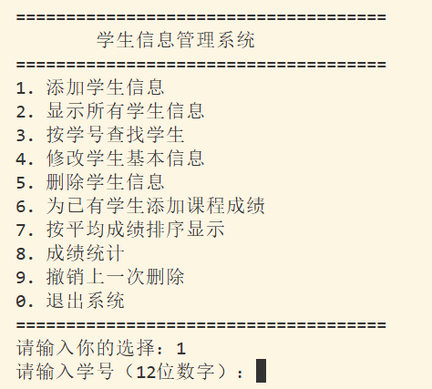
(二) 添加学生信息
核心代码：student.c的addstudent()
void addStudent()
{
StudentNode *newNode = (StudentNode *)malloc(sizeof(StudentNode));

...

readStudentId(newNode->data.id);

...

chooseGender(newNode->data.gender);

...
}
添加学生姓名，年龄，性别，年级，学院，专业，班级，宿舍门牌号，手机号，课程名称，课程成绩（其中年级，学院，专业和班级信息需要调用academic.c的函数）

其中
readStudentId(newNode->data.id);

if (searchHash(newNode->data.id) != NULL)
{
printf("该学号已存在，添加失败！\n");
free(newNode);
return;
}

该代码先读取学号，再通过哈希表判断学号是否已经存在，避免重复添加学生。
运行结果如下：
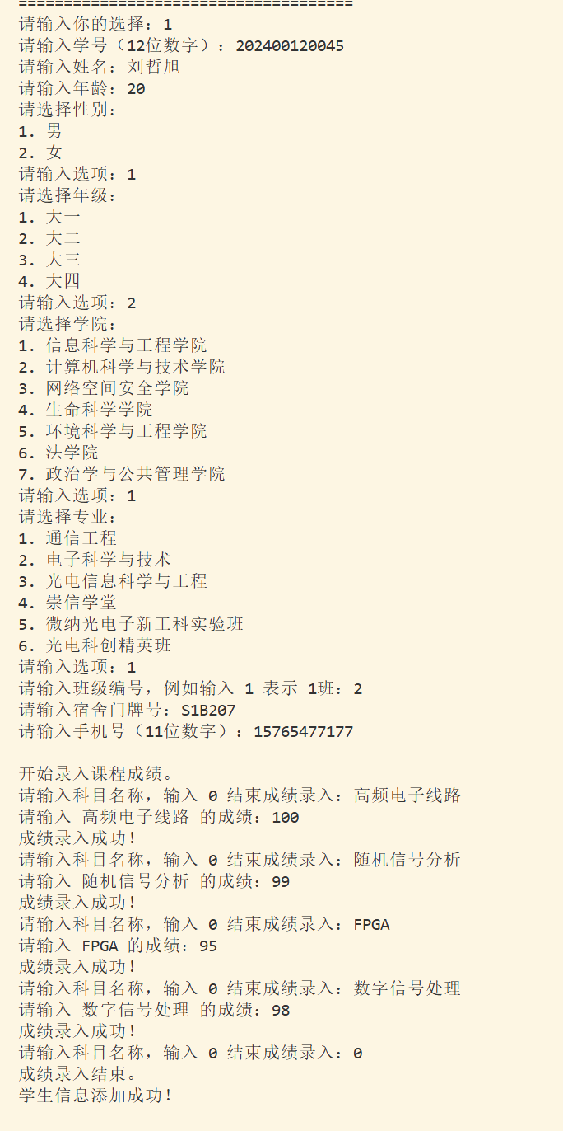
然后在添加两个名字相同的学生的信息，便于后续功能展示
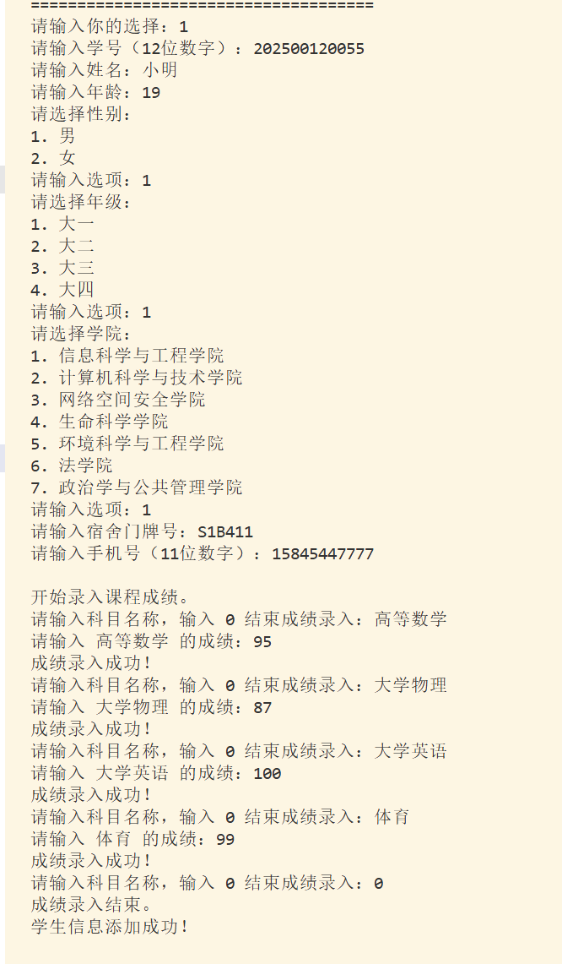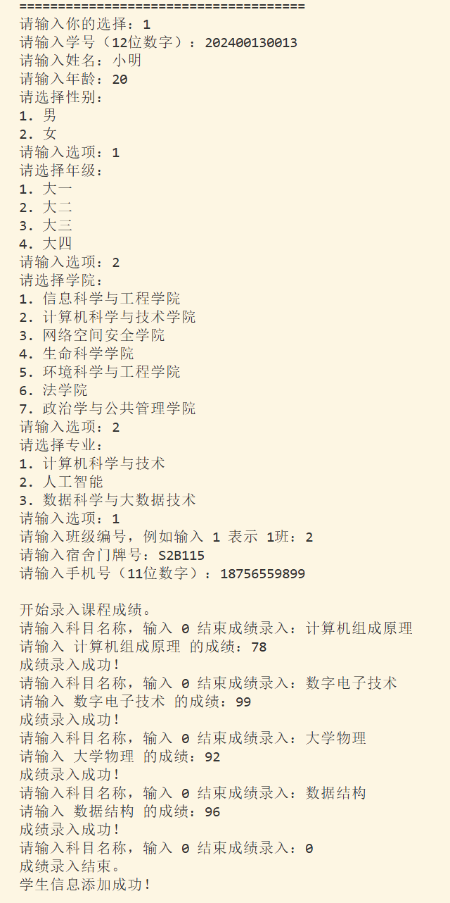
（三）显示学生信息
核心代码：student.c的showStudents() 和 showOneStudent()
运行结果如下
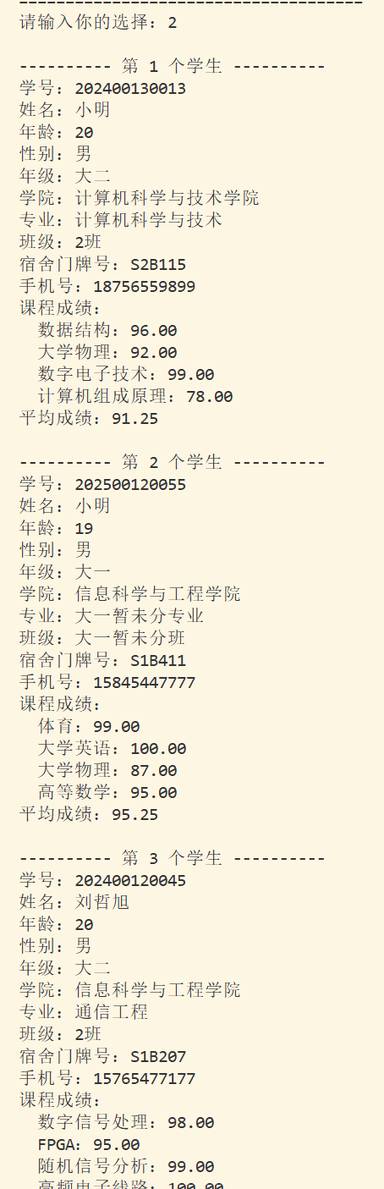
（四）按照查找学生
核心代码：
student.c 的 searchStudent()，再配合 student.c的 searchHash()。
说明：
用户输入学号后，系统通过哈希函数定位到哈希表中的对应位置，再在冲突链表中查找对应学生，提高查找效率。
运行结果如下：
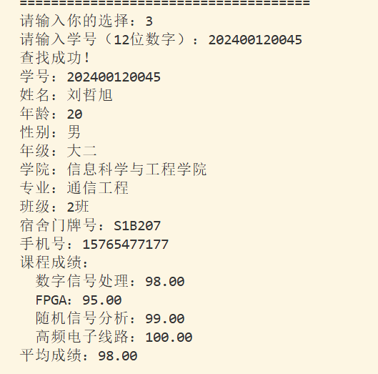
（五）修改学生信息
核心代码：student.c中 modifyStudent() 的代码。
说明：
系统先选择要修改的学生，再将原信息复制到临时变量 temp 中。用户修改后只有选择“保存”才会写回原学生结点，这样可以避免误操作。
运行结果如下
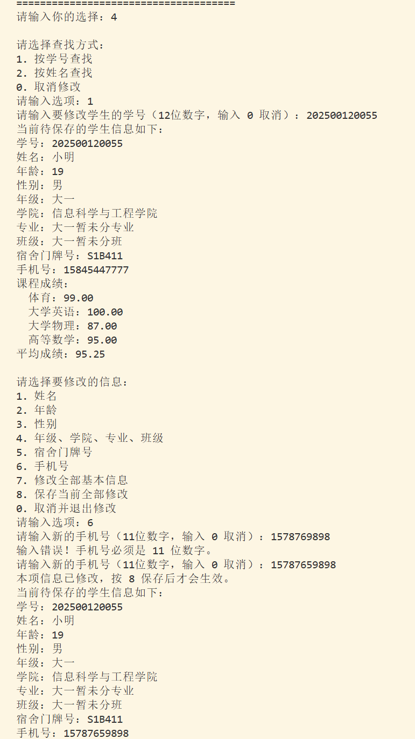
这次使用姓名方式查找小明的个人信息，由于有两个相同姓名的人，系统会输出重名的人的具体信息，然后进一步选择
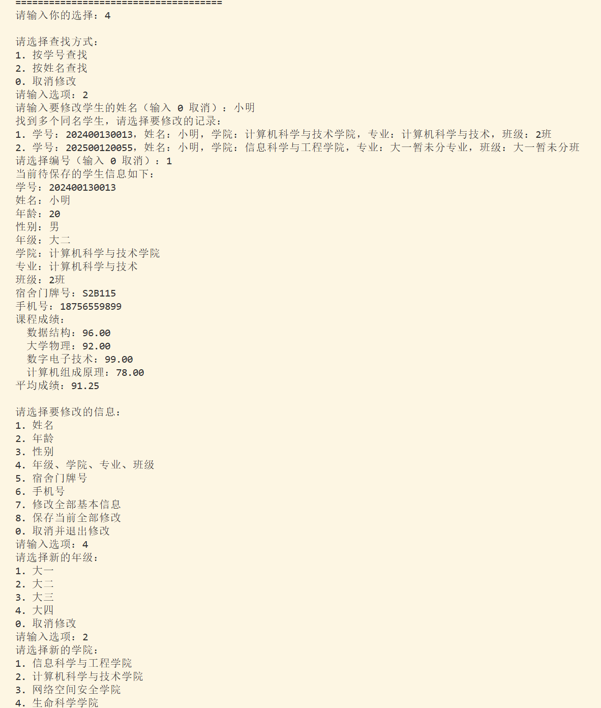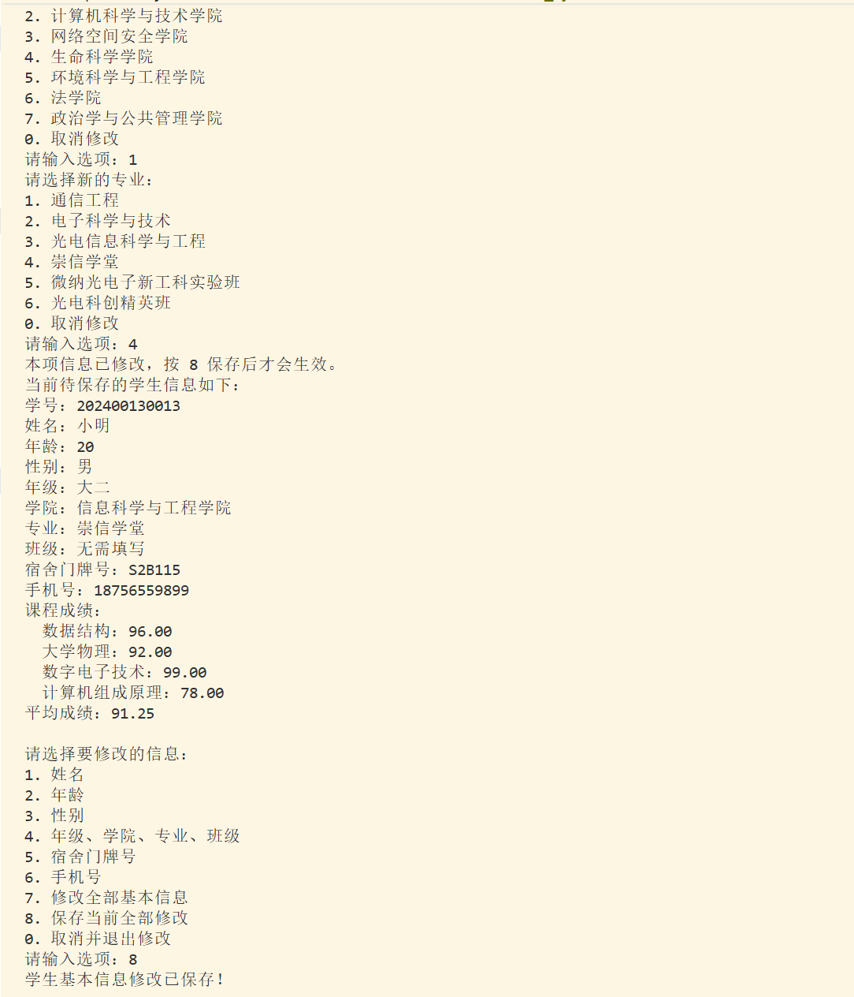
（六） 删除学生与撤销删除
核心代码：
删除功能贴 student.c的 deleteStudent()。
撤销功能贴 student.c的 undoDelete()。
删除前调用 pushUndo(cur->data) 保存被删除学生信息，删除后从链表和哈希表中移除该学生。撤销时再从撤销栈中取出最近一次删除的学生并恢复到链表中。
运行结果如下
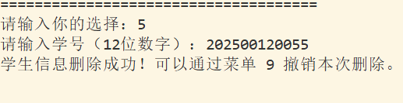
显示所有学生信息
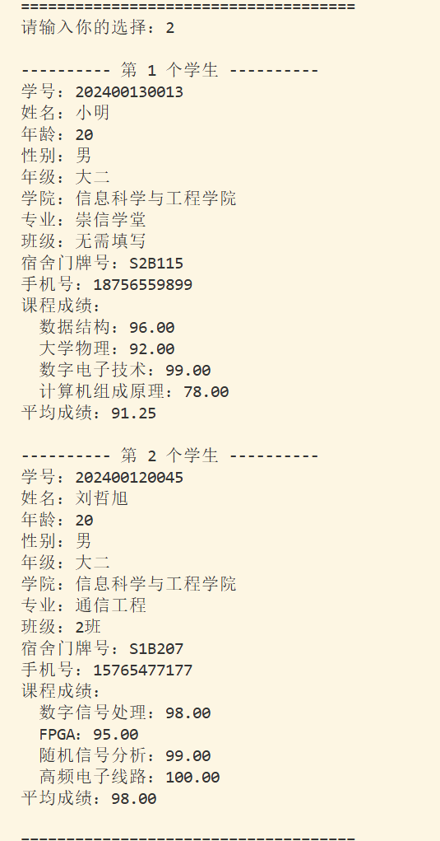
撤销上一次删除
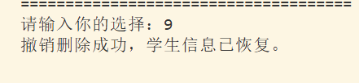
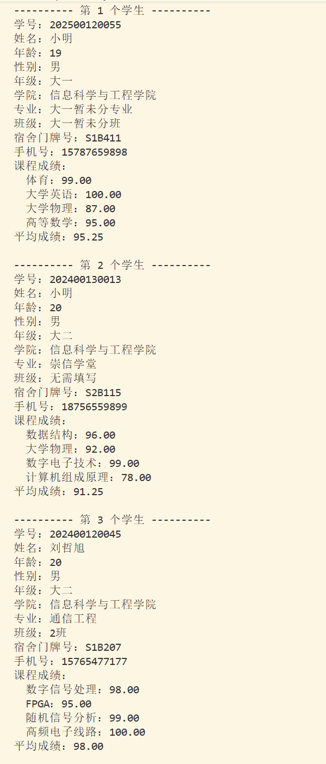
（七）为已有学生添加课程成绩
核心代码：“为已有学生添加课程成绩”的核心代码主要在 student.c里的 addGradeForStudent()，它会先按学号查找学生，找到后再调用 inputGrades() 录入课程成绩。对应的成绩录入核心逻辑是 student.c的 inputGrades()：

系统先输入学生学号，并通过哈希表查找该学生；如果学生不存在，则提示无法添加成绩；如果查找成功，则进入成绩录入循环，每输入一门课程和成绩，就创建一个成绩结点，并将其插入到该学生的成绩链表中。
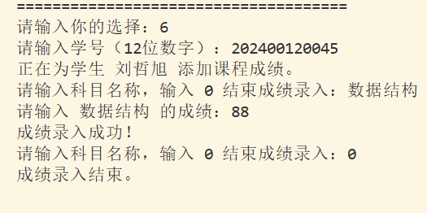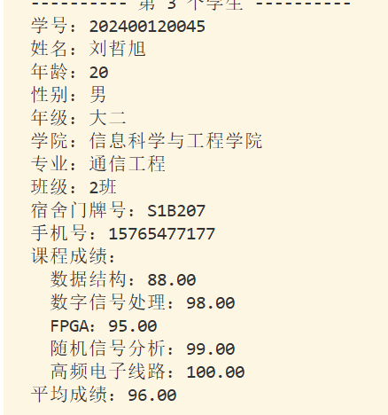
（八）成绩排序与统计
核心代码：
排序功能：student.c的 sortByAverageScore() 和 student.c的 quickSort()。
统计功能： student.c的 statistics()。
排序时先将链表中的学生结点指针存入数组，再使用快速排序按照平均成绩降序排列。统计功能通过遍历学生链表，计算总平均分，并找出平均成绩最高和最低的学生。

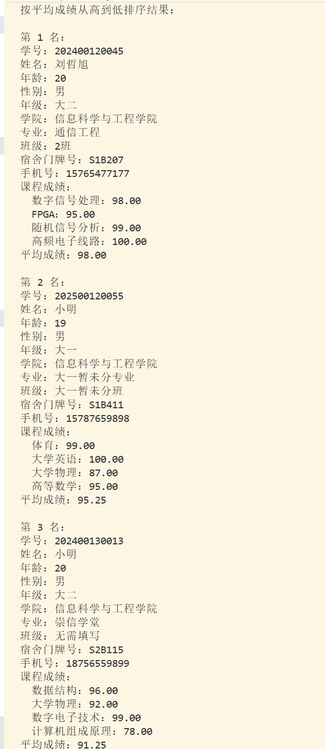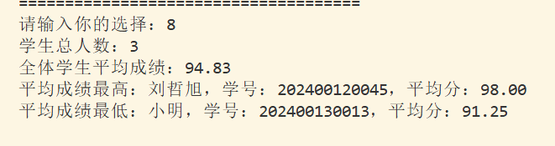

七、实验心得
通过本次大作业，我对数据结构在实际程序中的应用有了更直观的认识。以前学习链表、哈希表、栈和排序算法时，更多是停留在概念和单独练习上，而这次通过学生信息管理系统，我把这些知识结合到一个完整项目中，体会到了它们在实际功能中的作用。
在编写程序的过程中，我发现一个系统不仅仅是把功能写出来，还要考虑很多细节，比如输入是否合法、学号是否重复、删除后如何恢复、退出程序时如何释放内存等。这些问题让我更加理解 C 语言中指针和动态内存管理的重要性。
本次实验让我收获较大的是模块化设计思想。程序将不同功能分成多个文件实现，使代码更加清晰，也方便查找问题和后期修改。同时，通过实现按学号查找、平均成绩排序、成绩统计和撤销删除等功能，我进一步掌握了链表遍历、哈希查找、快速排序和栈操作的基本方法。
虽然在调试过程中遇到了一些问题，但通过不断修改和测试，最终系统能够较完整地运行。通过这次实验，我提高了综合运用数据结构知识解决实际问题的能力，也认识到写程序时需要注重代码结构、运行结果和用户体验。

