**This table shows how many people(in millions) used in different form public transport in Milan between 2010 and 2014**

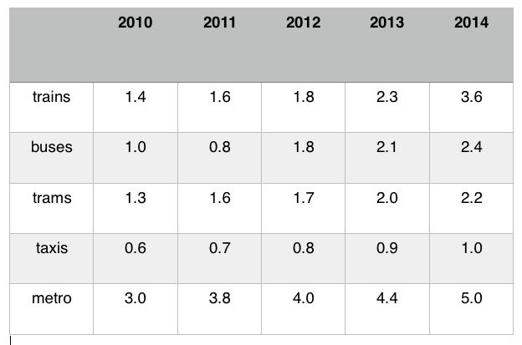

This table shows the amount of different public transport forms taken by people between 2010 and 2014.

Generally, the amount of all kind of public transportations listed in the table, namely trains, buses, trains, taxis and metro, fluctuated climbed up during this period.

As can be seen, metro took always the highest amount of public transport, with 3.0 Millions in 2010 up to 5.0 Millions in 2014, significantly exceeded the amount of all other public transportations. The statistics for trains, buses, and taxis followed a very similar patter with the figure varying between 0.6 Millions and 1.4 Millions in 2010, but it had dramatically a large range from a high of 3.6 Millions (trains) down to 1.0 Millions (taxis).

Overall, the table shows how the amount of different kinds of public transportations used by people increased dramatically over the period.