Milestone Report – Dart Detection Module
Project: HitScan DS
Milestone: Dart detection was completed
Finish-date: July 31, 2025

Objective
Develop a Develop a system that can identify where a dart has landed on the calibrated dartboard and classify in which field the dart tip has landed. The goal is to automatically detect darts and use the detected score for the played game.

1. Dart Tip Detection via Motion Analysis
- Purpose: Detect the position of darts after they hit the board using a fixed overhead camera.
- Mechanism:
◦ The camera feed is continuously analyzed to detect stillness after dart movement.
◦ A background frame is subtracted from the live feed to identify new motion regions.
◦ Once motion stabilizes, contours are extracted from thresholded differences.
◦ Contours are grouped and merged to estimate the dart tip using a triangle-based heuristic.
- Filtering:
◦ Darts already detected are masked out.
◦ Minimum blob area and contour proximity thresholds prevent false positives.
- Libraries: OpenCV used for image processing and contour operations.

2. Dartboard Region Classification
- Setup: A calibrated dartboard template is loaded from JSON files containing:
◦ Ring definitions: Six elliptical rings, including Bullseye, Triple, and Double zones.
◦ Sector lines: 20 radial segments numbered from 20 (top) clockwise to 5.
- Ring Classification:
◦ Determines which two rings a point lies between using normalized ellipse equations.
- Sector Classification:
◦ Calculates angular offset from the dartboard center to determine scoring wedge.
◦ Corrected for user-defined angular rotation to align between 20 and 1.
- Final Output:
◦ Each detected dart tip is assigned a score field such as "triple 20", "bullseye", or "single 14".

3. Marker-less Calibration (Static Setup Requirement)
- Change: ArUco markers are no longer required in the detection pipeline.
- Benefits:
◦ Simplifies the physical setup — no need to attach and detect reference markers.
◦ Reduces dependencies and visual clutter around the board.
- Trade-offs:
◦ The camera position must remain fixed after initial calibration.
◦ Even minor movement of the camera will invalidate the alignment of rings and sectors, requiring recalibration.

Accuracy Notes
- Because the detector uses precise motion detection, it can happen with bad lightning, that the detector sees the shadow of the darts and uses this difference for the calculation of the tip which often leads to wrong field classification.
- As said, the detector uses the difference and calculates the tip based on triangle-based heuristic, it is recommended to place the camera in a angle of 30°-50° to the dartboard.
- Depending on the light, calibration and threshold we get a good correct classification on the thrown darts.

In Progress / Next Steps
- Connect game to automatic detection

Screenshots

Correct classification:
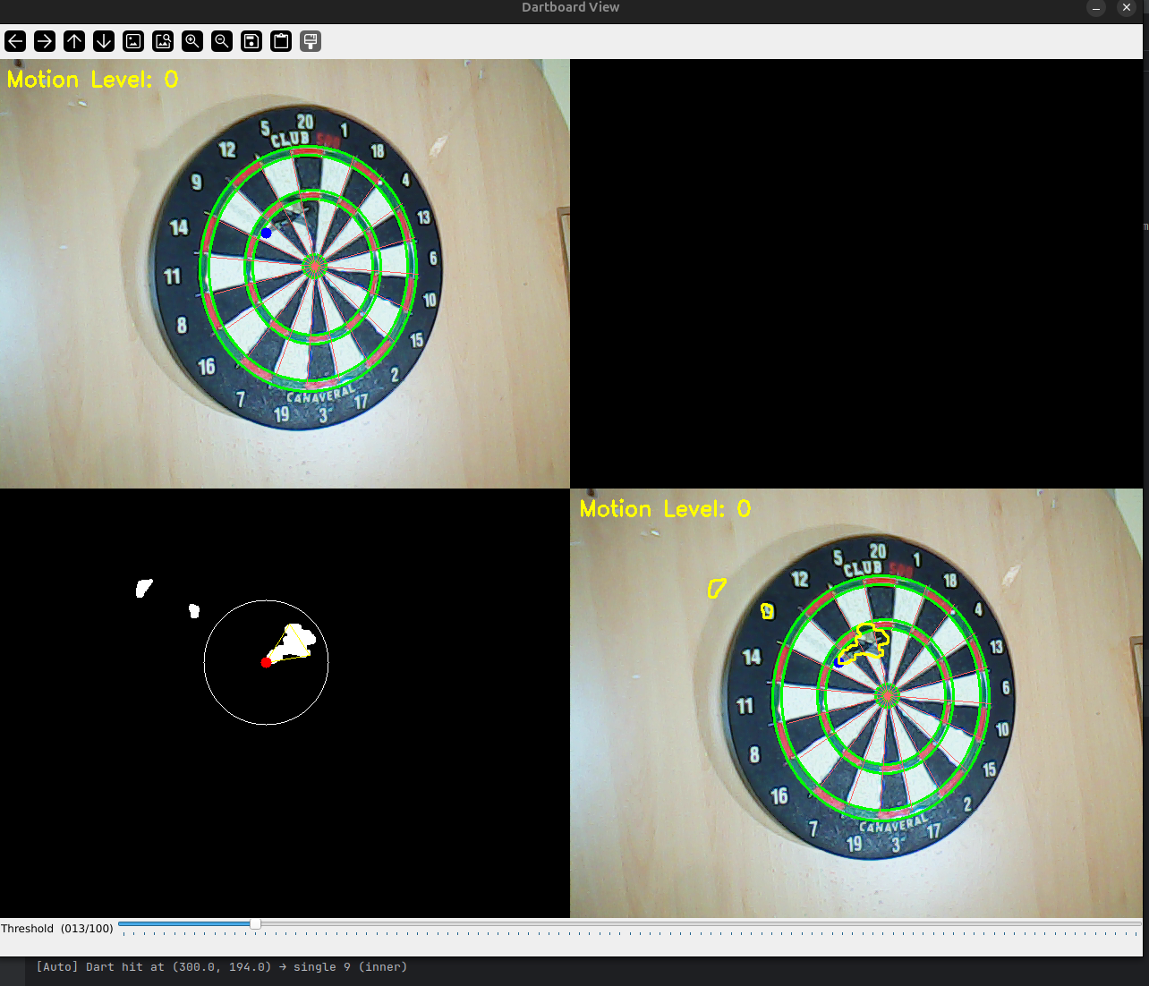

Wrong classification because of noise and shadows
