Consonants

⋁ - b ⋀ - p

ᐳ - s ᐸ - z

ʃ or S - c ʅ or Ƨ - j

⋂ - m ⋃ - n

׀ - x

ᒐ - f ᒍ - v

ᔓ - t ᔕ - d

ᓀ - k ᓂ - g

ᒥ - r ᒣ - l

Vowels and Punctuation

a
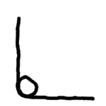
i
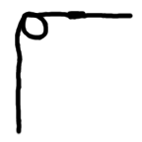

e
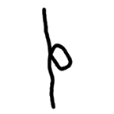

o
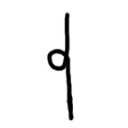

u
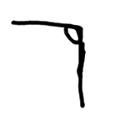

' - '

。or . - .

