**SOFT166 : Tutorial 08 Answers**

**CONTENTS**

INTRODUCTION 1

Javascript 1

MAPPING 2

HUE LIGHTS 3

**Part 1** 3

**Part 2** 4

## INTRODUCTION

This week we begin with a quick review of Javascript and then we extend the application we created last week so that we can add both a map and a mechanism to control the smart lights in the SMB109 lab.

## Javascript

This section is more for those who have not studied HTML and Javascript before. If you feel confident with this then feel free to skip the exercises.

The quick exercises provided will ensure you can do the following:

1. Insert a script element
2. Write JavaScript comments
3. Display an alert box
4. Use browser debugging tools
5. Reference browser and page objects
6. Open the tny_clock.html page with a text editor (or Web Storm) and enter your name and date in the comments section. Now directly before the closing </head> tag, insert a tag that links the accompanying tny_script.js file. Open the file in a browser to see the effect.

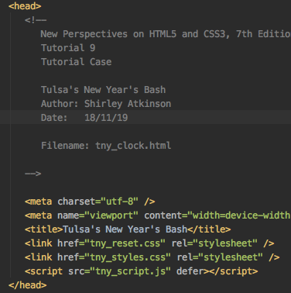

Use Script tag to link to your JavaScript file. Use defer to tell browser to load after the rest of the page has loaded.

Comments go in between <!-- -->

1. Using the same file as above, add an alert statement directly below the comments so that an alert pops up to say “Welcome”. Open the file in a browser to check it worked.

Use Script tag to tell browser that this is JavaScript code to be executed.

Call window.alert function with the text as a parameter.

Note: Script tag is different from having src attribute

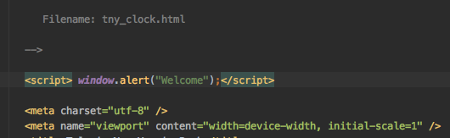

1. With the page open in Chrome, find the developer tools (either from the menu or press F12). From the menu list at the top of the Developer tools pane, click Sources to show the list of files used in the current page. Reload if you need to. Click on the tny_script.js in the sources list to show the programme code in that file. NOTE: This is where errors will display if they occur. Make note of this for when you think your programme just is not working. You can set breakpoints here.

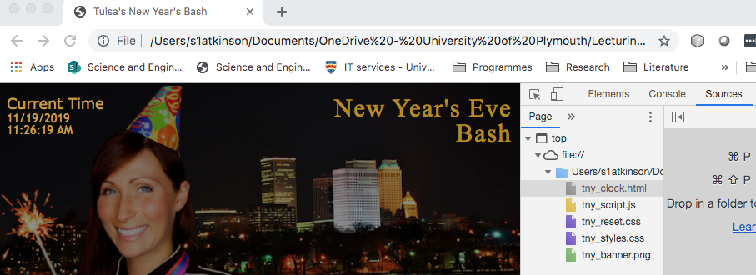

1. Open the tny-script.js file and create the code to declare a date variable, to obtain the date and time into separate strings and to display the output in the dateNow element. See the code below

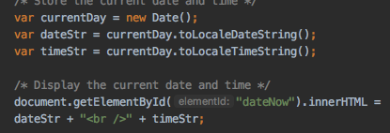

1. Open the file in your browser and check the result.

## MAPPING

NOTE: There is a podcast on the DLE page which shows how the map page is created. This is not exactly using the WebStorm IDE that we have so far and it uses a PHP page as a background. However, the principles of applying the map tutorial still apply.

## HUE LIGHTS

### **Part 2**

NOTE: Part 2 has now had a podcast created to explain how it fits together. You can find the podcast on the module DLE page.