SafeCover
Embedded microinsurance for e-commerce and retail POS: business case, architecture, and partnership path for a licensed insurer.
Confidential — partner discussion. Prepared May 2026. Builds on the internal white paper draft (Embedded MicroInsurance Platform Business Model) and the SafeCover reference implementation.

Executive summary
SafeCover is an API-first embedded microinsurance orchestration layer: quotes, bind, payment-aligned confirmation, webhooks, and a unified retail POS flow—so merchants can offer contextual protection without sending shoppers to a separate insurance journey.
Ask to the carrier: pilot one filed product (or rider) through SafeCover’s integration surface, connect your PAS and claims rails, and co-sell through one anchor distributor (e-commerce or POS)—proving attach rate, loss behaviour, and operational fit in 90–120 days.

Market opportunity
Embedded insurance shifts purchase from “find a policy later” to “protect this basket, trip, or ticket now.” Industry commentary points to a large gross-premium pool this decade; the strategic direction is consistent: ecosystems win distribution, and carriers win when partners meet them with APIs, speed, and clear compliance hooks.
Microinsurance fits short, well-defined exposures. SafeCover uses scenario-based offers and multi-provider comparison in demo workshops, with a production path to a single approved carrier per market.
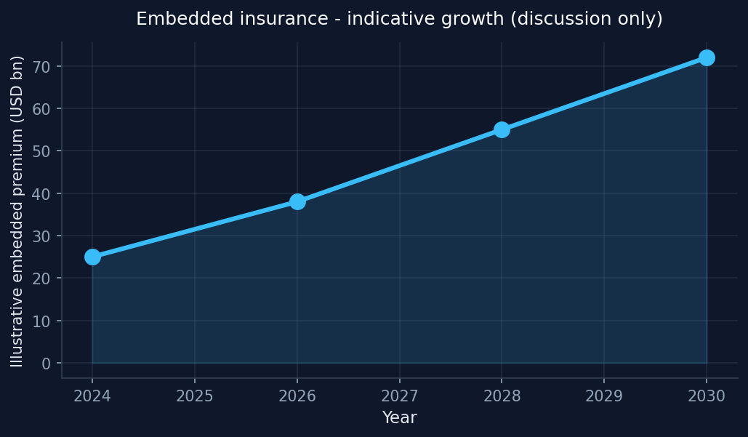

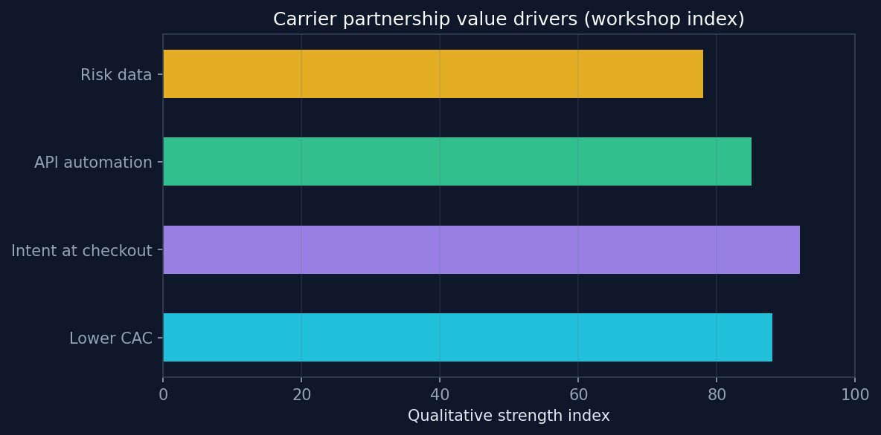

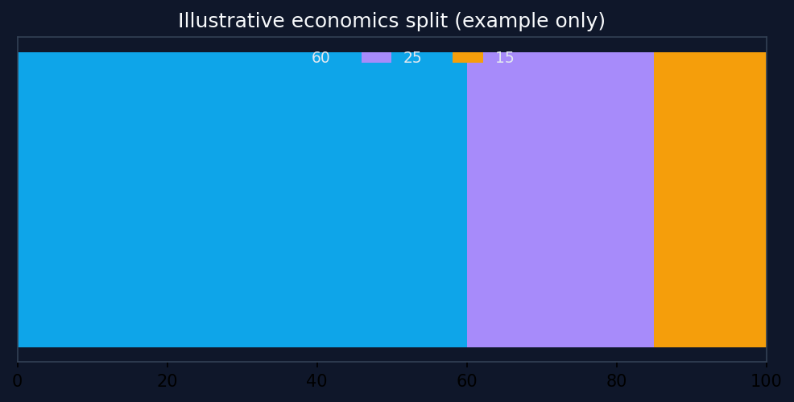

Illustrative charts for discussion only—not firm forecasts or scored research.

Stakeholder value
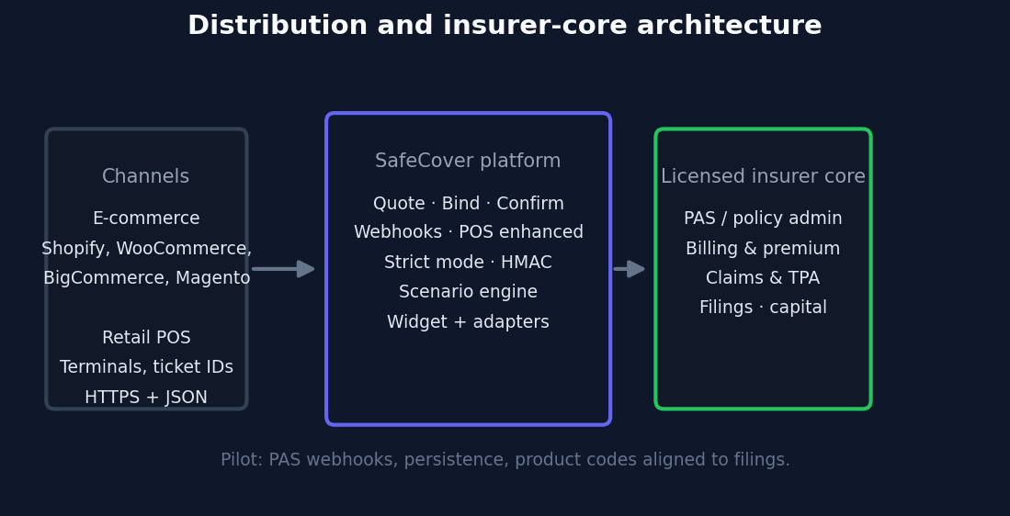

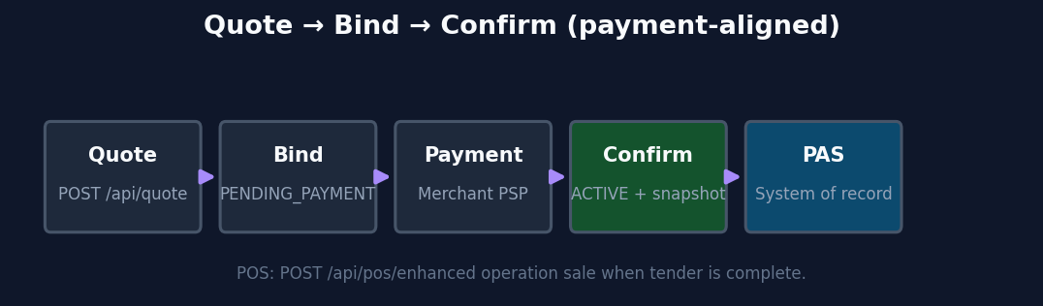

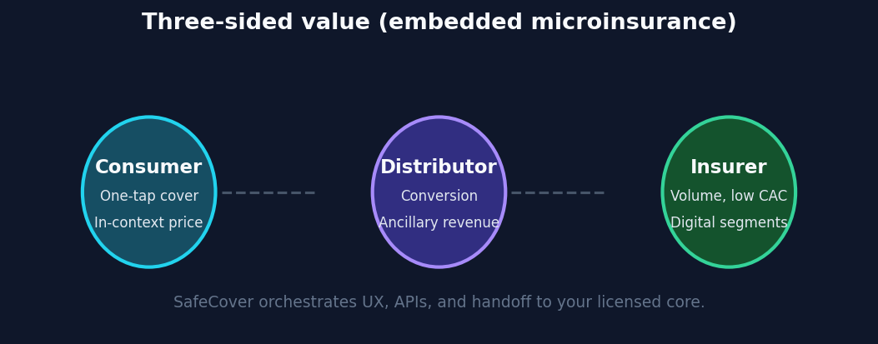

What SafeCover is today (reference stack)

Distribution surface
- Node.js Express API: quote, bind, confirm, webhook, claims stubs
- POST /api/pos/enhanced for retail: quote, bind, confirm, or sale
- Universal widget + adapters: Shopify, WooCommerce, BigCommerce, Magento, generic
- WooCommerce PHP plugin path for server-side checkout

Insurer-grade hooks (prototype)
- Strict mode: API keys, quote signing, registered quotes at bind, CORS allowlist
- Webhook HMAC, bind idempotency, regulatory_snapshot on policies
- Environment placeholders: carrier entity, license ref, filing code, wording version
- Solidity contract in repo; on-chain issuance from API is a roadmap item
See README.md, docs/API.md, docs/PRODUCTION.md, and docs/WHITEPAPER-CODEBASE-MAP.md in the repository.

Business case for the insurer
- Distribution leverage: digital-native volumes through checkout and POS vs standalone D2C acquisition.
- Product modularisation: scenario-tariff modules map to filed ingredients you approve.
- Operational efficiency: server-to-server APIs, idempotent binds, webhook contracts.
- Innovation narrative: embedded distribution with optional ledger path where appropriate.

Proposed pilot (90–120 days)
Phase | Outcomes
1 · Design | Chosen scenario(s), tariff mapping, disclosures, sandbox PAS events.
2 · Integrate | Strict mode in staging; webhook to PAS; confirm on payment capture.
3 · Live limited | One merchant or franchise POS cohort; monitoring, loss run, UX metrics.
4 · Scale decision | Attach rate, conversion, claims cycle, partner revenue—go / refine / pause.

Transparency (underwriting trust)
The reference implementation does not replace filings, capital, licensed claims payment, or full PAS depth. Items called out in WHITEPAPER-CODEBASE-MAP.md as not yet wired include on-chain issuance from the API, parametric oracle payouts, and full carrier billing integration—these are partnership build scope, with SafeCover supplying the distribution orchestration skeleton.

References (from your draft)
BCG embedded insurance tech stack; industry surveys on checkout protection; case patterns (airline attach, marketplace warranty uplift); Etherisc / parametric microinsurance references—as cited in your original Word document. Use compliance-approved third-party materials where required.

Regeneration
HTML/PDF: python docs/partner/build_partner_pitch_html.py. Word: python docs/partner/build_partner_pitch_docx.py. Requires matplotlib and python-docx.

