Team 12 – Advanced Telecommunications Solutions

Defined Architecture of the ANN Model
We built a feed-forward Artificial Neural Network (multi-layer perceptron) that outputs the probability that a customer will churn. It uses the cleaned Stage 2 dataset (6,741 customers; 302 duplicates removed, 256 inconsistent PhoneService/MultipleLines records corrected).
Layer | Details | Reason
Input | 12 neurons: gender, SeniorCitizen, Dependents, tenure*, PhoneService, MultipleLines, MonthlyCharges*, InternetService (2 one-hot), Contract (3 one-hot). *standardised | One neuron per prepared feature from Stage 2
Hidden 1 | 32 neurons, ReLU | Enough capacity to learn interactions between tenure, charges and service type, without overfitting a small 10-column dataset
Hidden 2 | 16 neurons, ReLU | Narrowing layer compresses patterns into fewer signals
Output | 1 neuron, sigmoid | Probability of churn (0–1); classified as churn at 0.5

Training configuration
- Optimiser: Adam, learning rate 0.001 – adaptive and converges reliably
- Regularisation: L2 penalty (alpha 0.001) and early stopping (10% validation split, patience 15 epochs) to improve generalisation
- Batch size 64, maximum 300 epochs
- Class imbalance (26.6% churners): churner rows in the training set only were randomly oversampled (5,392 → 7,918 rows). The test set was left untouched.
- Split: 80/20 stratified by Churn (5,392 train / 1,349 test), random seed 42
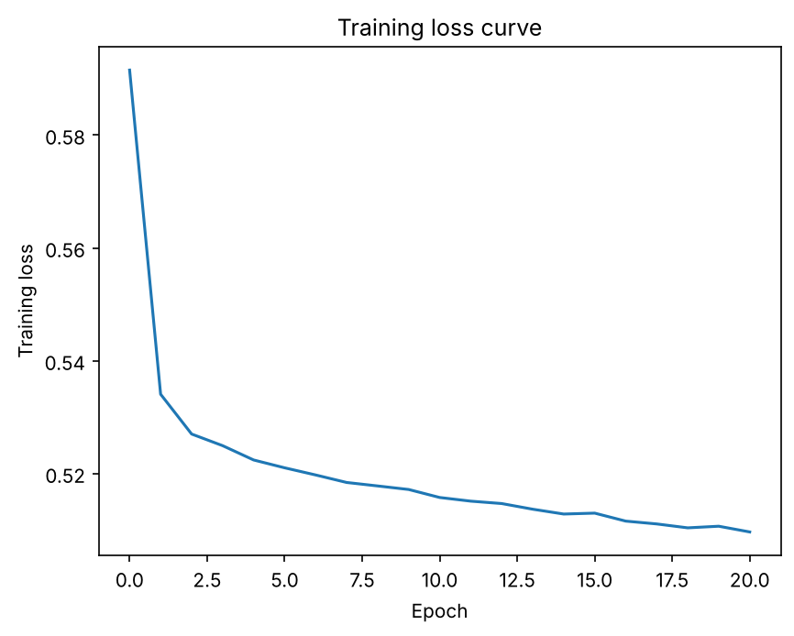
Figure 1: Training loss by epoch
Files: churn_ann_model.joblib (model, scaler, column list) and stage3_ann.py (code).

