Optimal Clusters Analysis
Customer Churn Analysis – Team 12
Stage 2: Clustering Analysis

1. Objective
The objective of this analysis is to determine an appropriate number of customer clusters for the customer churn dataset. The Elbow Method and Silhouette Score are used together to assess candidate cluster counts and support the selection of the final number of clusters.

2. Determining the Optimal Number of Clusters
Two complementary evaluation techniques were considered: the Elbow Method and the Silhouette Score. The Elbow Method examines how within-cluster variation decreases as the number of clusters increases. The Silhouette Score measures how well each observation fits within its assigned cluster compared with neighbouring clusters. Higher silhouette values indicate better separation and cohesion.
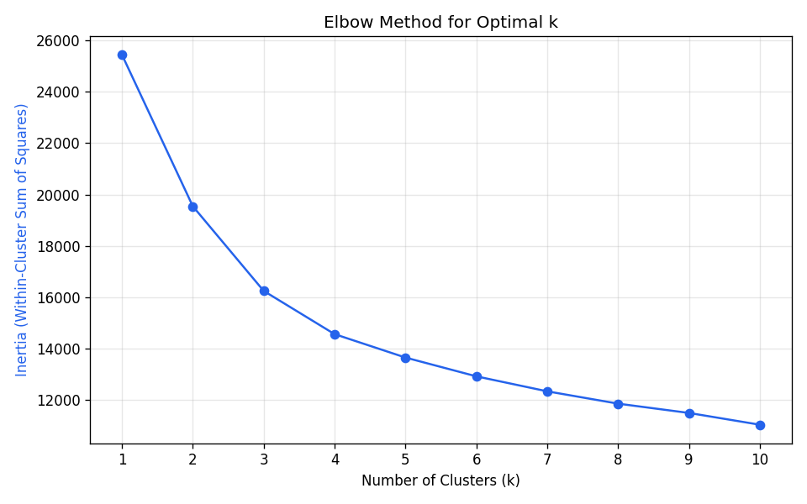
Figure 1. Elbow Method for candidate cluster counts.
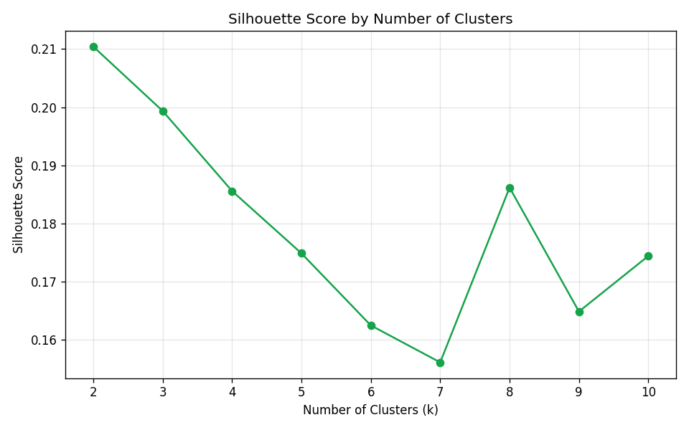
Figure 2. Silhouette Score for candidate cluster counts.
The supplied visualisations provide the supporting Elbow Method and Silhouette Score evidence used to select the final cluster count.

3. Selected Number of Clusters
For the customer segmentation analysis, four clusters (k = 4) are used to create the final customer segments. This provides a practical segmentation of the customer population while retaining interpretable differences between groups.

4. K-Means Clustering Results
Cluster | tenure | MonthlyCharges | SeniorCitizen | ChurnRate | MostCommonContract | MostCommonInternet | ClusterSize
0 | 54.3 | 35.0 | 0.1 | 0.048 | Month-to-month | DSL | 1128
1 | 15.1 | 81.8 | 0.2 | 0.491 | Month-to-month | DSL | 2134
2 | 58.6 | 93.2 | 0.2 | 0.156 | Month-to-month | DSL | 1888
3 | 11.3 | 33.9 | 0.1 | 0.248 | Month-to-month | DSL | 1591
The cluster profile summarises the average tenure, average monthly charges, churn rate, common contract type, common internet service, and cluster size for each group.

5. Cluster Interpretation

Loyal Low-Spend
Cluster size: 1128 customers. Average tenure: 54.35 months. Average monthly charges: 35.03. Churn rate: 5.0%.

New High-Spend (High Risk)
Cluster size: 2134 customers. Average tenure: 15.1 months. Average monthly charges: 81.77. Churn rate: 49.0%.

Loyal High-Spend
Cluster size: 1888 customers. Average tenure: 58.61 months. Average monthly charges: 93.18. Churn rate: 16.0%.

New Low-Spend
Cluster size: 1591 customers. Average tenure: 11.26 months. Average monthly charges: 33.88. Churn rate: 25.0%.

6. Supporting Cluster Visualisation
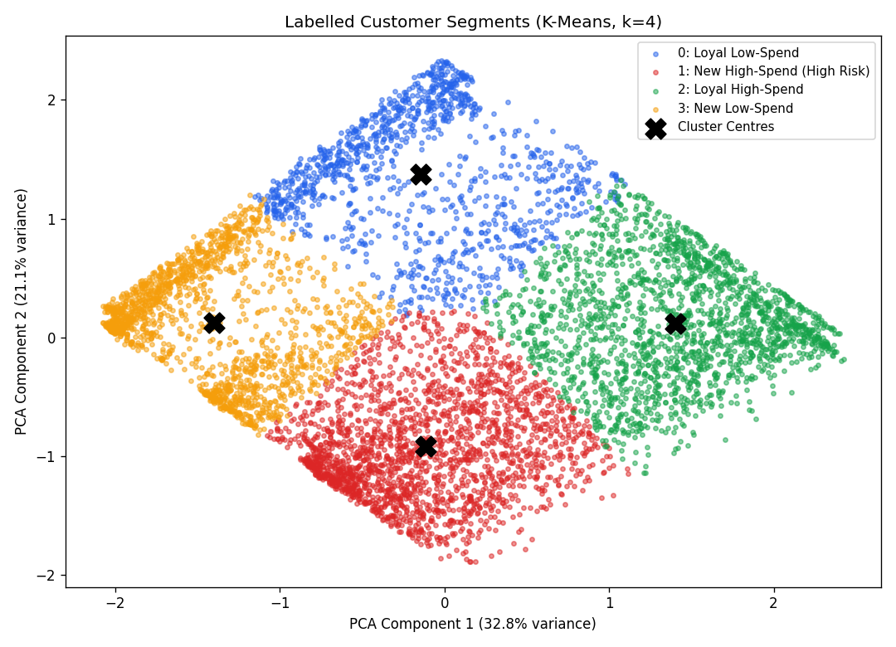
Figure 3. Labelled customer segments produced by the clustering analysis.
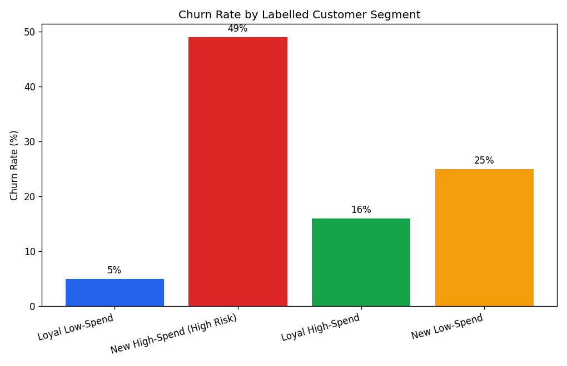
Figure 4. Churn rate across the labelled customer segments.

7. Conclusion
The analysis evaluates candidate cluster counts using the Elbow Method and Silhouette Score and uses a four-cluster K-Means segmentation for the final customer analysis. The resulting clusters provide a structured way to compare customer tenure, monthly charges, churn behaviour, contract characteristics, and internet-service patterns. These segments can support subsequent customer churn visualisation, modelling, and reporting activities.

