**Program:**

import warnings

warnings.simplefilter("ignore")

import numpy as np

import pandas as pd

import matplotlib.pyplot as plt

import seaborn as sns

advertising =pd.DataFrame(pd.read_csv("/content/advertising.csv"))

advertising.head()

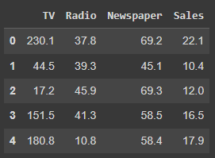

advertising.shape

advertising.info()

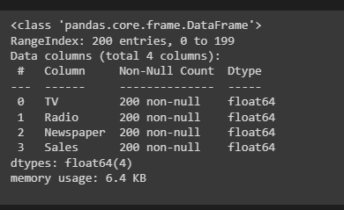

advertising.describe()

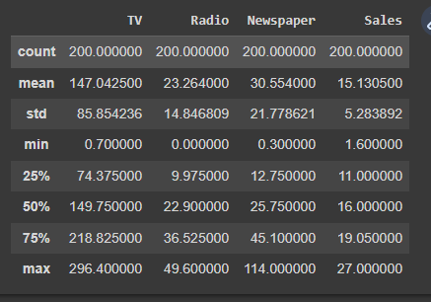

advertising.isnull().sum()*100/advertising.shape[0]

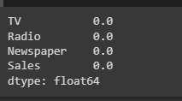

fig,axs=plt.subplots(3,figsize=(5,5))

plt1=sns.boxplot(advertising['TV'],ax=axs[0])

plt2=sns.boxplot(advertising['Newspaper'],ax=axs[1])

plt3=sns.boxplot(advertising['Radio'],ax=axs[2])

plt.tight_layout()

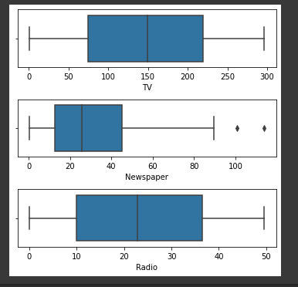

sns.boxplot(advertising['Sales'])

plt.show()

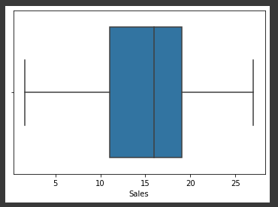

sns.pairplot(advertising,x_vars=['TV','Newspaper','Radio'],y_vars='Sales',height=4,aspect=1,kind='scatter')

plt.show()

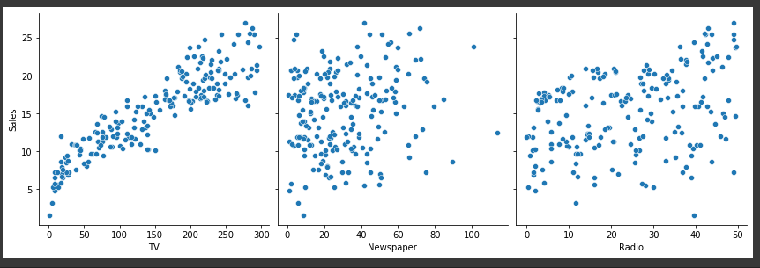

sns.heatmap(advertising.corr(),cmap="YlGnBu",annot=True)

plt.show()

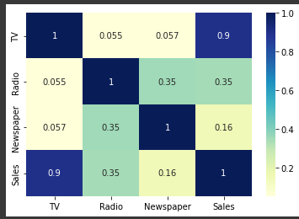

X=advertising['TV']

y=advertising['Sales']

from sklearn.model_selection import train_test_split

X_train,X_test,y_train,y_test=train_test_split(X,y,train_size=0.7,test_size=0.3,random_state=100)

X_train.head()

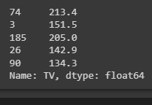

y_train.head()

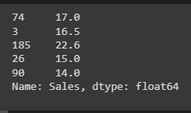

import statsmodels.api as sm

X_train_sm=sm.add_constant(X_train)

lr=sm.OLS(y_train,X_train_sm).fit()

lr.params

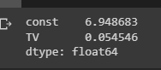

print(lr.summary())

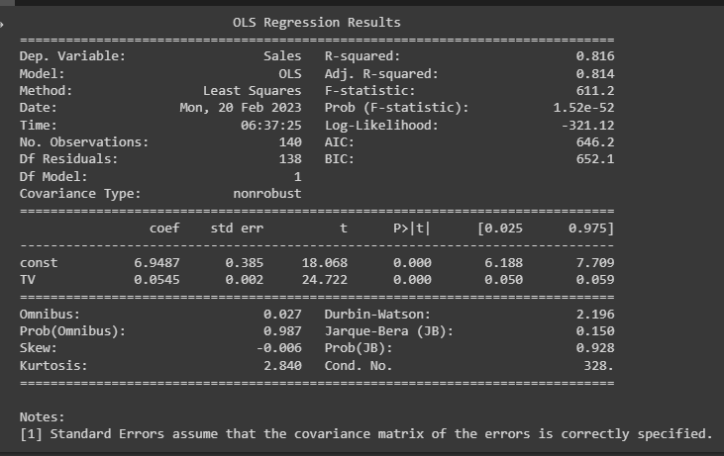

plt.scatter(X_train,y_train)

plt.plot(X_train,6.948+0.054*X_train,'r')

plt.show()

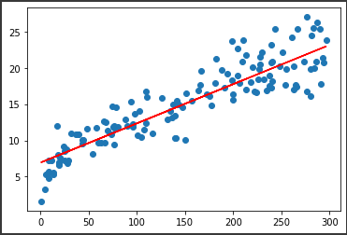

y_train_pred=lr.predict(X_train_sm)

res=(y_train-y_train_pred)

fig=plt.figure()

sns.distplot(res,bins=15)

fig.suptitle('Error Terms',fontsize=15)

plt.xlabel('y_train-y_train_pred',fontsize=15)

plt.show()

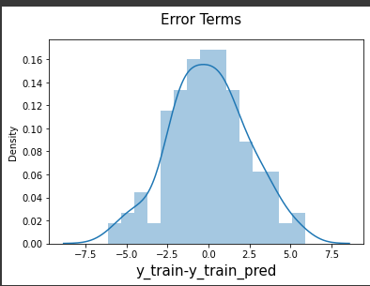

plt.scatter(X_train,res)

plt.show()

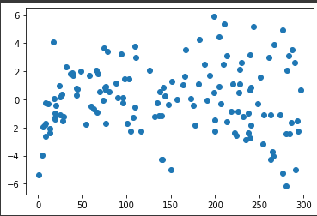

X_test_sm=sm.add_constant(X_test)

y_pred=lr.predict(X_test_sm)

y_pred.head()

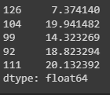

from sklearn.metrics import mean_squared_error

from sklearn.metrics import r2_score

np.sqrt(mean_squared_error(y_test,y_pred))

2.019296008966232

r_squared=r2_score(y_test,y_pred)

r_squared

0.792103160124566

plt.scatter(X_test,y_test)

plt.plot(X_test,6.948+0.054*X_test,'r')

plt.show()

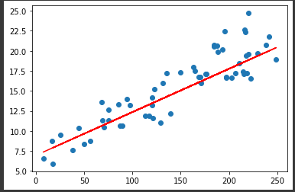

Program:

import csv

num_attributes = 6

a = []

print("\n The Given Training Data Set \n")

with open('/content/ENJOYSPORT.csv', 'r') as csvfile:

reader = csv.reader(csvfile)

for row in reader:

a.append (row)

print(row)

print("\n The initial value of hypothesis: ")

hypothesis = ['0'] * num_attributes

print(hypothesis)

for j in range(0,num_attributes):

hypothesis[j] = a[0][j];

print("\n Find S: Finding a Maximally Specific Hypothesis\n")

for i in range(0,len(a)):

if a[i][num_attributes]=='yes':

for j in range(0,num_attributes):

if a[i][j]!=hypothesis[j]:

hypothesis[j]='?'

else :

hypothesis[j]= a[i][j]

print("For Training instance No:{0} the hypothesis is ".format(i),hypothesis)

print("\n The Maximally Specific Hypothesis for a given Training Examples :\n")

print(hypothesis)

output:

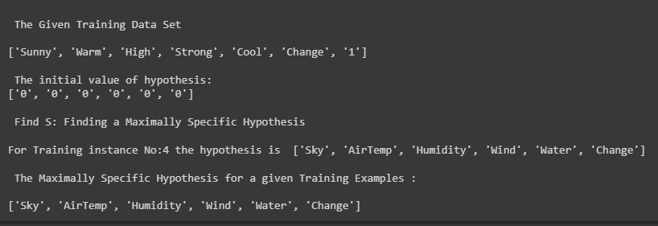

Program:

import numpy as np

import pandas as pd

data = pd.DataFrame(data=pd.read_csv('/content/ENJOYSPORT.csv'))

concepts = np.array(data.iloc[:,0:-1])

print(concepts)

target = np.array(data.iloc[:,-1])

print(target)

def learn(concepts, target):

specific_h = concepts[0].copy()

print("initialization of specific_h and general_h")

print(specific_h)

general_h = [["?" for i in range(len(specific_h))] for i in range(len(specific_h))]

print(general_h)

for i, h in enumerate(concepts):

if target[i] == "yes":

for x in range(len(specific_h)):

if h[x]!= specific_h[x]:

specific_h[x] ='?'

general_h[x][x] ='?'

print(specific_h)

print(specific_h)

if target[i] == "no":

for x in range(len(specific_h)):

if h[x]!= specific_h[x]:

general_h[x][x] = specific_h[x]

else:

general_h[x][x] = '?'

print(" steps of Candidate Elimination Algorithm",i+1)

print(specific_h)

print(general_h)

indices = [i for i, val in enumerate(general_h) if val == ['?', '?', '?', '?', '?', '?']]

for i in indices:

general_h.remove(['?', '?', '?', '?', '?', '?'])

return specific_h, general_h

s_final, g_final = learn(concepts, target)

print("Final Specific_h:", s_final, sep="\n")

print("Final General_h:", g_final, sep="\n")

output:

