Experiment 4a:

echo "enter filename"

read f

if [ -f $f ]

then

echo " it is a file"

elif [ -d $f ]

then

echo " it is a directory"

else

echo " not a file or directory "

fi

output:

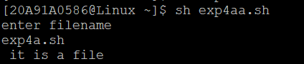

Experiment 4b:

echo "enter a file name"

read a

if [ -f $a ]

then

echo "file is present"

else

echo " file is not present"

fi

tr '[a-z]' '[A-Z]' < $a

output:

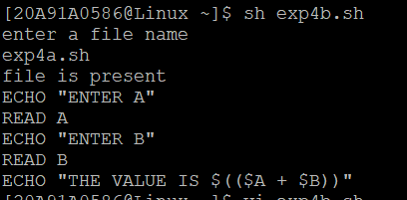

Experiment 5a:

echo "enter the user name"

read user

last $user

Output:

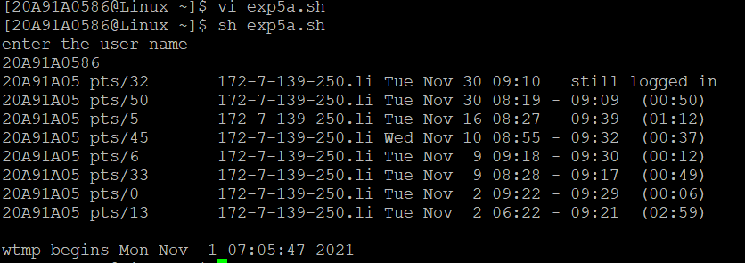

experiment 5b :

output: