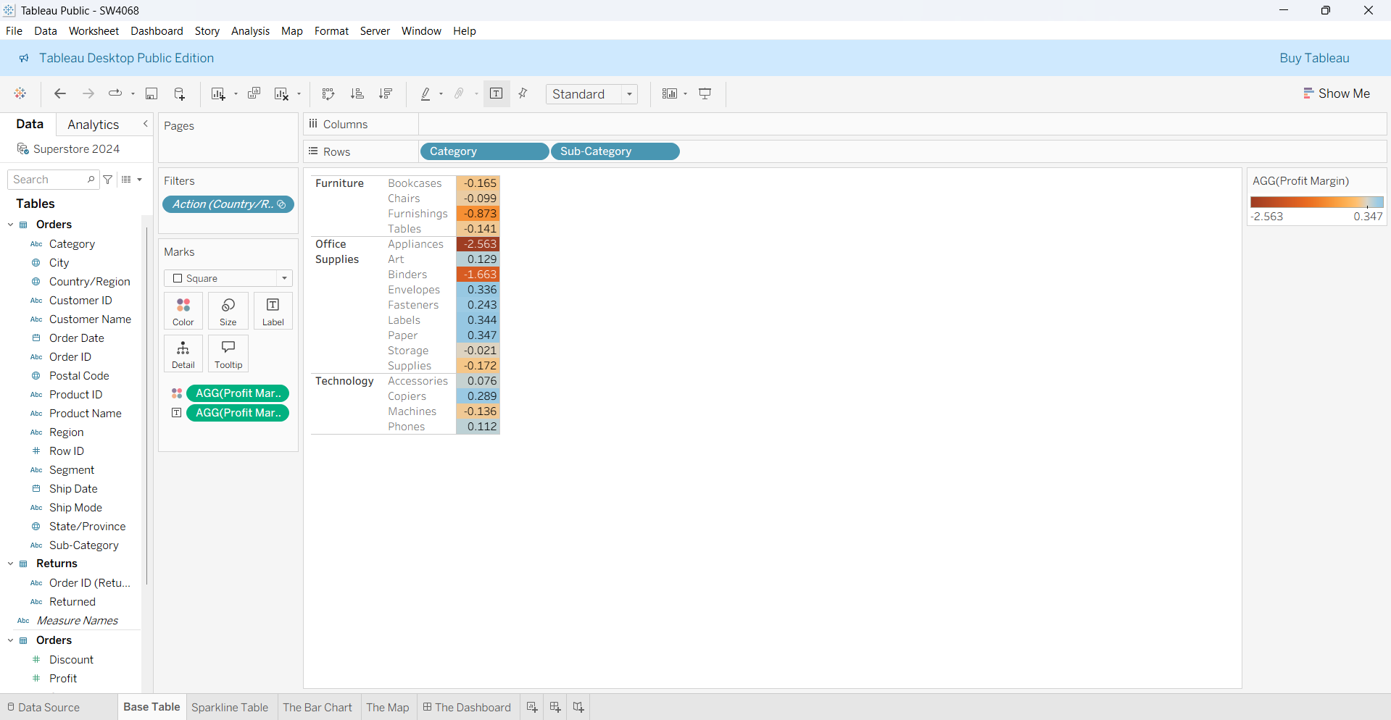

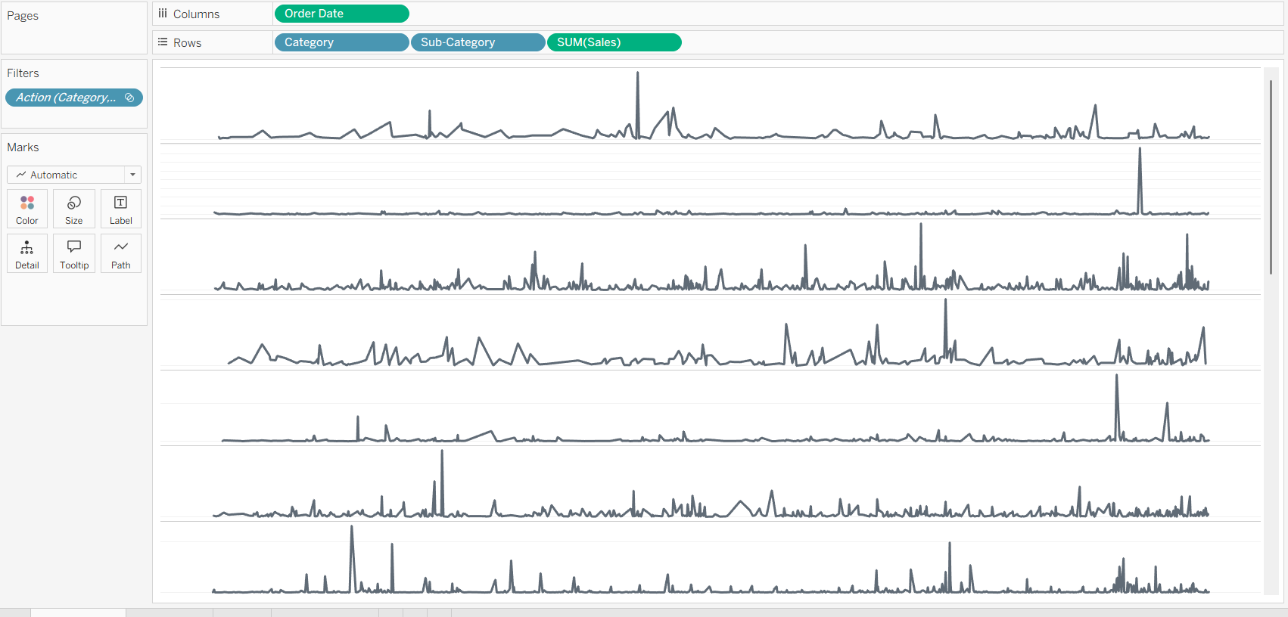
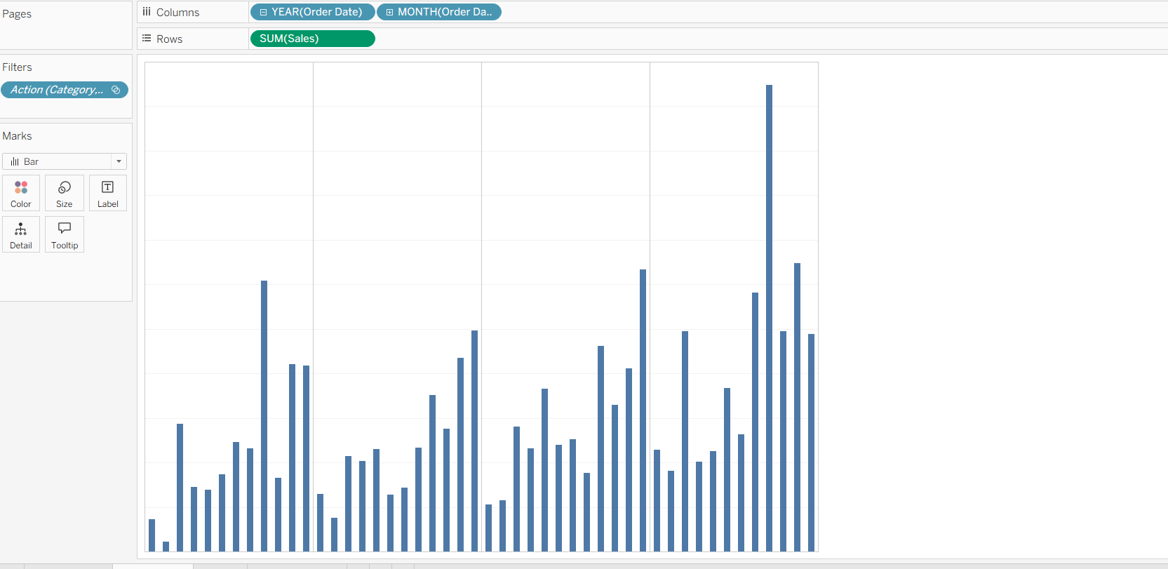

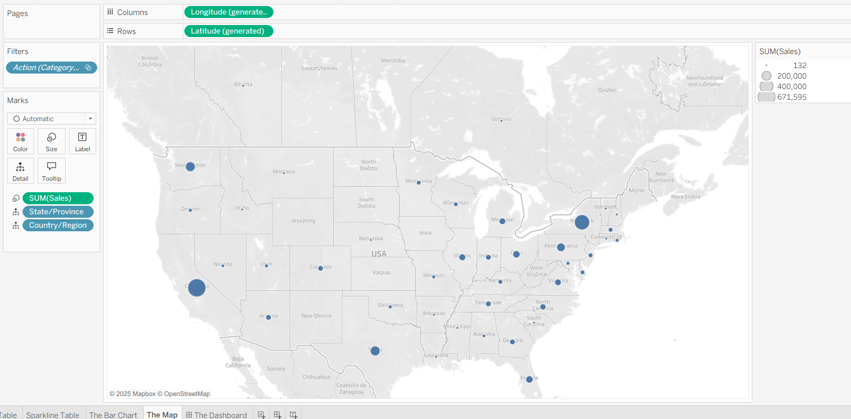

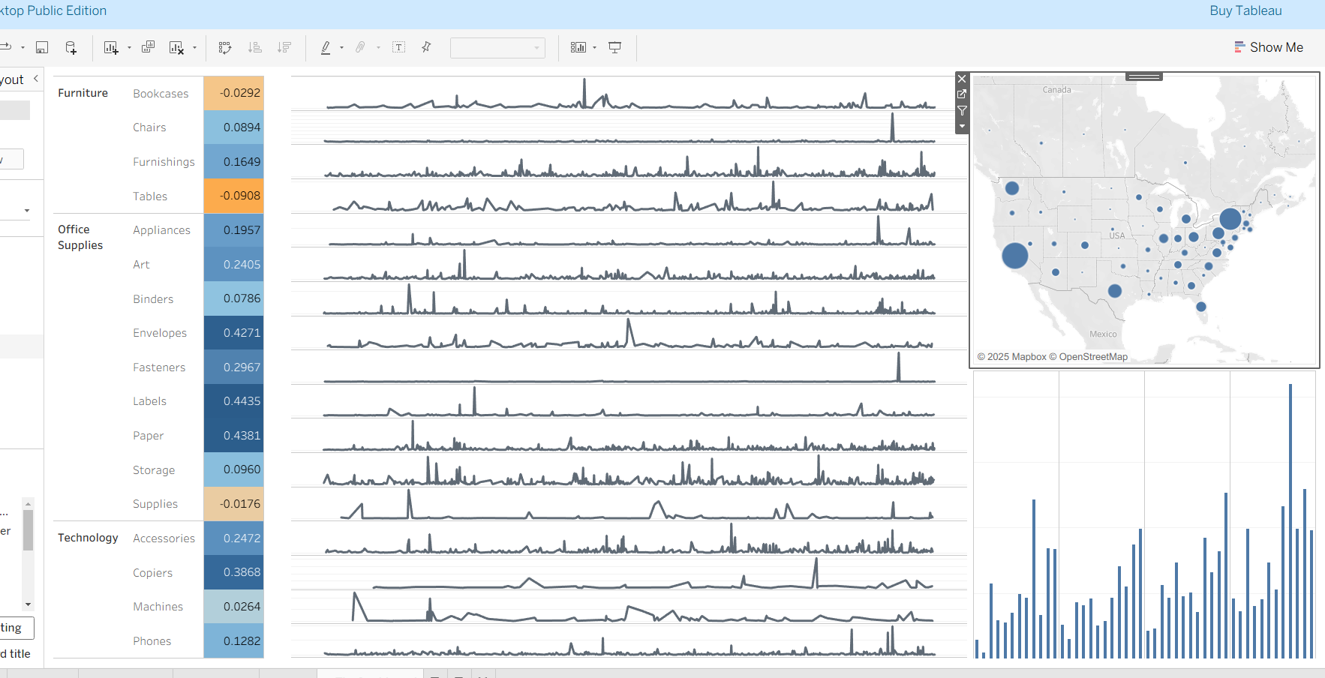

QUESTIONS
Based on the dashboard, answer the following questions (number your answers and insert them,
along with the relevant screenshots, into the Word document).
1. Examine the Map and identify the three states with the highest aggregate sales for Bookcases;
provide the sales figures along with the states.
Answer: Top three states are
- California: 39310
- New York: 23329
- Texas: 14793
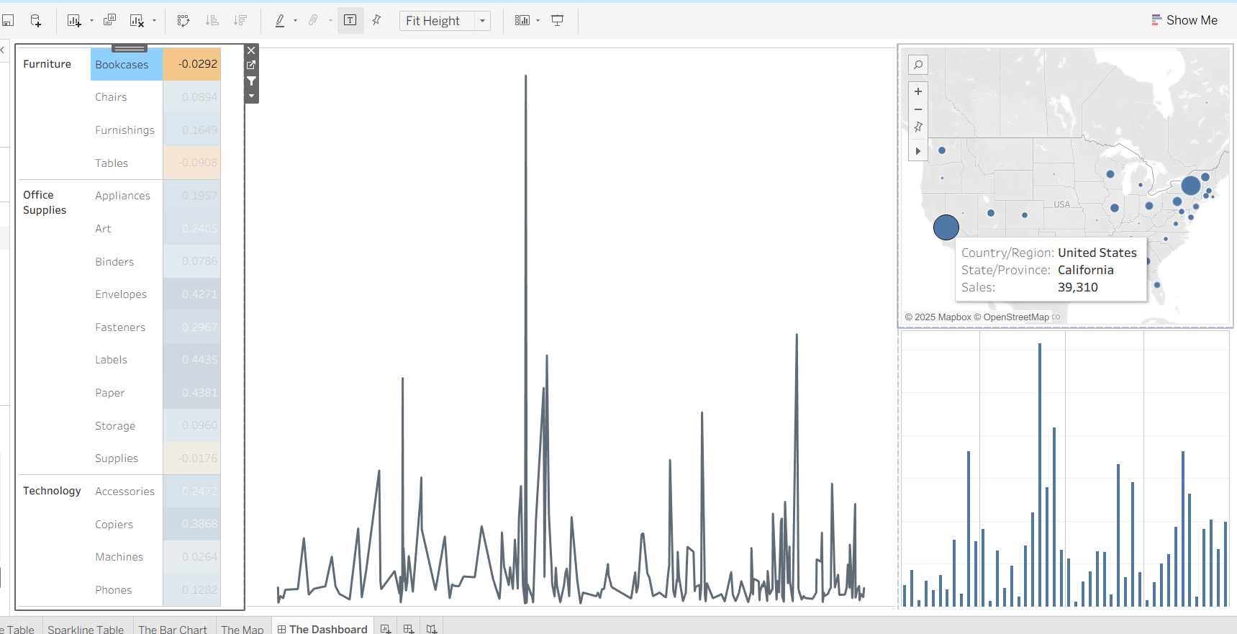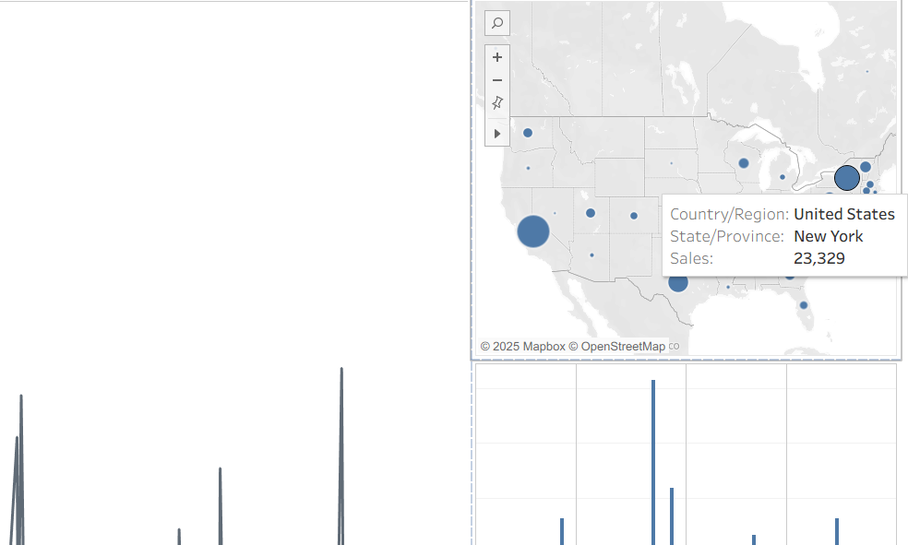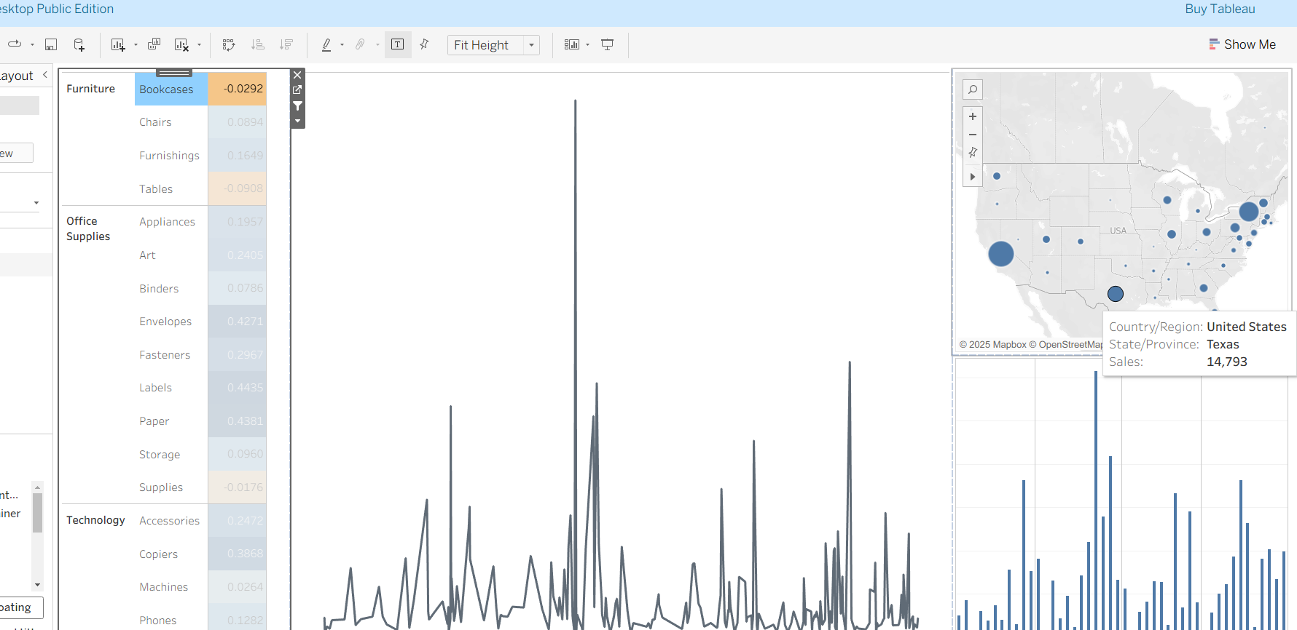
2. Examine the dashboard and identify the product subcategory that generated the highest
profit margin; what is that profit margin? Examine the sparkline for this subcategory and comment on its sales trend.
Answer: subcategory that generated the highest profit margin
Lables : 0.4435
This sparkline suggests that:
- Sales might be event-driven or seasonal, leading to irregular surges.
- The business experiences short-term boosts rather than sustained growth.
- There may be promotions, holidays, or product launches causing these spikes.
The sparkline shows an overall fluctuating sales pattern with predominantly low sales and several sharp peaks. These peaks indicate occasional high-sales periods, possibly due to events or promotions. However, there is no consistent upward or downward trend observed over time.
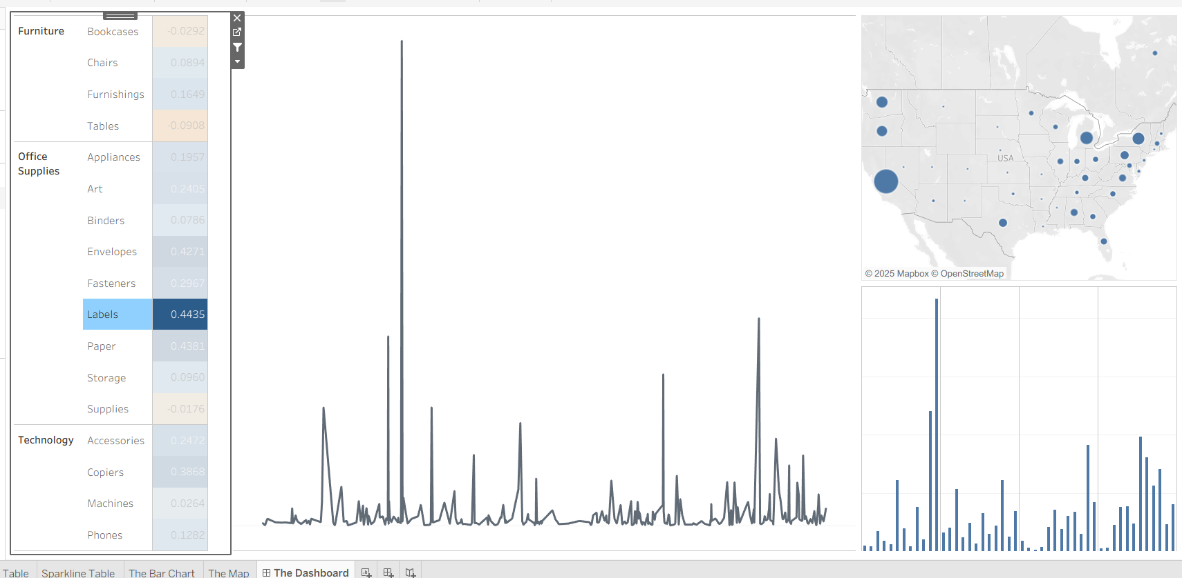
3. For this subcategory that you identified in Q2, which state generated the highest total sales
(across all the time periods) and what is that amount?
Answer: California with amount of 5,424 is the state generated the highest total sales
(across all the time periods)
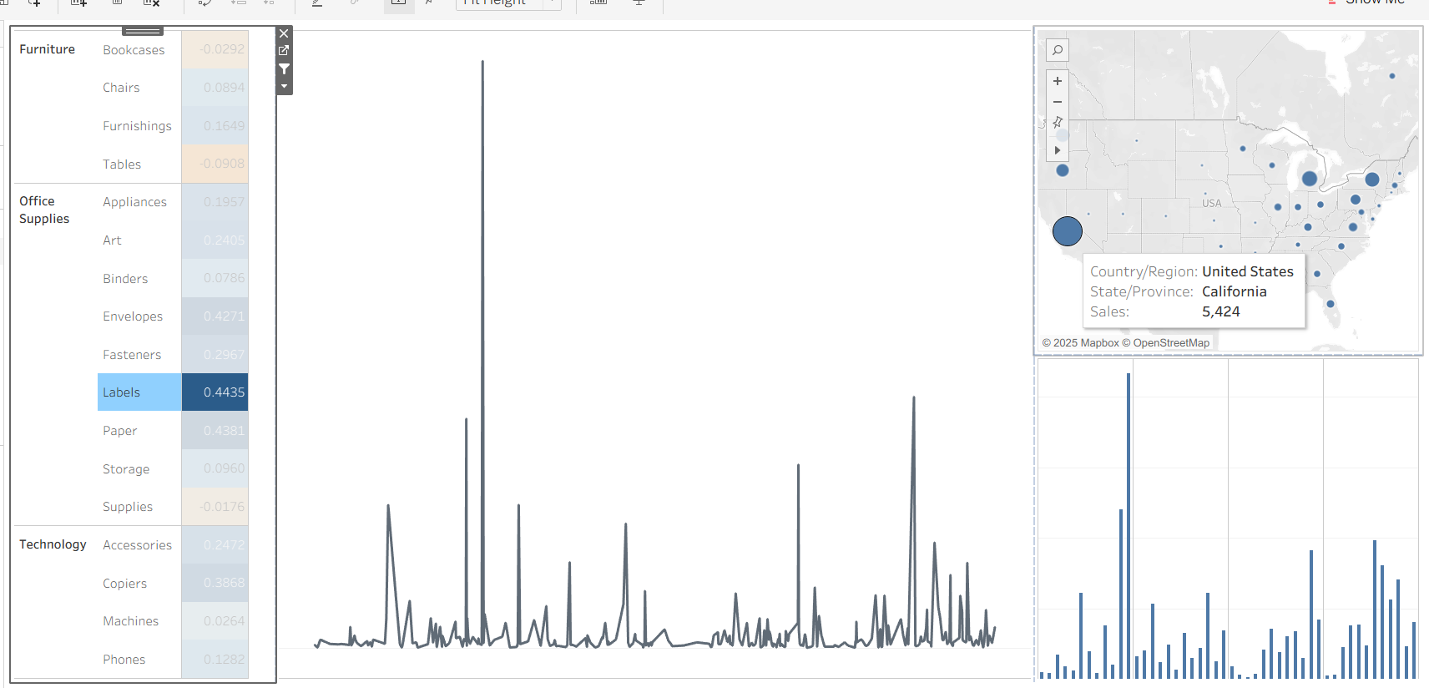
4. Examine the dashboard and identify the product category that generated the highest monthly
sales figure for 2024; along with the category, specify the month and the sales amount. Also, for
this category, which state generated the highest total sales (across all the time periods) and what is that amount?
Answer: Furniture category in month of September with total sales of 104366 is the product category that generated the highest monthly sales figure for 2024 for furniture California State with total sales of 216,551generated the hightest total sales.
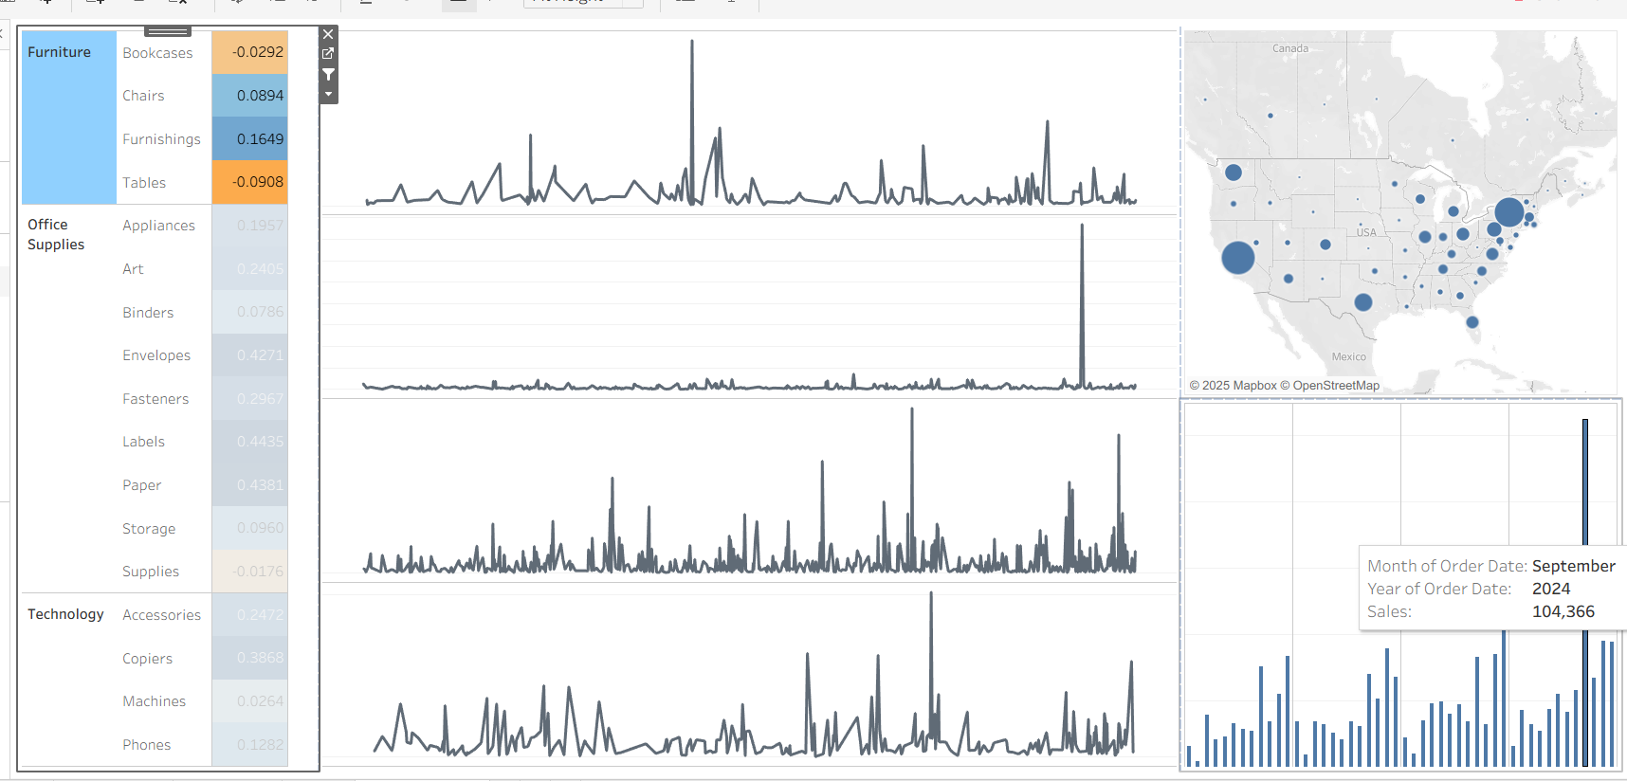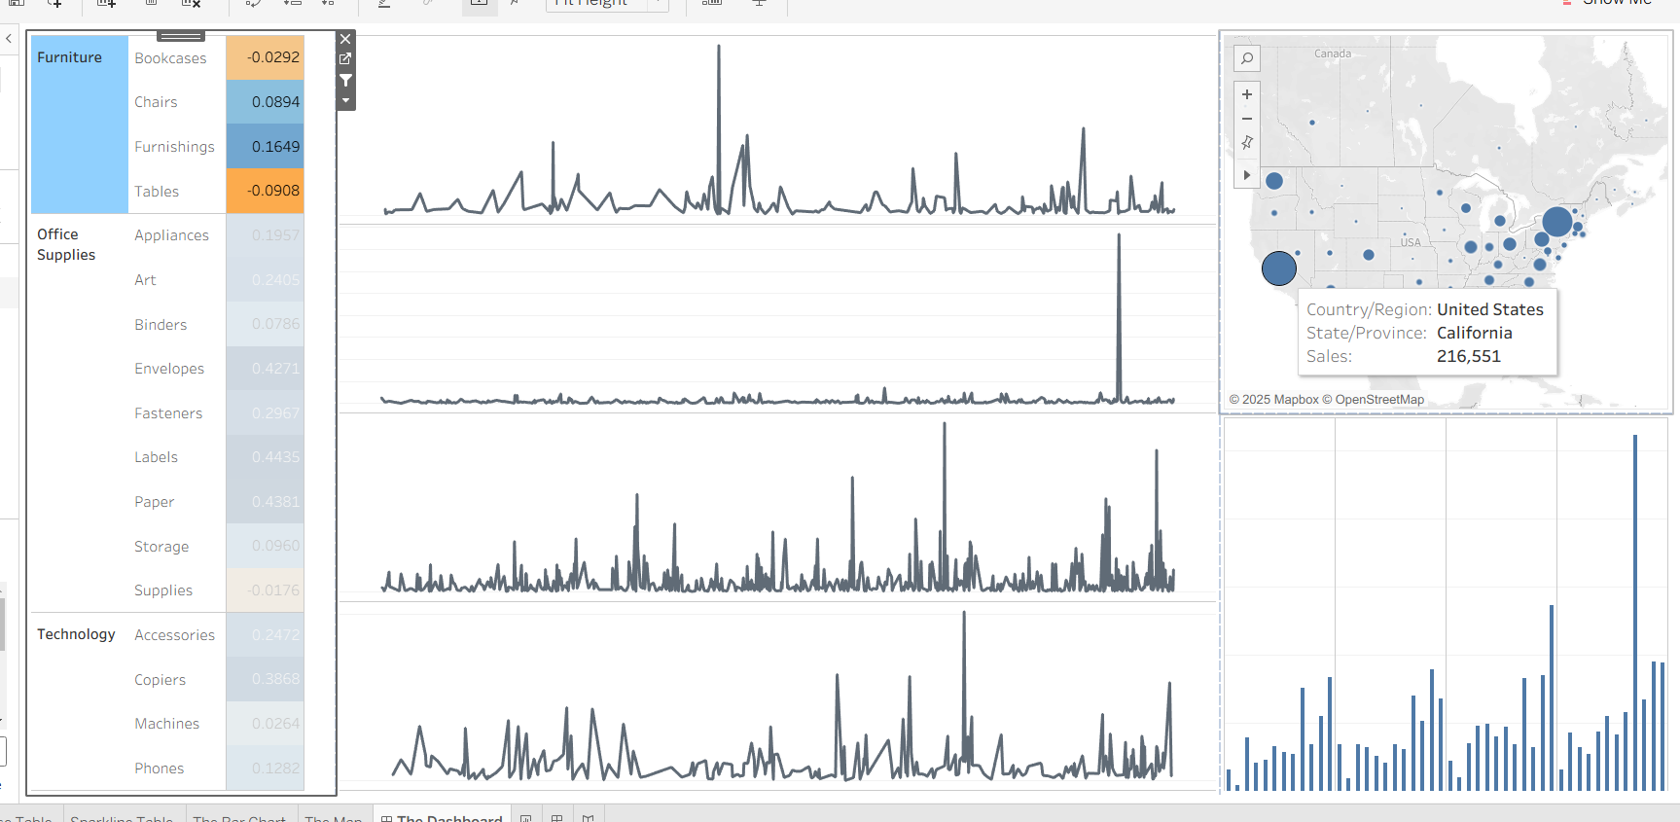
5. On the map, narrow down to the state of Texas (click on Texas and use it as a filter). Select
Technology products from the base table (use it as a filter) and then inspect the sparklines. Based
on your inspection, provide a short, one-paragraph report to top management on the sales trends
for Technology products as well as the product subcategories, where you see the opportunities
for growth, and where you believe there are major concerns.
Answer: Texas revealed varied performance across subcategories, with Copiers leading in profit margin and sales, indicating a strong growth opportunity. Accessories and Phones also show moderate profit margins and consistent, though less pronounced, sales trends, suggesting stable but incremental growth in these segments. Meanwhile, Machines, which display the lowest profit margin and volatile sales pattern, present a significant concern and may require strategic review or targeted interventions. Overall, while Copiers are positioned for robust expansion in Texas, attention should be given to Machines to address underlying issues and improve profitability compared to other Technology subcategories.
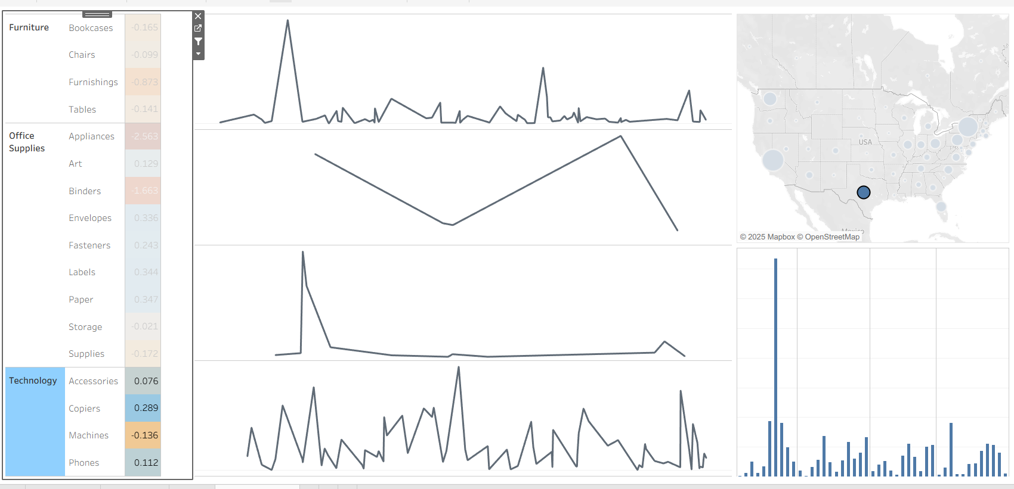
6. Which product subcategory in Q5 generated the lowest profit margin and what is that margin?
How does that profit margin compare with the profit margins for the other two subcategories?
Answer:
For Technology products in Texas, the subcategory "Machines" generated the lowest profit margin, with a margin of -0.136. In comparison, "Accessories" had a profit margin of 0.076, and "Copiers" had the highest at 0.289. Thus, Machines underperformed significantly compared to the other two subcategories, as its profit margin is negative while both Accessories and Copiers remain positive, indicating much stronger profitability for those segments.
