1a.
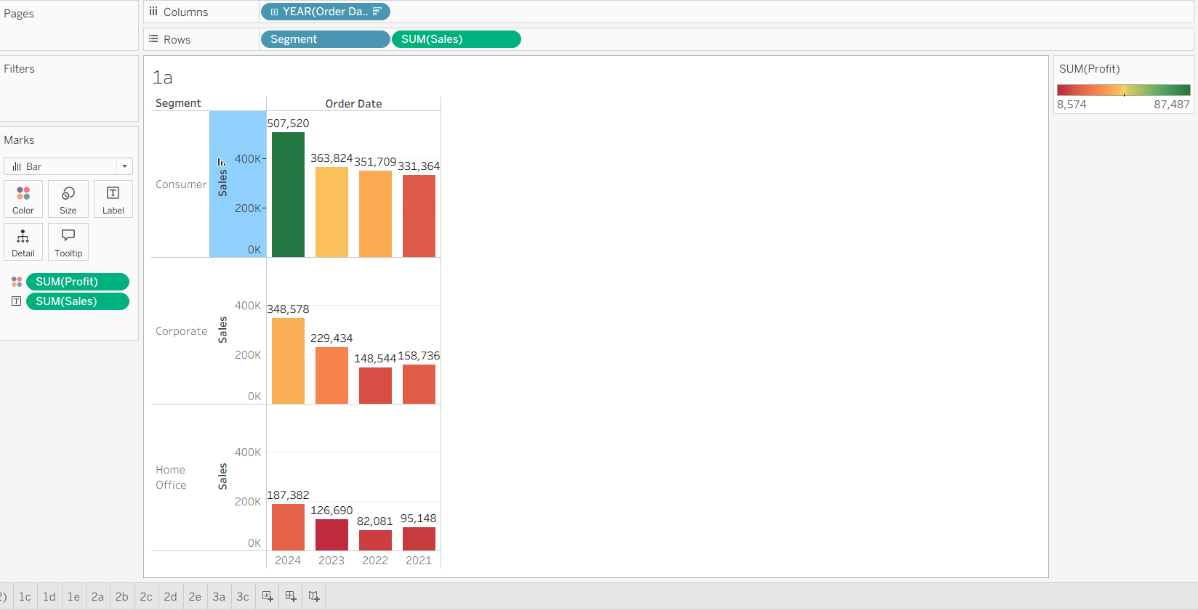

- Based on the graph the segment and year that generated the highest sales is Consumer Segment in Year 2024.
- Based on Colour graph the segment and year that generated the highest profit is again Consumer Segment in Year 2024 highlighted in Green colour.
1b.
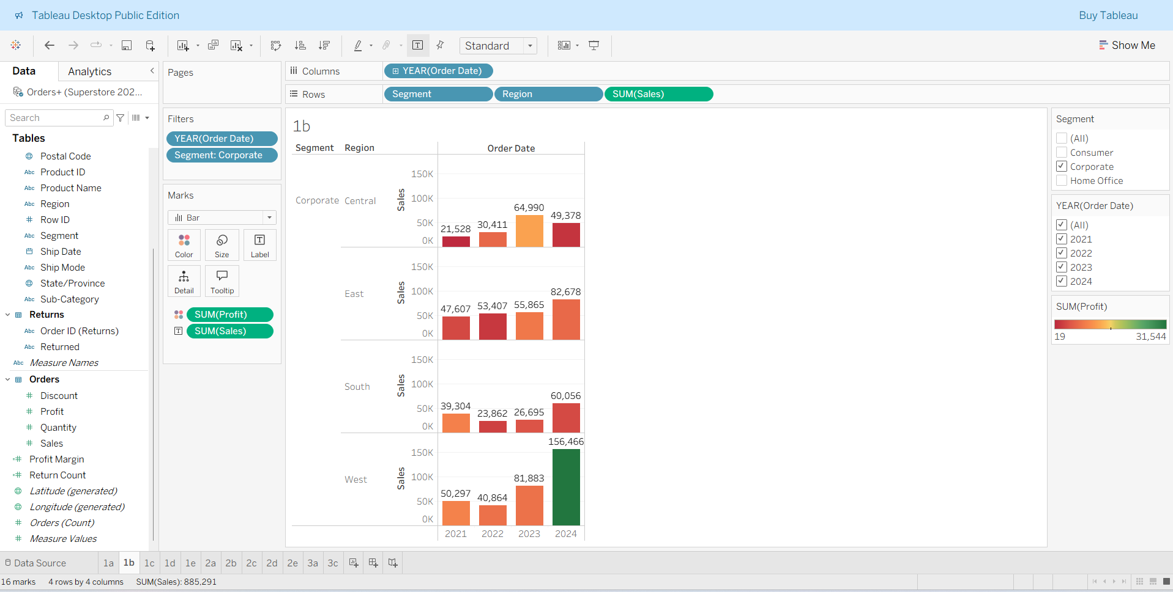
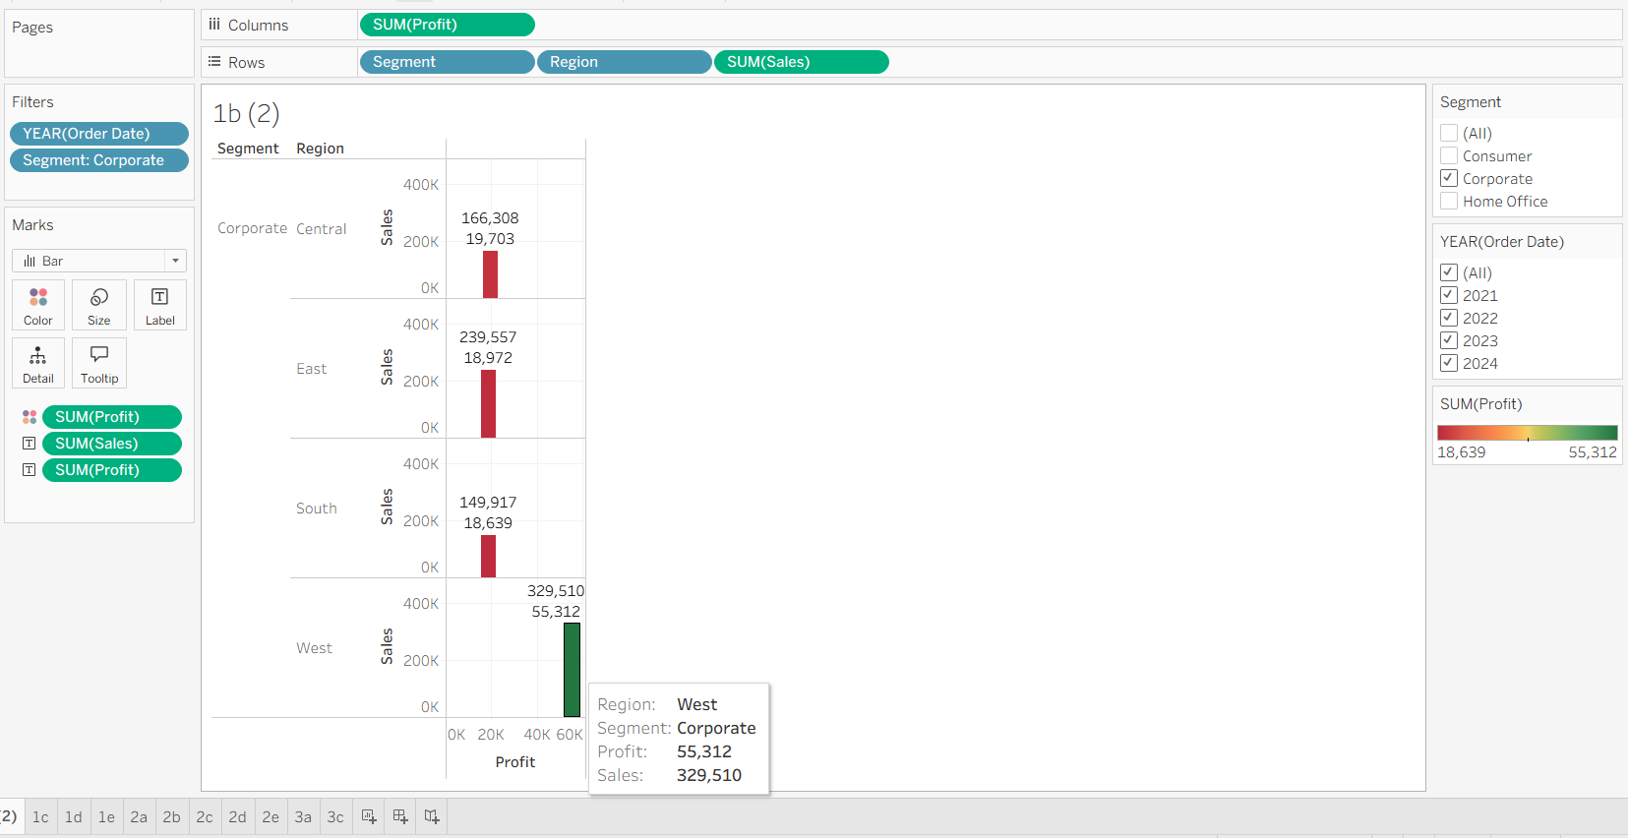
Region with Maximum Profit (Corporate Segment)
- The West Region clearly shows the darkest green bar and highest profit value (~$55,312).
- Other regions (Central, East, South) have lighter or reddish colors indicating lower or even negative profits.
Therefore, the Corporate–West region generated the maximum profit across the years.
Region Showing a Dramatic Turnaround
- Observing the East Region:
  - In earlier years (2021–2022), the bars are reddish/orange (low or negative profit).
  - In 2023–2024, they shift toward neutral/light green, indicating improved profitability.
- That change in color from red → green shows a dramatic turnaround in performance.
Therefore, the East Region (Corporate segment) experienced a major improvement in profit performance over the years.

1c.
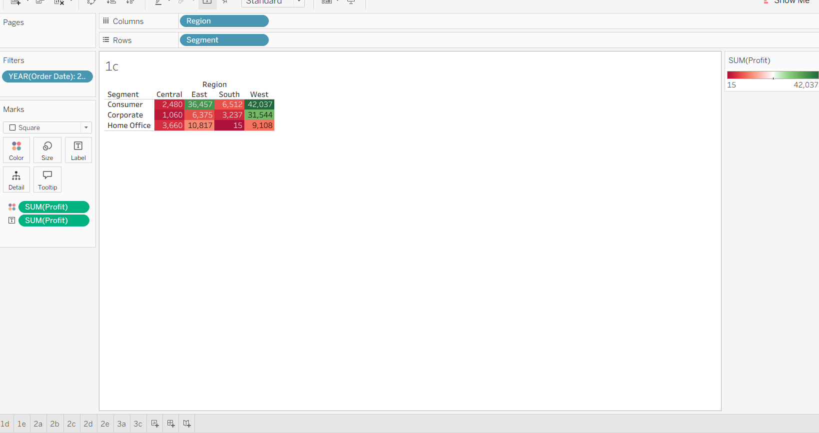
- The region combination that yields the highest total profit in 2024 from the above graph is Consumer in west regionm which is $42,037
1d.
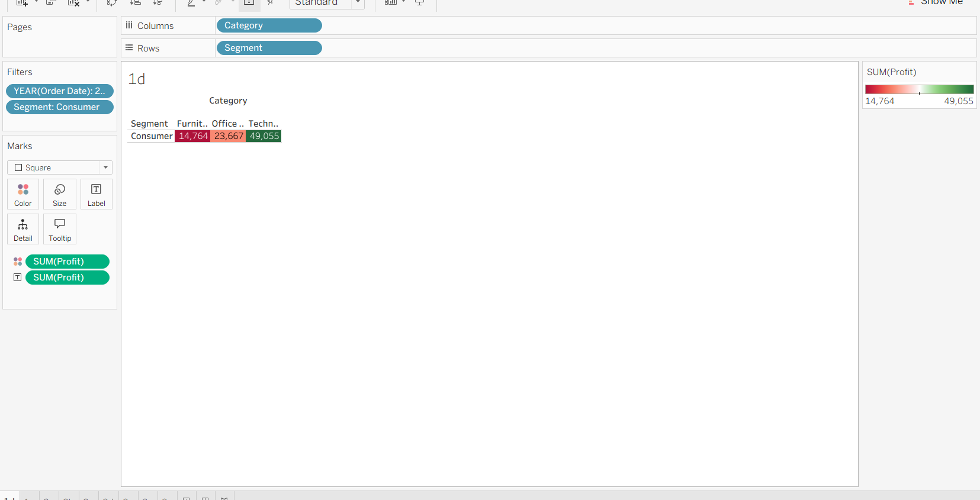
- After observing the above graph the particular category of products that contributes the most toward total profit in that segment(Consumer) for 2024 is Technology

1e.
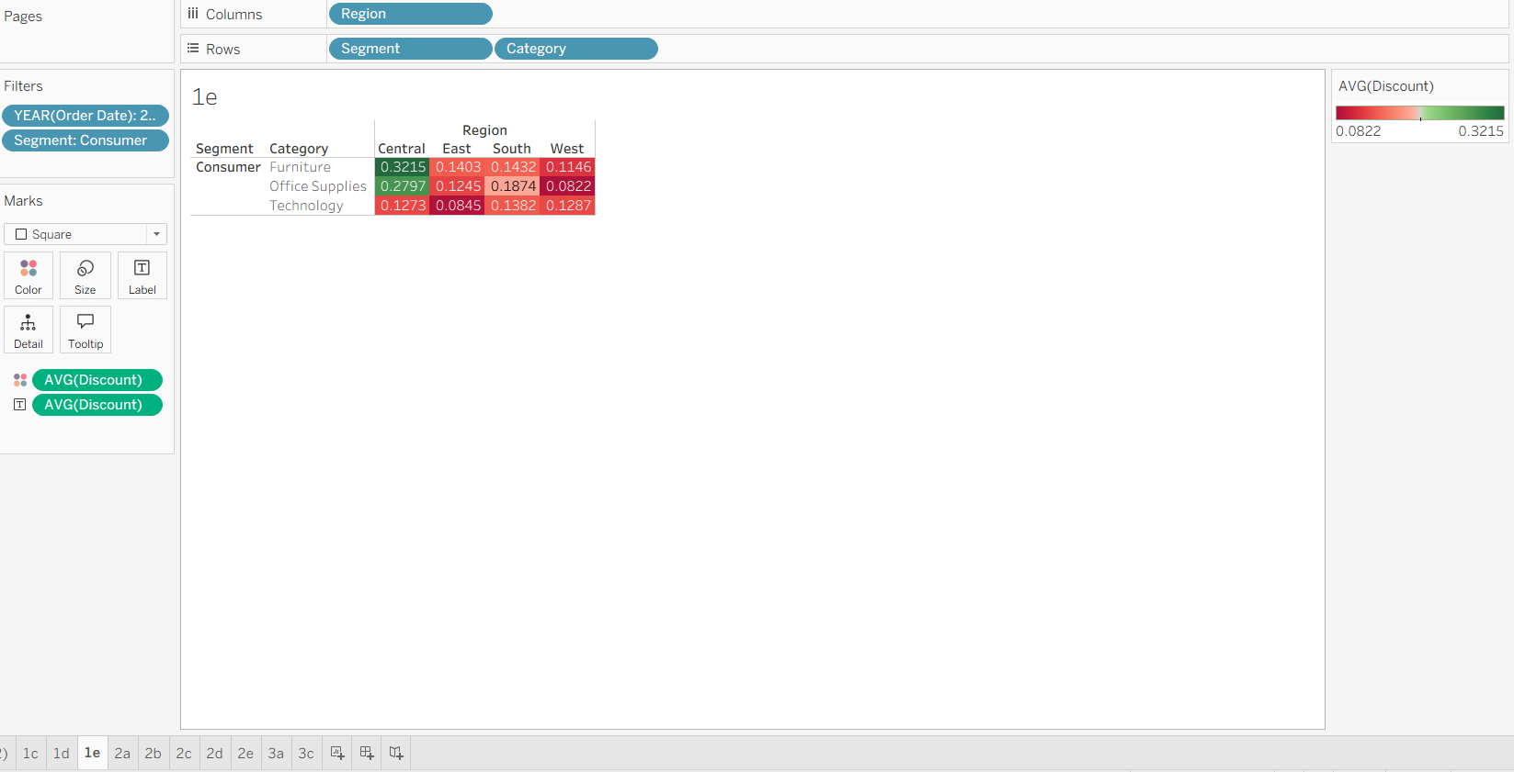
- The highest average discount is in the Furniture category – Central region,
with an average discount of approximately 0.3215 (32.15%).
- Other regions and categories have lower discounts (between 8%–18%).
Effectiveness:
- A 32% discount is quite high — it may help boost sales volume temporarily,
but it likely reduces profit margins significantly.
- To improve performance, Superstore should review pricing strategy for Furniture in the Central region —
large discounts may not be sustainable unless they drive substantial sales growth.
In 2024, the highest average discount (32.15%) was in the Furniture category for the Central region. This high discount might attract customers but could hurt profitability if not balanced by higher sales.

2a.
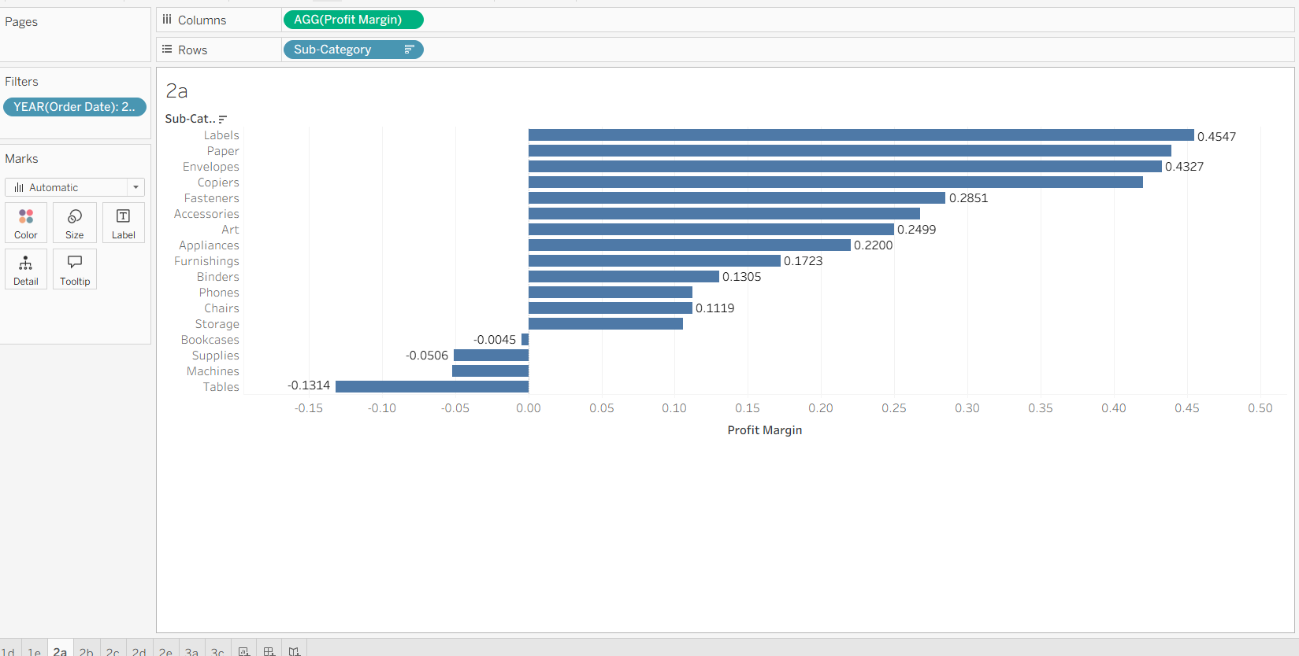

2b.
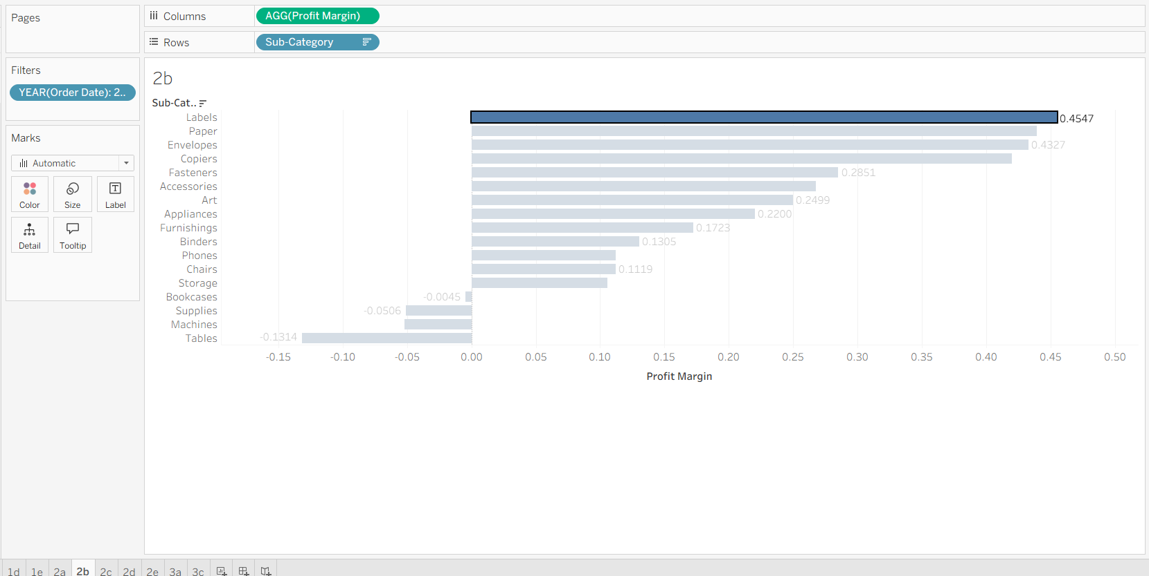
Based on chart for 2024, the product subcategory with the highest profit margin is:
Labels with a profit margin of approximately 0.4547 (45.47%).
That means Labels generated the highest profitability relative to sales among all subcategories in 2024.

2c.
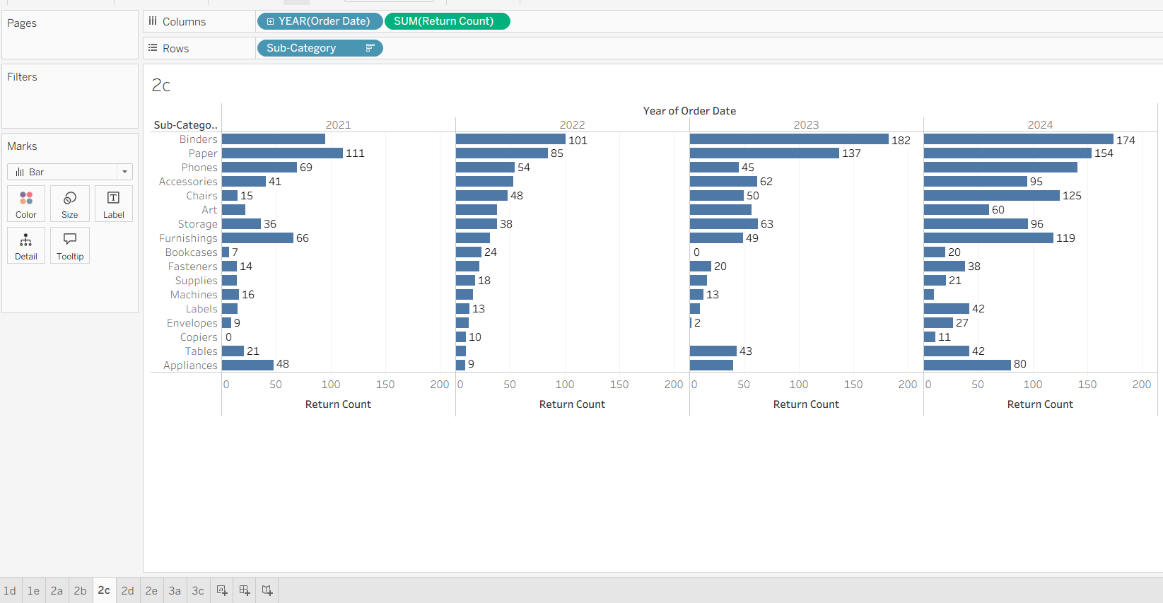

2d.
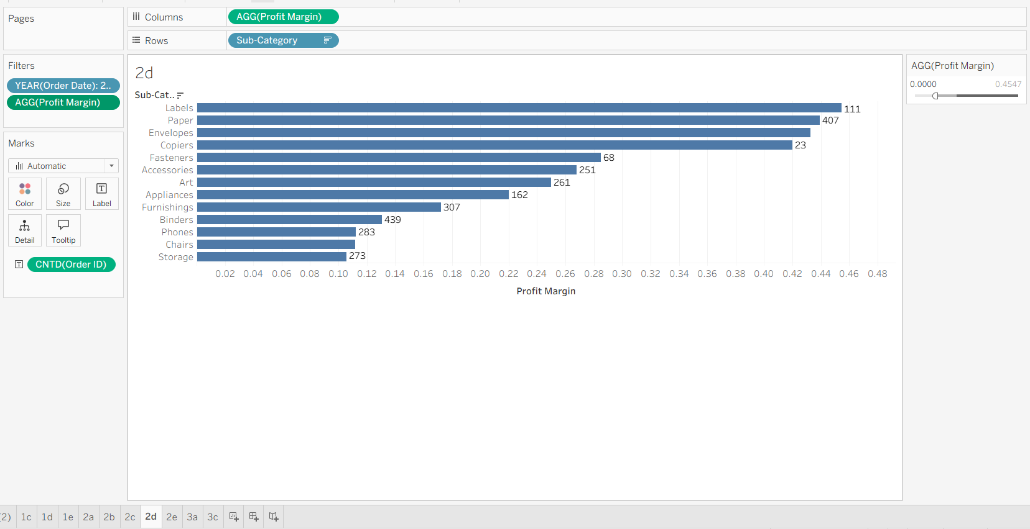

2e.
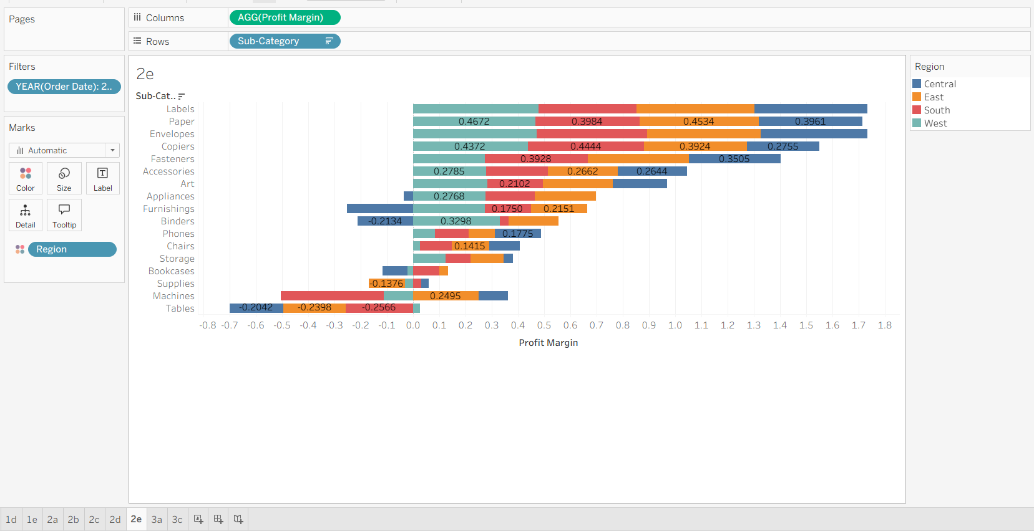
As a BI developer recommended Actions for Superstore
1. Focus on Underperforming Regions and Subcategories
- Target subcategories with negative or low profit margins in specific regions (such as Tables and Machines in the Central and South regions) for root-cause analysis and improvement strategies.​
- Investigate local customer preferences, competitive pressure, or operational inefficiencies leading to these lower margins.
2. Replicate Successes
- Analyze high-margin regions and subcategories (like Labels and Paper in all regions) to determine best practices that can be scaled to weaker areas.​
- Implement sales, marketing, and operational tactics from high-performing regions across the underperforming ones.
3. Product Portfolio and Promotions
- Consider repositioning or promoting products with consistent profitability across regions (e.g., Copiers, Fasteners).​
- For subcategories experiencing cross-regional profit disparity, tailor promotions and pricing strategies regionally, targeting areas needing margin growth.
4. Operational Efficiency
- Audit supply chains, cost structures, and vendor negotiations by region for subcategories consistently underperforming in specific locales.
- Streamline logistics to reduce costs in Central and South, especially for tables and machines subcategories.​
These targeted actions will help Superstore drive improved profitability and operational success across all regions based on the data visualization.​

3a.
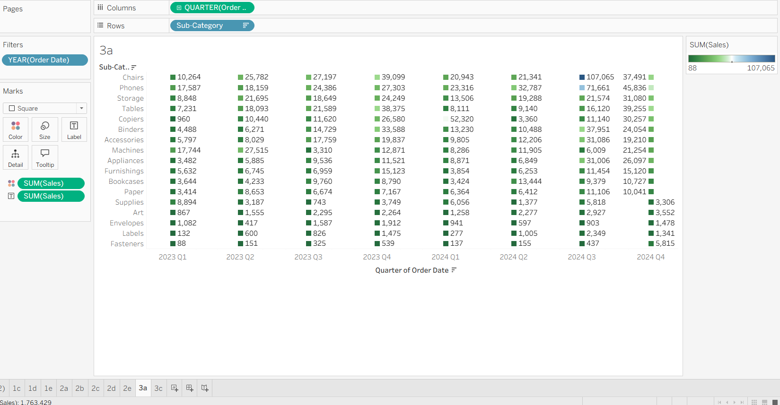

3b.
Observations from Quarterly Sales Analysis (2023–2024)
- Sales fluctuate across quarters, showing seasonal and category-specific variations.
- 2024 Q3 records the highest overall sales, driven mainly by spikes in top-performing subcategories.
- Chairs show an exceptional surge in 2024 Q3 (107,065) — the highest across all periods.
- Phones maintain consistently strong sales, peaking in 2024 Q3 (71,661) before a slight dip in Q4.
- Storage and Tables display steady growth, with notable peaks in late quarters (Q3–Q4).
- Appliances, Machines, and Bookcases show moderate but stable quarterly sales.
- Low-selling subcategories like Labels, Fasteners, Envelopes, Art, and Supplies remain consistently minimal.
- End-of-year quarters (Q3–Q4) generally perform better, suggesting seasonal demand or budget-cycle effects.
- Overall, there is a positive year-over-year growth trend from 2023 to 2024.
Overall Trends
- Sales fluctuate significantly across quarters — there isn’t a uniform trend, which suggests seasonality or fluctuating demand across product categories.
- 2024 Q3 shows a major spike for several sub-categories, indicating a strong quarter overall.
Seasonal or Cyclical Behavior
- There’s a noticeable increase in sales during Q3 and Q4 of both years for several categories (Tables, Chairs, Phones, Appliances).
This could indicate higher end-of-year purchasing — possibly due to fiscal year-end budgets or holiday-driven deman
High-Performing Sub-Categories
- Chairs – The most striking pattern: sales peak dramatically in 2024 Q3 (107,065), far higher than any other value in the table. This could reflect large corporate or institutional purchases.
- Phones – Strong performance throughout, with noticeable growth in 2024 Q3 (71,661) before slightly dropping in Q4. Phones maintain relatively high and consistent sales across all quarters.
- Storage – Shows fairly steady sales, peaking again in 2024 Q3 (21,574).
- Tables – Another steady performer, with a strong Q4 pattern both years, especially 2023 Q4 (38,375) and 2024 Q4 (39,255).

3c.

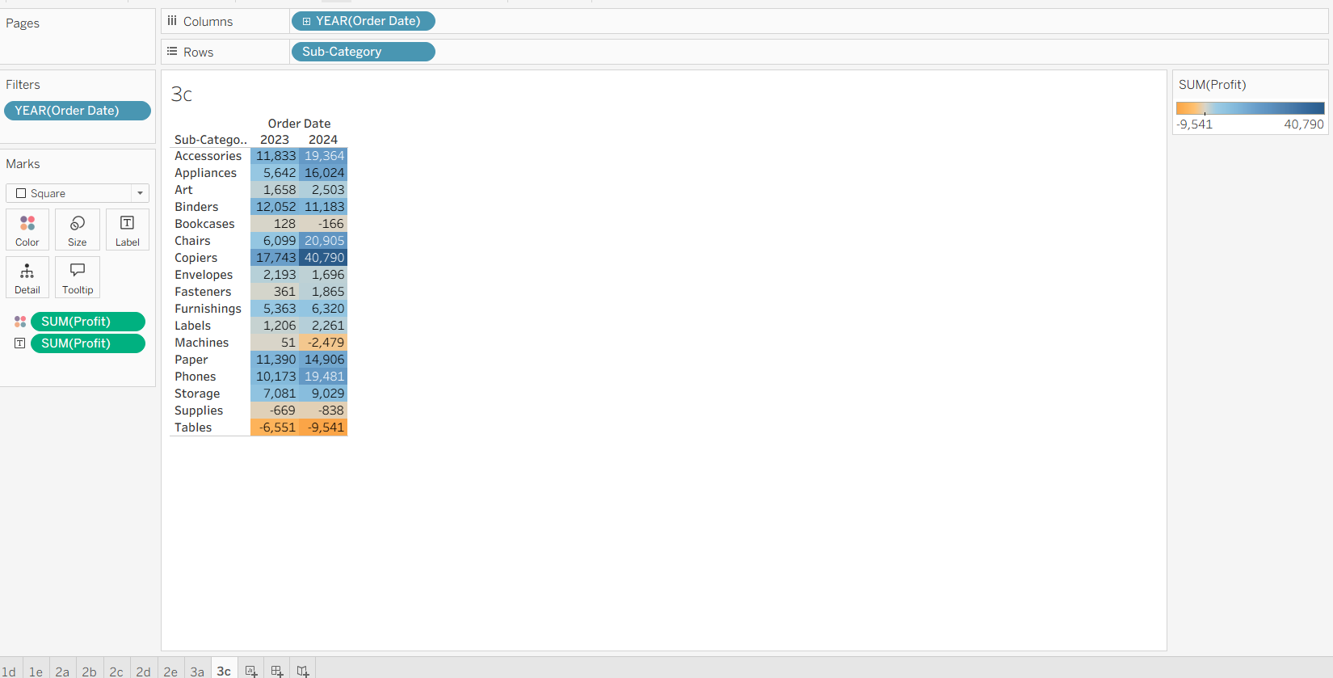

3d.

Opportunities
- Strong Profit Growth:
Subcategories such as Copiers, Chairs, Phones, and Accessories show consistently high and rising profits from 2023 to 2024 — these can be further leveraged through targeted marketing or expanded inventory.
- Increased Profitability in 2024:
Most subcategories show improved profits year-over-year, indicating effective cost control or stronger demand — an encouraging sign for scaling operations.
- High-margin Segments:
Copiers (40,790) and Phones (19,481) yield substantial margins, suggesting they are key profit drivers. Investing in these categories (e.g., premium models, bundled service plans) could sustain growth.
- Potential for Cross-Selling:
Profitable categories like Accessories and Appliances can be bundled with other products (e.g., office furniture or electronics) to boost overall revenue.
Challenges
- Negative Profit Categories:
Tables show consistent losses (–6,551 in 2023, –9,541 in 2024) — this is a red flag. The company should assess production, pricing, or discounting strategies in this segment.
- Low Contribution Items:
Bookcases, Supplies, Labels, and Envelopes have minimal profits, suggesting low demand or high operational costs. These may require reevaluation or optimization.
- Profit Concentration Risk:
A large share of total profit is concentrated in a few categories (Copiers, Chairs, Phones). Over-reliance on these could make the business vulnerable to market or supply changes.
- Cost Structure Variability:
Even with rising sales (from earlier charts), certain items don’t yield matching profit increases, indicating cost or pricing inefficiencies that need correction.
Summary
Superstore is experiencing strong overall profit growth, especially in high-margin categories like Copiers, Chairs, and Phones. However, persistent losses in Tables and low profitability in several smaller categories highlight the need for strategic product line adjustments, better pricing strategies, and cost management.

