**New:**

**Online French**

**Spring 2, 2020 (June 20-August 8)**

|  |
| --- |
|  |
|  |

**ELF102.7362 (64485)**

**Elementary French 2**  **(3 credits)**

**Learn French online on your schedule**

All meetings are conducted online

**REGISTER TODAY!**

## Challenge yourself: Continue learning French and exploring a different culture.

ELF102 is designed for students who have completed ELF101. If you have not, you may take a placement test in B-206.

ELF102 satisfies World Cultures and

Global Issues requirement of

Pathways Flexible Core

 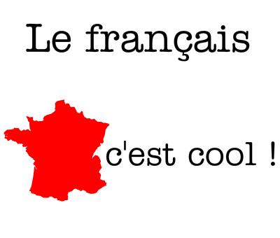 

For more information, contact Prof- Habiba Boumlik

[hboumlik@lagcc.cuny.edu](mailto:hboumlik@lagcc.cuny.edu)