
UNIVERSITY OF TRANSPORT AND COMMUNICATIONS
FACULTY OF INTERNATIONAL EDUCATION
--------------
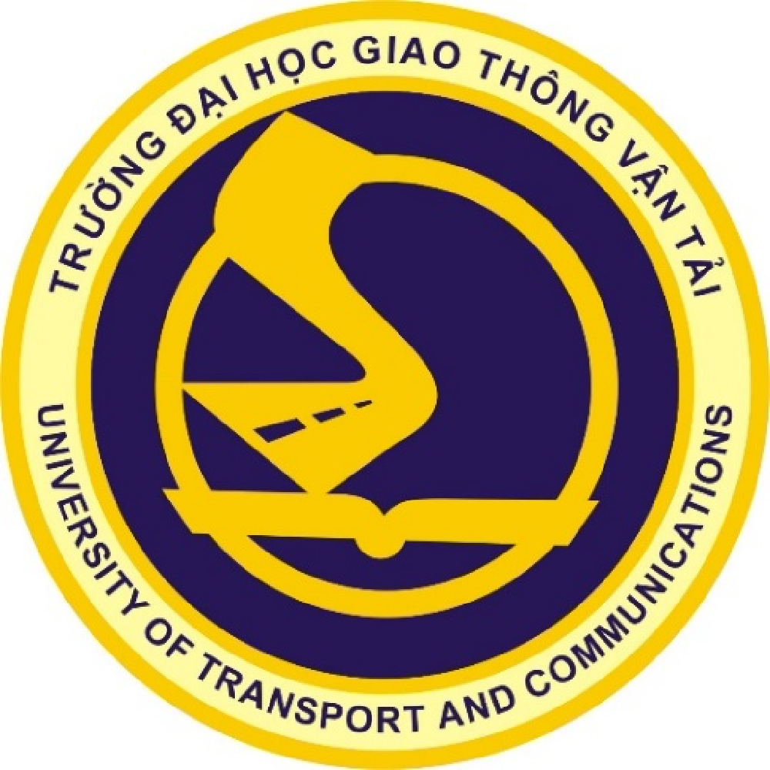

BACHELOR THESIS
TITLE

Fullname :
Student ID :
Class : Vietnamese – English Information Technology
Supervisor :

Hanoi – 2025
UNIVERSITY OF TRANSPORT AND COMMUNICATIONS
FACULTY OF INTERNATIONAL EDUCATION
--------------

BACHELOR THESIS
TITLE

Fullname :
Student ID :
Class : Vietnamese – English Information Technology
Supervisor :

Hanoi – 2025

