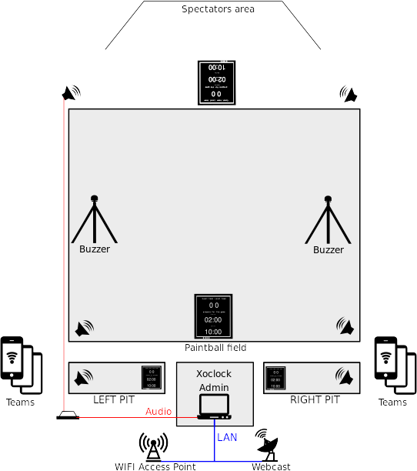
Xoclock – system description

Xball paintball field and tournament controller clock

Main features

- displays the game-time, and the break-time, and everything to stay informed
- Admin can start/stop games and matches, issue time and no point commands
- counts points, towels, timeouts, overtime, score - according to chosen formats
- Teams members can announce a Timeout, Towel, No-show if the game status permits
- announces with a female voice
- supports the dual-pit system
- fades the background music in an out automatically for the breaks
- use any tablet, smartphone, or notebook to connect as control client
- supports keyboard-inputs for buzzers, and referee functions

Technical details

- network enabled, open-source application-system, for X-ball games
- Uses web and Linux technologies, bash, node.js, socket.io, bootstrap
- modular extendable software to extend and to contribute to
- main clock is a computer acting as a http and sound-server
- view-only broadcast with http, log in with https as admin or as team
- Settings and Team-index in JSON format
- Pin for https authentication
- Announcement powered by the soundoftext.com engine with fallback to espeak
- downloads the team-name voice files automatically (needs internet on deployment)
- Black on white or white on black to properly use on screens or projectors

Xoclock – system description

Prepare the operating system
- For production, eg Tournaments and Fields, I suggest to dedicate an OS.
- best is to get the latest [fedora](https://getfedora.org/)
- can be installed manually on any unix-like operating system.
- any kind of bootable drive can be used, or it can be installed on a spare partition.

Software installation – in the terminal
- git clone https://github.com/LaKing/xoclock.git
- cd xoclock && ./install.sh (or the equivalent commands on other distributions)
- ./start.sh (will start the application, and vlc music playback in a terminal)
- default ports are used for http and https

Customize
- Make sure music files are present in the ~/Music folder
- edit settings.json to modify the defaults
- import or customize the team index.json (team, pass / hash)
- ./make-groups.sh will create a round-robin schedule based on team index

Extend
- Configure your buzzer, livestream, webcast, etc, ..

Beep sounds and music can be played back on the hosting server.
Announcements are best played in a chrome browser. Two soundcards can be used, so that beeps are on the sysdefault alsa soundcard, music and chrome speech on a secondary soundcard via pulseaudio. This makes it possible to use a tweeter.

Create your Buzzers with DIY techniques!

You can build your own buzzers and attach them to the xoclock system. Options are:
- Wired or Wireless USB keyboard
- Ethernet connection

The average distance between the buzzer and the controller is approx. 33 meters on a standard layout. Our experiments show that modern wireless keyboards are capable to transmit signals outdoors on a range of 80 meters, thus special one-key keyboards can be built with some DIY techniques. The only requirement is that the transmitter and the receiver have free visual to each other, thus I recommend to connect the buzzer button to the keyboard that acts as the transmitter.

On Fedora and other Gnome based systems like Ubuntu, the best option to assign custom buttons to the Xoclock systems is via settings → Keyboard / Keyboard shortcuts. These have to be set according to your hardware. Here is an example:

"/bin/bash /home/x/xoclock/key-input.sh left"
F1
"/bin/bash /home/x/xoclock/key-input.sh right"
F9
"/bin/bash /home/x/xoclock/key-input.sh leftpit"
F2
"/bin/bash /home/x/xoclock/key-input.sh rightpit"
F8

This would be a valid xbindkeys config, but xbindkeys is deprecated with wayland.
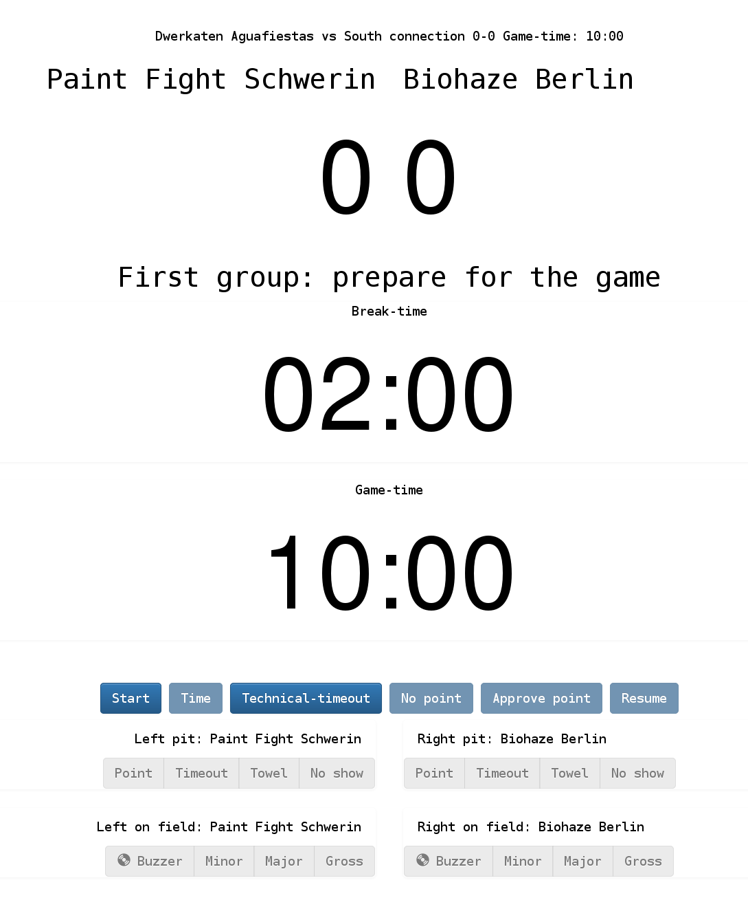
The Clock screen

Buttons are inactive/invisible if the user/viewer is not authorized to use them.
Mobile devices have a slightly different view.

Clock screen Primary buttons – Admin only

Start: Start the game.
If the game is already running, set the break-time to 15 seconds.

Time: Starts and Stops the clock.

Technical-Timeout: Announces “Technical timeout”.

No point: Starts the break, and announces no point.
Approve-point: if the buzzer was pressed, approve point for the side.

Resume: Continue the game.

Team buttons – Admin and playing teams.

Point: Admin only - award the point to the team.

Timeout: Request for the extension of the break.

Towel: Drop the towel while the game is running.
Awards point for the opposing team.

No show: Announce a no show.

Pressing any area outside of the buttons will switch color theme.

Additionally to the remote control over browser, a keyboard or an external USB numeric keypad can be used to control the software.For example:

7 – point left team
4 – timeout left team
1 – towel left team

9 – point right team
6 – timeout right team
3 – towel right team

Enter – start
+ – time
* – stop
0 – no point

Arrow Up / Arrow Down – volume
5 – announce on/off

Pages
- clock.html
- games.html
- schedule.html
- settings.html
- scoreboard.html
- admin.html
- debug.html

