PM_analysis
Laura Kwong
11/06/2019
R verion 3.6.1 downloaded 6 Nov 2019
https://cran.r-project.org/web/packages/MakefileR/vignettes/demo.html
sensor_pull_data.R is in the “munge” folder
#Input Files
list_of_file_path_pats_pre_intervention <- "C:/Users/admin/Google Drive (lakwong@stanford.edu)/Rohingya/Rohingya research - Fuel/Sensors/ALL DATA/Pre_intervention/PATS+"
list_of_file_path_pats_intervention <- "C:/Users/admin/Google Drive (lakwong@stanford.edu)/Rohingya/Rohingya research - Fuel/Sensors/ALL DATA/Intervention/PATS+"
list_of_file_path_hapex_pre_intervention <- "C:/Users/admin/Google Drive (lakwong@stanford.edu)/Rohingya/Rohingya research - Fuel/Sensors/ALL DATA/Pre-intervention/HAPEX"
list_of_file_path_hapex_intervention <- "C:/Users/admin/Google Drive (lakwong@stanford.edu)/Rohingya/Rohingya research - Fuel/Sensors/ALL DATA/Intervention/HAPEX"
### Output Files RDS
all_pm_data_path_rds <- "C:/Users/admin/Google Drive (lakwong@stanford.edu)/Rohingya/Rohingya research - Fuel/Sensors/ALL DATA/PATS+_Data_20191119.rds"
all_hapex_data_path_rds <- "C:/Users/admin/Google Drive (lakwong@stanford.edu)/Rohingya/Rohingya research - Fuel/Sensors/ALL DATA/Hapex_Data_20191119.rds"
all_hapex_data_path_csv <- "C:/Users/admin/Google Drive (lakwong@stanford.edu)/Rohingya/Rohingya research - Fuel/Sensors/ALL DATA/Hapex_Data_20191119.csv"
pm_data_min_rds <- "C:/Users/admin/Google Drive (lakwong@stanford.edu)/Rohingya/Rohingya research - Fuel/Sensors/ALL DATA/pm_data_min.rds"
pm_data_nearest_min_rds <- "C:/Users/admin/Google Drive (lakwong@stanford.edu)/Rohingya/Rohingya research - Fuel/Sensors/ALL DATA/pm_data_nearest_min.rds"
pm_data_hour_rds <- "C:/Users/admin/Google Drive (lakwong@stanford.edu)/Rohingya/Rohingya research - Fuel/Sensors/ALL DATA/pm_data_hour.rds"
pm_data_nearest_hour_rds <- "C:/Users/admin/Google Drive (lakwong@stanford.edu)/Rohingya/Rohingya research - Fuel/Sensors/ALL DATA/pm_data_nearest_hour.rds"
pm_data_min_csv <- "C:/Users/admin/Google Drive (lakwong@stanford.edu)/Rohingya/Rohingya research - Fuel/Sensors/ALL DATA/pm_data_min.csv"
pm_data_nearest_min_csv <- "C:/Users/admin/Google Drive (lakwong@stanford.edu)/Rohingya/Rohingya research - Fuel/Sensors/ALL DATA/pm_data_nearest_min.csv"
pm_data_hour_csv <- "C:/Users/admin/Google Drive (lakwong@stanford.edu)/Rohingya/Rohingya research - Fuel/Sensors/ALL DATA/pm_data_hour.csv"
pm_data_nearest_hour_csv <- "C:/Users/admin/Google Drive (lakwong@stanford.edu)/Rohingya/Rohingya research - Fuel/Sensors/ALL DATA/pm_data_nearest_hour.csv"
# Manually move the compiled file into the raw folder of the project
file_pm_data_base <- here::here("data", "raw", "PATS+_Data_20191119.rds")
file_HAPEX_data_base <- here::here("data", "raw", "HAPEX_Data_20191119.rds")

File of Pats+ Data
list_of_files_pats_pre_intervention <-
list.files(
path = list_of_file_path_pats_pre_intervention,
recursive = TRUE,
pattern = "*.csv",
full.names = TRUE
)
list_of_files_pats_intervention <-
list.files(
path = list_of_file_path_pats_intervention,
recursive = TRUE,
pattern = "*.csv",
full.names = TRUE
)
list_of_files_pats <- c(list_of_files_pats_pre_intervention, list_of_files_pats_intervention)
all_pm_data <-
list_of_files_pats %>%
set_names(sub(".*/", "", list_of_files_pats)) %>% # added file_name as first column value
map_dfr(
~ read_csv(
.x,
col_types =
cols(
"c", "d", "d", "d", "d", "d", "d",
"d", "d", "d", "d", "d", "d", "d", "d", "d"
),
skip = 31,
col_names = FALSE,
),
.id = "file_name" # labeled first column with as "file_name"
) %>%
select(-X) %>% # I don't know why there is an empty column X at the end
mutate(
file_name = str_replace(file_name, "\\..*","")
) %>%
`colnames<-`( # must be exactly `colnames<-`
c(
"file_name", "dateTime",
"V_power", "degC_sys", "degC_air", "RH_air",
"degC_CO", "CO_PPM", "status", "ref_sigDel",
"low20avg", "high320avg", "motion", "CO_mV",
"ignore", "iButton_Temp", "PM_Estimate"
)
)
## Warning: Unnamed `col_types` should have the same length as `col_names`. Using
## smaller of the two.
## Warning: Unnamed `col_types` should have the same length as `col_names`. Using
## smaller of the two.
## Warning: Unnamed `col_types` should have the same length as `col_names`. Using
## smaller of the two.
## Warning: Unnamed `col_types` should have the same length as `col_names`. Using
## smaller of the two.
# mutate(dateTime_lubridated = lubridate::ymd_hms(dateTime, tz = "Asia/Dhaka", locale = Sys.getlocale("LC_TIME"), truncated = 3)) %>%
all_pm_data %>%
saveRDS(all_pm_data_path_rds)
all_pm_data %>%
saveRDS(file_pm_data_base)

Hapex Data
list_of_files_hapex_pre_intervention <-
list.files(
path = list_of_file_path_hapex_pre_intervention,
recursive = TRUE,
pattern = "*.csv",
full.names = TRUE
)
list_of_files_hapex_intervention <-
list.files(
path = list_of_file_path_hapex_intervention,
recursive = TRUE,
pattern = "*.csv",
full.names = TRUE
)
list_of_files_hapex <- c(list_of_files_hapex_pre_intervention, list_of_files_hapex_intervention)
all_hapex_data <-
list_of_files_hapex %>%
set_names(sub(".*/", "", list_of_files_hapex)) %>% # added file_name as first column value
map_dfr(
~ read_csv(
.x,
col_types =
cols("c", "d", "d"),
skip = 29,
col_names = FALSE,
),
.id = "file_name" # labeled first column with as "file_name"
) %>%
mutate(
file_name = str_replace(file_name, "\\..*","")
) %>%
`colnames<-`(
c(
"file_name", "timestamp", "mother_compliance", "mother_pm"
)
)
all_hapex_data %>%
saveRDS(all_hapex_data_path_rds)
all_hapex_data %>%
saveRDS(all_hapex_data_path_rds)
write.csv(all_hapex_data, all_hapex_data_path_csv)
# mutate(dateTime_lubridated = lubridate::ymd_hms(dateTime, tz = "Asia/Dhaka", locale = Sys.getlocale("LC_TIME"), truncated = 3)) %>%

Clean data
Still not clean, must look at google sheet for other adjustments that need to be made.

Check data quality

Insufficient data
Were any hh recorded for less than 48 hours but not recorded as “Insufficient data”?
pm_data_hour_per_monitor_pre_revision <-
pm_data %>%
group_by(study_arm, note, hh_id, hh_id_note, dateTime_hour) %>%
summarise_at(
vars(PM_Estimate),
list(mean),
na.rm = TRUE
) %>%
group_by(study_arm, note, hh_id, hh_id_note) %>%
count() %>%
ungroup() %>%
rename(hours_recording = n)
pm_data_hour_per_monitor_pre_revision %>%
filter(hours_recording < 48)
## # A tibble: 5 x 5
## study_arm note hh_id hh_id_note hours_recording
## <ord> <chr> <chr> <chr> <int>
## 1 pre-intervent~ insufficient~ 8wDH2129~ 8wDH21291216_insuffici~ 16
## 2 pre-intervent~ normal 10G193127 10G193127_normal 37
## 3 pre-intervent~ normal 8wDI1810~ 8wDI18100959_normal 46
## 4 pre-intervent~ qc 8wDI2010~ 8wDI20101777_qc 20
## 5 intervention normal 4E184708 4E184708_normal 47
# Label files will insufficient data
pm_data <-
pm_data %>%
mutate(
# 10G193127_normal
note = ifelse(hh_id_note == "10G193127_normal", "insufficient data", note),
hh_id_note = ifelse(hh_id_note == "10G193127_normal", "10G193127_insufficient data", hh_id_note),
# 8wDI18100959
note = ifelse(hh_id_note == "8wDI18100959_normal", "insufficient data", note),
hh_id_note = ifelse(hh_id_note == "8wDI18100959_normal", "8wDI18100959_insufficient data", hh_id_note),
# 4E184708
note = ifelse(hh_id_note == "4E184708_normal", "insufficient data", note),
hh_id_note = ifelse(hh_id_note == "4E184708_normal", "4E184708_insufficient data", hh_id_note)
)
pm_data_hour_per_monitor <-
pm_data %>%
group_by(study_arm, note, hh_id, hh_id_note, dateTime_hour) %>%
summarise_at(
vars(PM_Estimate),
list(mean),
na.rm = TRUE
) %>%
group_by(study_arm, note, hh_id, hh_id_note) %>%
count() %>%
ungroup() %>%
rename(hours_recording = n)
pm_data_hour_per_monitor %>%
filter(hours_recording < 48)
## # A tibble: 5 x 5
## study_arm note hh_id hh_id_note hours_recording
## <ord> <chr> <chr> <chr> <int>
## 1 pre-intervent~ insufficient~ 10G193127 10G193127_insufficient~ 37
## 2 pre-intervent~ insufficient~ 8wDH2129~ 8wDH21291216_insuffici~ 16
## 3 pre-intervent~ insufficient~ 8wDI1810~ 8wDI18100959_insuffici~ 46
## 4 pre-intervent~ qc 8wDI2010~ 8wDI20101777_qc 20
## 5 intervention insufficient~ 4E184708 4E184708_insufficient ~ 47

File naming?
Are files named correctly? (above we fixed names for “insufficient data” here check “qc” - are qc files named qc, not qc files not qc?)
hhid_with_qc <-
pm_data %>%
filter(note == "qc") %>%
distinct(hh_id)
# pm_data_not_censored %>%
# filter(hh_id %in% hhid_with_qc$hh_id) %>%
# filter(hh_id == "4E179029") %>%
# View()
# 4E179029 is labeled as "qc" but there's no accompanying file to be the not qc file, so rename 4E179029_qc to 4E179029
pm_data <-
pm_data %>%
mutate(
note = ifelse(hh_id_note == "4E179029_qc", "normal", note),
hh_id_note = ifelse(hh_id_note == "4E179029_qc", "4E179029_normal", hh_id_note)
)
pm_data %>%
filter(note == "qc") %>%
distinct(hh_id)
## # A tibble: 18 x 1
## hh_id
## <chr>
## 1 8wDI18224646
## 2 8wDI20101777
## 3 8wDI20274944
## 4 10D193579
## 5 10G105368
## 6 10G105460
## 7 10G108169
## 8 10G116129
## 9 10F113975
## 10 9G600021
## 11 10H286043
## 12 4E280792
## 13 4E277017
## 14 4E179247
## 15 4F283027
## 16 4F180644
## 17 4F296441
## 18 4E179624
1 8wDI18224646 2 8wDI20101777 3 8wDI20274944 4 10D193579
5 10G105368
6 10G105460
7 10G108169
8 10G116129
9 10F113975
10 9G600021
11 10H286043
12 4E280792
13 4E277017
14 4E179247
15 4F283027
16 4F180644
17 4F296441
18 4E179624

Create analysis datasets
# uses the actual minute (always rounds down to the nearest min)
pm_data_min <-
pm_data %>%
filter(note != "insufficient data") %>%
group_by(study_arm, note, hh_id, hh_id_note, dateTime_min) %>%
summarise_at(
vars(PM_Estimate),
list(mean),
na.rm = TRUE
) %>%
ungroup()
# rounds to the nearest min (up or down)
pm_data_nearest_min <-
pm_data %>%
filter(note != "insufficient data") %>%
group_by(study_arm, note, hh_id, hh_id_note, nearest_min) %>%
summarise_at(
vars(PM_Estimate),
list(mean),
na.rm = TRUE
) %>%
ungroup()
# uses the actual hour (always rounds down to the nearest hour)
pm_data_hour <-
pm_data %>%
filter(note != "insufficient data") %>%
group_by(study_arm, note, hh_id, hh_id_note, dateTime_hour) %>%
summarise_at(
vars(PM_Estimate),
list(mean),
na.rm = TRUE
) %>%
ungroup() %>%
mutate(
over_100 = if_else(PM_Estimate > 100, 1, 0),
over_500 = if_else(PM_Estimate > 500, 1, 0)
)
# rounds to the nearest hour (up or down)
pm_data_nearest_hour <-
pm_data %>%
filter(note != "insufficient data") %>%
group_by(study_arm, note, hh_id, hh_id_note, nearest_hour) %>%
summarise_at(
vars(PM_Estimate),
list(mean),
na.rm = TRUE
) %>%
ungroup() %>%
mutate(
over_100 = if_else(PM_Estimate > 100, 1, 0),
over_500 = if_else(PM_Estimate > 500, 1, 0)
)
pm_data_min %>%
saveRDS(pm_data_min_rds)
pm_data_nearest_min %>%
saveRDS(pm_data_nearest_min_rds)
pm_data_hour %>%
saveRDS(pm_data_hour_rds)
pm_data_nearest_hour %>%
saveRDS(pm_data_nearest_hour_rds)
write.csv(pm_data_min, pm_data_min_csv)
write.csv(pm_data_nearest_min, pm_data_nearest_min_csv)
write.csv(pm_data_hour, pm_data_hour_csv)
write.csv(pm_data_nearest_hour, pm_data_nearest_hour_csv)

Compare quality control and normal files
qc_check_1 <-
pm_data_nearest_min %>%
filter(
hh_id_note %in%
c(
"10D193579_normal", "10D193579_qc",
"10F113975_normal", "10F113975_qc",
"10G105368_normal", "10G105368_qc",
"10G105460_normal", "10G105460_qc",
"10G108169_normal", "10G108169_qc",
"10G116129_normal", "10G116129_qc"
)
) %>%
ggplot(aes(nearest_min, PM_Estimate, color = hh_id_note)) +
geom_line(na.rm = TRUE) +
# geom_hline(yintercept = 100, color = "grey", lty = 2) +
# geom_hline(yintercept = 500, color = "black", lty = 2) +
scale_x_datetime(labels = scales::date_format("%H:%M")) +
scale_color_brewer(palette = "Paired") + # Unsuprisingly, palette = "Paired" is probably the best, max size is 12
# Max size of palette = Accent is 8, Set1 is 9, of Set2 is 8, of Set3 is 10?
# The palette = "Accent" or "Set[x]" worked better then the type = "divergent"
# scale_color_brewer(type = "div", palette = "Spectral") +
theme_classic() +
theme(
legend.position = "none"
) +
labs(
title = "Quality control comparison",
y = "PM 2.5 (ug/cm3)",
x = "Time"
) +
facet_wrap(. ~ hh_id, ncol = 3, scales = "free_y") # facet_grid splits ONLY on the horizontal or vertical direction while facet_wrap only has a horizontal dimension
# facet_grid(vertical ~ horizontal) - plots on the same row cannot have different y-axes, similarly, only one x-axis per column
# facet_wrap only stacks plots horizontally - each plot is indep so can each can have diff x and y axes
qc_check_2 <-
pm_data_nearest_min %>%
filter(
hh_id_note %in%
c(
"10H286043_normal", "10H286043_qc",
"8wDI18224646_normal", "8wDI18224646_qc",
"8wDI20101777_normal", "8wDI20101777_qc",
"4E277017_normal", "4E277017_qc",
"4E280792_normal", "4E280792_qc",
"4F180644_normal", "4F180644_qc"
)
) %>%
ggplot(aes(nearest_min, PM_Estimate, color = hh_id_note)) +
geom_line(na.rm = TRUE) +
scale_x_datetime(labels = scales::date_format("%H:%M")) +
scale_color_brewer(palette = "Paired") +
theme_classic() +
theme(
legend.position = "none"
) +
labs(
title = "Quality control comparison",
y = "PM 2.5 (ug/cm3)",
x = "Time"
) +
facet_wrap(. ~ hh_id, ncol = 3, scales = "free_y")
qc_check_3 <-
pm_data_nearest_min %>%
filter(
hh_id_note %in%
c(
"4E280792_normal", "4E280792_qc",
"4F283027_normal", "4F283027_qc",
"8wDI20274944_normal", "8wDI20274944_qc",
"9G600021_normal", "9G600021_qc",
"4F296441_normal", "4F296441_qc",
"4E179247_normal", "4E179247_qc"
)
) %>%
ggplot(aes(nearest_min, PM_Estimate, color = hh_id_note)) +
geom_line(na.rm = TRUE) +
scale_x_datetime(labels = scales::date_format("%H:%M")) +
scale_color_brewer(palette = "Paired") +
theme_classic() +
theme(
legend.position = "none"
) +
labs(
title = "Quality control comparison",
y = "PM 2.5 (ug/cm3)",
x = "Time"
) +
facet_wrap(. ~ hh_id, ncol = 3, scales = "free_y")
qc_check_1
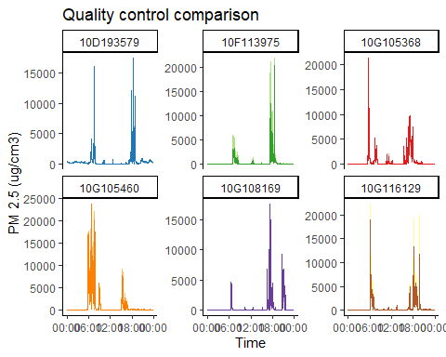
qc_check_2
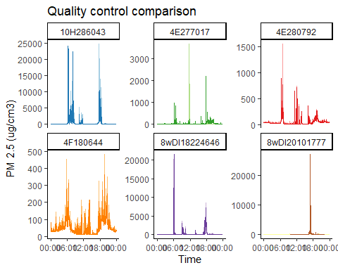
qc_check_3
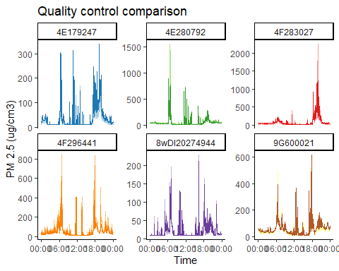
# ggsave(
# here::here("figs", "qc_check_3.png"),
# plot = last_plot(),
# scale = 0.8,
# height = 6,
# width = 10,
# units = "in",
# device = "png"
# )
# Are the outdoor values reasonable?
pm_data_nearest_min %>%
# filter(study_arm == "pre-intervention") %>%
filter(
note %in% c("mosque", "school")
) %>% # PM07745L_20191115_1_4F180644and PM07776R_20191115_1_4F180644_QC; PM07781I_20191115_1_4F296441 and PM07782G_20191115_1_4F296441_QC
# filter(dateTime_min > "2019-09-25", dateTime_min < "2019-09-26") %>%
ggplot(aes(nearest_min, PM_Estimate, color = hh_id_note)) +
geom_line(na.rm = TRUE) +
# geom_hline(yintercept = 100, color = "grey", lty = 2) +
# geom_hline(yintercept = 500, color = "black", lty = 2) +
scale_x_datetime(labels = scales::date_format("%H:%M")) +
# theme(
# legend.position = "none"
# )
# facet_grid(hh_id ~ ., scales = "free")
facet_wrap(. ~ hh_id_note, scales = "free")
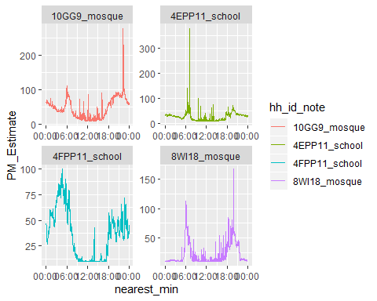
# pm_data_min$hh_id_note %>% unique()

Sample size
Now that we know the quality of the files is fine, determine the size of the data analysis sets
pm_data_hour_per_monitor %>%
filter(note != "qc") %>%
group_by(study_arm) %>%
summarise_at(
vars(hours_recording),
list(total_hours = sum, mean_hours = mean, median_hours = median)
) %>%
left_join(
pm_data %>%
filter(note != "qc") %>%
distinct(study_arm, hh_id) %>%
group_by(study_arm) %>%
count(),
by = "study_arm"
) %>%
select(study_arm, n, everything())
## # A tibble: 3 x 5
## study_arm n total_hours mean_hours median_hours
## <ord> <int> <int> <dbl> <dbl>
## 1 pre-intervention 111 5827 52.0 52
## 2 intervention 64 3289 52.2 52
## 3 outdoor 4 856 214 216
pre-intervention: 109 hh, mean 52.6 hr at each hh, total of 5728 hr intervention: 63 hh, mean 52.3 hr at each hh, total of 3293 hr outdoor: 4 locations, mean 214 hr at each location, total of 856 hr

Plot min-by-min data
pm_data_min %>%
filter(note != "qc") %>%
ggplot(aes(dateTime_min, PM_Estimate, color = hh_id)) +
geom_line(na.rm = TRUE) +
# geom_hline(yintercept = 100, color = "grey", lty = 2) +
# geom_hline(yintercept = 500, color = "black", lty = 2) +
theme(
legend.position = "none"
) +
facet_grid( ~ study_arm)
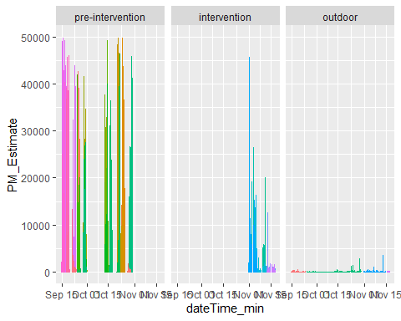
pm_data_nearest_min %>%
filter(note != "qc") %>%
ggplot(aes(nearest_min, PM_Estimate, color = hh_id)) +
geom_line(na.rm = TRUE) +
# geom_hline(yintercept = 100, color = "grey", lty = 2) +
# geom_hline(yintercept = 500, color = "black", lty = 2) +
scale_x_datetime(labels = scales::date_format("%H:%M")) +
theme(
legend.position = "none"
) +
facet_grid( ~ study_arm, scales = "free_y")
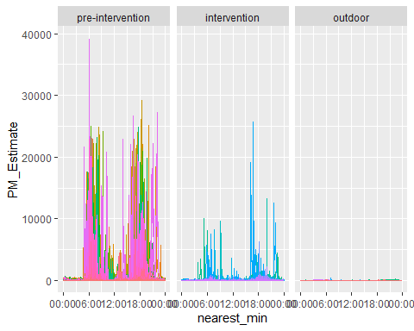
pm_data_hour %>%
filter(note != "qc") %>%
ggplot(aes(dateTime_hour, PM_Estimate, color = hh_id)) +
geom_line(na.rm = TRUE) +
geom_hline(yintercept = 100, color = "grey", lty = 2) +
geom_hline(yintercept = 500, color = "black", lty = 2) +
theme(
legend.position = "none"
) +
facet_grid( ~ study_arm)
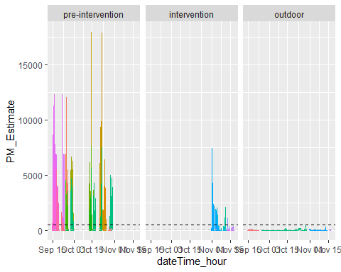
pm_data_nearest_hour %>%
filter(note != "qc") %>%
ggplot(aes(nearest_hour, PM_Estimate, color = hh_id)) +
geom_line(na.rm = TRUE) +
geom_hline(yintercept = 100, color = "grey", lty = 2) +
geom_hline(yintercept = 500, color = "black", lty = 2) +
scale_x_datetime(labels = scales::date_format("%H:%M")) +
theme(
legend.position = "none"
) +
facet_grid( ~ study_arm)
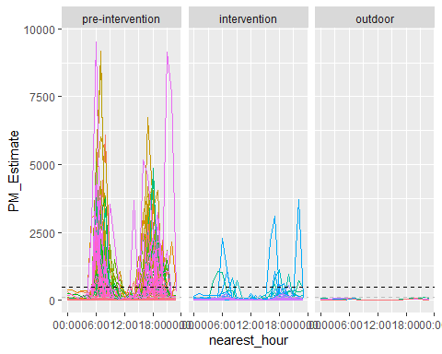
pm_data_nearest_hour %>%
filter(note != "qc") %>%
group_by(study_arm, nearest_hour) %>%
summarise(PM_Estimate_mean = mean(PM_Estimate)) %>%
ggplot(aes(nearest_hour, PM_Estimate_mean, color = study_arm)) +
geom_line(na.rm = TRUE) +
geom_hline(yintercept = 100, color = "grey", lty = 2) +
geom_hline(yintercept = 500, color = "black", lty = 2) +
scale_x_datetime(labels = scales::date_format("%H:%M")) +
viridis::scale_color_viridis(
discrete = TRUE,
name = "Study arm",
breaks = c("pre-intervention", "intervention", "outdoor"),
labels = c("Pre-intervention", "Intervention", "Outdoor"),
begin = 1/3
) +
labs(
title = "Average PM 2.5 measurement by hour of the day",
x = "Time",
y = "PM 2.5 (ug/cm3)"
) +
theme_classic()
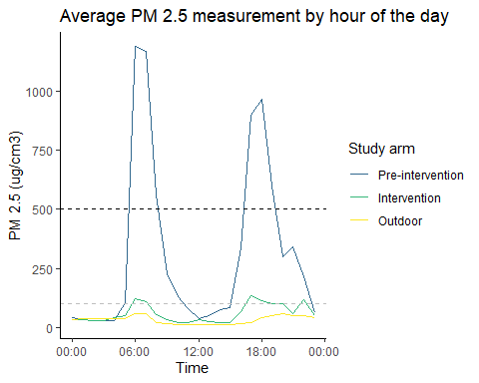
pm_data_nearest_hour %>%
filter(note != "qc") %>%
group_by(study_arm, nearest_hour) %>%
ggplot(aes(nearest_hour, PM_Estimate, color = study_arm)) + # , fill = study_arm
geom_jitter(alpha = 0.1, width = 1500, height = 0) + # This width was trial and error
geom_smooth() + # default is loess, local polynomial regression fitting,
# span = alpha controls the size of the neighborhood used for estimating the point in question
# geom_line(na.rm = TRUE) +
# geom_smooth(
# stat = 'summary',
# # color = 'red', fill = 'red',
# alpha = 0.5,
# fun.data = median_hilow, # Hmisc::smedian.hilow, computes the sample median and a selected pair of outer quantiles having equal tail areas
# fun.args = list(conf.int = 0.5) # plots the 25th and 75th percentiles, for max and min use conf.int = 1
# ) +
geom_hline(yintercept = 25, color = "red", lty = 2) +
# annotate("text", x = 0, y = 25, label = "25") +
geom_hline(yintercept = 100, color = "grey", lty = 2) +
geom_hline(yintercept = 500, color = "black", lty = 2) +
scale_x_datetime(labels = scales::date_format("%H:%M")) +
scale_y_log10() +
viridis::scale_color_viridis(
discrete = TRUE,
name = "Study arm",
breaks = c("pre-intervention", "intervention", "outdoor"),
labels = c("Pre-intervention", "Intervention", "Outdoor"),
begin = 1/3
) +
labs(
title = "Average PM2.5 measurement by hour of the day",
x = "Time",
y = "PM2.5 (ug/cm3)"
) +
theme_classic() +
theme(
legend.background = element_blank()
)
## `geom_smooth()` using method = 'gam' and formula 'y ~ s(x, bs = "cs")'
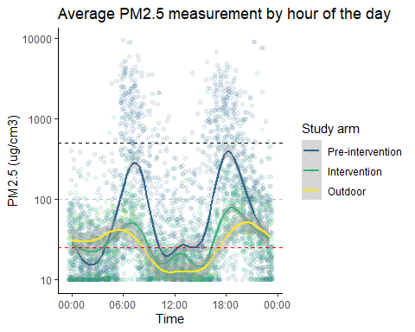
# ggsave(
# here::here("figs", "PM_by_hour_of_day.png"),
# plot = last_plot(),
# scale = 0.5,
# height = 6,
# width = 10,
# units = "in",
# device = "png"
# )
#
# # scale_y_log10() +
ggsave(
here::here("figs", "PM_by_hour_of_day_log.png"),
plot = last_plot(),
scale = 0.5,
height = 6,
width = 10,
units = "in",
device = "png"
)
## `geom_smooth()` using method = 'gam' and formula 'y ~ s(x, bs = "cs")'

Hourly summary
I can’t just look at how many hours the monitor was above 100 or 500, because the monitors were in place for different amounts of time.
One way to summarize is to this would be to calculate the total number of hours it was operating, then determine the fraction of 24 hours that was over 100 or 500 ppm
pm_data_hour_summary_by_fraction_time_recorded <-
pm_data_hour %>%
filter(note != "qc") %>%
group_by(study_arm, note, hh_id, hh_id_note) %>%
summarize_at(
vars(over_100, over_500),
list(sum)
) %>%
gather(-c(study_arm, note, hh_id, hh_id_note), key = "indicator", value = "hr_above_threshold") %>%
left_join(pm_data_hour_per_monitor %>% select(hh_id_note, hours_recording), by = "hh_id_note") %>%
mutate(
pc_time_above_threshold = hr_above_threshold / hours_recording,
hr_day_above_threshold = pc_time_above_threshold * 24
)
Another way to summarize the data, which is what Allie has done for the ventilation project, it so normalize all test to 48 hours just cut off all data after 48 hours, and use this. The means that each time period of the day is measured twice and measurements are unaffected by what time of day they started. (If they started just before cooking breakfast and the monitor ran for 52 hours then cooking breakfast would be captured 3 times, rather than just twice with a 38 hour time period or if the recording has started just a bit later.)
pm_data_hour_summary_by_48_hr <-
pm_data_hour %>%
filter(note != "qc") %>%
group_by(hh_id_note) %>%
slice(1:48) %>%
ungroup() %>%
group_by(study_arm, note, hh_id, hh_id_note) %>%
summarize_at(
vars(over_100, over_500),
list(sum)
) %>%
gather(-c(study_arm, note, hh_id, hh_id_note), key = "indicator", value = "hr_above_threshold") %>%
mutate(
pc_time_above_threshold = hr_above_threshold / 48,
hr_day_above_threshold = pc_time_above_threshold * 24
)

Plot data
Add pairwise p-value comparisons https://www.r-bloggers.com/add-p-values-and-significance-levels-to-ggplots/
pm_data_hour_summary_comparisons <-
list(
c("pre-intervention", "intervention"),
c("pre-intervention", "outdoor"),
c("intervention", "outdoor")
)
indicator.labs <-
c(
over_100 = "PM2.5 over 100 ug/cm3",
over_500 = "PM2.5 over 500 ug/cm3"
)
pm_data_hour_summary_by_48_hr %>%
# for the method where the entire recording time is used, replace "pm_data_hour_summary_by_48_hr" with
# "pm_data_hour_summary_by_fraction_time_recorded" and change the title to (Hours above threshold based on entire recording period)
ggplot(aes(x = study_arm, y = hr_day_above_threshold, color = study_arm)) +
geom_boxplot() +
geom_jitter(alpha = 0.2, width = 0.4, height = 0) +
# scale_color_discrete() +
ggpubr::stat_compare_means(
comparisons = pm_data_hour_summary_comparisons,
label = "p.format", #"p.signif"
method = "t.test",
# label.y = 18,
hide.ns = TRUE#,
# ref.group = ".all."
) +
viridis::scale_color_viridis(
discrete = TRUE,
# The following is to control the legend
name = "Study arm",
breaks = c("pre-intervention", "intervention", "outdoor"),
labels = c("Pre-intervention (n = 109)", "Intervention (n = 63)", "Outdoor (n = 4)"),
begin = 1/3
) +
labs(
title = "Hours per day exceeding PM2.5 threshold",
y = "Hours per day",
x = "Study arm"
) +
theme_bw() +
theme(
legend.position = "none",
panel.grid.major.x = element_blank(),
panel.grid.minor.x = element_blank(),
# axis.title.x = element_blank(),
# axis.text.x = element_blank(),
axis.ticks.x = element_blank()
) +
facet_grid(
. ~ indicator,
labeller = labeller(indicator = indicator.labs)
)
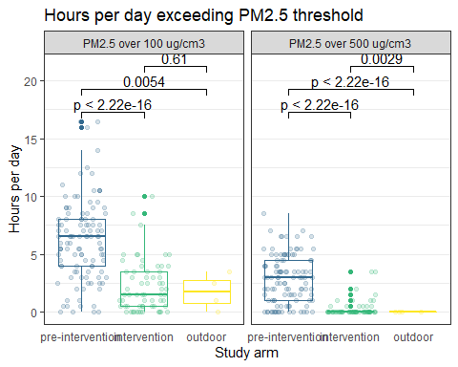
# ggsave(
# here::here("figs", "pm_data_hour_summary_by_48_hr.png"),
# plot = last_plot(),
# scale = 0.7,
# height = 6,
# width = 10,
# units = "in",
# device = "png"
# )

