ABSTRACT

IP Sentinel is a IoT-based wireless monitoring and Access Control System developed using the ESP8266 microcontroller. The system operates in Soft Access Point mode, allowing devices to connect directly to it while automatically assigning IP addresses through its internal DHCP server. Each connected device is identified using its MAC address and verified against a predefined authorization list. This enables the system to distinguish between approved and unauthorized devices in real time.
When an unknown device connects, the system immediately activates visual and audible alerts to signal potential unauthorized access. In addition, an embedded web dashboard with administrator authentication provides real-time monitoring, device management, and connection time tracking. By integrating wireless networking, MAC-based authorization, and an embedded web interface, IP Sentinel demonstrates a practical and cost-effective approach to small-scale network security monitoring using IoT technology.

SYSTEM ARCHITECTURE

Block Diagram:
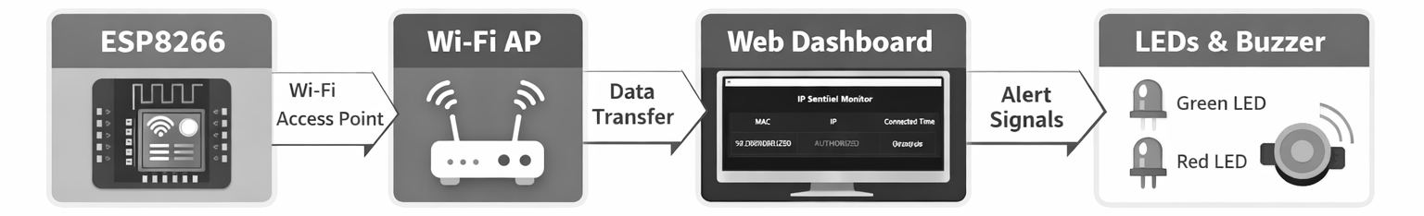
ESP8266 → Wi-Fi AP → Web Dashboard → LEDs/Buzzer.

Hardware Requirements:
Component | Description
ESP8266 | Microcontroller with Wi-Fi AP mode
Green LED | Indicates authorized devices
Red LED | Indicates unauthorized devices
Active Buzzer | Audio alert for unauthorized access
Breadboard | Circuit assembly platform
Jumper Wires | Connections between components
USB Cable | Power and programming interface

Software Requirements:
Software/Library | Purpose
Arduino IDE | Programming and uploading code
ESP8266WiFi library | Enables Wi-Fi and AP functionality
ESP8266WebServer library | Hosts the local web dashboard
Web Browser | Accesses the dashboard via IP

IMPLEMENTATION

Circuit Diagram:
The circuit connects the ESP8266 microcontroller to two LEDs and a buzzer. The green LED is connected to pin D1 (GPIO 5), the red LED to D3 (GPIO 0), and the buzzer to D2 (GPIO 4). Each component is grounded through separate GND pins of the ESP8266.
The green LED indicates that all connected devices are authorized. The red LED and buzzer activate when unauthorized devices are detected, providing both visual and audio alerts.
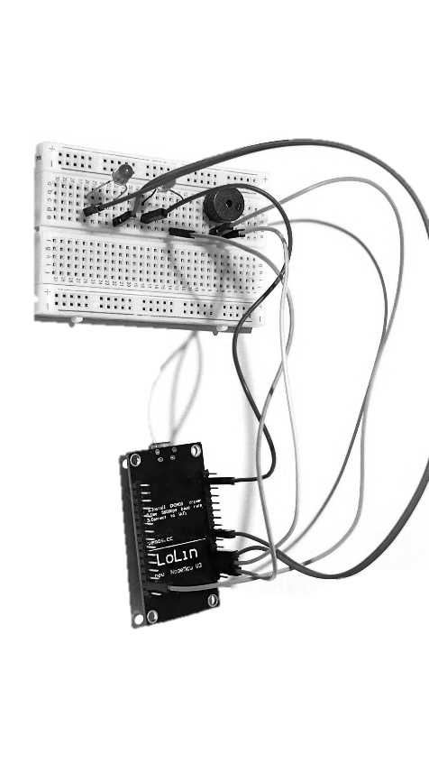
Screenshots:
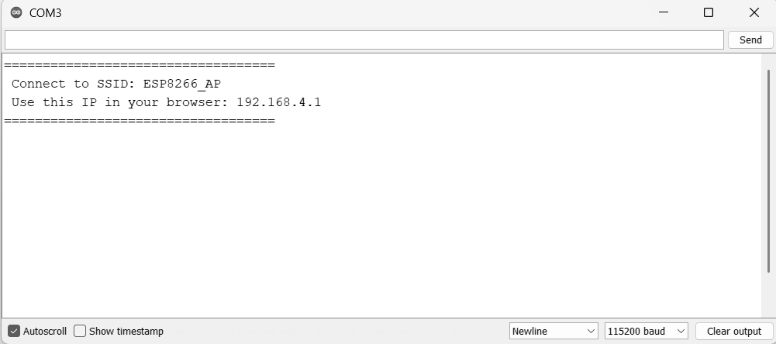
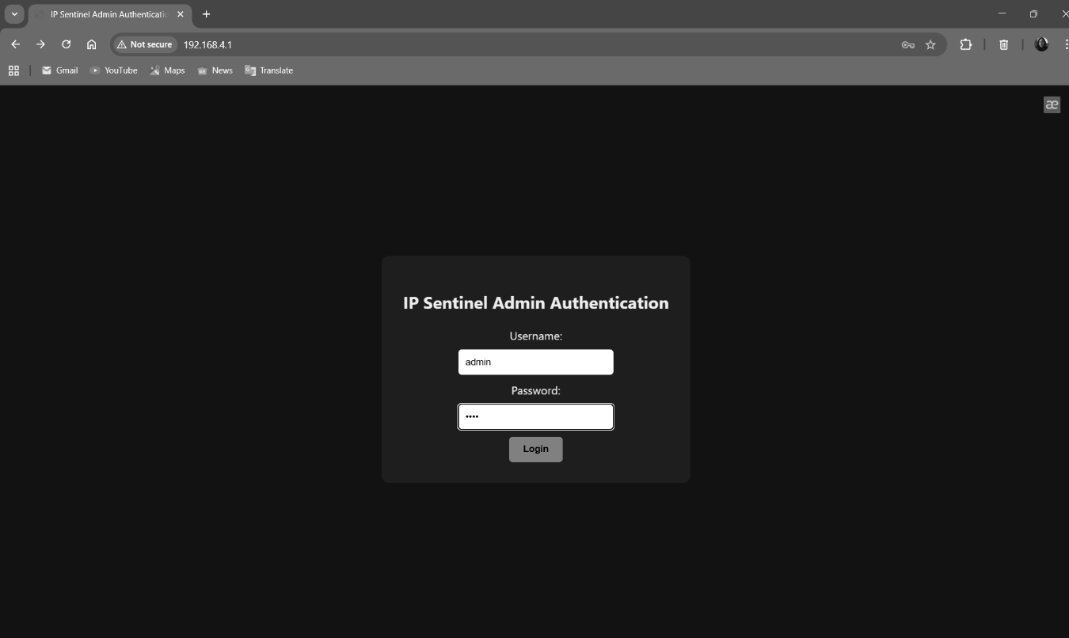
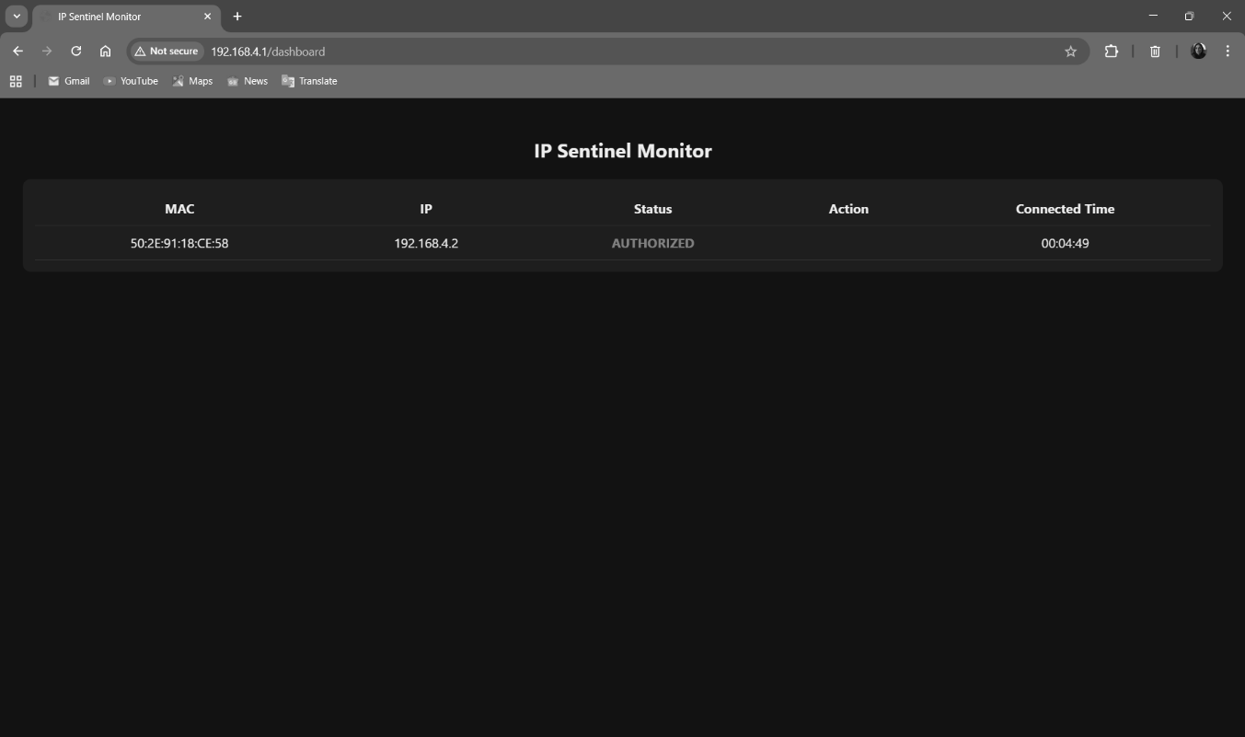.
RESULTS
System Working Status:
Successfully detects connected devices, distinguishes authorized vs unauthorized.

Output Results:
Device Status | Green LED | Red LED | Buzzer | Dashboard Display
Authorized | ON | OFF | OFF | Green “AUTHORIZED”
Unauthorized | OFF | ON | ON | Red “UNAUTHORIZED”

