**BookNook Mockups**

**HomePage**

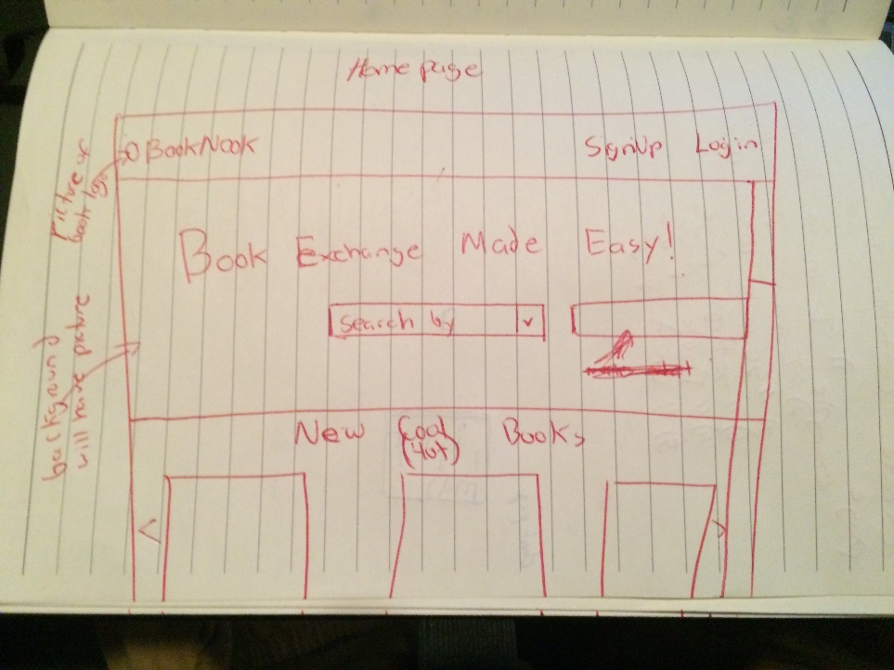

**\****Login and Signup will bring a popup window on the homepage when clicked*

**Login**

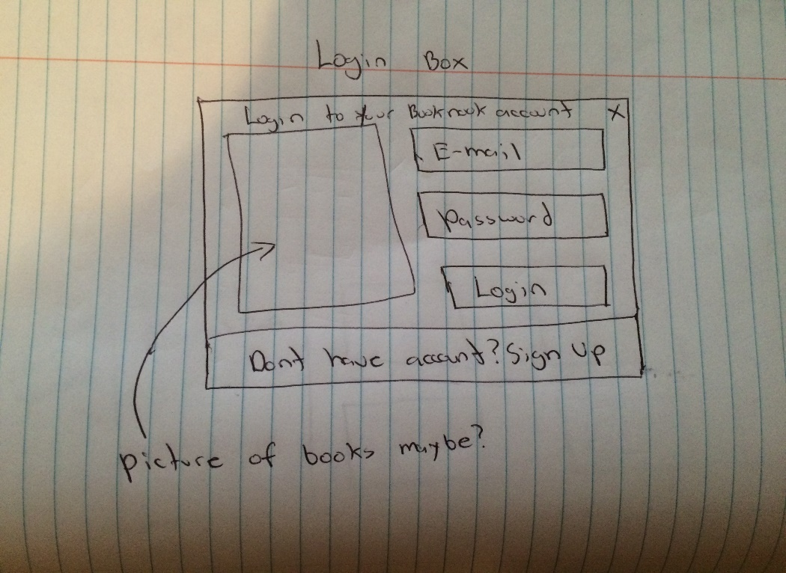

**Sign Up**

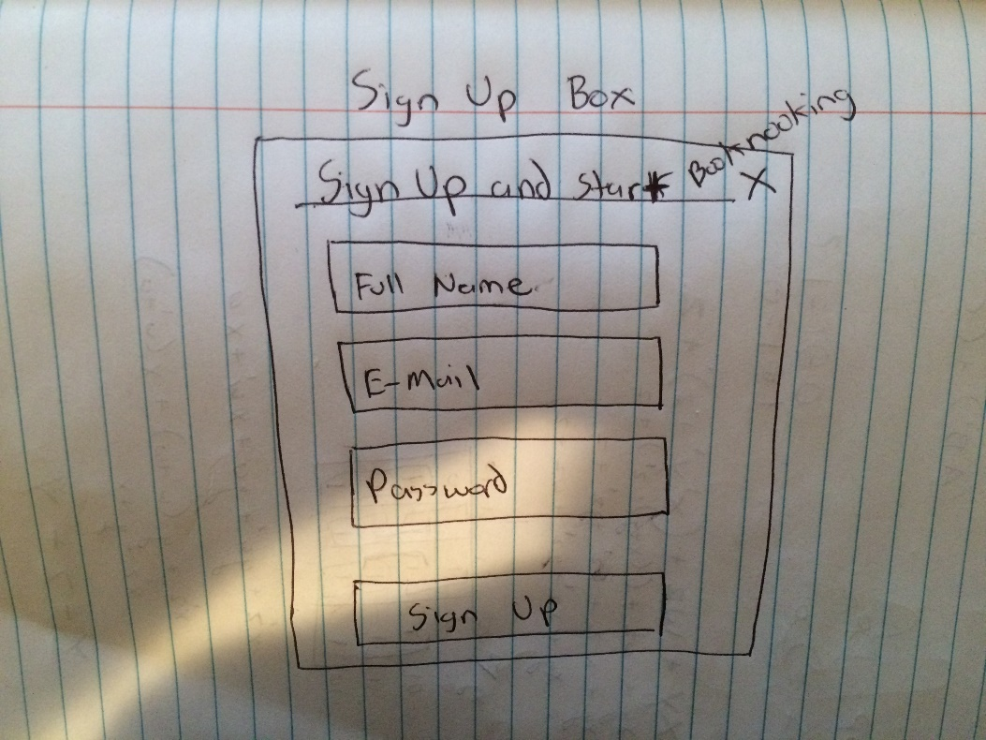

**Profile Page**

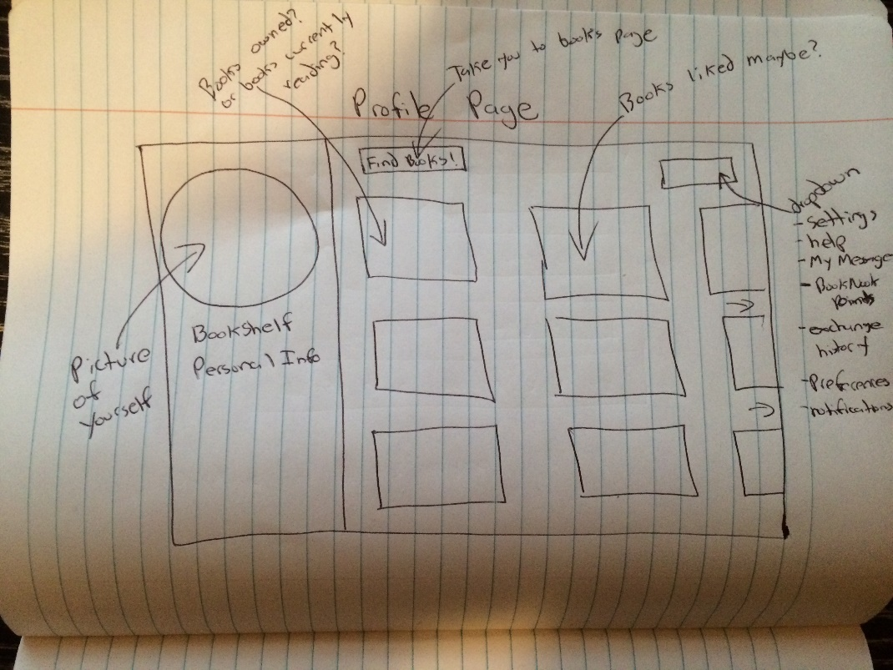

**BookSearch Page**

