1.Testing Wallet:

QFPAY does not provide testing wallet to merchants, so please ask Chinese mainland colleague for help.

Alipay HK Wallet link:

<https://play.google.com/store/apps/details?id=hk.alipay.wallet&hl=zh-cn>

HK Alipay wallet only applicable offline quick pay right now.

If a customer uses a HK wallet to scan the Alipay QR code on a PC, it will shows like:

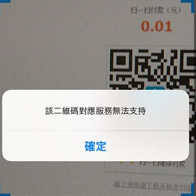

If a customer uses a HK wallet with WAP payment, it will shows like:

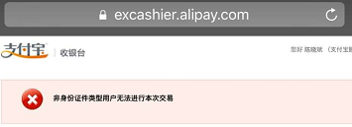

2.Filter error:

When shows like below:

[respcd] => 1104

[respmsg] => filter error

It means this payment type is not available right now.

For example, merchant applies Alipay, but not Wechat. And the merchant use Wechat payment.

3.What does 2999 means?

When invoke refund interface, sometimes, it will return like this:

{"orig_syssn":"201706090901990033885758","resperr":"交易失败，请联系客服(2999)","txdtm":"2017-06-09 19:16:36","txamt":"1","respmsg":"","out_trade_no":"qfpay_alipay999920170609191636","syssn":"201706090901990033885799","origssn":"201706090901990033885758","respcd":"2999","sysdtm":"2017-06-09 19:16:21"}

2999 means in pending state.

After transaction finishes, the merchant backend should use query interface to check the transaction is OK or not.Usually it take less than 5 seconds.

4.product_name：

From Alipay APP：

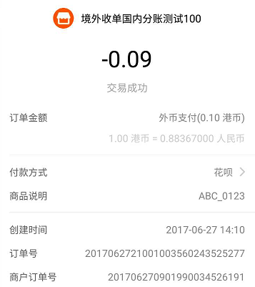

订单号：Alipay reference number

商户订单号：QFPay reference number

商品说明:product_name(Please use shop name+out_trade_no format for reference)

Wechat:

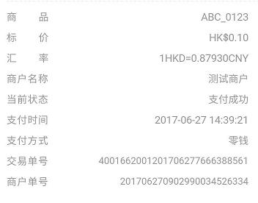

交易单号：Wechat reference number

商户单号：QFPay reference number

商品：product_name(Please use shop name+out_trade_no format for reference)

5. What does 0000 means?

{

"respmsg": "",

"resperr": "",

"respcd": "0000",

"data": [

{

"pay_type": "800151",

"sysdtm": "2017-06-20 10:27:27",

"order_type": "payment",

"txcurrcd": "",

"txdtm": "2017-06-20 10:27:23",

"txamt": "10",

"out_trade_no": "TEST001",

"syssn": "201706200902990034258091",

"cancel": "0",

"respcd": "1145",

"errmsg": "交易错误，请联系钱方客服"

}

],

"page": 1,

"page_size": 10

}

0000 means successful. But there are also two meanings:

The first 0000,outside data field means it is a successful response.

The second 0000, inside data field means the request is successful.

6.How do I handle timeout?

The recommend time out time is 600s.

7.If the merchant does a refund, how long does it take?

It Depends. If refund to balance, it will in minutes. If refund to credit card, it may as long as 3 days.

8.How do I define the currency?

What currency merchant apply for, which currency is available for use.

9.How about the exchange rate?

The exchange rate is set by Alipay and Wechat, it will update twice every day(10:00AM and 3:00PM). Merchant see local currency, customer pay RMB. QFPay do not do the settlement.

10. Sometimes, I can not get refund, what is the reason?

Because there are not enough sufficient amount in Alipay or Wechat.

For example, the merchant has a settlement on yesterday, and request a refund in the morning.

11. We see this website(<https://qfpay.com/>), does it relevant with oversea QFPay API？

It is only for China mainland non-interface users ,please ignore that.

12.If I do not have Wechat official account, can I use Wechat payment?

You can use 800201,800208

13.What does the picture below mean？

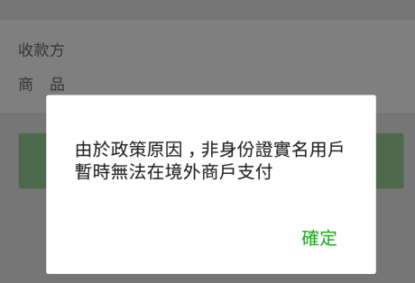

It means when a mainland customer wants to do the payment outside mainland China, the payment account should be link with a mainland China ID card .This is Tencent policy.

1. What does refund period?

Alipay：

Old Version PID(Only RMB,before May 2017 ): 3 month

New Version PID(HKD+RMB,after May 2017 ):12 month

Wechat：

3 month

1. Over limit

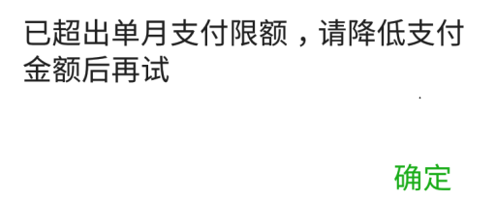

16.China mainland Wechat User follow HK Wechat official account.

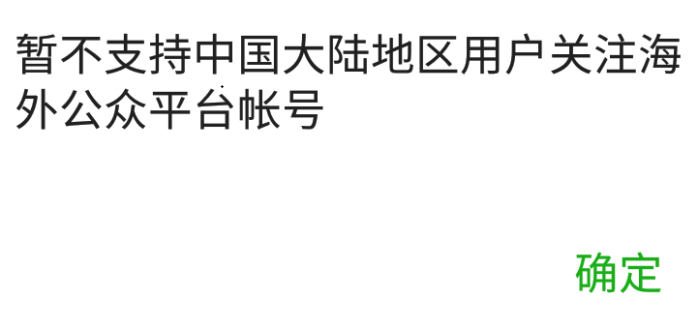

1. Do QFPay provide provide a merchant back end for API?

QFPay only provides merchant back end for APP user,not API user.

1. How many numbers can be in a transaction?

The answer is 3:

1. Alipay/Wechat transaction number
2. QFPay transaction number(syssn): It is strongly recommended to save this number every time,because refund needs QFPay number and merchant number .
3. Merchant transaction number(out_trade_no)
4. Does query interface provide currency code？

No.Query interface does not provide currency code.

1. Cancel meaning:

1：Reversal succeed(Usually return with query the reversal syssn number)

2：Refund succeed(Usually return with query the original refund syssn number)

1. If I want to know the balance after refund, does the API provide this function?

No. But if merchant save the relevant refund number, the balance can be calculated.

1. If I want to know the specific day of the settlement , what should I do?

Our system does not provide this function, our settlement API matches with Wechat and Alipay settlement API.If one merchant also use QFPay APP and our API with same Wechat/Alipay number.It will show the total transaction amount of APP and API transaction.

1. Do I need to encode?

If you use UTF-8, it does not needed.

1. If I want to do a query about a single syssn number,what should I do?

data['syssn']='201708300902990041204977'  
data['start_time']='2017-08-01 00:00:00'  
data['end_time']='2017-08-30 17:43:00'

The first 8 digits of syssn is date(YYYYMMDD),if you want to do a query on this number:'201708300902990041204977', please also pass in start_time and end_time at the same time.

25.