1. What is auth_code?

a.Mainland Wechat:

IMG_256IMG_256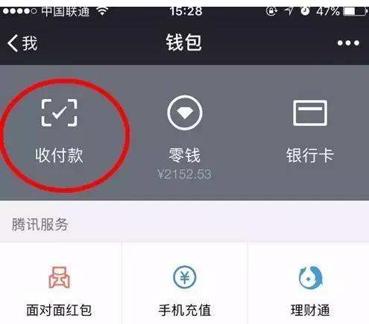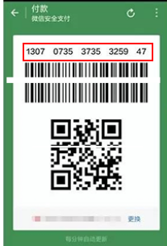

b.Mainland Alipay:

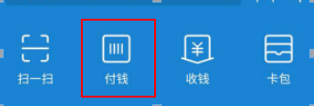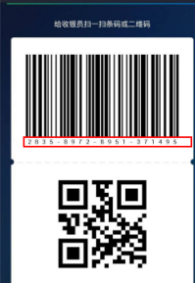

The number around the QRCode is the QR code content.

1. Difference between reverse and refund.

Quote from Alipay:

Reverse interface provides reverse functionality, when there is network issue between partner system and Alipay system, or Partner system gets an unknown response from Alipay, use this interface to reverse the transaction.

Refund interface provides the ability to refund a transaction both in whole and in partial.

1. What does the below error mean?

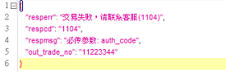

It means when use800108,800208. No auth_code passed in.

1. Do I need to set return and callback address for offline scene?

No, you do not.It is only for online scene.

1. Can I distinguish Alipay and Wechat?

No.

Explanation:

Although Wechat specified as follow,from the first two digits it can be recognized as Wechat.

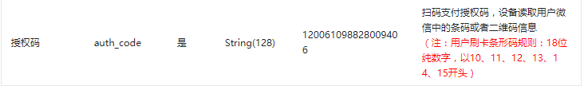

Alipay HK:

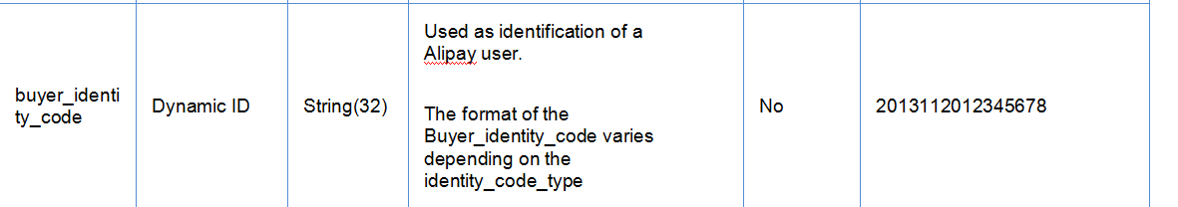

But Wechat and Alipay always change the format ,so it is easier not to distinguish different payment type by auth_code.

1. Offline Payment Flow：

