1.URL(Callback/Return)

They are set by QFPay staff.

One appid can only have one pair of URL(Callback/Return).

Return URL:After success payment, it will redirect to that URL.(Only applicable for Alipay not Wechat.)

Callback URL:After success payment, QFPay will send notification to merchants’ back-end.(30s interval with 4 times)

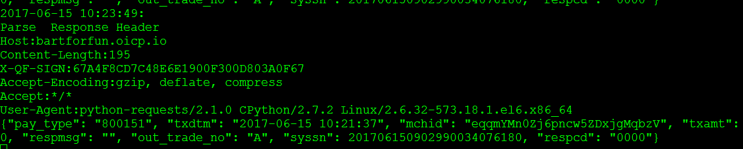

2.Can I use Alipay payment in Wechat APP？

You can not use Alipay in Wechat APP, but if you jump out of Wechat APP, you can use Alipay WAP payment.

3.After successful payment, what should I do?

The merchant can get asynchronous notification from QFPay, then the merchant back end should use query API to confirm the payment is successful.

4.Difference between Wechat H5 and Alipay WAP:

Wechat H5 means Wechat official account payment. In the final step, invoke H5 to open the payment dialog.

Alipay WAP means Alipay payment in a mobile phone browser.

5.If I use E-Shop plugin, can I use Oversea Qiantai?

It depends.If developer can develop the platform plugin,they can use QFPay API.

6.What is the difference between Alipay WAP and pre order?

Alipay WAP usually applicable for mobile browser. Picture like below:

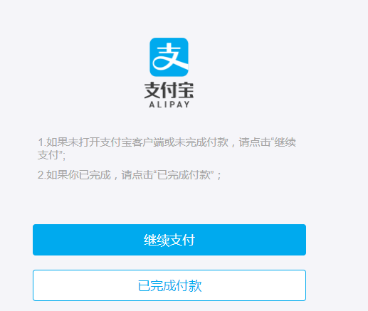

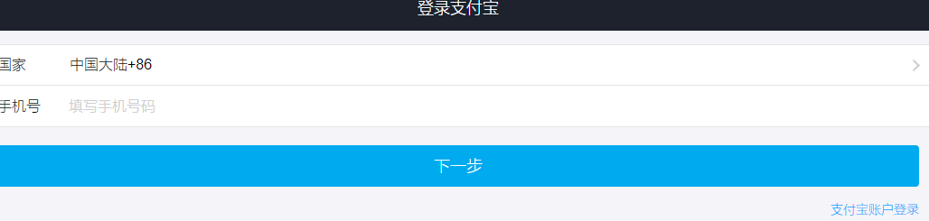

Alipay pre order:

It means customer opens Alipay APP and scan the code , the code is in the browser,usually in a PC.

7.How to generate from Wechat payment response?

The payment response is like:weixin://wxpay/bizpayurl?pr=HQGGuMT

You can use some websites like to generate a QR code:

<https://www.the-qrcode-generator.com/>

<https://www.qrcode-monkey.com/>

<https://davidshimjs.github.io/qrcodejs/>

8.What if I use Magento,opencart these online shops?

Right now, the workaround for your Magento online shop to integrate with Alipay and Wechat is as follows:

a.Alipay: Buy the plugin (https://magento.com/search/gss/alipay%20cross%20border) and we provide Alipay PID and private key to you.

b.Wechat: Change from service provider mode to direct mode, and buy the plugin(https://magento.com/search/gss/wechat).

9.Can I press the QR code in a cell phone and do the payment？

The answer is no!It will show like below.

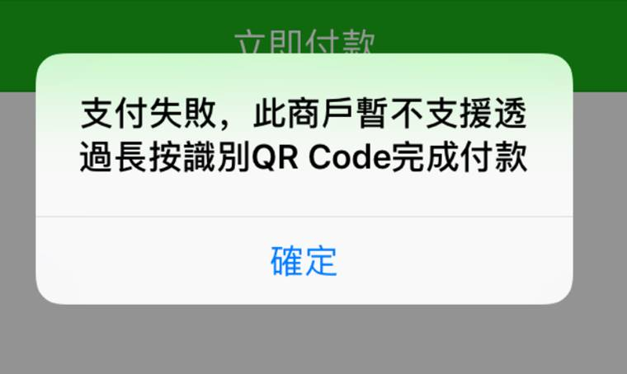

Explanation:

For a PC website, users can use their cell phone and scan the QR code to do the payment But , Tencent disables the way to press the QR code in Wechat APP and do the payment. So please use Wechat OA payment(800207).Please fill the [info](https://github.com/linan0828/QFPAY_Oversea/tree/master/Contents/Wechat/OA), and send them to QFPay technical support.

10.sub_openid and sub_mch_id与sub_appid不匹配。

Please confirm the parameters are right.

1. Online payment flow：

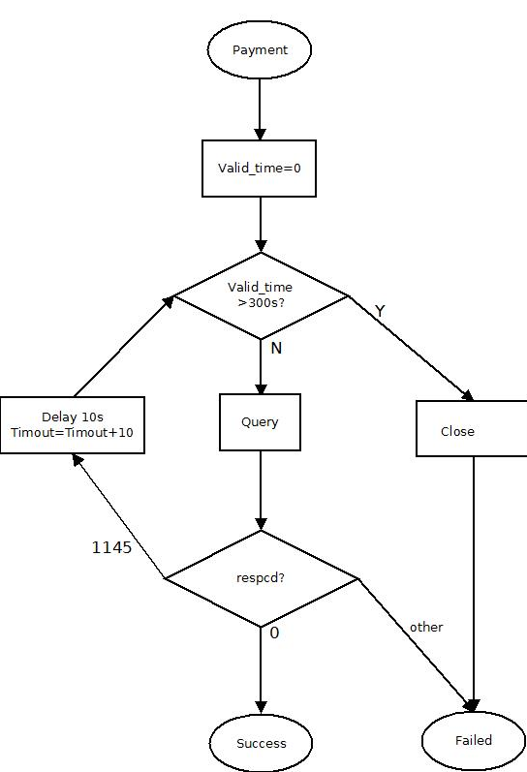

1. Valid_time and close the order

Valid_time:It is only applicable for online payment.

Close the order: Only applicable for Wechat(800201,800207). Alipay online order will be closed after the time exceed the valid_time.

If user close one Alipay order, it will show like below:

