README
The Market Reaction to the 2013 Rana Plaza Disaster: A Constructive Replication and Extension of Jacobs and Singhal (2017)

Overview
This replication package provides the Stata do-files that reproduce the analyses and results reported in the main text and appendices (Online Supplement) of the paper “The Market Reaction to the 2013 Rana Plaza Disaster: A Constructive Replication and Extension of Jacobs and Singhal (2017)”. It also includes the event-dates input dataset (Repl_eventdates_RP.dta), and an Excel file that contains firm names and Datastream mnemonics of the firms and market indexes (Datastream_Data_tickers.xlsx). This is to assist data downloading, since sharing LSEG Datastream data, raw or processed, is not permitted. We therefore cannot provide the three remaining input files required to reproduce the results. Instead, we only include short snippets of them (see below) to show their structure. The first of those files should contain firms returns, while the second should contain the returns of stock market indexes (and the respective Fama-French factors, needed to estimate Carhart’s four-factor model, which are free to download from https://mba.tuck.dartmouth.edu/pages/faculty/ken.french/data_library.html). We assume that the user has downloaded the prices and trading volumes, calculated discrete returns (i.e. using the formula $[\frac{p_{t}-p_{t-1}}{p_{t}-1}]$, where p is the dividend- and stock split-adjusted price) and structured the two input files as specified in the eventstudy2 help file (http://fmwww.bc.edu/RePEc/bocode/e/eventstudy2.sthlp). Please install the program in Stata by using the command ssc install eventstudy2, download the example files provided by the author (Thomas Kaspereit) and construct your files accordingly. Our dataset snippets may also be helpful. We call these three input datasets security_returns2.dta, market_returns.dta, and Appendix_F1_F2.dta, respectively. All files need unique firm and country/market identifiers that ‘match’ those in the Repl_eventdates_RP.dta file. The do-files use the eventstudy2 command to automatically produce estimates, test statistics and descriptive summaries using the supplied datasets. As noted in the do-files, the results are exported to Excel and organized into tables included in the manuscript. In the do-files we include many notes, which we strongly recommend that the user reads.

Data availability and provenance
We downloaded all stock market data from LSEG (formerly Thomson Reuters) Datastream. These data were accessed under license and cannot redistributed under the applicable licensing terms. Consequently, the replication package does not include security_returns2.dta, market_returns.dta, and Appendix_F1_F2.dta. Researchers wishing to reproduce the analyses must obtain the required Datastream data through their own licensed access. The identifiers and data codes needed for downloading are provided in Datastream_Data_tickers.xlsx.
Share prices are dividend- and split-adjusted, and each firm is linked to its primary listing and the corresponding country market index. The identifier for each firm’s return (Security_ID) and the corresponding ones for market index returns (Country_ID) can be found in the Repl_eventdates_RP.dta dataset. These IDs will need to match their respective returns in the firm- and market-returns datasets that must be constructed by the user.
The entire sample (file Repl_eventdates_RP.dta) includes 121 unique firms: 64 with identified Bangladesh-sourcing links (Hypothesis 3) and 57 without affirmative evidence of such links. The baseline analysis uses 39 early signatories (Hypothesis 1), while the Rana Plaza sourcing firms (Hypothesis 2) are only eight. Also, 17 firms were involved in past ‘similar’ events (Hypothesis H4). The manuscript and appendices explain sample construction in detail. In the Repl_eventdates_RP.dta, the variable Event_RP_1 takes the value of 1 for the Rana Plaza event, while numbers 2-5 signify the other past events.
In the do-file 3. Appendix_F1_F2_reproduction, we assume that the user has downloaded and merged firm-specific financial data with Day-0 abnormal returns (ARs) and cumulative abnormal returns (CARs) over Days 0-10 from the completed event-study analysis that includes all firms (if Event_RP_1 =1, see Section G of Main-analysis_v2.do). These data can be merged using Security_ID or another firm identifier (like firm name). We call our constructed and merged dataset Appendix_F1_F2.dta. The Datastream codes for the covariates we used (for data downloading) are listed in the file Datastream_Data_tickers.xlsx (sheet name Firm_data). Covariates use 2012 values and 2010–2012 averages, as specified in the Appendix F. Where possible, a few missing covariate values were supplemented using online information, mainly public company reports.

Dataset list
Dataset | Contents
Repl_eventdates_RP.dta | PROVIDED. Firm identifiers, event dates, sourcing indicators and sample classifications; 138 firm-event records.
security_returns2.dta | NOT PROVIDED. Daily close-to-close, day and night security returns, plus trading volume and firm-country identifiers (see snippet below).
market_returns.dta | NOT PROVIDED. Country market returns, day/night market returns, four-factor variables and the risk-free rate. (see snippet below)
Appendix_F1_F2.dta | NOT PROVIDED. AR/CAR outcomes, sourcing status and prepared covariates for 121 firms. (see snippet below)
Datastream_Data_tickers.xlsx | PROVIDED. Contains various sheets:  - Company names, Datastream mnemonics and identifiers (that match the ones in Repl_eventdates_RP.dta). Note that the Security_ID ‘skips’ some numbers.  - Market index names and mnemonics  - Datastream codes for the firm-financial data  - Risk-free rates  - Historical Fama-French factors for different regions

Dataset snippets
These are provided to aid the user’s dataset construction. Please also consult the eventstudy2 help file.
Security_returns2
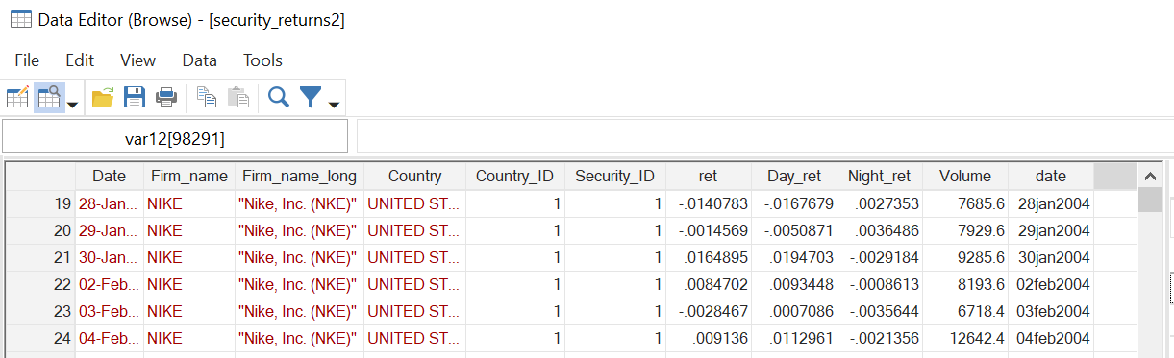

Market_returns
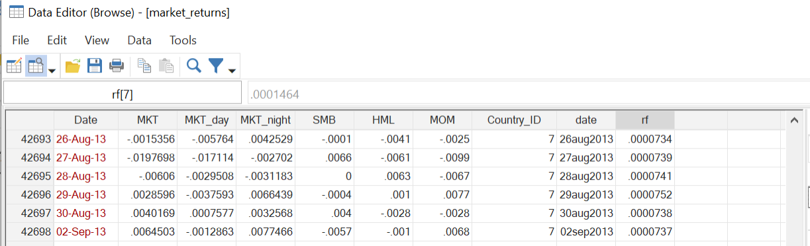

Appendix_F1_F2
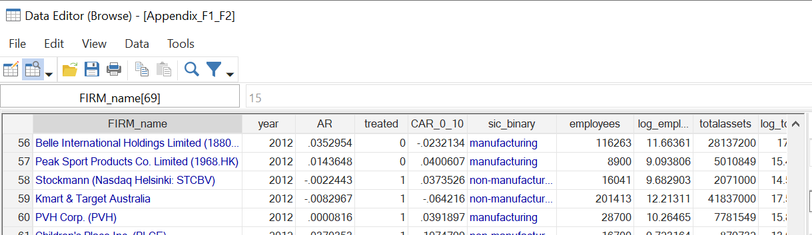

Computational requirements
We used Stata 19. The user-written packages eventstudy2 and psmatch2 are required. Install them once in Stata:
ssc install eventstudy2
ssc install psmatch2
The analyses contain no simulation or bootstrap steps. The five processed inputs occupy approximately 49 MB, excluding generated results. Runtime has not been benchmarked.

Description of programs
Programs 1–3 below refer to the following files.
1.Main-analysis_v2.do
Main event studies, four-factor robustness analysis, prior disasters, and preliminary steps to construct Appendix_F1_F2.dta
2.JS-direct-repl_and_Volume-event-study_v2.do
Direct replication of Jacobs & Singhal (2017) and abnormal-volume analysis. The volume block uses stockdata_JS.dta created by the preceding block.
3.Appendix_F1_F2_reproduction.do
Descriptive statistics for Table F2, followed by the regressions and propensity-score matching estimates for Table F1. It can be run separately once Appendix_F1_F2.dta has been constructed.

Instructions to replicators
1. Work with a copy of the package. Replace the original computer-specific paths in the do-files with your own paths. Set the working directory accordingly.
2. Run the labelled sections of Program 1 in order. Load Repl_eventdates_RP.dta before each eventstudy2 analysis. When switching datasets, save any work you need and clear the current data, or use the clear option on use. Generated files are saved in the working directory and existing results with the same names may be replaced.
3. Run Program 2 from section A before section B, so that its intermediate datasets are created. Apply the same dataset-switching procedure. Run Program 3 to obtain F2 first and then F1.
4. Use the map below to assemble the tables. Multiply ARs, CARs and their standard errors by 100 to express them as percentages; leave test statistics and p-values unchanged.

List of tables and programs
Manuscript or appendix result | Program and section | Output prefix or result
Table 3, Panels A and B | 1 — A1 and A2 | JS1; JSadj
Table 4, Panels A and B | 1 — B1 and B2 | JSnight; JSday
Table 5 | 1 — D1 | RP
Table 6 | 1 — D2 | Firm-level RP daily ARs
Table 7 | 1 — E1 | BGL
Table 8 | 1 — F | H4
Appendix Table C1 | 2 — A1–A5 | AR/CAR summaries and tests
Appendix Table D1 | 1 — C | FF
Appendix E separate-event results | 1 — H | Ev2; Ev3; Ev4; Ev5
Appendix Table F2 | 3 — first block | 2012 and three-year summaries
Appendix Table F1, Panels A and B | 3 — subsequent blocks | AR; CAR_0_10
Appendix Table G1 | 2 — B1 and B2 | corrado_z by event day
Tables 1 and 2, Figure 1, and Appendix Tables A1, B1 and E1 were compiled separately. Program 1 section G creates ALL outcomes; it does not reconstruct the financial covariates. Section E2 provides an additional non-Bangladesh-sourcing event study.

Reading the event study output
For each Program 1 prefix, *_aabn_ret_file.dta contains daily mean ARs, sample sizes, test statistics and p-values; *_cum_average_abn_ret_file.dta contains the corresponding CAR results. The *_abn_ret_file.dta and *_cross_sec_file.dta files contain firm-level ARs and CARs used for medians and percentages of negative returns.
The table labels B-M-P, Kol-Py, GenSign and Cor-Zi correspond to Boehmer, Kolari, GenSign and Zivney in the output (Zivney_Cowan for CARs). P-prefixed fields contain p-values. Follow each block’s comments for the reported event windows. The main event studies retain a common calendar alignment; the direct replication and volume analysis instead remove market holidays and align trading days.

References
LSEG. 2026. Datastream [database].
Kaspereit, T. 2019. eventstudy2 — A program to perform event studies with complex test statistics in Stata, Version 3.0.
Leuven, E., and B. Sianesi. 2018. PSMATCH2. Statistical Software Components S432001, Boston College Department of Economics.
StataCorp. 2025. Stata Statistical Software: Release 19. College Station, TX: StataCorp LLC.

