**Credit Card Fraud Detection**

**PHASE-4**

**PROGRAM:**

**import pandas as pd**

**from collections import Counter**

**import itertools**

**dataframe = pd.read_csv("creditcard.csv")**

**dataframe.head()**

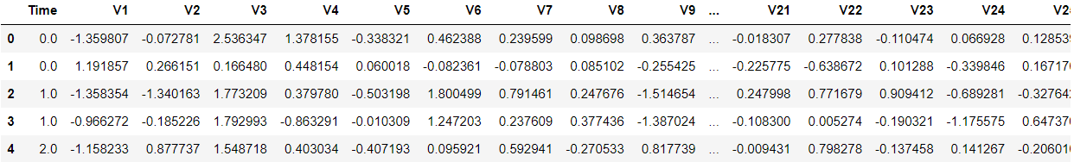

**dataframe["Amount"].describe()**

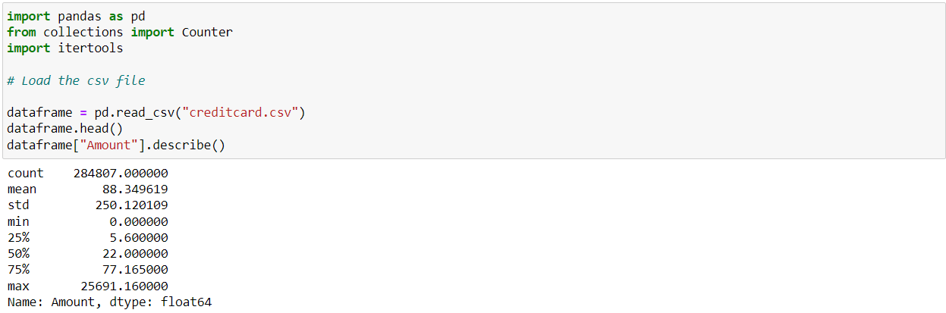

**non_fraud = len(dataframe[dataframe.Class == 0])**

**fraud = len(dataframe[dataframe.Class == 1])**

**fraud_percent = (fraud / (fraud + non_fraud)) * 100**

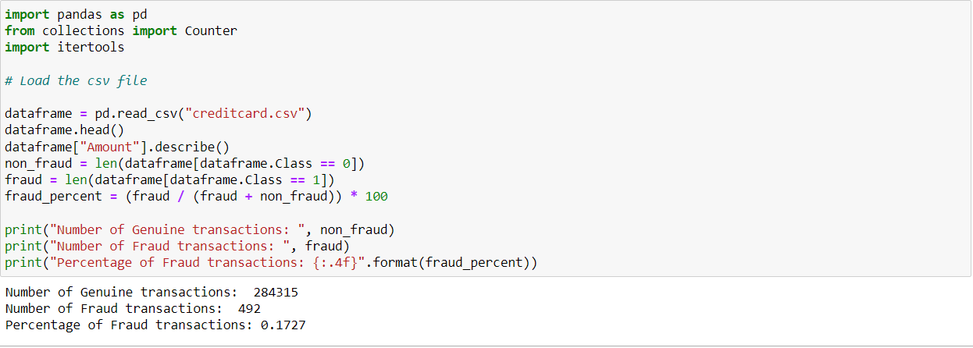

**import matplotlib.pyplot as plt**

**labels = ["Genuine", "Fraud"]**

**count_classes = dataframe.value_counts(dataframe['Class'], sort= True)**

**count_classes.plot(kind = "bar", rot = 0)**

**plt.title("Visualization of Labels")**

**plt.ylabel("Count")**

**plt.xticks(range(2), labels)**

**plt.show()**

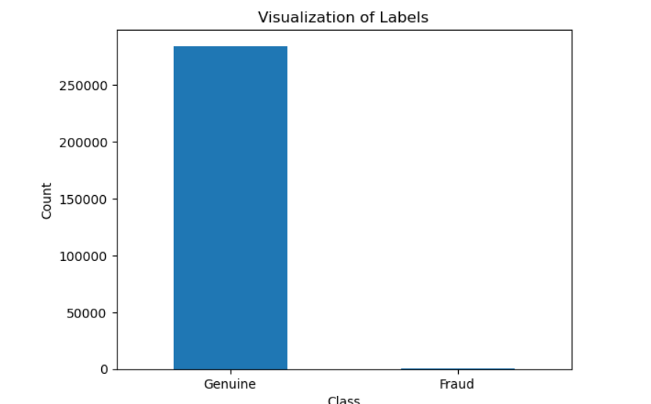

**from sklearn.model_selection import train_test_split**

**(train_X, test_X, train_Y, test_Y) = train_test_split(X, Y, test_size= 0.3, random_state= 42)**

**print("Shape of train_X: ", train_X.shape)**

**print("Shape of test_X: ", test_X.shape)**

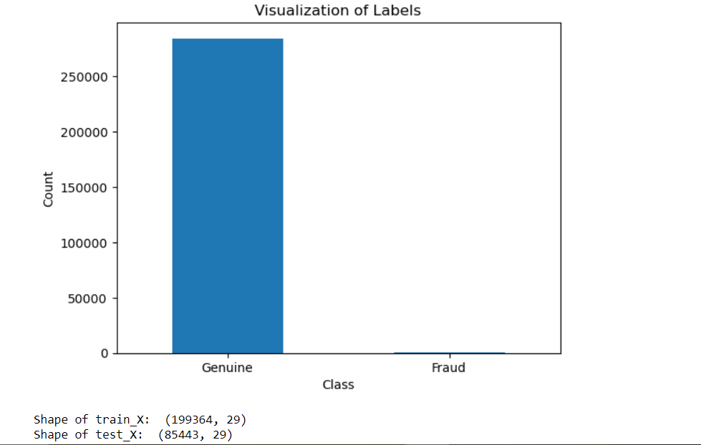

**dataframes.head()**

**dataframes.info()**

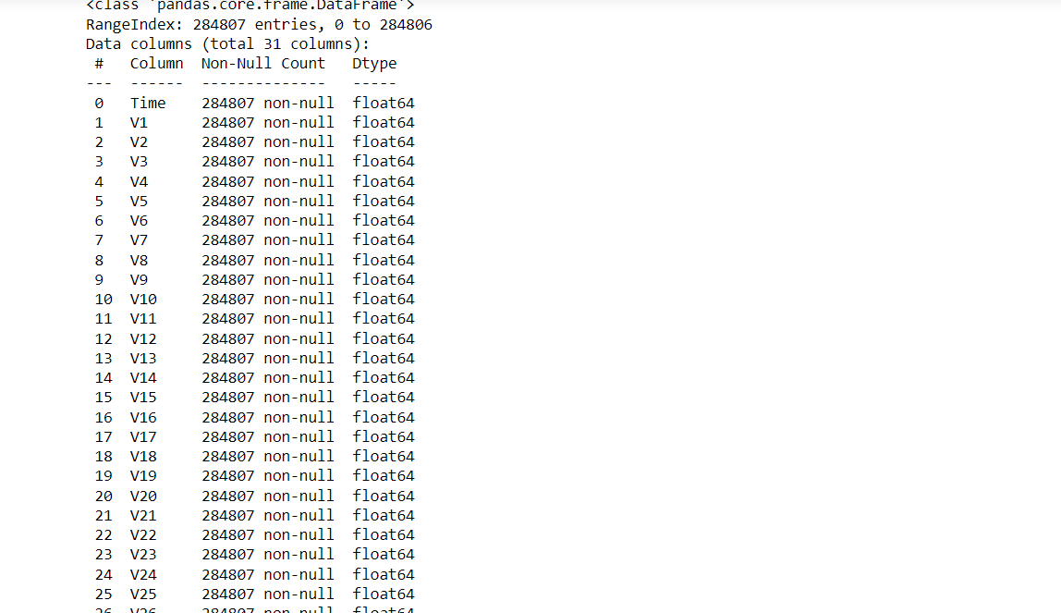

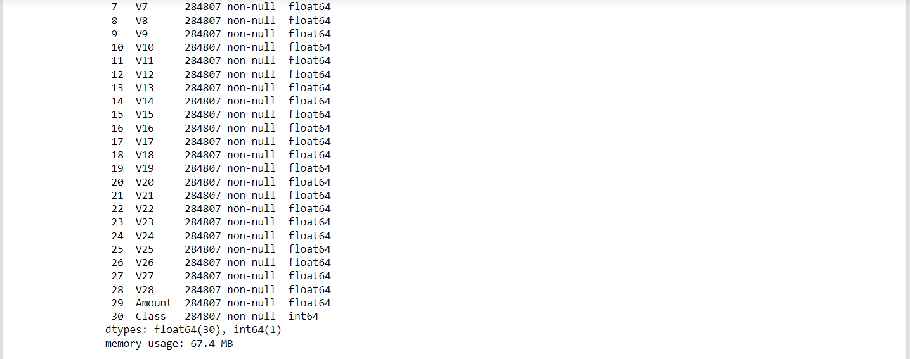

**dataframe.describe()**

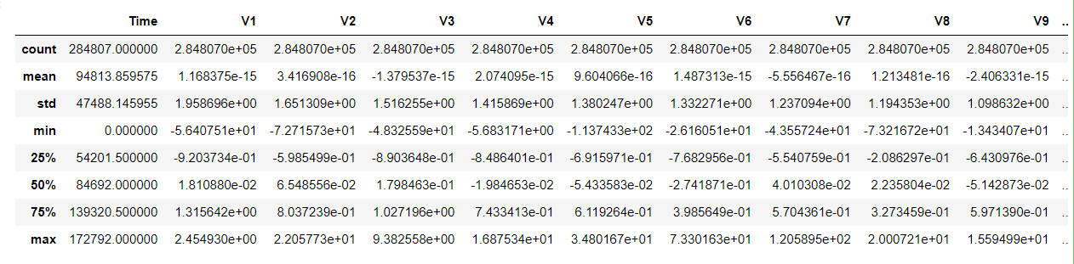

**dataframe.isnull().sum()**

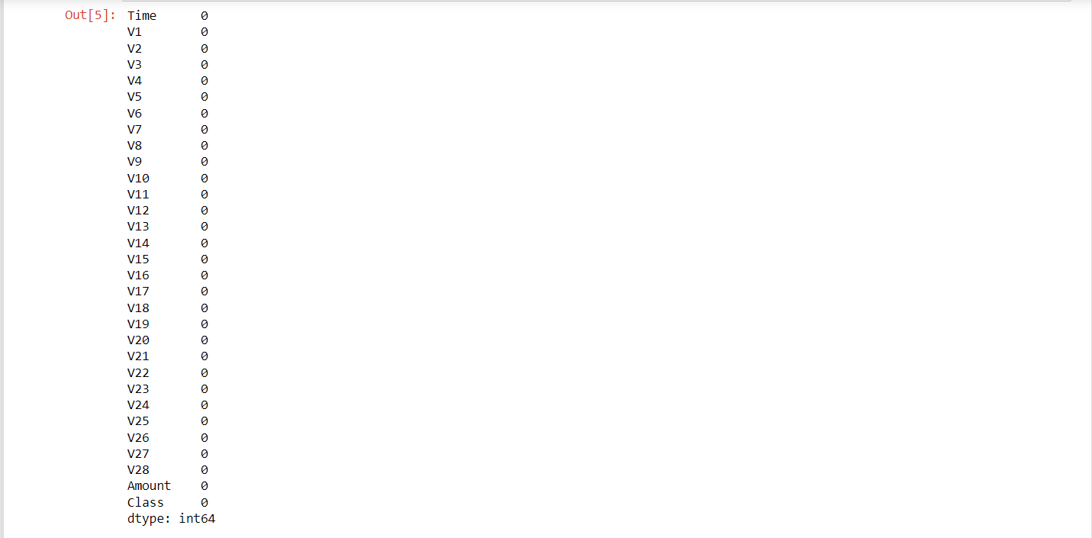

**dataframe.columns**

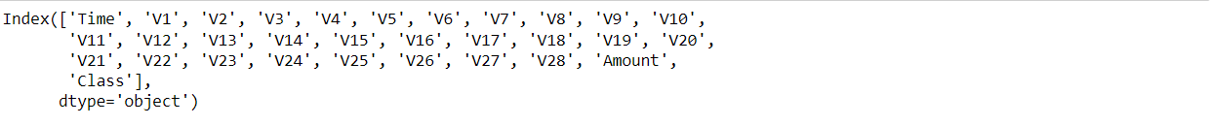

**dataframe.shape**

(284807, 31)

**dataframe.duplicated().value_counts()**

False 283726

True 1081

Name: count, dtype: int64

**dataframe.Class.unique()**

array([0, 1], dtype=int64)

**print(legitimate)**

**print(fraud)**

284315

492

# ****Handling Imbalance of the data using SMOTE:****

x=data.drop("Class",axis=1)

y=data["Class"]

In [18]:

linkcode

smote = SMOTE(random_state=42)

x_smote, y_smote = smote.fit_resample(x, y)

## Data Visualization:

corr_balanced = x_smote.corr()

plt.figure(figsize=(8, 6))

sns.heatmap(corr_balanced, annot=False, cmap="plasma", linewidths=0.5)

plt.title("Correlation Matrix for Balanced Data")

plt.show()

