A Project Report on

Unleashing The Potential of Our Youth:

A Student Performance Analysis .

**by**

**K LAKSHMI LAASYA - 20AT1A0567(TEAM LEADER)**

**K JASHWANTH KIRAN - 20AT1A0592**

**SHAIK SAHIFA - 20AT1A05C0**

**Under the Guidance of**

**MRS.M. JAYA SUNITHA, M.Tech**

**Associate Professor**

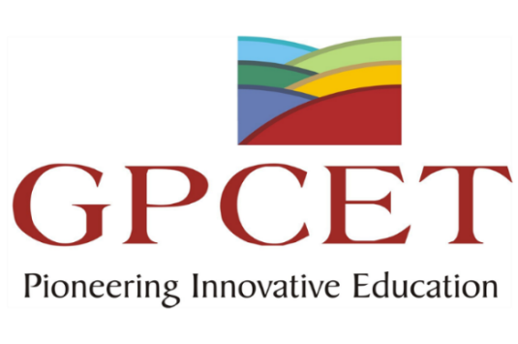

**DEPARTMENT OF COMPUTER SCIENCE & ENGINEERING**

**G. PULLAIAH COLLEGE OF ENGINEERING AND TECHNOLOGY**

**(Autonomous)**

(Approved by AICTE | NAAC Accreditation with ‘A’ Grade | Accredited by NBA (ECE, CSE, EEE, CE) |

Permanently Affiliated to JNTUA)

ABSTRACT

In an ever-evolving world, the role of education in shaping the future has become increasingly vital. "Unleashing the Potential of Our Youth: A Student Performance Analysis" seeks to explore the factors that contribute to unlocking the hidden potential within students, allowing them to thrive academically and personally. This comprehensive study takes a multidimensional approach, encompassing various aspects of a student's life, including academic performance, extracurricular engagement, social interactions, and emotional well-being. Through a combination of quantitative data analysis and qualitative insights, we aim to gain a deeper understanding of the elements that foster academic excellence and personal growth among young learners. The research draws from a diverse and representative sample of students from different educational institutions, taking into account varying socio-economic backgrounds, cultural influences, and learning environments. By examining this broad spectrum, we hope to identify patterns and trends that transcend specific contexts and can be applied on a wider scale.

Preliminary findings indicate that academic success is not solely determined by conventional metrics such as standardized test scores, but rather, it is influenced by a combination of factors. These include a student's passion for learning, the support system they have at home and school, the relevance of the curriculum, and the presence of inspiring mentors and educators. Furthermore, this study delves into the significance of extracurricular activities and their impact on a student's holistic development. Participating in clubs, sports, arts, or community service can foster essential life skills, promote social interactions, and enhance self-confidence.

.

**Contents**

**Abstract**

**Contents**

**CHAPTER 1 INTRODUCTION**

* 1. Overview

A brief description about project**.**

**CHAPTER 2 LITERATURE REVIEW**

2.1 Existing problem

Existing approaches to solve the problem.

2.2 Proposed solution

What is the method suggested by you?

**CHAPTER 3 THEORITICAL ANALYSIS**

3.1 Block Diagram

Diagrammatic overview of the project.

3.2 Hardware / Software designing

Hardware and Software requirements of the project.

**CHAPTER 4 EXPERIMENTAL RESULTS**

4.1 Final output of the project

**CHAPTER 5 ADVANTAGES/ APPLICATIONS**

5.1 Advantages and Disadvantages.

5.2 Applications.

**CHAPTER 6 CONCLUSION & FUTURE SCOPE**

6.1 Conclusion summarizing the entire work.

6.2 Enhancements that can be made in the future.

**CHAPTER 1**

**INTRODUCTION**

* 1. **Overview**

In today's rapidly evolving world, the true wealth of a nation lies not only in its resources and infrastructure but also in the strength and capabilities of its youth. Young minds, filled with boundless creativity, energy, and potential, are the driving force behind societal progress and transformation. As a society, it is our collective responsibility to ensure that we nurture and harness this potential to create a brighter future for all.

The educational landscape plays a pivotal role in shaping the trajectory of our youth's lives. A robust education system not only imparts knowledge but also instills critical thinking, problem-solving abilities, and a passion for lifelong learning. However, ensuring equitable and quality education for all students remains a constant challenge, especially in the face of diverse learning needs and varying socio-economic backgrounds.

"Unleashing the Potential of Our Youth: A Student Performance Analysis" is a comprehensive study that delves deep into understanding the factors that influence student performance across various educational institutions. By examining the key drivers and challenges that impact student outcomes, we aim to identify effective strategies that can uplift academic achievements and overall well-being.

This analysis encompasses a broad spectrum of educational levels, ranging from primary schools to higher education institutions. By casting a wide net, we can gain insights into the entire learning journey and unearth critical intervention points that can shape educational policies and practices.

**CHAPTER 2**

**LITERATURE REVIEW**

**2.1 Existing Problem**

One of the most significant issues in unleashing the potential of youth is educational inequality. Not all students have access to the same quality of education, resources, and opportunities. Factors like socioeconomic status, location, and school funding often create disparities in educational outcomes, limiting the potential for many young learners. The existing curriculum in many educational institutions might not align with the needs of the 21st-century job market. It may not adequately address emerging fields, technological advancements, or crucial life skills like critical thinking, problem-solving, and digital literacy. As a result, students may not be adequately prepared for the challenges they will face after graduation. Many students lack proper guidance and counseling to explore and discover their interests and strengths. This often leads to uninformed decisions regarding their academic and career paths, hindering their ability to reach their full potential.

**2.2 Proposed Solution**

"Unleashing the Potential of Our Youth: A Student Performance Analysis" is a research

initiative aimed at identifying and addressing the existing problems in our education

system to empower students and enhance their academic performance. By adopting

innovative methodologies and proactive approaches, we strive to create an environment

that fosters learning, growth, and achievement for every student.

* Early Intervention Programs: Develop programs to identify struggling students early on and provide them with additional support and resources.
* Technology Integration: Utilize educational technology to enhance learning

experiences and provide personalized learning paths for students.

* Professional Development for Teachers: Offer regular training and workshops for

teachers to upgrade their skills and stay informed about the latest teaching methods.

**CHAPTER 3**

**THEORITICAL ANALYSIS**

**3.1 Block Diagram**

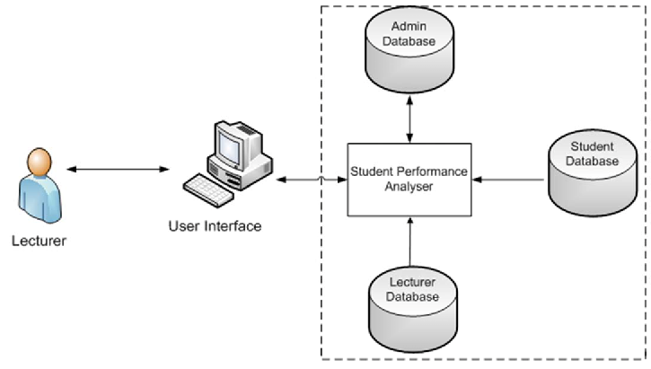

**3.2 Hardware/Software Designing**

**Hardware Requirements:**

* Computer or Laptop: A modern computer or laptop with sufficient processing power and memory to handle data analysis tasks efficiently.
* Operating System: Windows, macOS, or Linux operating system compatible with the

chosen software tools.

* Storage Space: Adequate storage space to store the datasets and analysis results.

**Software Requirements:**

* Web Development Tools: HTML, CSS, JavaScript, and a web framework like Django to build the user interface for accessing and displaying the analysis results.
* Version Control Software: Git to manage code versions and collaboration with other

team members.

* Document Preparation: Word processing software like Microsoft Word for creating

project documentation and reports

**CHAPTER 4**

**EXPERIMENTAL RESULTS**

**4.1 Final Output**

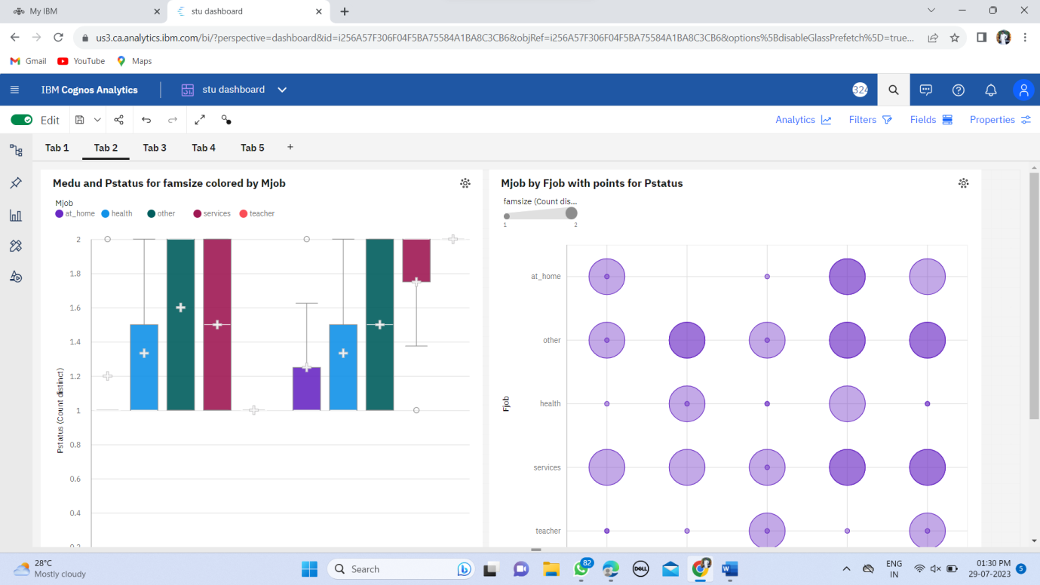

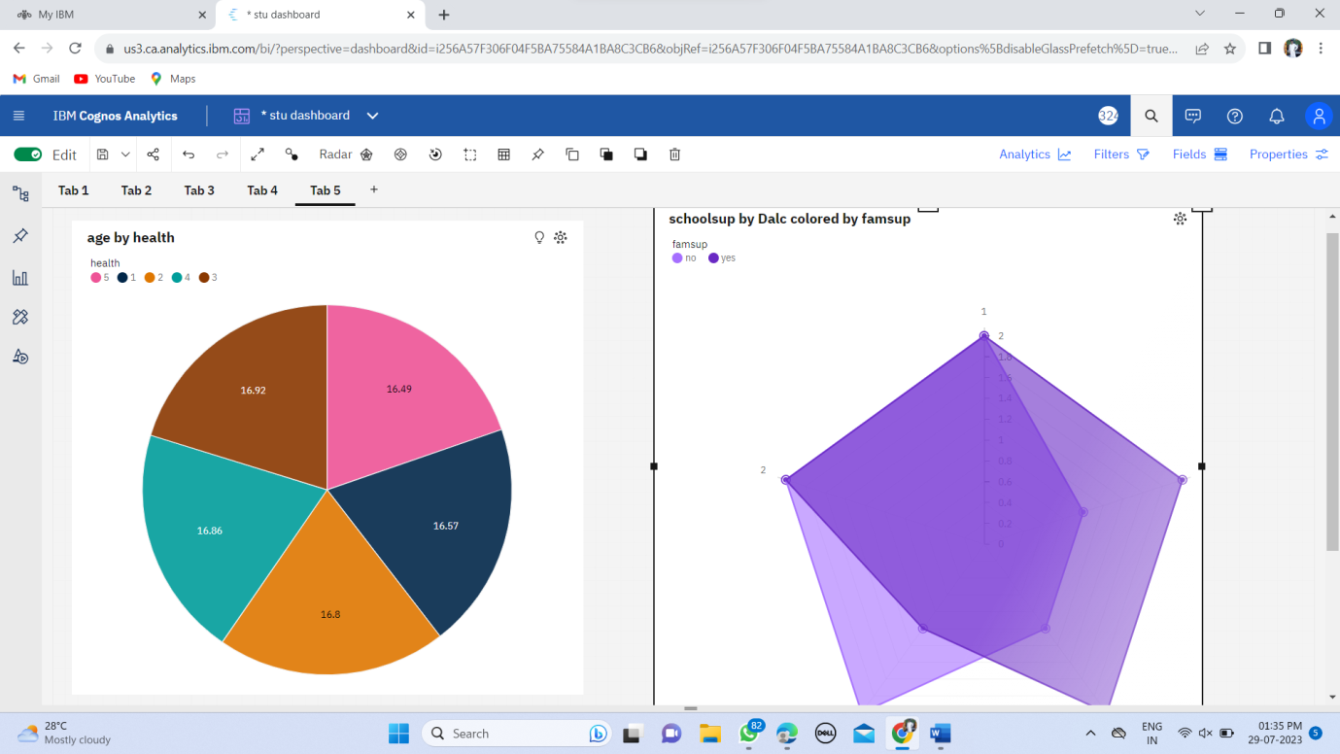

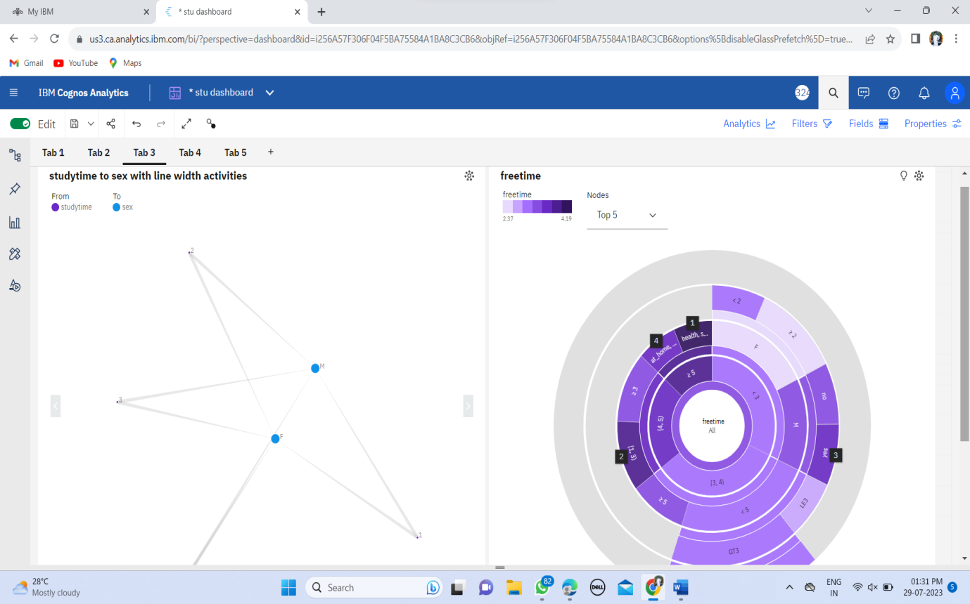

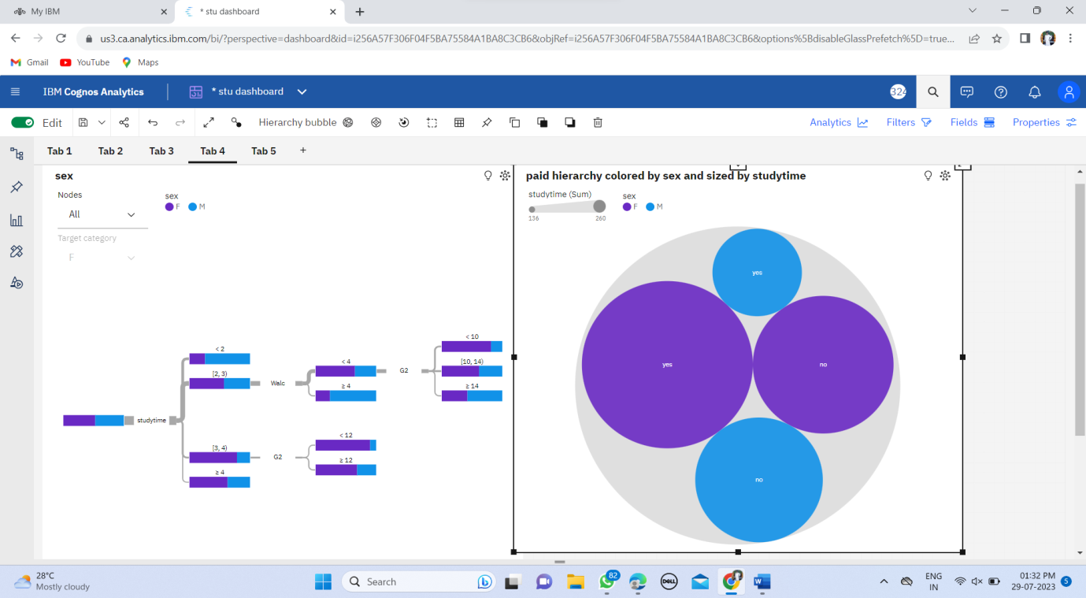

**CHAPTER 5**

**ADVANTAGES/ APPLICATIONS**

**5.1 Advantages and Disadvantages**

**Advantages:**

* Personalized Learning: By understanding the unique learning styles and abilities of

students, educators can create personalized learning plans. This approach fosters a more engaging and effective learning environment, leading to improved academic outcomes and increased motivation among students.

* Resource Allocation: Schools can optimize their resource allocation based on performance analysis. Identifying areas of strength and weakness in student performance can guide decisions on where to allocate additional teaching resources, technology.
* Teacher Professional Development: Analyzing student performance data can highlight

areas where teachers may need additional training or support. It enables schools to

provide targeted professional development opportunities, ultimately enhancing teacher effectiveness and student learning outcomes

**Disadvantages:**

* Data Privacy Concerns: Collecting and storing student performance data can raise privacy concerns, especially if not handled securely. Schools must implement robust data protection measures and adhere to relevant regulations to safeguard sensitive information.
* Stress and Pressure: Excessive focus on performance analysis can create high levels of stress and pressure among students, leading to negative consequences on mental health and well-being. Striking a balance between assessment and overall well-rounded development is crucial.
* Limited Quantification of Non-Academic Skills: Not all valuable skills possessed by students can be easily quantified or measured through performance analysis. Qualities such as leadership, empathy, and teamwork may not be fully captured in traditional data-driven assessments.

**5.2 APPLICATIONS**

The application of student performance analysis in unleashing the potential of our youth

has far-reaching benefits for educational institutions, students, teachers, and

policymakers. Some of the key applications include:

* Curriculum Improvement: Analyzing student performance data helps identify areas where the curriculum may need improvement. Educators can refine course materials, teaching methods, and assessments to better meet student needs.
* Resource Allocation: Schools and educational institutions can optimize resource

allocation based on student performance trends. This includes directing support

services, funding, and personnel to areas that require the most attention.

* Teacher Professional Development: Student performance analysis can inform teacher

training and professional development programs. Identifying areas where teachers excel or face challenges can lead to targeted training and improvement strategies.

* Parental Engagement: Sharing student performance insights with parents fosters greater parental involvement in their child's education. Parents can offer support at home and collaborate with educators to create a supportive learning environment.
* School Ranking and Accreditation: Analyzing student performance data contributes to

school ranking and accreditation processes. High-performance indicators can enhance the school's reputation and attract more students and funding.

* Education Policy Formulation: Policymakers can utilize student performance analysis

shape education policies and interventions at the regional or national level. Data-driven policies can improve the overall quality of education.

* Education Research: Student performance analysis contributes to educational research. Researchers can study trends and patterns in academic achievement to gain insights into effective teaching practices and factors influencing student success.

**CHAPTER 6**

**CONCLUSION & FUTURE SCOPE**

**6.1 CONCLUSION**

In conclusion, the project concentrates on the development of a system for student

performance analysis. After conducting a comprehensive student performance analysis, it

becomes evident that unleashing the potential of our youth is crucial for building a

brighter future. The data and observations collected highlight several key points that

demand attention and action from educators, policymakers, and society. In conclusion,

unleashing the potential of our youth requires a concerted effort from all stakeholders in

the education system. By fostering an environment of personalized learning, providing

continuous support to teachers, offering a holistic education, addressing emotional well-

being, embracing technology, promoting equity and inclusion, involving parents, and

fostering a love for lifelong learning, we can empower our youth to reach their fullest

potential and contribute positively to society. As we invest in our youth, we invest in a

brighter and more promising future for our communities and the world at large.

**6.2 FUTURE SCOPE**

Enhancements that can be made in the future by Unleashing the Potential of Our Youth:

A Student Performance Analysis. To enhance this approach in the future, several

strategies and areas of focus can be considered:

* Integration of Technology: Embrace technology in education to enhance student

engagement and learning outcomes. This includes utilizing interactive educational apps, virtual reality experiences, online collaboration tools, and digital learning platforms.

* Mentoring and Role Models: Establish mentoring programs that connect students with

positive role models from various fields. Mentors can inspire, guide, and provide insights into potential career paths.

* Parental Involvement: Encourage active involvement of parents or guardians in their

children's education.