**Name:** LAAVANYA GANESH

**UIN:** 654324917

**IDS 462: ANOVA ASSIGNMENT 7**

**QUESTION**

A manufacturing company has three different factories. They want to know if there is a difference between them in the average number of defects they produce because they are considering moving all the manufacturing of this product to one of the three factories. Execute ANOVA test and comparison test on the data provided.

**Part 1**

Ho: µ(Factory1) = µ(Factory2) = µ(Factory3)

Ha: At least one of them is different.

**Part 2**

**Program:**

data MANUFACTURING;

input FACTORY $DEFECTS;

datalines;

1 85

1 80

1 79

1 84

2 79

2 75

2 78

2 77

3 82

3 84

3 88

3 86

;

run;

PROC ANOVA DATA=MANUFACTURING;

TITLE "Analysis of Factory Data";

CLASS FACTORY;

MODEL DEFECTS = FACTORY;

MEANS FACTORY /snk;

RUN;

quit;

**Log:**

1 OPTIONS NONOTES NOSTIMER NOSOURCE NOSYNTAXCHECK;

61

62

63 data MANUFACTURING;

64 input FACTORY $DEFECTS;

65 datalines;

NOTE: The data set WORK.MANUFACTURING has 12 observations and 2 variables.

NOTE: DATA statement used (Total process time):

real time 0.00 seconds

cpu time 0.00 seconds

78 ;

79 run;

80

81 PROC ANOVA DATA=manufacturing;

82 TITLE "Analysis of Factor Data";

83 CLASS FACTORY;

84 MODEL DEFECTS = FACTORY;

85 MEANS FACTORY /snk;

86 RUN;

87 quit;

NOTE: PROCEDURE ANOVA used (Total process time):

real time 3.67 seconds

cpu time 0.31 seconds

88

89 OPTIONS NONOTES NOSTIMER NOSOURCE NOSYNTAXCHECK;

102

**Results:**



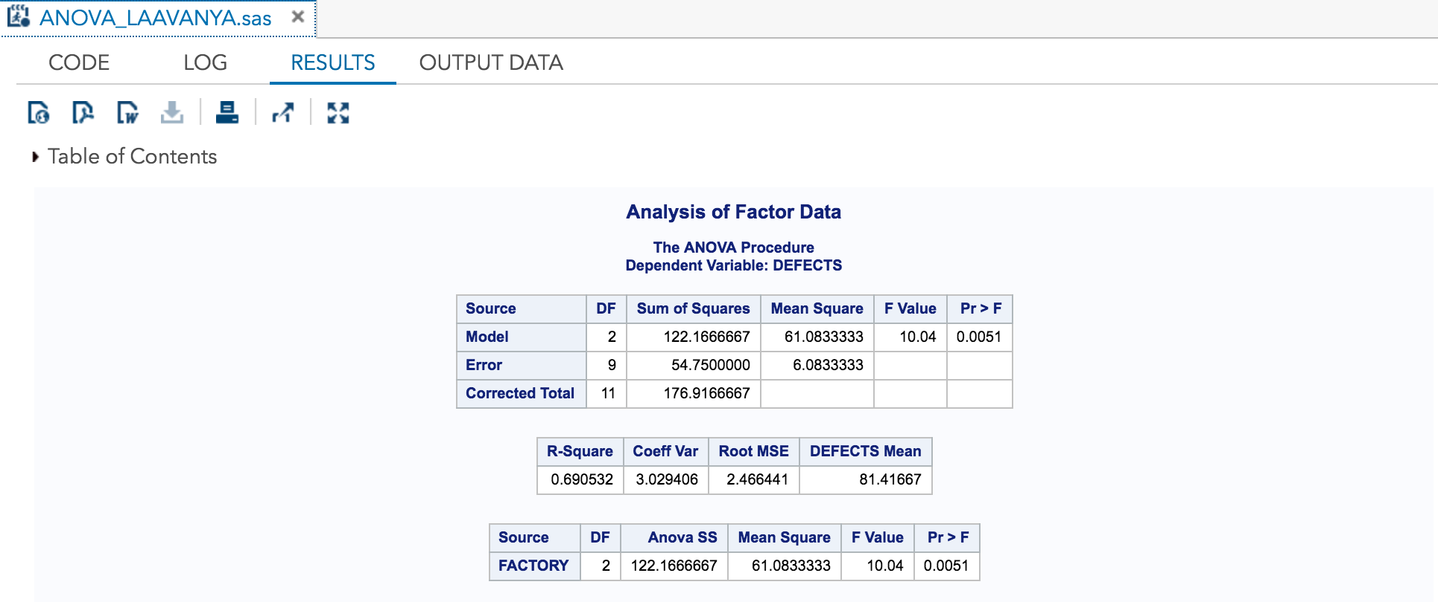

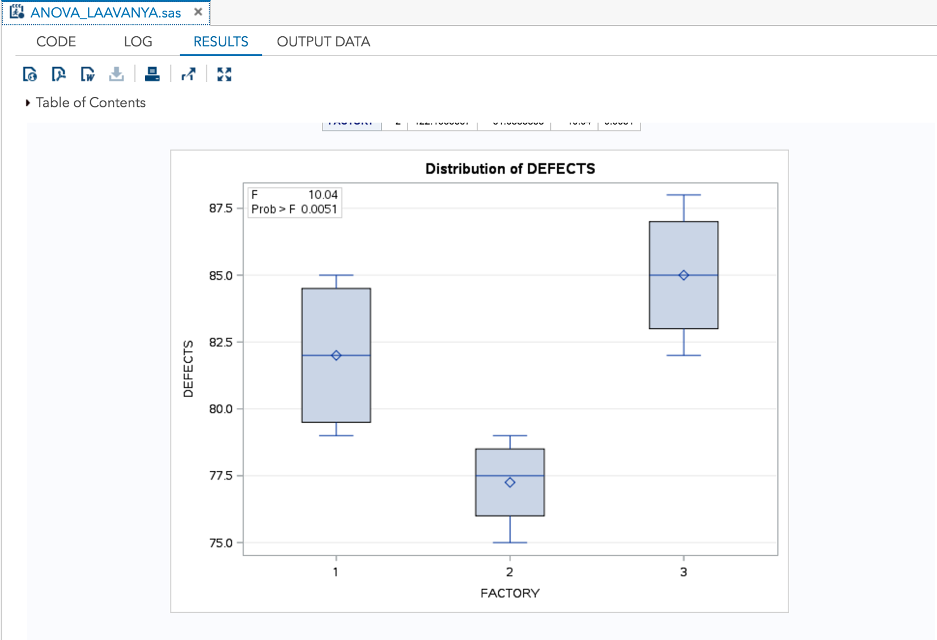

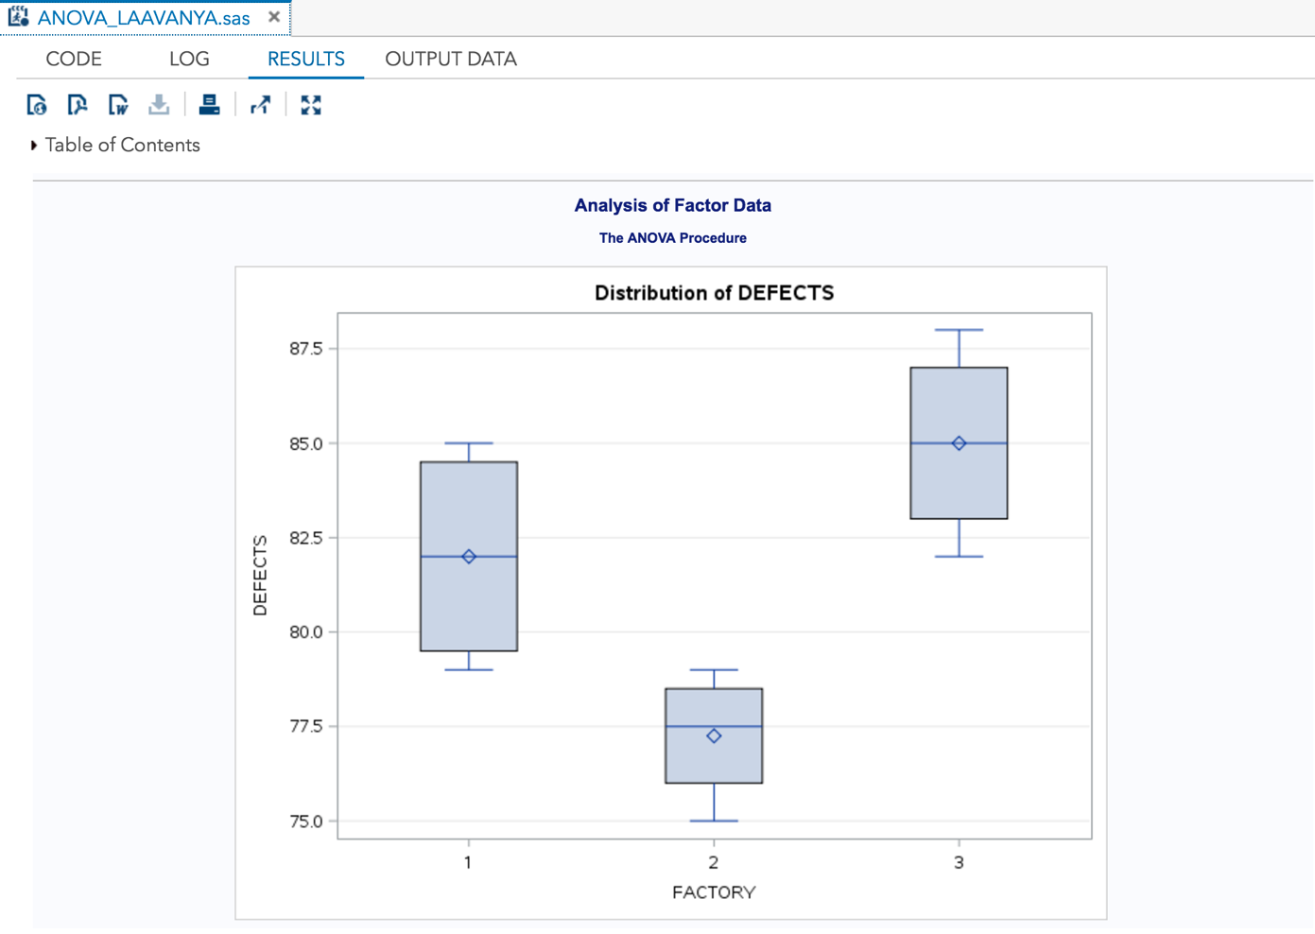

The p-value for the ANOVA test is 0.0051.

**Conclusion:** Reject Ho for Ha (any standard alpha 1%, 5%, or 10%).

**Inference in Plain English:** We therefore conclude that a statistically significant difference does exist for the average number of defects produced by the three different factories.

**Results of the Student-Newman-Keuls Test**

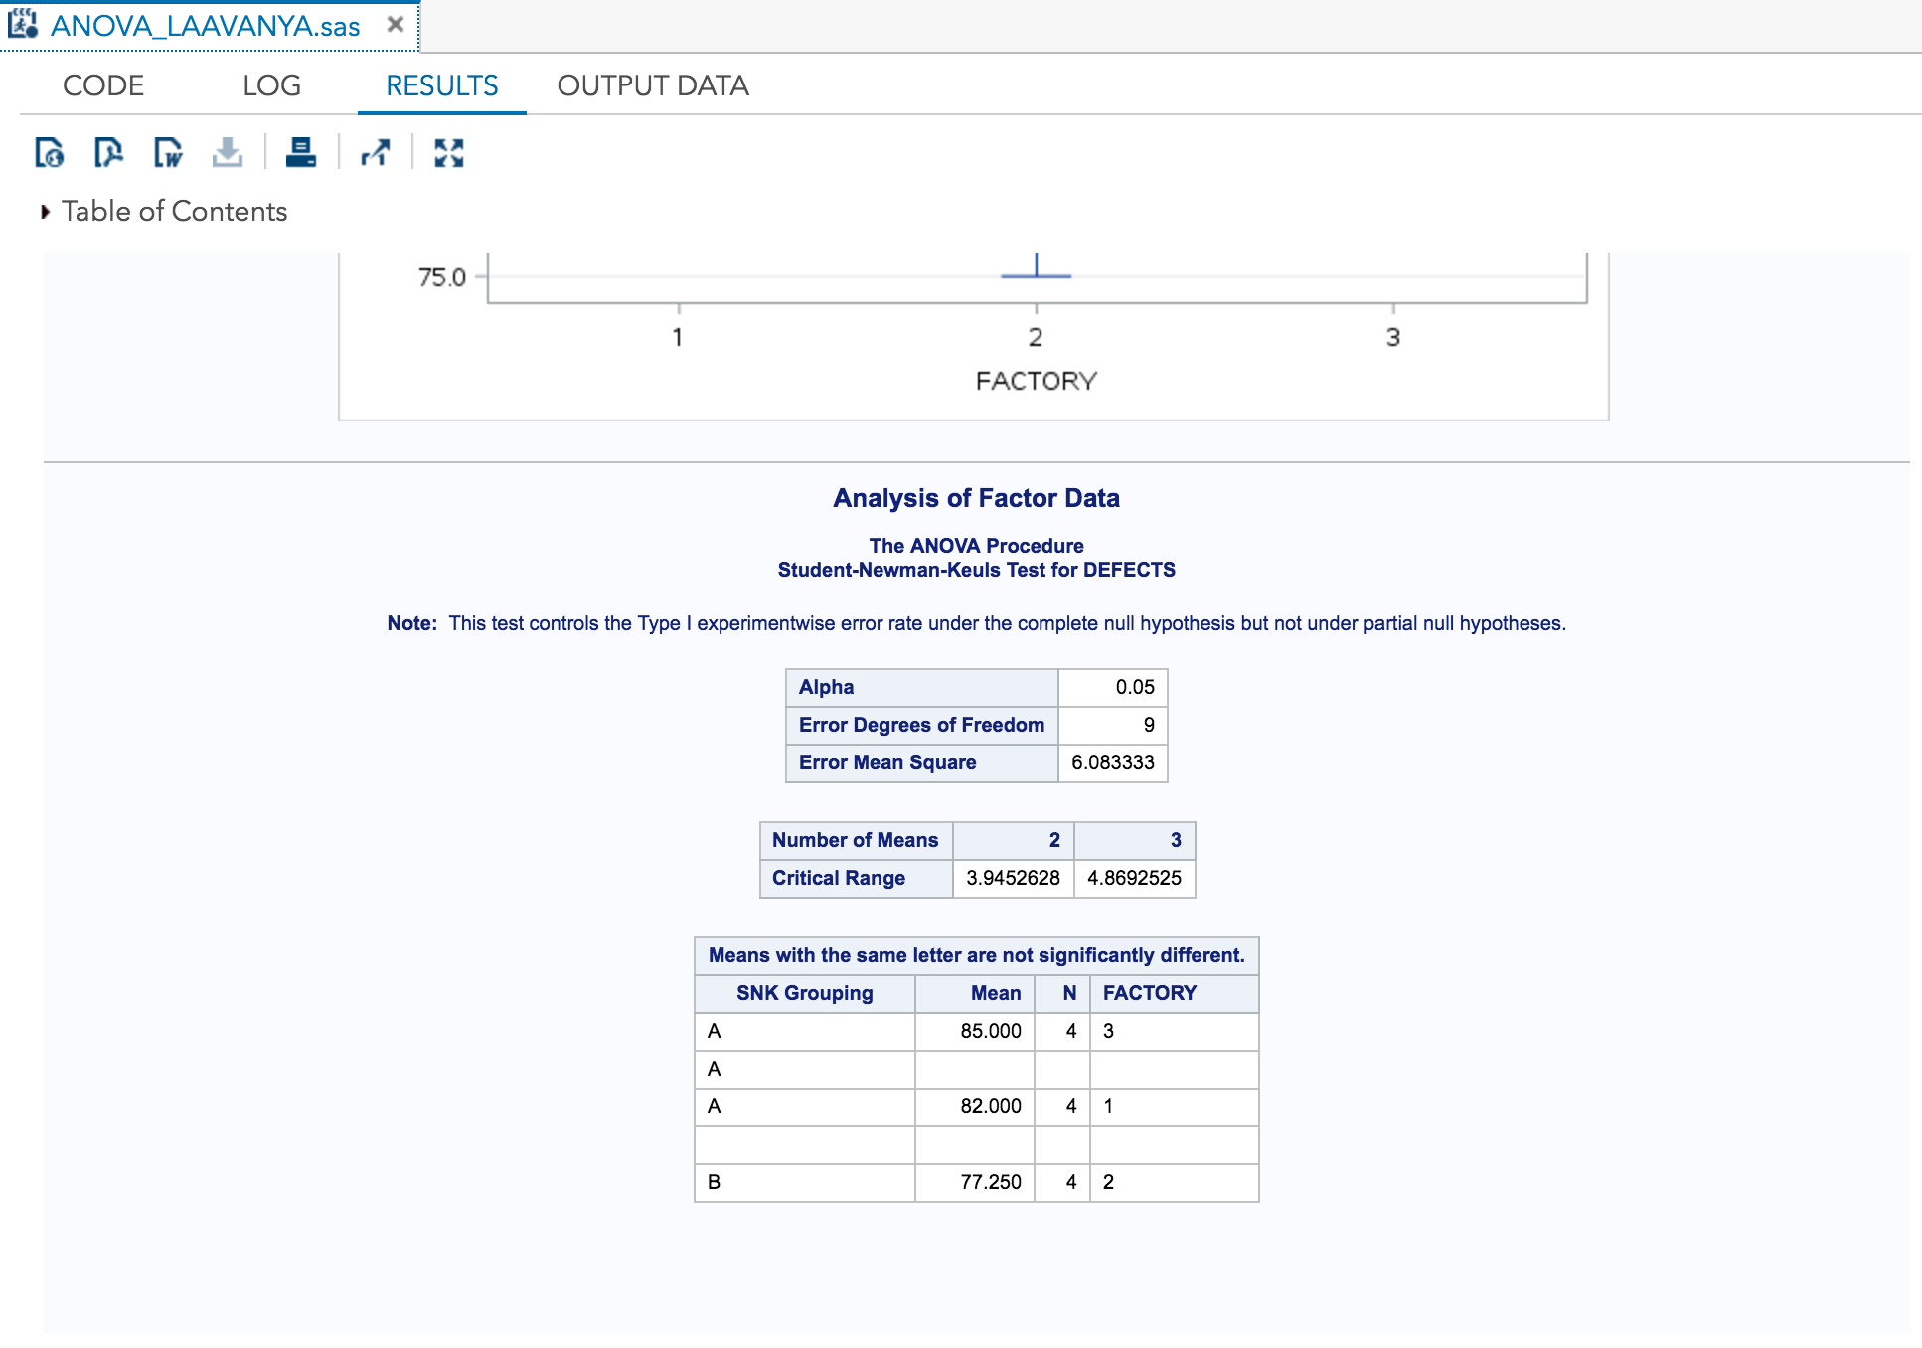

The average defects produced for Factory 3 is 85 and for Factory 1 is 82. The statistical test does not detect a statistically significant difference between these two averages, as indicated by the ‘A’ connecting their two averages in the results table above. Factory 2 had a much lower average of 77.250. This method was statistically different (and lower) than the other as indicated by its different SNK grouping letter: ‘B’.

**Since, Factory 2 had a statistically significant lower average number of defects produced, it has the superior manufacturing method. It is therefore recommended to move all the manufacturing to Factory 2.**