**Name:** Laavanya Ganesh

**UIN:** 654324917

**IDS 462:** Statistical Software for Business

**Assignment 5**

**PROGRAM**

DATA LOGISTIC;

INPUT ACCIDENT DRINK PREVIOUS @@;

LABEL ACCIDENT = 'Accident in Last Year?'

DRINK = 'Drinking Problem?'

PREVIOUS = 'Accident in Previous Year?';

DATALINES;

1 0 1 1 1 1 1 1 1 1 0 0 1 1 1 0 0 1 0 1 0 0 1 0

0 0 1 0 0 0 0 1 0 0 0 1 0 1 0 0 0 0 0 0 0 1 1 0

1 0 1 1 1 1 1 1 1 1 0 1 1 1 1 1 1 0 1 0 1 1 1 0

1 1 1 0 1 1 0 1 1 0 0 1 0 0 1 0 1 0 0 0 0 0 0 1

0 1 0 0 0 0 0 0 0 1 1 1 1 1 0 1 1 1 1 1 0 1 1 1

1 1 1 1 1 1

;

run;

PROC LOGISTIC DATA=logistic descending;

Title "Predicting Accidents Using Logistic Regression";

Model Accident = Drink Previous/selection=STepwise Risklimits;

RUN;

**LOG**

1 OPTIONS NONOTES NOSTIMER NOSOURCE NOSYNTAXCHECK;

61

62 DATA LOGISTIC;

63 INPUT ACCIDENT DRINK PREVIOUS @@;

64 LABEL ACCIDENT = 'Accident in Last Year?'

65 DRINK = 'Drinking Problem?'

66 PREVIOUS = 'Accident in Previous Year?';

67 DATALINES;

NOTE: SAS went to a new line when INPUT statement reached past the end of a line.

NOTE: The data set WORK.LOGISTIC has 42 observations and 3 variables.

NOTE: DATA statement used (Total process time):

real time 0.00 seconds

cpu time 0.00 seconds

74 ;

75 run;

76

77

78 PROC LOGISTIC DATA=logistic descending;

79 Title "Predicting Accidents Using Logistic Regression";

80 Model Accident = Drink Previous/selection=STepwise Risklimits;

81 RUN;

NOTE: PROC LOGISTIC is modeling the probability that ACCIDENT=1.

NOTE: Convergence criterion (GCONV=1E-8) satisfied in Step 0.

NOTE: Convergence criterion (GCONV=1E-8) satisfied in Step 1.

NOTE: Convergence criterion (GCONV=1E-8) satisfied in Step 2.

NOTE: There were 42 observations read from the data set WORK.LOGISTIC.

NOTE: PROCEDURE LOGISTIC used (Total process time):

real time 2.93 seconds

cpu time 0.30 seconds

82

83 OPTIONS NONOTES NOSTIMER NOSOURCE NOSYNTAXCHECK;

96

**SAS CALCULATIONS**

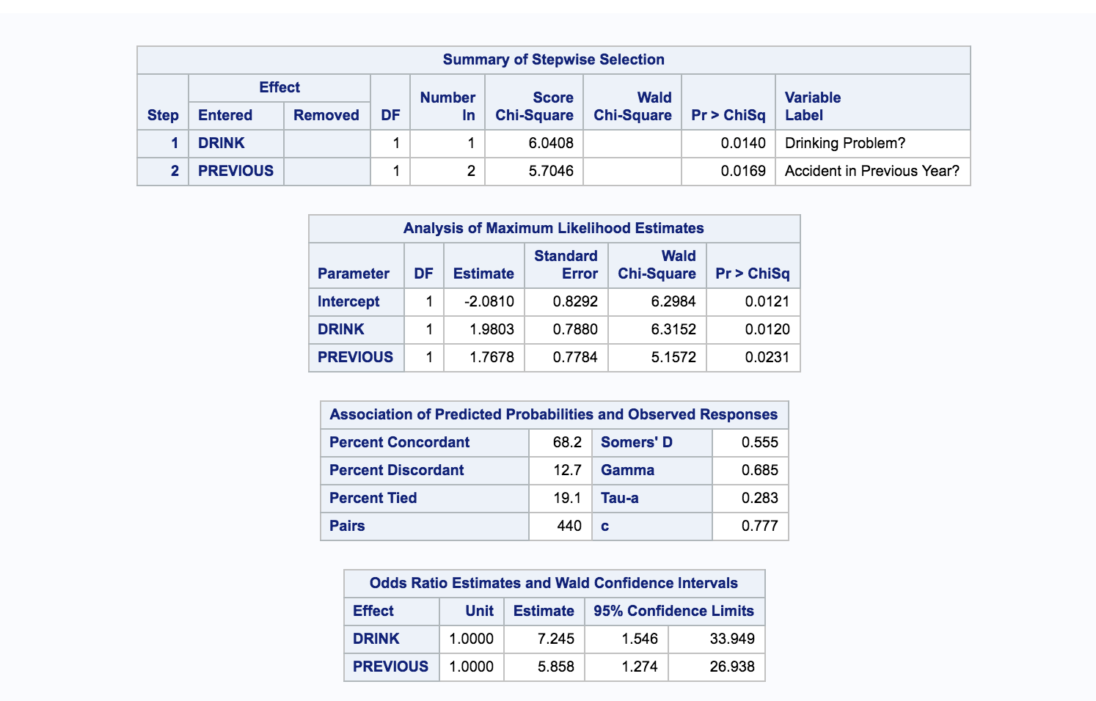

From the above results,

**Log of odds**: -2.0810 + 1.9803(DRINK) + 1.7678(PREVIOUS)

1. **Putting Drink=0, Previous=0,**

**Log of odds**= -2.0810 + 1.9803*(0) + 1.7678*(0)

= -2.0810

**odds** = e^ (-2.0810)

=0.1248053444

**Probability p**= odds/(1+odds)

= 0.1248053444/(1+0.1248053444)

=0.1109572825

1. **Putting Drink=1, Previous=0,**

**Log of odds**= -2.0810 + 1.9803*(1) + 1.7678*(0)

= -0.1007

**odds** = e^ (-0.1007)

=0.9042042535

**Probability p**= odds/(1+odds)

= 0.9042042535/(1+0.9042042535)

=0.4748462524

**Ratio of odds of 2) by 1)** = 0.9042042535/ 0.1248053444 = 7.245

**Therefore, the Odds Ratio calculated from the regression equation is same as listed in the SAS output.**