Two Sample T-Test Homework **Name:** LAAVANYA GANESH **UIN:** 654324917

Suppose the Congressional Budget Office is assessing whether or not to tax cars from Europe because European cars consume more gas on average when compared to cars produced in the US. You have been assigned the task of evaluating whether or not there is a statistical decrease in the average Miles Per Gallon (MPG_Highway) of European vs. US manufactured cars. Note that if a car consumes more gas then it will have lower MPG.

1. What are Ho and Ha for this test expressed in MPG?

**ANSWER**

Ho: mu(MPG_Highway of European Manufactured Cars) - mu(MPG_Highway of US Manufactured Cars) = 0

Ha: mu(MPG_Highway of European Manufactured Cars) - mu(MPG_Highway of US Manufactured Cars) < 0

From the file sas.cars, isolate only those cars that come from Europe vs. the US by running the code

**data** TwoOrigins;

set sashelp.cars;

if origin in ('Europe','USA');

**run**;

1. Execute the two sample T-Test using SAS. Paste in the code and results into your submission.

**ANSWER**

data TwoOrigins;

set sashelp.cars;

if origin in ('Europe','USA');

run;

proc sort data= TwoOrigins;

by descending origin;

run;

proc ttest data=TwoOrigins order=data;

class origin;

var MPG_Highway;

run;

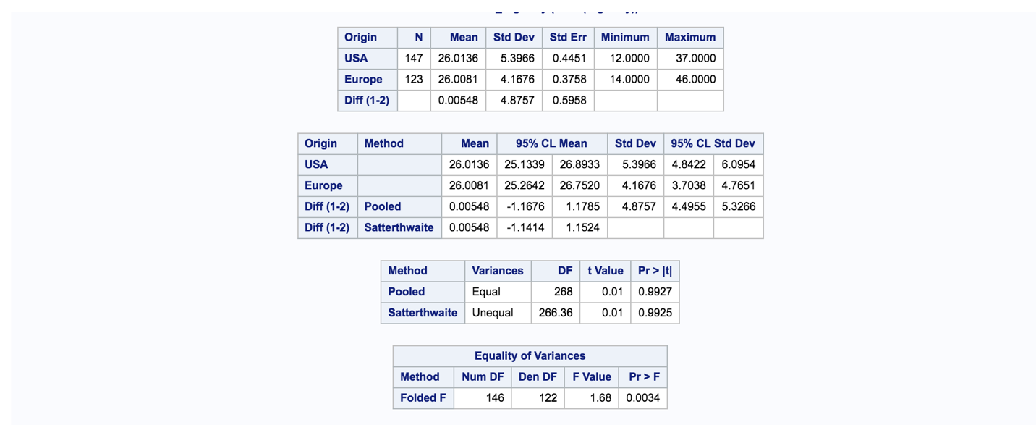

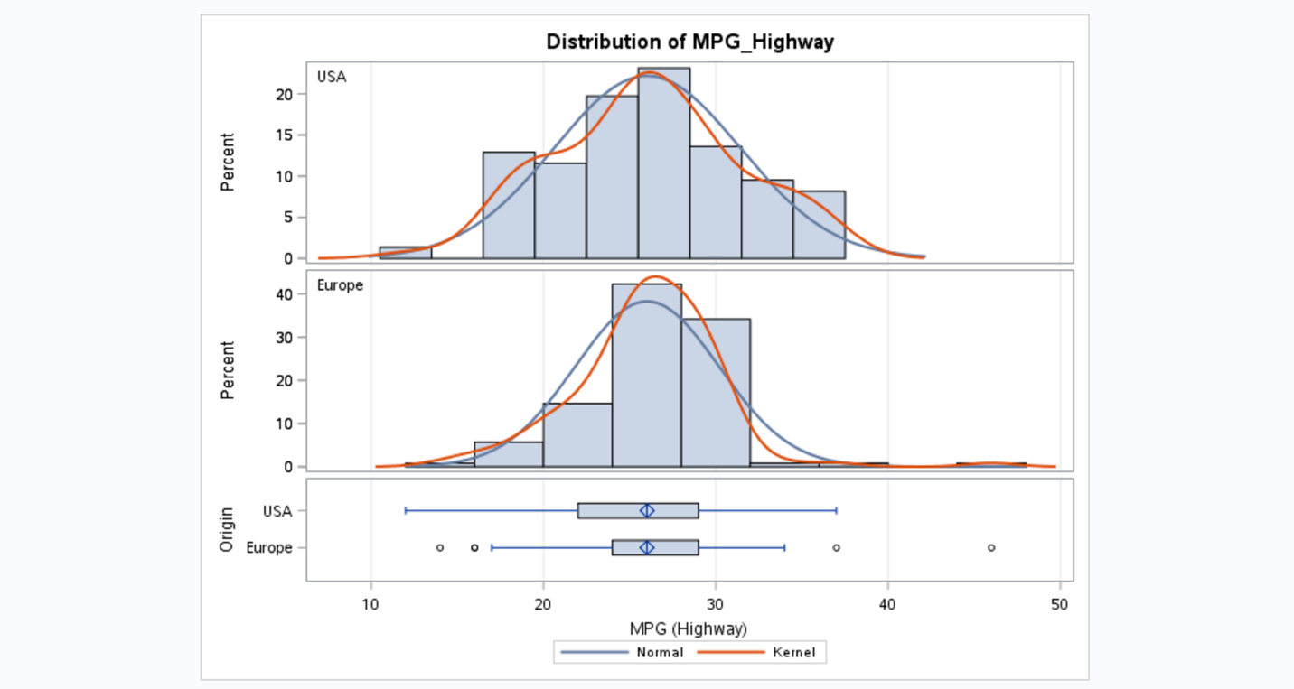

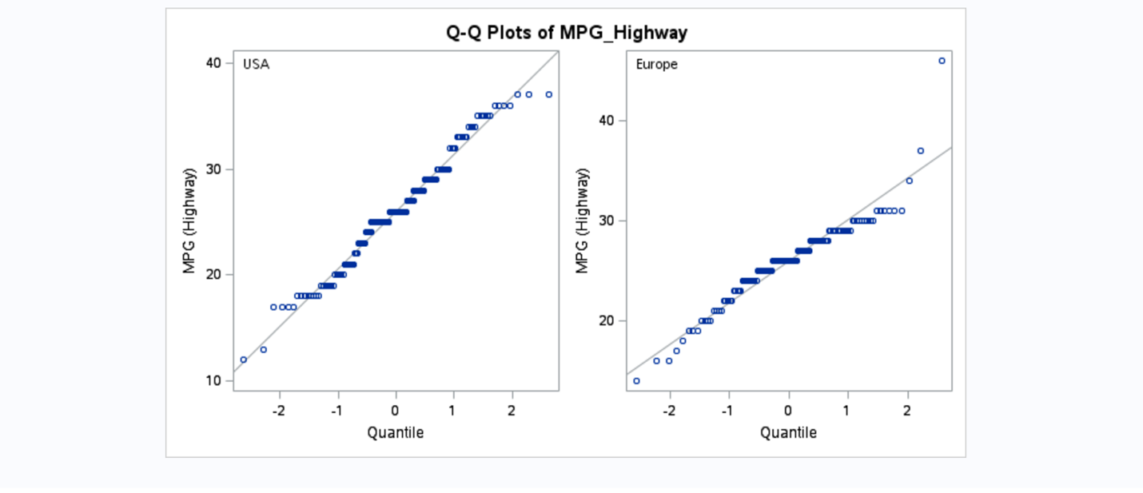

1. What is your conclusion regarding reject Ho vs. not reject Ho and why. Use and alpha of 0.01

**ANSWER**

By looking at the p-value for unequal variance, we observe that the p-value is 0.9925 (2-sided test). As we require a one-sided test, we divide by 2. Therefore, the p-value is 0.49625 (0.9925/2). Since, the p-value is greater than alpha, we reject Ho for Ha.

Statistical conclusion: Fail to reject Ho for Ha.

1. Briefly state what the results of your conclusion mean in terms of what you would tell your client at the Congressional Budget Office.

**ANSWER**

Inference: We do not have enough statistical evidence to conclude that there is a statistical decrease in the average Miles Per Gallon (MPG_Highway) of European vs. US manufactured cars.