GLOBAL SUPERSTORE MANAGEMENT

Milestone 4 (NoSQL Implementation)

Group-16
Laawanyaa Sai Thota
Udhay Chityala

Submission Date: 12/06/2023

/* Finding the Sales ($) through each payment method */
Analytical Purpose: Identifying the share of each payment method so that we can contact a credit/debit card vendor for special offers for using their credit/debit card which boosts the sales
db.payments.aggregate([
{
$group: {
_id: “$Mode_of_Payment”,
totalAmount: {$sum:”$amount”}
}
},
{$sort: {totalAmount: -1}}
])
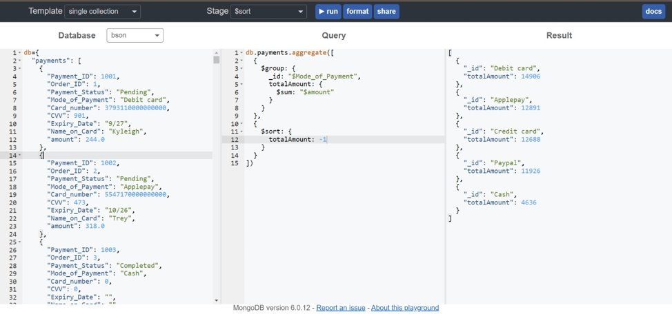

/* Identifying the employees in accounts department in store 3*/
Purpose: Need to do background verification of the employees in store 3 accounts department.
db.employee.find({
“Department_Name”:“Accounts”,
“Store_ID”: 3
})
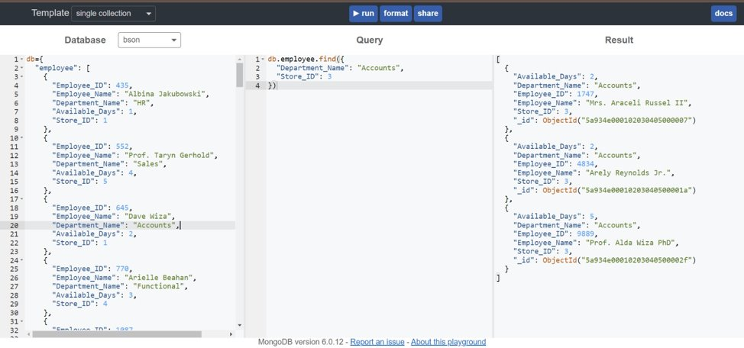
/* Identifying the payment details of completed payments with amount > $750*/
Purpose: Need to manually verify transactions with huge amount
db.payments.find({
“amount”: {$gt: 750},
“Payment_Status”: “Completed”
})
