SAB India Tracker
End-to-end activity flow charts
Fire, plumbing and utility installation operations · internal tool · v3.2
Covers sign-in → sales → project execution → procurement → invoicing → reporting.
Each diagram is a standalone view; flows connect through a single project ledger.

Contents
- 1. System navigation map
- 2. Procurement — vendor to payment
- 3. Sales — quote to cash
- 4. Project lifecycle
- 5. Timesheets & operations
- 6. Users & roles
- 7. PO approval thresholds
- 8. Vendor bill state machine

1. System navigation map
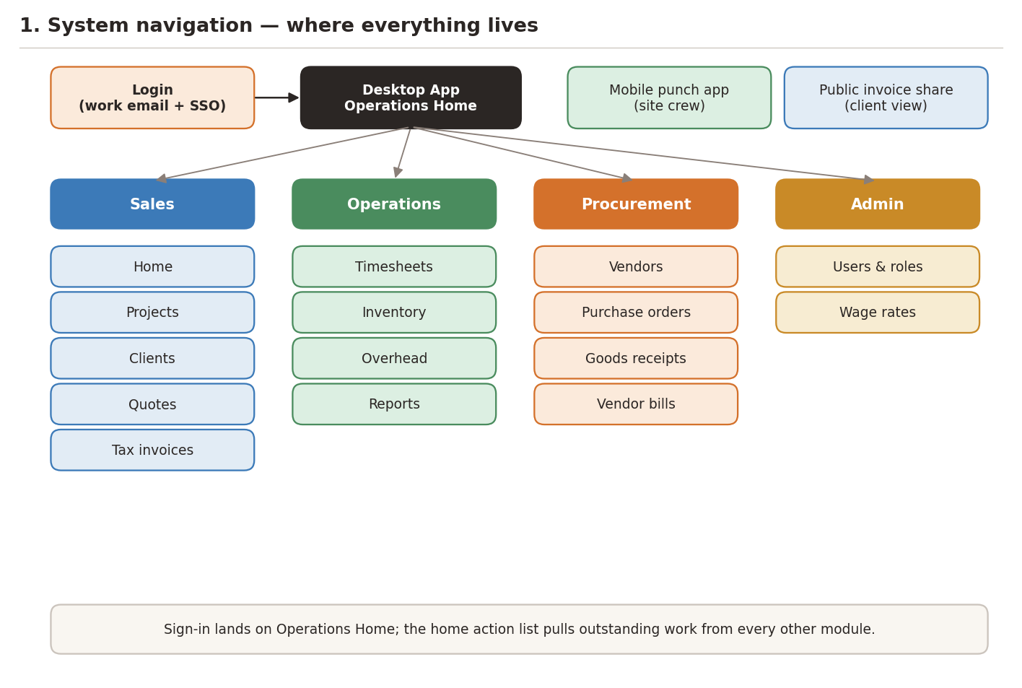
The app has four left-rail sections — Sales, Operations, Procurement, Admin — plus two side-channels: the mobile punch app for site crew and the public invoice share page for clients. Sign-in lands on the Operations Home, which surfaces action items pulled from every other module.

2. Procurement — vendor to payment
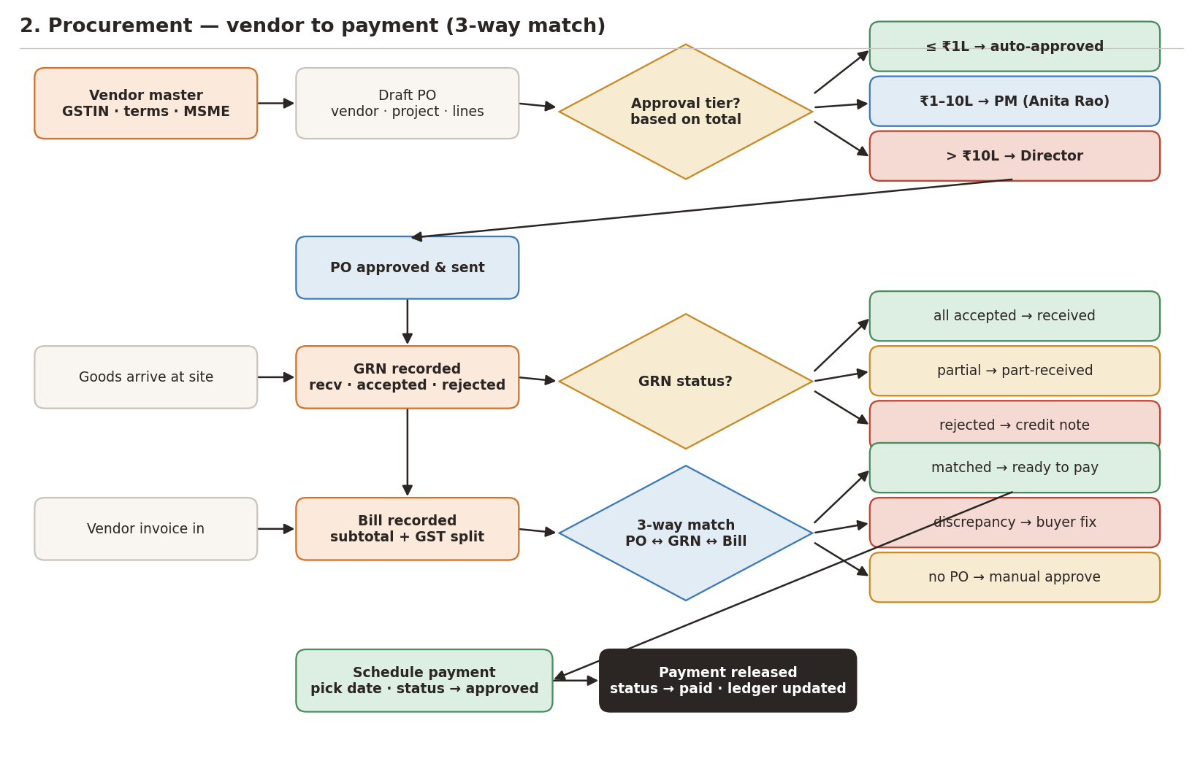
The most ledger-sensitive path in the app. Every PO draft passes a three-way threshold test before it can be sent to the vendor. The GRN captures shortfall and rejection data that drives vendor credit notes. Bills then reconcile through a 3-way match (PO ↔ GRN ↔ Bill) before they are routed to finance for payment scheduling.

3. Sales — quote to cash
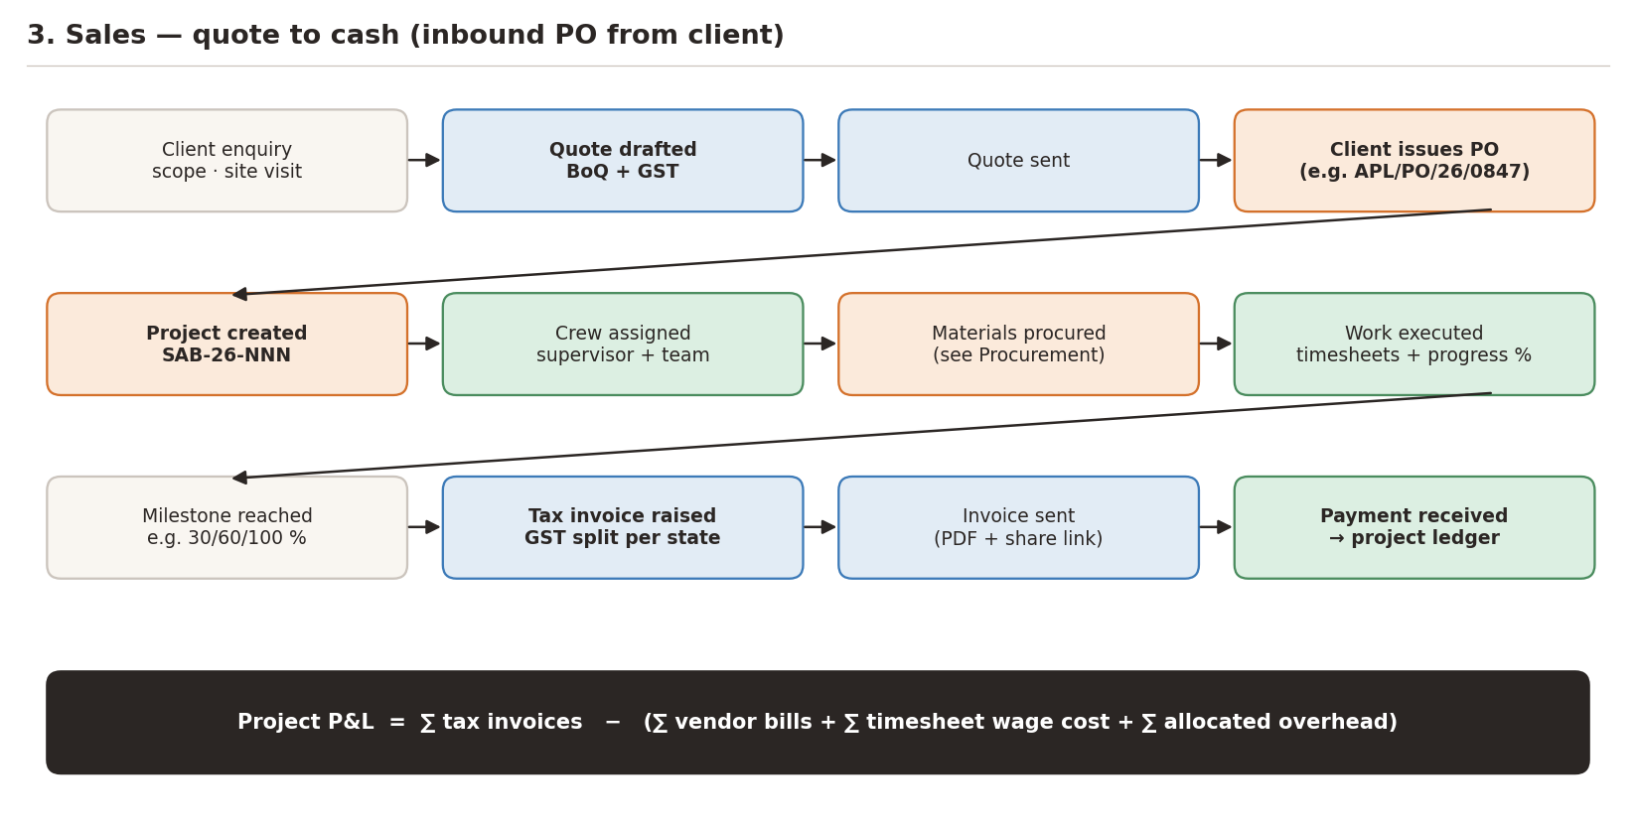
Sales starts with a client enquiry and ends with a payment posted to the project ledger. Once the client issues their inbound PO, a project is created and the execution track picks up — crew assignment, materials procurement (separate flow, diagram 2), and milestone-based invoicing. Every invoice writes to the same project ledger where vendor bills, wages and overhead also land, producing one P&L per project.

4. Project lifecycle
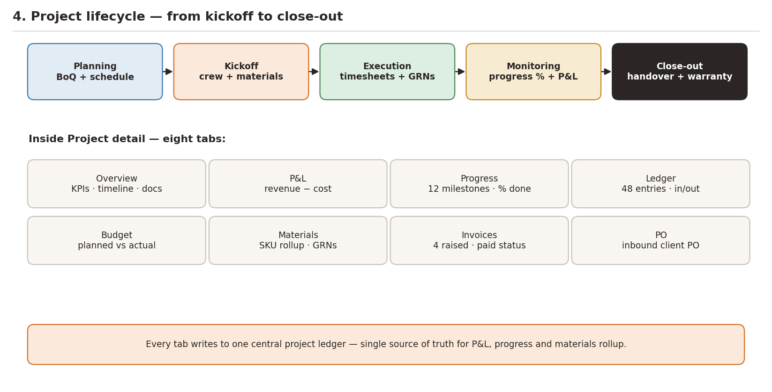
Inside the Project Detail view, work is organised across eight tabs. Each tab writes back to the same central project ledger — that is why P&L, progress and materials rollup always stay in sync. Close-out captures handover docs and starts the warranty clock.

5. Timesheets & operations
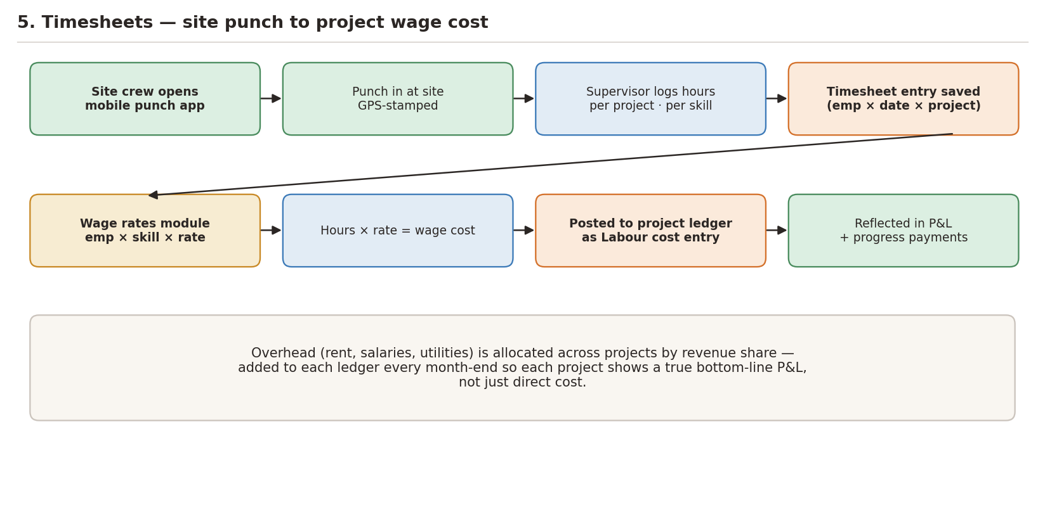
Site crew punches in via the mobile app (GPS-stamped). Supervisors log hours per project per skill; the Wage rates module provides the multiplier that turns hours into labour cost. That cost lands on the project ledger as a Labour entry, feeding P&L, progress payments and overhead allocation.

6. Users & roles
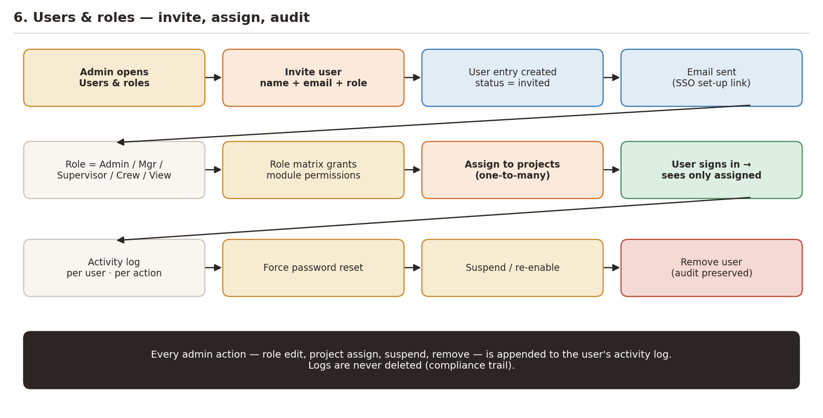
Admins invite users by email and role. The role matrix grants module-level permissions (Admin / Manager / Supervisor / Crew / View-only). Project assignment is separate and narrows what a given user actually sees once signed in. Every action — role edit, project assign, suspend, remove — is appended to the user's activity log for compliance.

7. PO approval thresholds
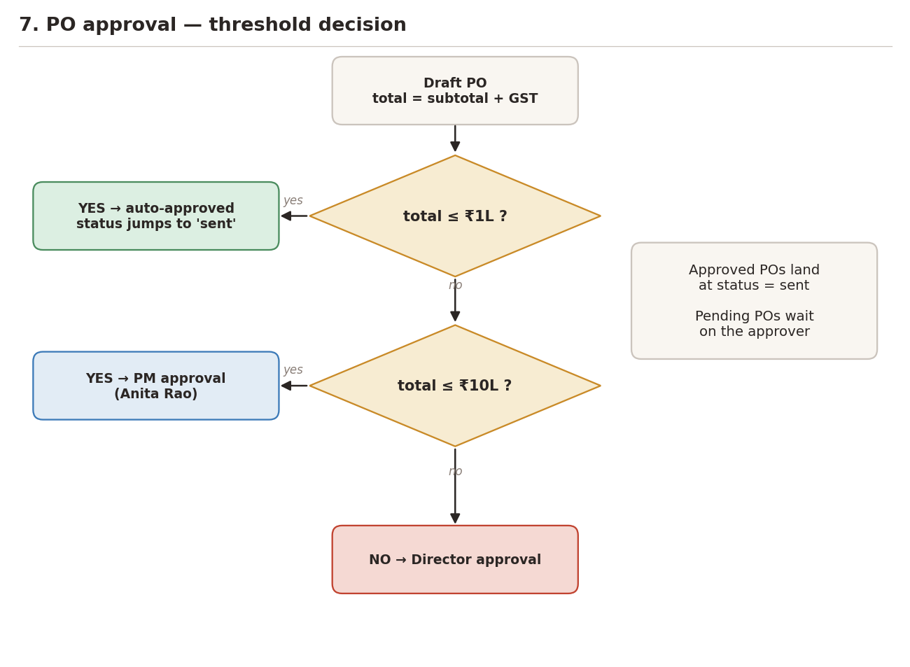
A single helper (approvalTierFor) drives the whole approval routing. Under ₹1L the PO is auto-approved and immediately marked 'sent'. Between ₹1L and ₹10L the PO waits for a project manager's click. Over ₹10L only a Director can sign off. The tier is stored with the PO so an auditor can later see why a given PO went where it did.

8. Vendor bill state machine
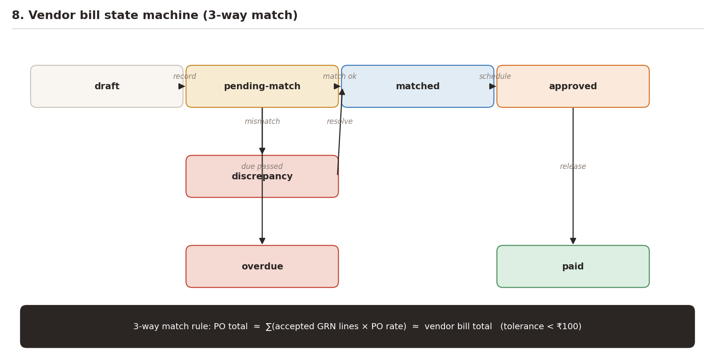
Every vendor bill moves through a fixed set of states. The green path — draft → pending-match → matched → approved → paid — is the happy flow. Bills can sidetrack through 'discrepancy' (resolved by the buyer) or 'overdue' (passed due date without payment). Tolerance for the 3-way match is currently ₹100.

Legend
Orange box — Procurement or core record (vendor, PO, bill, project)
Blue box — Sales-side record (quote, invoice, payment)
Green box — Successful completion / happy path
Amber diamond — Decision point (threshold, match, status check)
Red box — Failure, discrepancy or overdue state
Dark box — System-level or cross-cutting fact (e.g. P&L formula)

