HW1 REPORT: ELASTICSEARCH INDEXING & RETRIEVAL

1. INTRODUCTION
This assignment implements an Information Retrieval system using Elasticsearch. The system indexes the Cranfield dataset and retrieves relevant documents based on user queries. It demonstrates how a search engine backend stores, indexes, and retrieves documents efficiently.

2. OBJECTIVE
The objective of this assignment is to build a document indexing system using Elasticsearch, store all Cranfield dataset documents in an index, and process queries to retrieve ranked results.
3. DATASET
The Cranfield TREC dataset is used, which contains 1400 scientific documents along with query files (cran.qry.xml).
4. IMPLEMENTATION (PARAGRAPH FORMAT)
A local Elasticsearch server was first started and connected using localhost:9200. The indexing program was executed to parse the Cranfield dataset XML file. Each document was processed by extracting the <docno> field as the unique document ID and the <text> field as the document content. These documents were then indexed into an Elasticsearch index named cranfield_index.
The system successfully indexed all 1400 documents, and the indexing progress was displayed in the terminal during execution. After indexing, query processing was performed using the query file. Queries were sent to Elasticsearch, which retrieved and ranked relevant documents based on its internal scoring mechanism.

Run command used:
python HW1/Create_Index.py

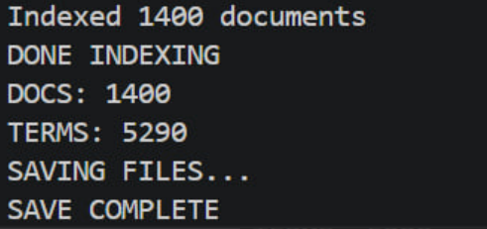

After indexing, query processing was performed using the query file. Queries were sent to Elasticsearch, which retrieved and ranked relevant documents based on its internal scoring mechanism.
Run command used:
python HW1/Query_Processing.py

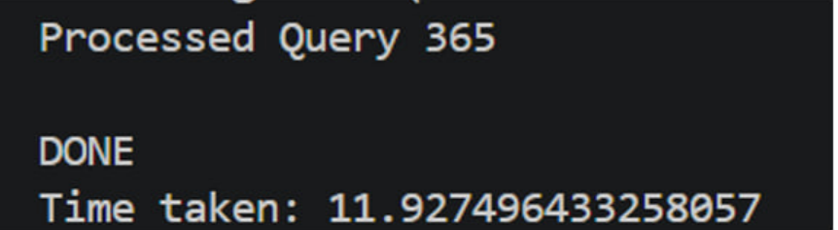

This screenshot confirms successful execution of query processing.

5. RESULT
The system successfully indexed all 1400 documents and processed all queries without errors. Elasticsearch handled retrieval and ranking internally, confirming correct system execution.

6. CONCLUSION
This assignment successfully demonstrates the implementation of an Information Retrieval system using Elasticsearch. It shows how documents can be indexed and retrieved efficiently, forming the basis of modern search engines.

