HW2 REPORT: CLASSICAL INFORMATION RETRIEVAL MODELS

1. INTRODUCTION
This assignment implements classical Information Retrieval models using Python. Unlike HW1 which uses Elasticsearch indexing and retrieval, this assignment builds an inverted index manually and applies different retrieval models to rank relevant documents for user queries.
2. OBJECTIVE
The objective of this assignment is to build an inverted index from the Cranfield dataset, implement multiple retrieval models, process queries, and generate ranked document results.
3. DATASET
The Cranfield dataset was used in this assignment, consisting of:
- 1400 documents
- 225 queries from cran.qry.xml
- Relevance judgments from the Cranfield qrel file

4. IMPLEMENTATION
The documents were parsed and tokenized to construct an inverted index. During indexing, document statistics such as term frequencies and document lengths were computed and stored for retrieval.
The retrieval models implemented include:
- Okapi TF
- TF-IDF
- BM25
- Proximity-based retrieval
The BM25 index was built successfully and saved into index files for query processing.
Run command used:
python HW2/Build_BM25_Index.py
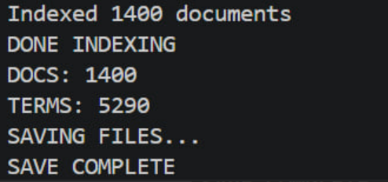
This screenshot shows successful creation of the inverted index and supporting files.
After index construction, query processing was performed using all four retrieval models. Each query was evaluated and ranked results were generated and written to output files.
Run command used:
python HW2/Query_Processing.py
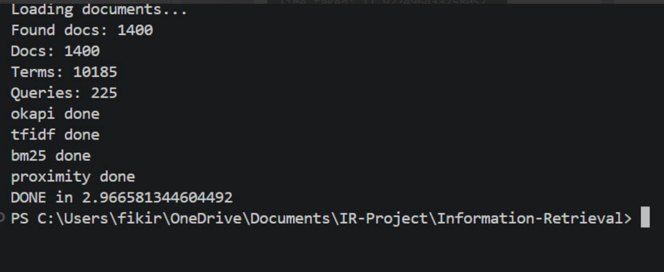
This screenshot confirms successful processing of all queries across all retrieval models.
5. RESULT
The system successfully processed all 1400 documents and 225 queries. All retrieval models executed correctly and produced ranked outputs. Result files such as okapi.txt, tfidf.txt, bm25.txt, and proximity.txt were generated successfully.
6. CONCLUSION
This assignment successfully demonstrates implementation of classical Information Retrieval models using manual indexing and ranking techniques. The results show correct functioning of multiple retrieval algorithms, especially BM25 and proximity-based retrieval.

