Imprinted Proteins as a Receptor in Fluorescent Sensing Microplate Assay for Herbicides Determination
Supplementary material
Kirill Yu. Presnyakov¹, Ivan S. Matlakhov¹, Ivan A. Reshetnik¹, Polina M. Ilicheva¹, Daria V. Tsyupka¹,
Daria G. Koganova¹, Svetlana A. Mescheryakova¹, Tatyana Yu. Rusanova¹, Mikhail V. Pozharov¹,
Daniil D. Drozd¹, Pavel S. Pidenko¹, Irina Yu. Goryacheva¹, Natalia A. Burmistrova¹*
¹—Institute of Chemistry, Saratov State University, Astrakhanskaya Street 83, Saratov, 410012, Russia.
*—Corresponding author, e-mail address: naburmistrova@mail.ru
List of Tables
Table S1: Maximum permissible levels of imazamox in cereal plants in different countries ii
Table S2: Molecularly imprinted polymers selective to herbicides iii
Table S3: Influence of assay conditions to imazamox recovery rate (%) at IPs modified microplate surface iv
List of Figures
Figure S1: Imazamox structure v
Figure S2: Complex protein–imazamox at pH 3.0 vi
Figure S3: Influence of free amino acids in soil for fluorescence of QDs with and without IPs modification of microplate vii

Table S1: Maximum permissible levels of imazamox in cereal plants in different countries
Country | Culture | Concentration limit | Ref.
Russia | Sunflower seeds | 0.004 mg m⁻³ | ¹
USA | Wheat | 0.3 ppm | ²
China | Wheat | 0.05 mg kg⁻¹ | ³
Australia | Barley | 0.02–0.04 mg kg⁻¹ | ⁴
EU | Sunflower seeds | 0.30 mg kg⁻¹ | ⁵
¹Federal Center for Hygiene and Epidemiology of Rospotrebnadzor. Guidelines for control methods. Collection. MUK 4.1.2665—10.
²Federal Register. Vol. 66, No. 248. Rules and Regulations 66773.
³National Food Safety Standard—Maximum Residue Limit of Pesticides in Foods (GB 2763–2021).
⁴Public release summary on “Evaluation of the new active imazamox in the products raptor herbicide & raptor wg herbicid". National Registration Authority for Agricultural and Veterinary Chemicals. NRA Refs: 50853 & 50854.
⁵Commission Regulation (EU) 2021/2202 of 9 December 2021.

Table S2: Molecularly imprinted polymers selective to herbicides
Monomer / Cross-linked agent | Detectable substances | Substrate | LOD | Linear range | Recovery | Ref.
1–VN | Imazapyr | n/a | 0.09 μg L⁻¹ | 0.29–200.0 μg L⁻¹ | 86–107 % | ¹
 | Imazapic | = | 0.06 μg L⁻¹ | 0.21–200.0 μg L⁻¹ | =
 | Imazethapyr | = | 0.04 μg L⁻¹ | 0.15–200.0 μg L⁻¹ | =
 | = | fCBPE | 0.03 μmol L⁻¹ | 0.10–70.00 μmol L⁻¹ | 96.3–105.7 % | ²
AA / TRIM | = | CPR | 15 ng g⁻¹ | 0.1–5.0 μg mL⁻¹ | 91.1–97.5 % | ³
 | = | Fe₃O₄@SiO₂ | 2.13 μg L⁻¹ | 5–100 μg L⁻¹ | 87.7–102 % | ⁴
4–VP / EGDMA | = | SPME fiber | 0.16 μg mL⁻¹ | 0.50–50 μg mL⁻¹ | 87.5–123 % | ⁵
 | Imazameth | = | 0.16 μg mL⁻¹ | = | 70.0–99.9 %
 | Imazamox | = | 0.070 μg mL⁻¹ | = | 60.0–87.9 %
 | Imazapyr acid | = | 0.16 μg mL⁻¹ | = | 63.1–87.0 %
 | Imazaquin acid | = | 0.29 μg mL⁻¹ | 1.0–100 μg L⁻¹ | 81.2–99.5 %
All papers in the table used imazethapyr as a template.
List of acronyms: =—similar value, 1–VN—1-vinylimidazole, 4–VP—4-vinylpyridine, AA—acrylamide,
CPR—chloromethylation polystyrene resin, EGDMA—ethylene glycol dimethacrylate, fCBPE—functionalized carbon black paste electrode, LOD—limit of detection, MA—methacrylic acid, SPME—solid phase microextraction,
TRIM—trimethylolpropane trimethacrylate.
¹doi.org/10.1016/j.foodchem.2020.127345—Development of selective preconcentration/clean-up method for imidazolinone herbicides determination in natural water and rice samples by HPLC-PAD using an imazethapyr imprinted poly(vinylimidazole-TRIM).
²doi.org/10.1002/elan.202100360—Development of a Novel Molecularly Imprinted Polyvinylimidazole/Functionalized Carbon Black Nanocomposite-based Paste Electrode for Electrochemical Sensing of Imazethapyr in Rice Samples.
³doi.org/10.1155/2018/7535417—Preparation of Imazethapyr Surface Molecularly Imprinted Polymers for Its Selective Recognition of Imazethapyr in Soil Samples.
⁴doi.org/10.1039/d0ay02116d—Highly selective enrichment and direct determination of imazethapyr residues from milk using magnetic solid-phase extraction based on restricted-access molecularly imprinted polymers.
⁵doi.org/10.1002/jssc.201400960—Molecularly imprinted polymer as a novel solid-phase microextraction coating for the selective enrichment of trace imidazolinones in rice, peanut, and soil.

Table S3: Influence of assay conditions to imazamox recovery rate (%) at IPs modified microplate surface
 |  | Recovery rate, %
 |  | BSA based IPs | GOx based IPs
IPs dilution  (pH 8, blocking buffer 0.5 % wt. BSA) | 10 | 31±7 | 14±8
 | 20 | 64±6 | 38±4
 | 40 | 89±3 | 70±5
 | 80 | 96±12 | 86±10
 | 120 | 93±14 | 92±15
IPs immobilization pH  (IPs 40, blocking buffer 0.5 % wt. BSA)* | 3.0 | 71±4 | nd
 | 7.4 | 82±2 | nd
 | 9.0 | 89±1 | nd
BSA content  in blocking buffer, % wt (IPs 40, pH 9)** | 0 | 99±15 | nd
 | 0.1 | 91±2 | nd
 | 0.5 | 87±3 | nd
 | 1.0 | 80±2 | nd
nd—Negative result,
*,**—The optimal condition for immobilization pH and blocking buffer were obtained for BSA-based IPs as a result in recovery rate at IPs dilution investigation

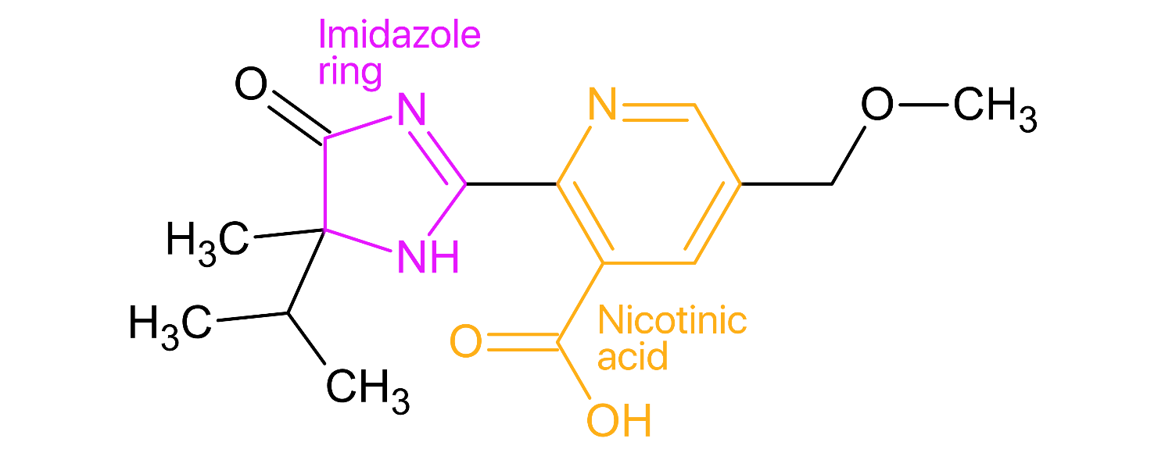
Figure S1: Imazamox structure

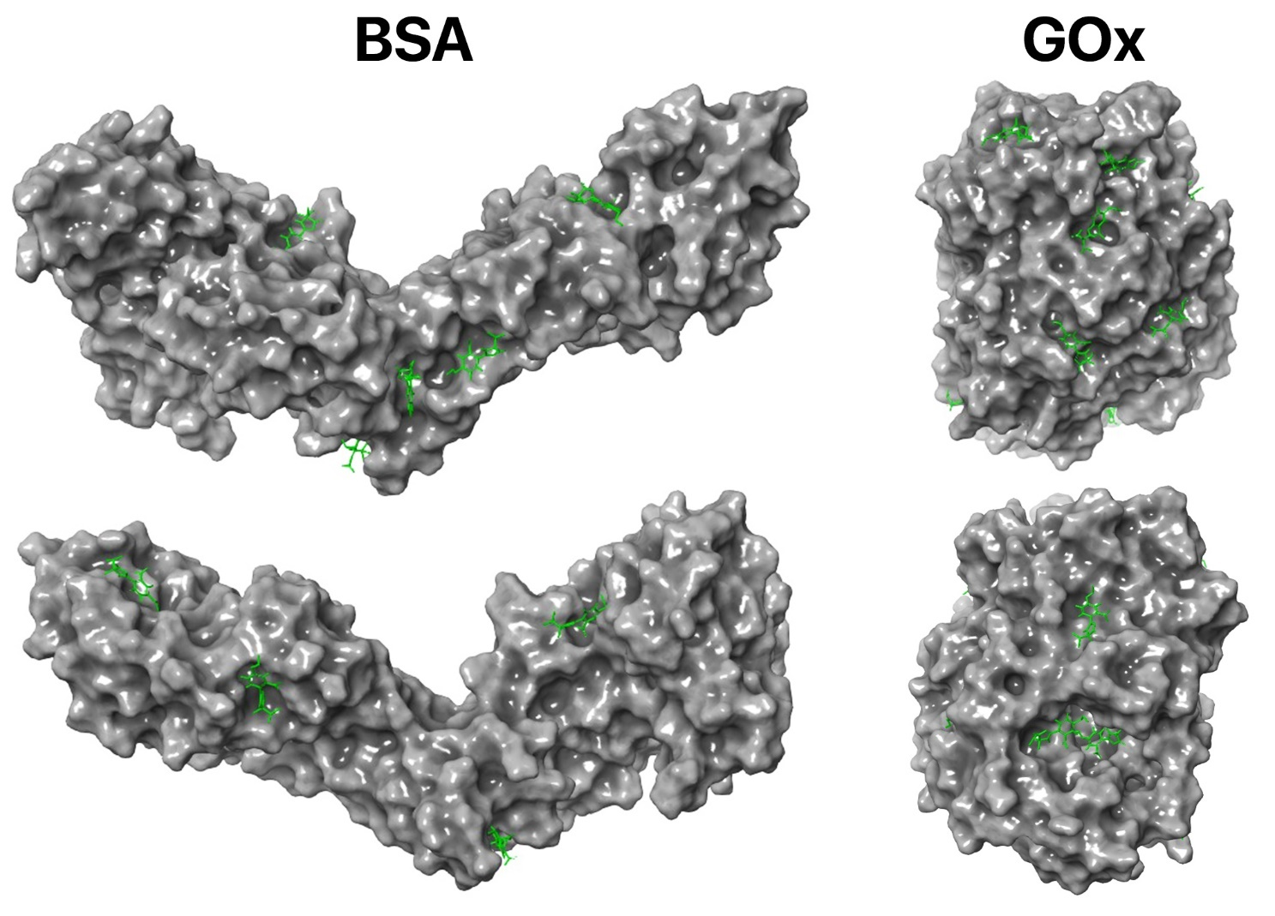
Figure S2: Complex protein–imazamox at pH 3.0

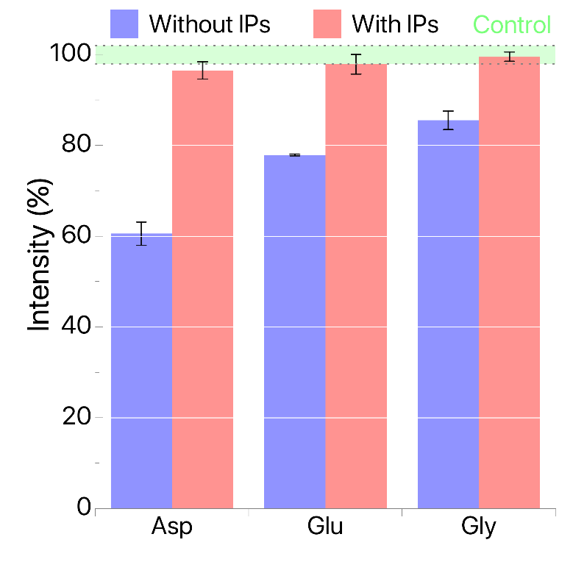
Figure S3: Influence of free amino acids in soil for fluorescence of QDs with and without IPs modification of microplate

