# Euclidean Distance (Taylor’s Version)

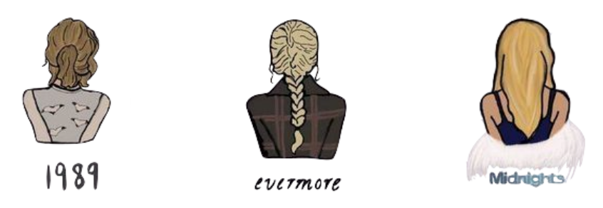

## **Instructions**

Taylor Swift is contemplating re-releasing three of her albums (Midnights, folklore, and 1989). She has also covered three different songs:

* Boyz II Men’s “End Of The Road”,
* Guns ‘N’ Roses’ “Sweet Child O’ Mine”, and
* Prince’s “Purple Rain”

She wants to include these cover songs on her re-released albums. Because she ❤️s statistics, T-Swift wants to include each cover song on the album that the song is most similar to based on their musical properties. After hearing about your prodigious skills in classification, she would like your help in determining which album to put these extra tracks on.

| Spotify collects data on nine musical properties, but for now we will only consider two:   * **Danceability:** Measure of how suitable a track is for dancing based on a combination of musical elements including tempo, rhythm stability, beat strength, and overall regularity. Higher values indicate the song is more danceable. * **Loudness:** The overall loudness of a track in decibels (dB). Loudness values are averaged across the entire track and are useful for comparing relative loudness of tracks. |
| --- |

The Spotify metrics for three cover songs Taylor Swift wants to add to her re-released albums.

| **Track** | **Danceability** | **Loudness** |
| --- | --- | --- |
| End Of The Road | 66.80 | 58.00 |
| Purple Rain | 13.48 | 47.39 |
| Sweet Child O’ Mine | 28.91 | 95.18 |

## Part I: Measuring Similarity in Two Dimensions

1. The Danceability and Loudness metric for two of Taylor Swift’s songs (*Lavendar Haze* and *cardigan*) are given below. Create a two-dimensional plot of the Danceability (*x*-axis) and Loudness (*y*-axis) metrics that includes these two songs, as well as, *End of the Road.* Label all three tracks in the plot.

| **Track** | **Album** | **Danceability** | **Loudness** |
| --- | --- | --- | --- |
| Lavender Haze | Midnights | 84.96 | 46.76 |
| cardigan | folklore | 61.52 | 64.57 |

1. Based on the Danceability and Loudness metrics, is *End of the Road* more similar to *Lavendar Haze* or *cardigan?* Explain by referring to your plot?
2. Come up with a way to quantify how similar two songs are. Use your method to compute how similar *End of the Road* is to *Lavendar Haze.* Also compute how similar *End of the Road* is to *cardigan.*
3. Remember, Tay-Tay wants to add each cover song to the album based on similarity to other songs on the album’s musical properties. Based on your values from the previous question, which album should Tay-Tay add *End of the Road* to? Explain.