# You Belong with Me:

# Classifying Taylor Swift

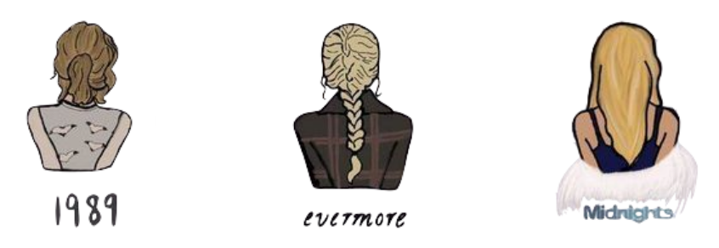

The Spotify metrics for three cover songs Taylor Swift wants to add to her re-released albums.

| **Track** | **Danceability** | **Loudness** |
| --- | --- | --- |
| End Of The Road | 66.80 | 58.00 |
| Purple Rain | 13.48 | 47.39 |
| Sweet Child O’ Mine | 28.91 | 95.18 |

## Part II: Computing Euclidean Distance Using Technology

1. Open the ***taylor-swift-spotify-metrics*** Google Sheet and make a copy to work in. Write a formula to compute the Euclidean distance between *End of the Road* and each of the tracks on 1989, folklore, and Midnights based on the Danceability and Loudness metrics.
   1. Check that your formula is computing correctly by double-checking the Euclidean distance for *Lavender Haze* and *cardigan*.

[Key spreadsheet link](https://docs.google.com/spreadsheets/d/1DVQFwrly1EYfR1kj2Tp5SBuyu1o-I_NEsWGizqCkuOo/edit#gid=0)

1. Based on your distance measures, which song is most similar to *End of the Road* on the Danceability and Loudness metrics? Explain.

Based on the distance similarity measure here, cardigan is the most similar to End of the Road.

1. Based on your response to the previous question, which album should *End of the Road* be released on if we were using the nearest neighbor (*k*=1)?

Based on this, we should put it on the folklore album.

## Part III: Optimal Number of Nearest Neighbors

1. Compute and report the optimal value for *k* to determine how many nearest neighbors we should base our classification on. Show your work.
$optimal k = sqrt(42) = 7$

2. Use the optimal number of nearest neighbors (that you reported in the previous question) to determine the album that *End of the Road* should be released on. Also report the “vote” tally for each class (album).

| cardigan | folklore | 61.52 | 64.57 | 8.428718764 |
| --- | --- | --- | --- | --- |
| Maroon | Midnights | 66.21 | 67.33 | 9.348636264 |
| mad woman | folklore | 57.42 | 60.76 | 9.777627524 |
| betty | folklore | 57.62 | 62.95 | 10.4295206 |
| Bejeweled | Midnights | 77.73 | 58.93 | 10.96949406 |
| the last great american dynasty | folklore | 75.78 | 65.35 | 11.6044345 |
| You're On Your Own, Kid | Midnights | 77.73 | 48.64 | 14.39008339 |

Vote Tally:

folklore = 4

Midnights = 3

Based on this we would classify End of the Road as most similar to a folklore song.