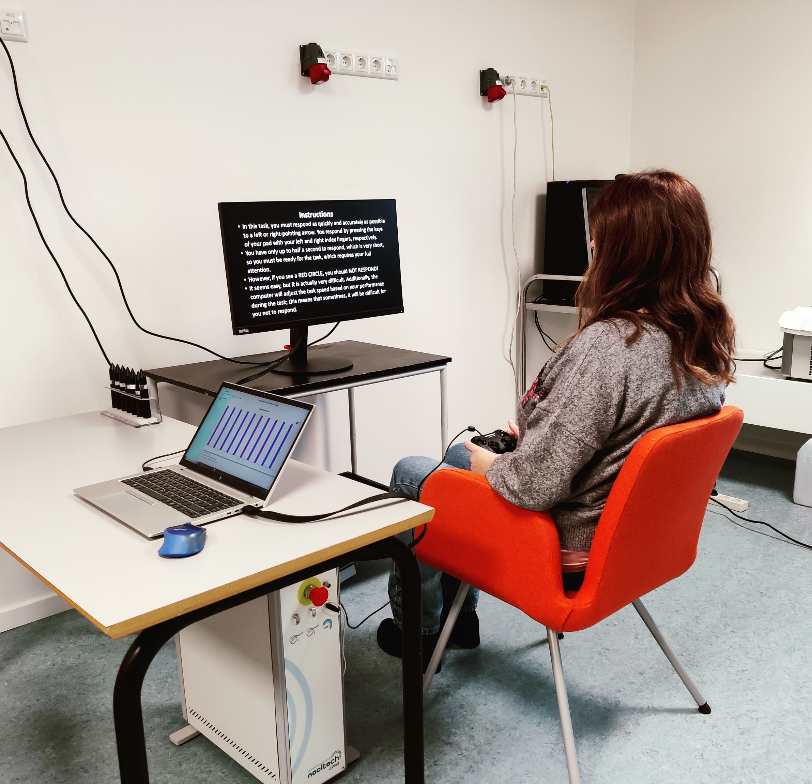

Cogni Pain II
Laura Petrini

Summary of the protocol


Contents
Introduction 2
Experimental Setup 2
Protocol 2
Analysis 2
Discussion 2

Introduction

Experimental Setup

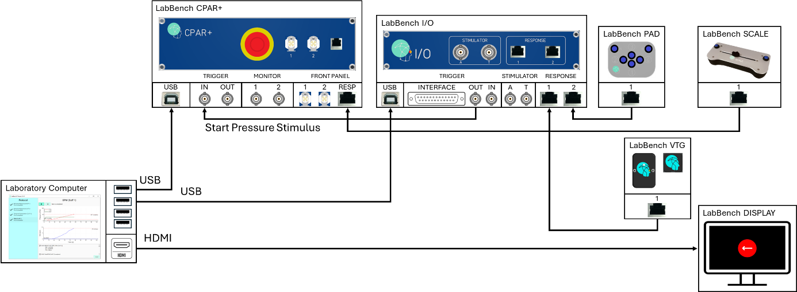
Figure 1: Illustration of the experimental setup, which consists of a LabBench I/O, LabBench CPAR+, LabBench PAD, LabBench SCALE, LabBench VTG, and LabBench DISPLAY as well as a laboratory computer that run LabBench.

Protocol

Analysis

Discussion

